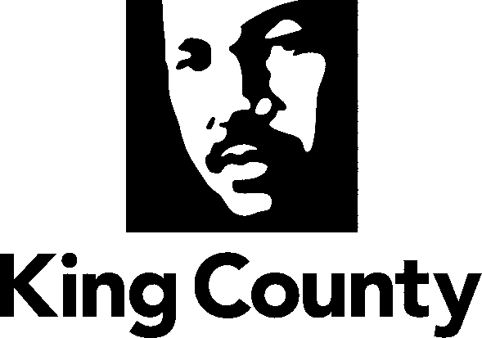

Metropolitan King County Council

Regional Water Quality Committee

Staff Report

Agenda Item No.: | 7 |  | Name: | Beth Mountsier
Proposed Ordinance No.: | 2012-0459 |  | Date: | January 9, 2013
Attending: | Pam Elardo, Director, Wastewater Treatment Division, Department of Natural Resources and Parks  William Blakney, Supervising Attorney, Civil Division, Prosecuting Attorney’s Office  Verna Bromley, Attorney, Civil Division, Prosecuting Attorney’s Office
SUBJECT:

An ordinance relating to King County’s long-term combined sewer overflow control plan and authorizing the King County Executive to sign and fulfill the obligations in a consent decree with the United States Environmental Protection Agency and the Washington State Department of Ecology.

SUMMARY:

The United States Environmental Protection Agency (“EPA”) and the Washington State Department of Ecology (“Ecology”) have alleged that the County violated Sections 301 and 402 of the Clean Water Act (“CWA”) and the conditions and limitations of the County’s National Pollutant Discharge Elimination system (“NPDES”) permit issued to the County by Ecology. These are violations related to the quality of the effluent released from combined sewer overflow (“CSO”) control facilities that act as satellite treatment plants to West Point Treatment Plant. In response, King County, without admitting any liability related to the alleged violations, has negotiated a consent decree (Attachment A to PO 2012-0459) with EPA and Ecology.

The consent decree obligates King County and its Wastewater Treatment Division (“WTD”) to implement the long-term CSO control plan that the Council just approved in September 2012 (Ordinance 17413) for future projects per the proposed design criteria/specifications and schedule in the plan, including final completion of all projects by 2030. In addition, the consent decree provides direction for 1) implementation of CSO control projects currently in design 2) improvements in operations of existing CSO treatment plants to meet effluent standards, 3) various reporting requirements regarding progress towards these goals, including post-construction monitoring 4) dispute resolution procedures and 5) penalties.

The overall goal of the consent decree and EPA’s compliance action is to ensure that combined sewer overflows at King County’s outfalls occur on average only once per year based on a rolling 20-year average and that the effluent discharged from CSO control treatment plants meet prescribed standards.

The consent decree contains some provisions for ‘flexibility’ with regard to the implementation of King County’s long term combined sewer overflow control plan. King County may propose changes to the design specifications for projects, and the priority and sequencing of projects. In addition, King County may propose a supplemental ‘integrated plan’ that includes additional activities or refines the proposed CSO control projects to address other water pollution issues, thereby resulting in better water quality in the receiving waters where CSOs currently discharge.

The consent decree also includes payment of a civil penalty totaling $400,000 with half paid to EPA and half paid to Ecology. By agreeing to the consent decree and paying the penalty, all potential liabilities related to the alleged Clean Water Act and NPDES permit violations are discharged and King County is also held harmless from third party lawsuits, related to past or potential future violations covered by the consent decree. However, there are stipulated penalties (with payments to EPA and Ecology) should King County fail to comply with the consent decree with regard to completing the specified projects (including meeting various milestones), improving the operations of existing facilities, achieving effluent standards, and meeting reporting requirements.

BACKGROUND:

Combined Sewer Overflows
Combined sewer overflows are discharges of untreated or partially treated sewage and stormwater released directly into marine waters, lakes and rivers during heavy rainfall, when the sewers have reached their capacity. Although the sewage in CSOs is greatly diluted by stormwater, both CSOs and stormwater may be harmful to public health and aquatic life because they carry chemicals and disease-causing pathogens.

From the late 1800s through the 1940s, engineers designed combined sewers (sewers that carry sewage and stormwater runoff in a single pipe) to convey sewage, horse manure, street and rooftop runoff, and garbage from city streets to the nearest receiving body of water. Around the 1950s, most sewer systems were built as separated systems (sewage in one pipe; stormwater in another pipe). In the late 1950s, treating wastewater became the standard. Interceptor pipes were built to transport all wastewater (from either combined or separated systems) to treatment plants.
Combined sewers exist in many parts of older cities, including Seattle. During heavy or long storms, the volume of the stormwater runoff may become too much for the combined sewers to handle. To protect treatment plants and avoid sewer backups into homes, businesses and streets, combined sewers sometimes overflow into Puget Sound, the Duwamish Waterway, Elliott Bay, the Lake Washington Ship Canal and Lake Washington.
Both King County and the City of Seattle manage CSOs within Seattle. King County's Wastewater Treatment Division manages 38 locations and Seattle Public Utilities manages more than 90. King County also has four CSO treatment plants, one in north Seattle (Carkeek Park CSO Treatment Plant) and one in West Seattle (Alki CSO Treatment Plant), and the relatively new Mercer/Elliott West at the north end of downtown/lower Queen Anne and Henderson/MLK facilities in southeast Seattle near Lake Washington (see map below).
Clean Water Act and CSO Control Planning and Implementation
The federal Clean Water Act was adopted in 1972. Its objective is to restore and maintain the integrity of the nation’s waters with two primary goals of eliminating discharges of pollutants into the nation’s waters and achieving/maintaining swimmable and fishable waters. The Clean Water Act requires all wastewater treatment facilities and industries that discharge effluent into surface waters to have a National Pollutant Discharge Elimination System (NPDES) permit. The Washington State Department of Ecology (Ecology) issues the permit as a vehicle for setting limits on the quality and quantity of effluent discharged from point sources such as treatment plants, CSOs, and industrial facilities. King County holds NPDES permits for the West Point, South, and Vashon Treatment Plant.

By 1979 King County (under the auspices of “Metro”, prior to the merger) was planning for CSO control projects. Metro’s CSO control program was first formalized with the development of the 1979 Combined Sewer Overflow Control program, which identified nine projects to control sewer overflows into fresh water areas of Lake Washington, Lake Union and the Ship Canal.
In 1984, Ecology introduced legislation requiring agencies with CSOs to develop plans for the “greatest reasonable reduction [of CSOs] at the earliest possible date.” In 1987 the greatest reasonable reduction was defined as “control of each CSO such that an average of one untreated discharge may occur per year.” In the following year, Metro published the “Final 1988 Combined Sewer Overflow Control Plan” which addressed control alternatives for the remaining CSOs discharging to the Ship Canal, Duwamish River and Elliott Bay. The County subsequently prepared an update/amendment of the 1988 Plan in 1995 that included an assessment of the effectiveness of CSO reduction efforts to date, a re-evaluation of priority for CSO control projects and a list of three projects the County intended to implement in the following five years.
In 1999 King County adopted the Regional Wastewater Services Plan (“RWSP) to update its policies and describe wastewater projects to be built to protect human health and the environment, provide sufficient wastewater treatment capacity and conveyance for anticipated population growth and meet regulatory requirements. It established policies for completing CSO control by 2030 and identified 21 projects, that when completed, were to bring all County CSOs into compliance. In 2000, King County produced an update to the 1988 Plan entitled the Year 2000 CSO Control Plan Update. It summarized King County’s progress on its CSO projects and was approved by Ecology as amendment to the CSO reduction plan.
A CSO program review in 2005-2006 reaffirmed the RWSP priorities of protecting public health, the environment and endangered species that are the foundation of the CSO control program. The review also reinforced the environmental and operational benefits of transferring as many CSO flows as possible to regional treatment plants for best available treatment prior to discharge.
The 2008 CSO Control Plan Update described the county’s wastewater system and the control status of its CSOs, indicated how the county was meeting the EPA’s Nine Minimum Controls, and summarized the scientific studies that had shaped the control program over time. The update also described completed, in progress, and planned CSO control projects, available CSO control strategies, and how these strategies applied to county projects.
Most recently, King County adopted the 2012 CSO Control Plan Update and an amendment to its long term combined sewer overflow control plan (Ordinance 17413) to be submitted to Ecology with the next NPDES permit renewal for West Point. It was developed to provide the blueprint and updated schedule for construction of projects to address the remaining CSO outfalls that do not meet state standards. It was also understood that the approved 2012 CSO plan would become part of the consent decree with EPA and Ecology.
To date, out of the thirty-eight CSO sites in the regional wastewater system, sixteen of the sites are controlled to the Department of Ecology’s standard of no more than one overflow per year. Of the remaining CSO locations, three are being refined and adjusted to meet the control standard, five CSO control projects are currently in design. Fourteen sites remain uncontrolled and are addressed through nine projects (2 treatment plants and 7 storage facilities) in the 2012 Update and incorporated into the consent decree as Appendix B. An illustration of the remaining projects is below.
Significant progress has been made to meet federal and state CSO control standards. Thus far approximately $389 million has been spent to reduce untreated wastewater and CSO volumes from over 2 billion gallons per year in 1980 to 800 million gallons per year. Completion of the five projects currently in design is estimated to cost $100 million. The nine remaining projects have a very preliminary cost estimate of $711 million.
Seattle and King County Combined Sewer Overflow Locations

King County's Approved Long-term CSO Control Plan Amendment

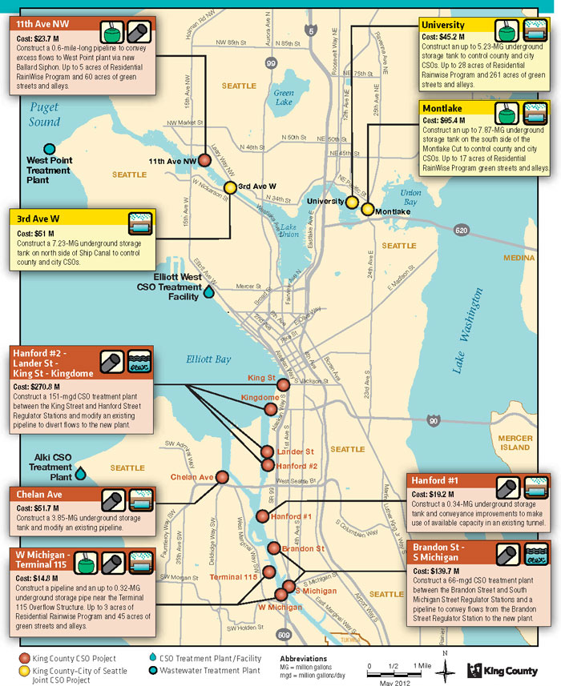

Environmental Protection Agency Policy Compliance and Enforcement
Based on a 2004 report to Congress noting the lack of progress in many communities, the Environmental Protection Agency (‘EPA’) stepped up its efforts in nearly all major metropolitan areas that have combined sewer systems to ensure that long-term control plans were being implemented. EPA has been systematically auditing and then enforcing compliance across the country via consent decrees which mandate CSO control actions.
Though King County has successfully controlled about half of its 38 CSOs since the 1980s and was only slightly off its schedule to complete control of all CSOs by 2030, EPA began a compliance review of the County’s wet weather management programs in 2008. The County met with EPA and its contractors several times and by December 2010 the County presented an analysis of the Ecology performance or control standard to EPA’s presumptive standards for system control. WTD had also submitted an overview of the process and milestones of its CSO Program Review (that had started in 2009 and was scheduled to conclude with Council action in 2012). In mid-2011, EPA and the U.S. Department of Justice and the County began discussing potential elements of a consent decree as a start to negotiations. Conversations and technical meetings with EPA, its contractor and the Department of Justice continued to occur through 2012 with the understanding that the County’s proposed (now adopted) 2012 Long-term CSO Control Plan Amendment met EPA’s requirements and would be referenced as a part of a consent decree.
Consent Decree
A consent decree is a written agreement between all parties to a lawsuit that describes the actions that must be taken to resolve the alleged violations of law. In this case the parties are the U.S. Environmental Protection Agency (EPA) and the Washington State Department of Ecology and King County. A consent decree avoids the cost and uncertainty of litigation. Rather than litigating with EPA and Ecology regarding the alleged violations, the King County Executive and WTD chose to negotiate a settlement agreeing to implement a schedule for improvement of operations at existing CSO Treatment plants, construction of CSO control projects currently in design (the “Beach projects”) and design and construction of an additional nine projects to address 14 uncontrolled combined sewer overflow outfalls.

The decree has to be acceptable to the federal and state agencies involved. Once the terms are agreed to, the proposed decree will be lodged in federal court where a federal court judge will review the terms, allow for interested parties to comment during a comment period, and may enter the decree as final, provided all parties agree to its terms. After the consent decree is entered by the court, changes to the consent decree must be approved by the court.

Consent Decree Description
The proposed consent decree is a legal document with twenty-six sections. Each was the subject of negotiation, though the Department of Justice and EPA had many components/sections they consider to be “boiler plate”. The following is a summary of some of the key sections of the consent decree.
Applicability The consent decree applies to and is binding upon King County, including its officers, directors, agents and employees. It also applies to contractors and all persons, firms and corporations acting under the direction and control of the County.

Objective The primary objective is to have King County obtain Construction Completion of all CSO control project no later than December 31, 2030. But the overall objective is to not only have the projects constructed but also operating to meet the Washington State standard of no more than one overflow event per year on average (over a 20 year period) for each outfall or meeting effluent standards at the CSO treatment plants. The rest of the consent decree details the schedule for completing projects and monitoring projects post-construction to ensure they meet these standards.

Compliance Programs These sections essentially describe how King County will implement the consent decree to complete construction, monitor and report on all of the CSO outfalls that still need to meet Washington State defined CSO control standards.

Sections 10-11 prescribe the schedule for completion of projects currently being constructed (Ballard Siphon and related CSO control project) or in design that are to begin construction by December 2013 (the “Beach Projects”)

Section 12 stipulates the post construction monitoring and reporting required for the projects above. If projects have not achieved control within one year, a supplemental compliance plan is required.

Sections 13-14 requires a plan within 30 days of the effective date of the consent decree for modifications of facilities or operations at Dexter, Denny Way and Harbor Ave regulators) to meet control parameters. And, the CSO Annual Report (for EPA and Ecology) must show compliance to control parameters by December 2015 for those projects; otherwise a supplemental compliance plan is due August 2016.

Section 15 directs construction of the nine projects (to control the remaining 14 uncontrolled CSOs) per the design and performance criteria and the schedule for significant milestones as described in Appendix B. This is the implementation of the updated long-term control plan.

Section 16 – 18 requires post-construction monitoring for those projects including submittal of Annual Reports and additional Supplemental Compliance Plans if the effluent standards are not being met or discharges at the storage facilities exceed one per year.

Sections 21 – 27 describe some opportunities for proposals King County may make to deviate from the proposed projects and schedules.
- Section 21 allows King County to request deviations from the design criteria for individual projects if it can demonstrate the requested revision reflects good engineering practice and will still meet the performance criteria. EPA and Ecology have discretion to approve such a change. If a modification is rejected, King County is entitled to dispute resolution and appeal of the decision to the EPA Region 10 Compliance and Enforcement Director. If a modification is judged to be a revision of 20% of more, the consent decree must be modified and approved by the court.
- Section 22 allows the County to propose Green Stormwater Infrastructure (GSI) control measures to substitute in part or reduce the “Gray” Infrastructure projects for the four designated projects.
- Section 23 allows the County to propose/request a modification of the critical milestones in Appendix B for the sole purpose of “revising the priority and sequencing of its CSO Control Measures if the County demonstrates the requested modification 1) reflects good engineering practice, 2) is required to coordinate or align with the City of Seattle’s stormwater or CSO infrastructure projects 3) is necessary to attain cost effective and technically sound CSO Control Measures and 4) will not change, modify or extend in any way the County’s final Construction Completion of December 31, 2030.”
- Section 24 - 26 recognizes the parties interest in supporting comprehensive and integrated planning approach to obligations under the Clean Water Act, and allows the County to submit a work plan or “Integrated Plan” that proposed water quality improvement projects to be implemented by the county or jointly by the County and other entities to result in significant benefits to surface water quality beyond those that would be achieved by implementation of the approved CSO Control Measures only. If an Integrated Plan is rejected, there is a dispute resolution process.
- Section 27 allows the County to request a modification of CSO Control Measure and/or an extension of milestone up to a maximum of five years if the County experiences significant adverse changes to its financial circumstances.

Sewer System Operation Program Plan Within 90 days of the effective date of the consent decree the County must submit a Sewer System Operation Program Plan which details how the system will be operated to maximize or essentially optimize the utilization of all of the facilities constructed to control CSOs and also provide for real-time coordination with Seattle and its CSO control system.

Joint Operations and System Optimization Plan Between City of Seattle and the County This section requires the development and submittal by March 2016 of a Joint Operations and System Optimization Plan for Seattle and King County.

Civil Penalties Within 30 days of the effective date of the consent decree, King County must pay $400,000.

Stipulated Penalties There are various penalty amounts for failure to comply with effluent standards at CSO Treatment Plants, failure to meet milestone dates for projects, failure to meet reporting requirements, etc.

ANALYSIS

The purpose of the proposed consent decree is to settle a lawsuit between all the parties (King County, Ecology and EPA) through a written agreement describing the actions that must be taken to resolve the alleged violations of law. Though King County has been aggressively pursuing a combined sewer control plan and implementation of projects over two decades, EPA and the Department of Justice have signaled that the federal government expects to have a long-term legally enforceable instrument – either by consent or issued unilaterally.

The consent decree incorporates the recently adopted long-term CSO Control Plan as the means to accomplish control of the remaining CSO overflows that do not meet state standards. Additionally the consent decree prescribes a schedule for modifications to facilities and/or operations to ensure existing projects meet compliance standards. King County’s adopted policies in the Regional Wastewater Services Plan had already committed to these standards and completion of projects by 2030, as stipulated by the consent decree.

King County would have more flexibility to modify or adjust its plans for completion of CSO projects without a consent decree. However, the proposed decree does allow some level of flexibility when King County can demonstrate that modifications (for schedule and design) will reflect good engineering practice and will still meet performance criteria.

The civil penalties to be paid by King County ($400,000) seem to be within the range of penalties paid by other jurisdictions (materials summarizing other CSO decrees and plans were distributed at the December 5, 2012 meeting).

REASONABLENESS:
Adoption of the ordinance approving the consent decree and authorizing the King County Executive to sign and fulfill the county’s obligations contained in the consent decree would constitute a reasonable business decision to settle the lawsuit.

ATTACHMENTS:
- Proposed Ordinance 2012-0459

King County is one of the last jurisdictions (along with Seattle) with combined sewers to have negotiated a consent decree. EPA ‘s lawsuit related to violations of the Clean Water Act is part of a national enforcement strategy to compel completion of CSO control and water quality improvements across the country.
The West Point NPDES permit includes the Alki and Carkeek CSO treatment plants, the Mercer/Elliott West and Henderson/Norfolk CSO storage and treatment facilities and all of the King County CSO outfalls. Department of Ecology’s CSO regulations (WAC 173-245) and King County’s RWSP policies require WTD to submit a CSO plan update to Ecology that coincides with each NPDES permit renewal for the West Point Treatment Plant. Updates are intended to describe WTD’s progress on its CSO program to date, identify its program for the next 5 years, and provide a vehicle for making changes in the overall long-term CSO control program.
King County’s predecessor agency was the Municipality of Metropolitan Seattle, also known as “Metro”, which was consolidated/merged with the County in 1994.
The standard of an average of one untreated discharge per year is now based on a 20-year moving or rolling average.
The proposed consent decree has some provisions for flexibility with regard to design criteria/specifications, schedule and re-sequencing of projects and a supplemental integrated plan that might lead to refinements of CSO control projects. Some of the decision-making for these changes is proposed to be at the discretion of EPA and Ecology, beyond a certain threshold the court would need to approve the changes.

