OFFICE OF RISK MANAGEMENT SERVICES
Analyst: Mellisa Bailey

 |  | Expenditures |  | Revenues |  | FTEs |  | TLTs
2024 Revised Budget, Annualized |  | $59,668,205 |  | $74,426,944 |  | 27.5 |  | 1.0
2025 Base Budget Adjust. |  | $12,682,373 |  | $0 |  | 0.0 |  | (1.0)
2025 Decision Packages |  | $1,821,083 |  | $7,197,657 |  | 2.0 |  | 0.0
2025 Proposed Budget |  | $74,172,000 |  | $81,625,000 |  | 29.5 |  | 0.0
% Change from prior biennium, annualized |  | 24.3%
Dec. Pkg. as % of prior biennium, annualized |  | 3.1%
Major Revenue Sources: ORMS Internal Service Rate

Description

The Office of Risk Management Services (ORMS) manages the county’s self-insurance program and all supplemental insurance coverages, investigates and resolves claims filed against the county, advises county agencies on liability related to contracts, and recovers compensation for damages to county assets by negligent third parties. Through the enterprise risk management program and loss control program, ORMS collaborates with county departments to identify and address risks. ORMS also handles complex public records requests.

ORMS, which is within the Department of Executive Services, is supported by an internal service rate charged to all county departments to cover insurance premiums, claim costs, and all other operational costs of the office.

Summary of Proposed Budget and Changes

The ORMS budget is proposed to increase by approximately 24.3% in 2025. This increase is due to base budget and central rate adjustments, ongoing litigation, and the addition of two FTEs.

Base Budget. The ORMS base budget would increase by nearly $12.7 million. According to Executive staff, this increase is "primarily for a $12.5 million annual appropriation for claims expense that was added to the ORMS budget in the 2nd omnibus 2023-2024 budget. The decision package was entered as one-time, but it should have been ongoing. The remaining amount is for the standard increases to personnel costs."
Ongoing Litigation. The Executive is proposing to reappropriate $1.4 million of Coronavirus Local Fiscal Recovery (CLFR) moneys to support ongoing litigation related to the county's vaccine mandate. This work continues to be handled by external counsel on the county's behalf. According to Executive staff, the county has received 59 tort claims and 16 lawsuits from employees who were separated for declining to receive the COVID vaccine per the mandate. ORMS continues to receive new tort claims and lawsuits and anticipates a multi-plaintiff suit, similar to those filed against the City of Seattle and the state. ORMS estimates that $1.4 million will be needed in 2025 to cover the cost of outside legal services for these claims and lawsuits.

Additional FTEs. The proposed budget would provide ORMS with $338,756 in ongoing appropriation authority for two additional FTEs. ORMS is requesting one Project/Program Manager III to support the Insurance and Contracts Section. ORMS reports that, on average, there is a 17% growth year-over-year in daily contract and scope review and evidence of insurance compliance work. Additionally, there have been more large capital projects (such as the Harborview Owner Controlled Insurance Program (OCIP) and the Mouth of the Duwamish OCIP). This position would help address the increased workload.

ORMS is also requesting one Tort Claim Investigator to support the Claims Section. As previously reported to council, the number of claims and amounts paid out for claims has increased over the last several years. This position was reduced in the 2021-2022 budget due to budget reductions; however, ORMS is requesting the position be added back so they can adequately serve customers who file claims with the county.

Risk Management Fund. The Risk Management Fund has one reserve, the Actuarial Reserve for Losses Incurred, which is set by the actuary as the estimated outstanding losses limited to the self-insured retention level. The Year End 2023 Actuary Report increased the amount advised to be on reserve for 2024 and beyond. To help mitigate increased risk management costs and comply with required reserve levels, ORMS is raising the internal service rate that it charges all county departments by 8.11% in 2025. The financial plan also assumes a 4.7% increase in 2026-2027 and a 5.8% increase in 2028-2029.

The Risk Management Financial Policy requires the fund balance to be maintained at a minimum of 75% of the actuarially determined reserve amounts. Additionally, the policy states that "if reserves are more or less than 100% of the actuarially determined amounts, the financial plan shall reflect a plan over two biennia to match the actuarial amount." The transmitted financial plan showed a reserve shortfall in the outyears; however, Executive staff state this was in error and have provided an updated financial plan (included with this staff report). The updated financial plan shows reserves reaching 100% of the actuarially determined amount in the 2026-2027 biennium.

Key Issues

Staff have not identified any key issues with this budget.

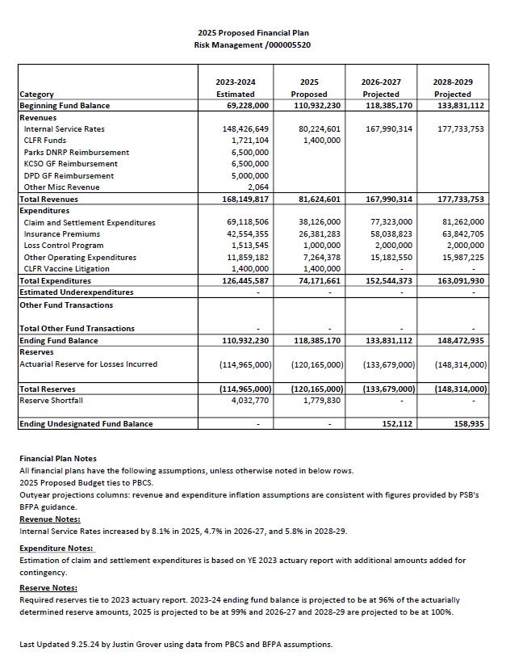

ORMS functions are governed by K.C.C. chapter 2.21.
Revenues are deposited into the Risk Management Fund (see K.C.C. 4A.200.630 for allowable uses).
In 2023, ORMS requested and received $2.8 million in CLFR funding and, in partnership with the PAO, ran an RFP for outside counsel to defend the county in this litigation. The RFP was awarded to Pacifica Law Group in October 2023. Executive staff report that, as of September 24, 2024, Pacifica has billed $763,149, and estimates a total of $1.0 million will be charged to the project by the end of the 2023-2024 biennium. Of the remaining $1.8 million in CLFR moneys, the 2025 Proposed Budget would reappropriate $1.4 million to ORMS for this litigation and the remaining $400,000 would support other programs.
This litigation is anticipated to continue beyond 2025; however, executive staff state that the statute of limitations for the newest known claims will run out in mid-2025.
BFM Committee Briefing 2022-B0043 (March 23, 2022); BFM Committee Briefing 2022-B0125, Attachment 2 (October 11, 2022); the staff report for the 2023-2024 2nd Omnibus (Ordinance 19712); and recent annual ORMS annual reports to council (2024-RPT0043). Most recently, ORMS reports that a total of 1,539 liability claims were filed in 2023, compared with 1,358 in 2022, a 13% increase. Claims costs increased by 91% from 2020 to 2023, with a total of $36.6 million paid in claim and settlement expenditures in 2023.
According to ORMS, in the April 2024 excess liability insurance renewals, the self-insured retention was increased from $6.5 million (non-Metro) and $7.5 million (Metro) to $10 million for all county agencies. The total premium for excess liability insurance was increased by 31% ($2.2M).
The required reserves increased by $5.2 million in 2025, $13.5 million in 2026-2027, and another $14.6 million in 2028-2029.
The county’s risk management internal service rate for 2025 is comprised of the following: (a) Claims – 56%, (b) Insurance Premiums – 34%, (c) ORMS Administration – 8%, and (d) Public Records Program – 2%. Claim rates are calculated based on 5-year claim history (uncapped) plus reserves on open claims (one claim per division capped at $250,000). Insurance premiums, ORMS administration, and Public Records program rates are calculated based on agency’s property values, number of FTEs, number of claims, and claim allocation methods.
These numbers are from the updated financial plan dated 9.25.2024 (and included with this staff report). The transmitted financial plan assumed a 3.8% increase in the 2026-2027 biennium and a 6.0% increase in the 2028-2029 biennium. However, executive staff confirmed that this was incorrect and needed to be updated to comply with the Risk Management Financial Policy.
Risk Management Financial Policy adopted by the Risk Management Committee on March 16, 2016 and updated August 1, 2019.
In the transmitted financial plan, the 2023-2024 ending fund balance was projected to be at 96% of the actuarially determined reserve amounts (with a $4 million reserve shortfall), 2025 is projected at 99% (with nearly a $1.8 million reserve shortfall), 2026-2027 is projected at 99% (with almost a $1.3 million reserve shortfall) and 2028-2029 is projected at 98% (with about a $2.5 million reserve shortfall). The updated plan is still projected at 99% in 2025 but is now projected at 100% in 2026-2027 and 100% in 2028-2029. Reserves are determined annually by the actuary and are therefore subject to change depending on future actuarial reports.

