Updated July 29, 2026
Lynnwood Link Public Transportation Service Changes for King County
As Adopted by Ordinance 19751 and Amended by Ordinance XXXX (2026-0218)

Route: 16 (delete)

OBJECTIVES:

Replacement service for Route 16 will be provided by the Route 5. Restructure service to provide better all-day transit service levels in accordance with the Strategic Plan for Public Transportation, 2021-2031, and King County Metro Service Guidelines.

Strategic Plan Strategies
- Develop, evaluate, and adjust products, services, and programs that address barriers and increase mobility, especially among priority populations.
- Deliver mobility services that connect people to jobs and job centers, opportunities, and activities of daily living. Improve service during non-peak periods.
- Be flexible and responsive to changes in demand for service and community engagement.
- Use Metro’s Service Guidelines and performance measures to ensure service investments align with needs and values and build toward Metro Connects.

Service Guidelines
- 1. Network Connections
  - Services should be designed in the context of the entire transit system, which includes local and regional bus routes, Link 1 Line, commuter rail lines, and other modes.
  - Metro strives to make transfers easy. Network design should consider locations where transfer opportunities could be provided to improve mobility and efficiency.
  - Where many transfers are expected between services of different frequencies, timed transfers should be maintained to reduce wait times.
- 2. Multiple Purposes and Destinations
  - Routes are more efficient and successful when designed to serve multiple purposes and destinations rather than specialized travel demands.
  - Specialized service should be considered when there is sizeable and demonstrated demand that cannot be adequately met by more generalized service.
- 4. Route Spacing and Duplication
  - Routes should be designed to avoid competing for the same riders. In general, routes should be no closer than 1/2 mile.
  - Services may overlap or be more closely spaced where urban and physical geography makes it necessary, where services in a common segment serve different destinations, or where routes converge to serve regional growth centers. Where services do overlap, they should be scheduled together, if possible, to provide shorter waits along the common routing.
  - Metro should consider transit access in defining a route or route segment as duplicative. Access should be based on the frequency of service.

IMPACTED SERVICE AREA:
Shoreline, Greenwood, Phinney, Fremont, Downtown Seattle

SERVICE CHANGE:
Delete Route 16 to reallocate hours to all-day service. Alternative service will be provided by Route 5.

Frequency:
 | Weekday |  |  | Saturday |  | Sunday
 | Peak | Midday | Night | Daytime | Night | Daytime | Night
March 2022 | 15-20 min | - | - | - | - | - | -
Current | - | - | - | - | - | - | -
Proposed | - | - | - | - | - | - | -

Hours of Service:
 | Weekday | Saturday | Sunday
March 2022 | 4:45 AM –7:30 AM, 4:00 PM– 6:30 PM | - | -
Current | - | - | -
Proposed | - | - | -

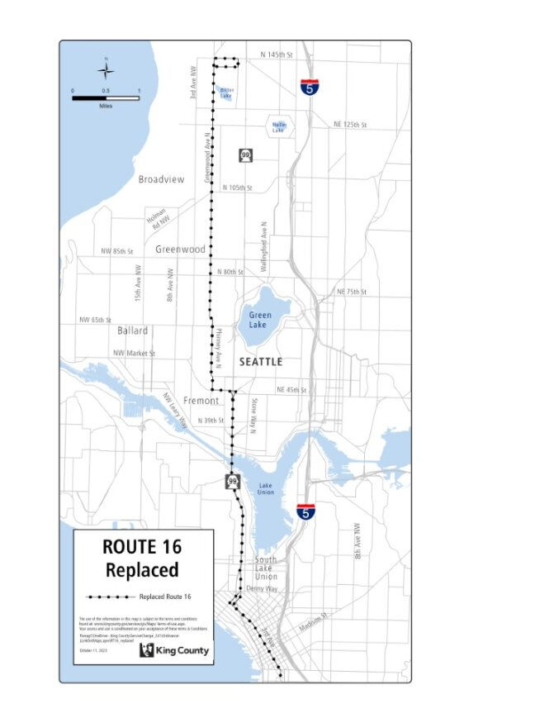

Route: 20 (delete)

OBJECTIVES:
Replacement service for Route 20 will be provided by Routes 44, 45, 61, and 62.
Restructure service to leverage high-capacity transit investments, reduce duplication, and provide new east-west connections and better all-day transit service levels in accordance with the Strategic Plan for Public Transportation, 2021-2031, and King County Metro Service Guidelines.

Strategic Plan Strategies:
- Develop, evaluate, and adjust products, services, and programs that address barriers and increase mobility, especially among priority populations.
- Deliver mobility services that connect people to jobs and job centers, opportunities, and activities of daily living. Improve service during non-peak periods.
- Be flexible and responsive to changes in demand for service and community engagement.
- Use Metro’s Service Guidelines and performance measures to ensure service investments align with needs and values and build toward Metro Connects.

Service Guidelines
- 1. Network Connections
    - Services should be designed in the context of the entire transit system, which includes local and regional bus routes, Link 1 Line, commuter rail lines, and other modes.
    - Metro strives to make transfers easy. Network design should consider locations where transfer opportunities could be provided to improve mobility and efficiency.
    - Where many transfers are expected between services of different frequencies, timed transfers should be maintained to reduce wait times.
- 2. Multiple Purposes and Destinations
    - Routes are more efficient and successful when designed to serve multiple purposes and destinations rather than specialized travel demands.
    - Specialized service should be considered when there is sizeable and demonstrated demand that cannot be adequately met by more generalized service.
  - 4. Route Spacing and Duplication
    - Routes should be designed to avoid competing for the same riders. In general, routes should be no closer than 1/2 mile.
    - Services may overlap or be more closely spaced where urban and physical geography makes it necessary, where services in a common segment serve different destinations, or where routes converge to serve regional growth centers. Where services do overlap, they should be scheduled together, if possible, to provide shorter waits along the common routing.
    - Metro should consider transit access in defining a route or route segment as duplicative. Access should be based on the frequency of service.

IMPACTED SERVICE AREA:
Lake City, Northgate, Licton Springs, Green Lake, Wallingford, University District

SERVICE CHANGE:
Delete Route 20 to reduce duplicative service. Alternative service will be provided by Routes 44, 45, and 61. The Route 44 will replace the service lost between the University District and Wallingford, The Route 45 will provide alternative north-south service between the UW station and Loyal Heights. The new route 61 will provide alternative service between Greenwood and Lake City via Northgate.
Frequency:
 | Weekday |  |  | Saturday |  | Sunday
 | Peak | Midday | Night | Daytime | Night | Daytime | Night
March 2022 | 15-20 min | 30 min | 30 min | 30 min | 30 min | 30 min | 30 min
Current | 15 min | 30 min | 60 min | 30 min | 60 min | 30 min | 60 min
Proposed | - | - | - | - | - | - | -

Hours of Service:
 | Weekday | Saturday | Sunday
March 2022 | 4:45 AM –7:30 AM, 4:00 PM– 6:30 PM | 6:00 AM – 12:00 AM | 6:00 AM – 12:00 AM
Current | 5:45 AM – 12:05 AM | 6:00 AM – 12:00 AM | 5:55 AM – 11:55 PM
Proposed | - | - | -

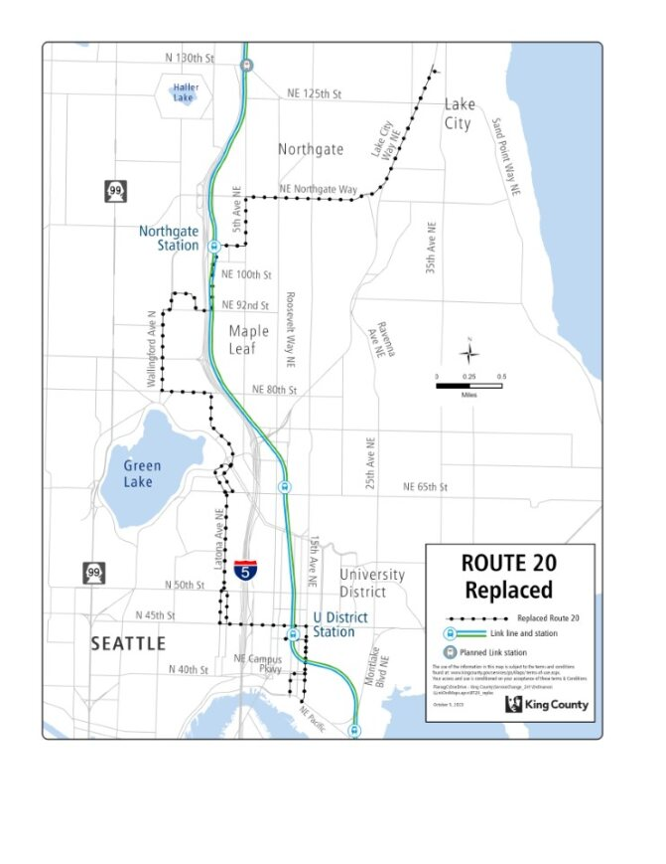

Route: 28 (revise)

OBJECTIVES:
Revise service on Route 28 to no longer serve the peak-only northern tail of the route, in the Broadview area, in accordance with the Strategic Plan for Public Transportation, 2021-2031 and King County Metro Service Guidelines.

Strategic Plan Strategies:
- Prioritize service in geographic areas that have highly dense, transit-supportive development; a high proportion of priority populations; and limited midday and evening service.
- Develop, evaluate, and adjust products, services, and programs that address barriers and increase mobility, especially among priority populations.
- Deliver mobility services that connect people to jobs and job centers, opportunities, and activities of daily living. Improve service during non-peak periods.
- Be flexible and responsive to changes in demand for service and community engagement.
- Use Metro’s Service Guidelines and performance measures to ensure service investments align with needs and values and build toward Metro Connects.

Service Guidelines
- 1. Network Connections
- Services should be designed in the context of the entire transit system, which includes local and regional bus routes, Link 1 Line, commuter rail lines, and other modes.
- Metro strives to make transfers easy. Network design should consider locations where transfer opportunities could be provided to improve mobility and efficiency.
- Where many transfers are expected between services of different frequencies, timed transfers should be maintained to reduce wait times.
- 2. Multiple Purposes and Destinations
- Routes are more efficient and successful when designed to serve multiple purposes and destinations rather than specialized travel demands.
- Specialized service should be considered when there is sizeable and demonstrated demand that cannot be adequately met by more generalized service.
  - 3. Easy to Understand
- A simple transit network is easier for riders to understand and use than a complex network.
- Routes should have predictable and direct routings and should provide frequency and span appropriate to the market served.
- Routes should serve connection points where riders can connect with frequent services, opening the widest possible range of travel options.
- 5. Route Directness
- A route that operates directly between two locations is faster and more attractive to riders than one that takes a circuitous path. Circulators or looping routes do not have competitive travel times compared to walking or other modes of travel, so they tend to have low ridership and poor performance.
- Directness should be considered in relation to the market for the service. Where a route deviates away from its major path to serve a specific destination, the delay to riders on board the bus should be considered in relation to the ridership gained on a deviation.

IMPACTED SERVICE AREA:
Broadview, Carkeek Park, Ballard, Fremont, Downtown Seattle

SERVICE CHANGE:
Delete the peak-only portion of Route 28 between NW 103 St. and NW 145 St. due to low ridership and availability of nearby alternatives on Greenwood Ave N where riders can use Route 5.

Frequency (segment between NW 103 St. and NW 145 St.):
 | Weekday |  |  | Saturday |  | Sunday
 | Peak | Midday | Night | Daytime | Night | Daytime | Night
March 2022 | 20-30 min | - | - | - | - | - | -
Current | 45 min | - | - | - | - | - | -
Proposed | - | - | - | - | - | - | -

Hours of Service (segment between NW 103 St. and NW 145 St.):
 | Weekday | Saturday | Sunday
March 2022 | 6:00 AM – 8:30 AM, 5:00 PM – 7:00 | - | -
Current | 6:00 AM – 8:30 AM, 5:00 PM – 7:00 PM | - | -
Proposed | - | - | -

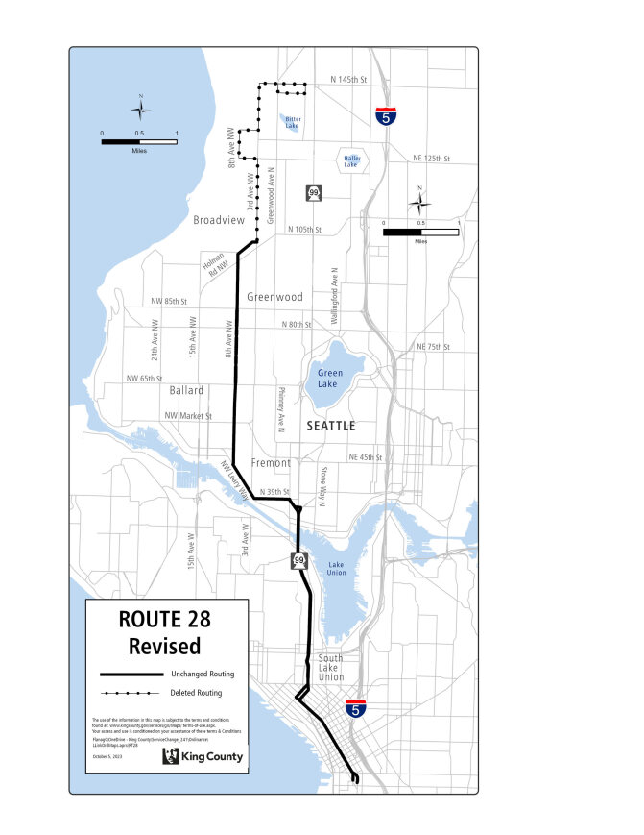

Route: 45 (revise)

OBJECTIVES:

Revise service on Route 45 to improve route reliability, match service levels to ridership demand, and secure appropriate layover facilities in accordance with the Strategic Plan for Public Transportation, 2021-2031, and King County Metro Service Guidelines.

Strategic Plan Strategies:
- Improve speed and reliability consistent with Metro Connects.
- Use Metro’s Service Guidelines and performance measures to ensure service investments align with needs and values and build toward Metro Connects.

Service Guidelines
- 1. Network Connections
    - Services should be designed in the context of the entire transit system, which includes local and regional bus routes, Link 1 Line, commuter rail lines, and other modes.
- 3. Easy to Understand
    - Routes should have predictable and direct routings and should provide frequency and span appropriate to the market served.
    - Routes should serve connection points where riders can connect with frequent services, opening the widest possible range of travel options.
  - 9. Route Terminals
    - Metro carefully selects the locations where bus routes end and buses wait before starting the next trip (layover). Maintaining existing layover spaces at route terminals is a critical priority to support continued and future service, and expanding layover may be required to support service expansion.
    - Terminals should be in areas where restroom facilities are available for operators, considering the times of day when the facilities would be needed.

IMPACTED SERVICE AREA:
Loyal Heights, Greenwood, Green Lake, Roosevelt, University District.

SERVICE CHANGE:
Revise Route 45 to extend south along University Way to NE Pacific St. and Boat St. layover upon implementation of Route 522 Express realignment from Roosevelt to 148th. Revise peak-period frequency from every 10-12 minutes to every 12-15 minutes.

Frequency:
 | Weekday |  |  | Saturday |  | Sunday
 | Peak | Midday | Night | Daytime | Night | Daytime | Night
March 2022 | 10-12 min | 15 min | 30 min | 15 min | 30 min | 15 min | 30 min
Current | 10-13 min | 15 min | 15 min | 15 min | 15 min | 15 min | 15 min
Proposed | 12-15 min | 15 min | 30 min | 15 min | 30 min | 15 min | 30 min

Hours of Service:
 | Weekday | Saturday | Sunday
March 2022 | 5:00 AM – 1:00 AM | 5:15 AM – 1:00 AM | 5:15 AM – 1:00 AM
Current | 5:00 AM – 1:00 AM | 5:15 AM – 1:00 AM | 5:15 AM – 1:00 AM
Proposed | 5:00 AM – 1:00 AM | 5:15 AM – 1:00 AM | 5:15 AM – 1:00 AM
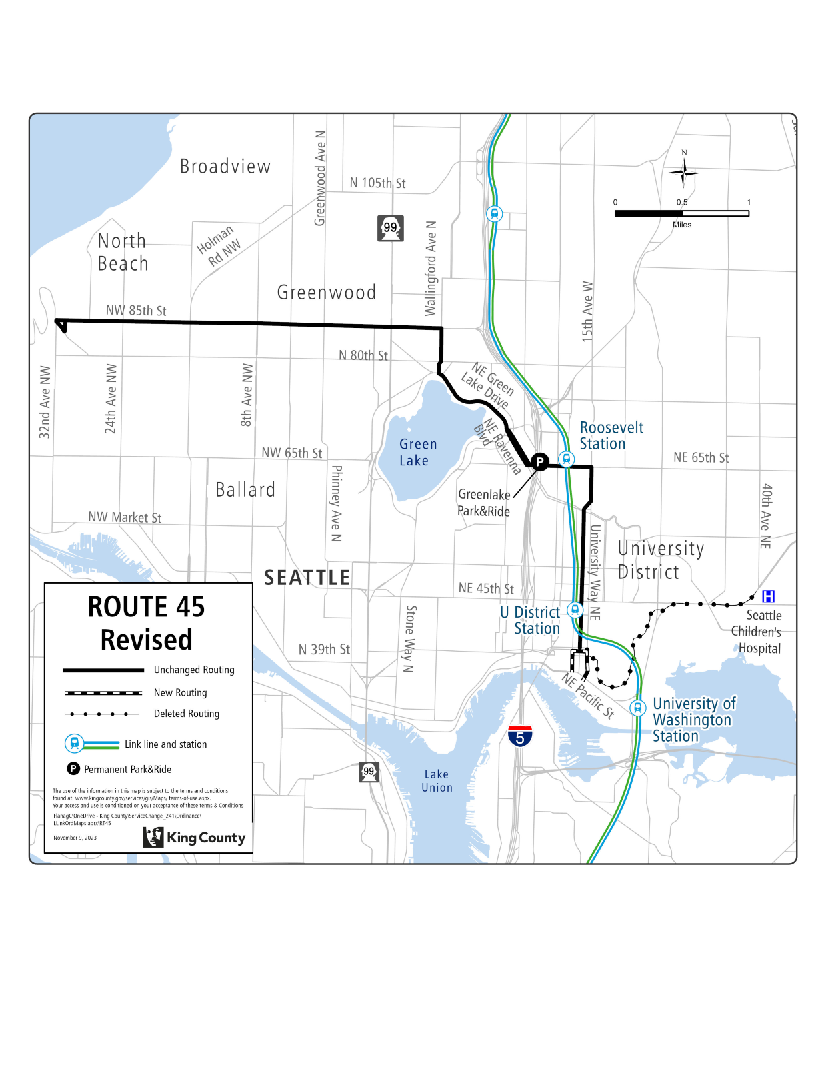
Route: 61 (new)

OBJECTIVES:

Create new route that serves Greenwood, Northgate, and Lake City Way in order to leverage high-capacity transit investments, improve network connectivity and create new east-west connections in accordance with the Strategic Plan for Public Transportation, 2021-2031, and King County Metro Service Guidelines.

Strategic Plan Strategies:
- Prioritize service in geographic areas that have highly dense, transit-supportive development; a high proportion of priority populations; and limited midday and evening service.
- Develop, evaluate, and adjust products, services, and programs that address barriers and increase mobility, especially among priority populations.
- Deliver mobility services that connect people to jobs and job centers, opportunities, and activities of daily living. Improve service during non-peak periods.
- Be flexible and responsive to changes in demand for service and community engagement.
- Use Metro’s Service Guidelines and performance measures to ensure service investments align with needs and values and build toward Metro Connects.

Service Guidelines
- 1. Network Connections
    - Services should be designed in the context of the entire transit system, which includes local and regional bus routes, Link 1 Line, commuter rail lines, and other modes.
    - Metro strives to make transfers easy. Network design should consider locations where transfer opportunities could be provided to improve mobility and efficiency.
    - Where many transfers are expected between services of different frequencies, timed transfers should be maintained to reduce wait times.
- 2. Multiple Purposes and Destinations
    - Routes are more efficient and successful when designed to serve multiple purposes and destinations rather than specialized travel demands.
  - 3. Easy to Understand
    - A simple transit network is easier for riders to understand and use than a complex network.
    - Routes should have predictable and direct routings and should provide frequency and span appropriate to the market served.
    - Routes should serve connection points where riders can connect with frequent services, opening the widest possible range of travel options.
  - 4. Route Spacing and Duplication
    - Services may overlap or be more closely spaced where urban and physical geography makes it necessary, where services in a common segment serve different destinations, or where routes converge to serve regional growth centers. Where services do overlap, they should be scheduled together, if possible, to provide shorter waits along the common routing.

IMPACTED SERVICE AREA:
Greenwood, Northgate and Lake City Way.

SERVICE CHANGE:
Implement new Route 61, which will provide service between Greenwood, the Northgate Station, and Lake City Way. On weekdays and weekends Route 61 will operate every 15 minutes from 5:30 AM to 10:00 PM, and every 30 minutes from 10:00 PM to 1:30 AM.
Frequency:
 | Weekday |  |  | Saturday |  | Sunday
 | Peak | Midday | Night | Daytime | Night | Daytime | Night
March 2022 | - | - | - | - | - | - | -
Current | - | - | - | - | - | - | -
Proposed | 15 min | 15 min | 30 min | 15 min | 30 min | 15 min | 30 min

Hours of Service:
 | Weekday | Saturday | Sunday
March 2022 | - | - | -
Current | - | - | -
Proposed | 5:00 AM – 1:30 AM | 5:30 AM – 1:30 AM | 5:30 AM – 1:30 AM

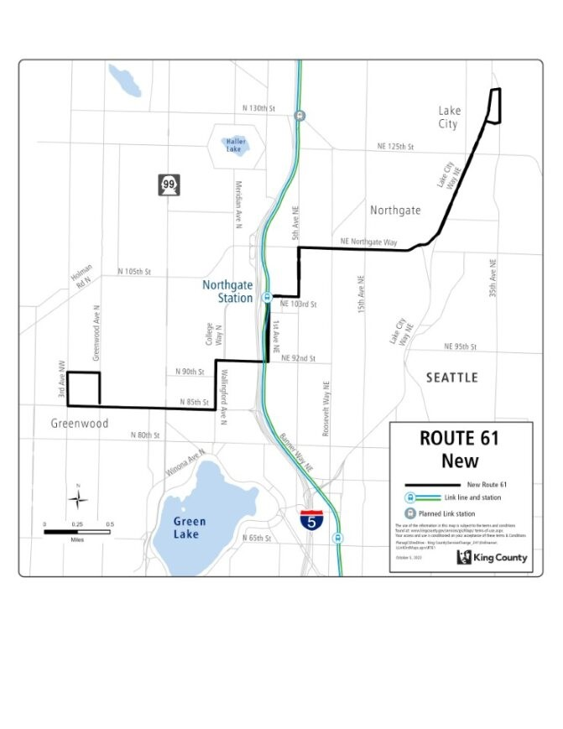

Route: 64 (delete)

OBJECTIVES:
Replacement service for Route 64 will be provided by Routes 62 and 65.
Restructure service to provide better all-day transit service levels in accordance with the Strategic Plan for Public Transportation, 2021-2031, and King County Metro Service Guidelines.

Strategic Plan Strategies:
- Develop, evaluate, and adjust products, services, and programs that address barriers and increase mobility, especially among priority populations.
- Deliver mobility services that connect people to jobs and job centers, opportunities, and activities of daily living. Improve service during non-peak periods.
- Be flexible and responsive to changes in demand for service and community engagement.
- Use Metro’s Service Guidelines and performance measures to ensure service investments align with needs and values and build toward Metro Connects.

Service Guidelines
- 1. Network Connections
    - Services should be designed in the context of the entire transit system, which includes local and regional bus routes, Link 1 Line, commuter rail lines, and other modes.
    - Metro strives to make transfers easy. Network design should consider locations where transfer opportunities could be provided to improve mobility and efficiency.
    - Where many transfers are expected between services of different frequencies, timed transfers should be maintained to reduce wait times.
- 2. Multiple Purposes and Destinations
    - Routes are more efficient and successful when designed to serve multiple purposes and destinations rather than specialized travel demands.
    - Specialized service should be considered when there is sizeable and demonstrated demand that cannot be adequately met by more generalized service.
  - 4. Route Spacing and Duplication
    - Routes should be designed to avoid competing for the same riders. In general, routes should be no closer than 1/2 mile.
    - Services may overlap or be more closely spaced where urban and physical geography makes it necessary, where services in a common segment serve different destinations, or where routes converge to serve regional growth centers. Where services do overlap, they should be scheduled together, if possible, to provide shorter waits along the common routing.
    - Metro should consider transit access in defining a route or route segment as duplicative. Access should be based on the frequency of service.

IMPACTED SERVICE AREA:
Wedgwood, Ravenna, Roosevelt, South Lake Union

SERVICE CHANGE:
Delete Route 64 to reallocate hours to all-day service. Alternative service will be provided by Routes 62 and 65. The Route 62 will provide service between Downtown Seattle and Sand Point via Greenlake, while the Route 65 will provide service to the Shoreline South/148th Station and Lake City via 35th Ave. NE.
Frequency:
 | Weekday |  |  | Saturday |  | Sunday
 | Peak | Midday | Night | Daytime | Night | Daytime | Night
March 2022 | 15-20 min | - | - | - | - | - | -
Current | - | - | - | - | - | - | -
Proposed | - | - | - | - | - | - | -

Hours of Service:
 | Weekday | Saturday | Sunday
March 2022 | 4:45 AM – 7:30 AM,  4:00 PM – 6:30 PM | - | -
Current | - | - | -
Proposed | - | - | -

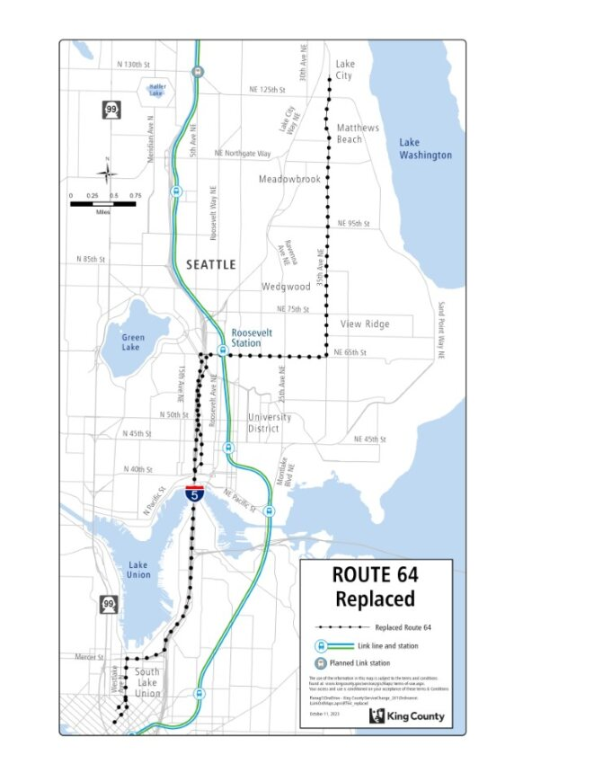

Route: 65 (revise)

OBJECTIVES:
Revise service on Route 65 to serve the new Shoreline South/148th Street Station in accordance with the Strategic Plan for Public Transportation, 2021-2031 and King County Metro Service Guidelines.

Strategic Plan Strategies:
- Prioritize service in geographic areas that have highly dense, transit-supportive development; a high proportion of priority populations; and limited midday and evening service.
- Develop, evaluate, and adjust products, services, and programs that address barriers and increase mobility, especially among priority populations.
- Deliver mobility services that connect people to jobs and job centers, opportunities, and activities of daily living. Improve service during non-peak periods.
- Be flexible and responsive to changes in demand for service and community engagement.
- Use Metro’s Service Guidelines and performance measures to ensure service investments align with needs and values and build toward Metro Connects.

Service Guidelines
- 1. Network Connections
- Services should be designed in the context of the entire transit system, which includes local and regional bus routes, Link 1 Line, commuter rail lines, and other modes.
- Metro strives to make transfers easy. Network design should consider locations where transfer opportunities could be provided to improve mobility and efficiency.
- Where many transfers are expected between services of different frequencies, timed transfers should be maintained to reduce wait times.
- 2. Multiple Purposes and Destinations
- Routes are more efficient and successful when designed to serve multiple purposes and destinations rather than specialized travel demands.
- Specialized service should be considered when there is sizeable and demonstrated demand that cannot be adequately met by more generalized service.
  - 3. Easy to Understand
- A simple transit network is easier for riders to understand and use than a complex network.
- Routes should have predictable and direct routings and should provide frequency and span appropriate to the market served.
- Routes should serve connection points where riders can connect with frequent services, opening the widest possible range of travel options.
  - 5. Route Directness
- A route that operates directly between two locations is faster and more attractive to riders than one that takes a circuitous path. Circulators or looping routes do not have competitive travel times compared to walking or other modes of travel, so they tend to have low ridership and poor performance.
- Directness should be considered in relation to the market for the service. Where a route deviates away from its major path to serve a specific destination, the delay to riders on board the bus should be considered in relation to the ridership gained on a deviation.

IMPACTED SERVICE AREA:
Aurora Avenue, Lake City, University of Washington, Roosevelt

SERVICE CHANGE:
Revise service on Route 65 to serve the Shoreline South/148th Street Station via NE 150th Street and NE 155th Street after Sound Transit light rail trains can operate across Lake Washington and 1 Line frequency increases with full 2 Line opening. Sound Transit may also consider changes to Route 522 Express at this time. In the interim, before any proposed revisions to Route 522 are implemented, extend Route 65 to Shoreline South Station via N 145th St.

Frequency:
 | Weekday |  |  | Saturday |  | Sunday
 | Peak | Midday | Night | Daytime | Night | Daytime | Night
March 2022 | 15-20 min | - | - | - | - | - | -
Current | 15 min | 15 min | 15 min | 17 min | 22 min | 17 min | 22 min
Proposed | 30 min | - | - | - | - | - | -

Hours of Service:
 | Weekday | Saturday | Sunday
March 2022 | 6:00 AM – 9:30 AM,  4:00 PM – 6:30 PM | - | -
Current | 5:00 AM – 2:55 AM | 5:15 AM – 3:15 AM | 5:15 AM - 2:55 AM
Proposed | 5:30 AM – 9:00 AM,  3:50 PM – 7:00 PM | - | -

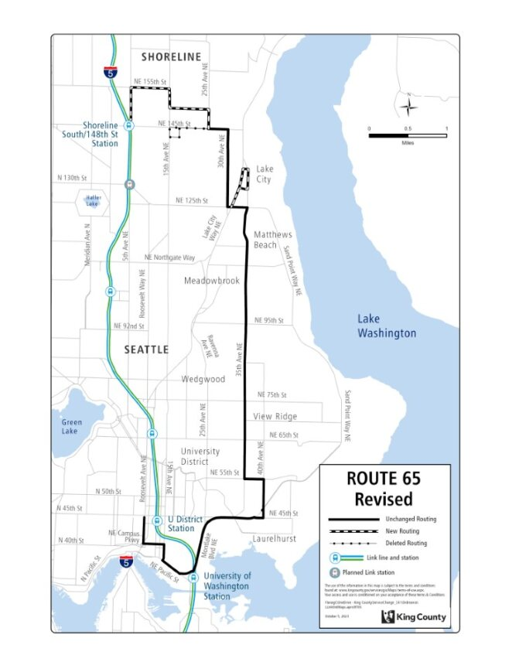

Route: 72 (new)

OBJECTIVES:

Create new route that serves Lake City, Wedgewood, Ravenna, and the University District in order to leverage high-capacity transit investments, improve service legibility, and match service to ridership demand in accordance with the Strategic Plan for Public Transportation, 2021-2031, and King County Metro Service Guidelines.

Strategic Plan Strategies:
- Develop, evaluate, and adjust products, services, and programs that address barriers and increase mobility, especially among priority populations.
- Deliver mobility services that connect people to jobs and job centers, opportunities, and activities of daily living. Improve service during non-peak periods.
- Be flexible and responsive to changes in demand for service and community engagement.
- Use Metro’s Service Guidelines and performance measures to ensure service investments align with needs and values and build toward Metro Connects.

Service Guidelines
- 1. Network Connections
    - Services should be designed in the context of the entire transit system, which includes local and regional bus routes, Link 1 Line, commuter rail lines, and other modes.
    - Metro strives to make transfers easy. Network design should consider locations where transfer opportunities could be provided to improve mobility and efficiency.
    - Where many transfers are expected between services of different frequencies, timed transfers should be maintained to reduce wait times.
- 2. Multiple Purposes and Destinations
    - Routes are more efficient and successful when designed to serve multiple purposes and destinations rather than specialized travel demands.
  - 3. Easy to Understand
    - A simple transit network is easier for riders to understand and use than a complex network.
    - Routes should have predictable and direct routings and should provide frequency and span appropriate to the market served.
    - Routes should serve connection points where riders can connect with frequent services, opening the widest possible range of travel options.
  - 4. Route Spacing and Duplication
    - Services may overlap or be more closely spaced where urban and physical geography makes it necessary, where services in a common segment serve different destinations, or where routes converge to serve regional growth centers. Where services do overlap, they should be scheduled together, if possible, to provide shorter waits along the common routing.

IMPACTED SERVICE AREA:
Lake City, Wedgwood, Ravenna, U-District.

SERVICE CHANGE:
Implement new Route 72 after Link 2 Line in operation across Lake Washington between Downtown Seattle and Bellevue, and Sound Transit considers changes to ST Express Route 522, and construction along 145th St is substantially complete. Route 72 will provide service between Lake City, Wedgewood, Ravenna, and the University District via N 145th St., Lake City Way NE, and 25th Ave. NE.
On weekdays Route 72 will operate every 20 minutes from 4:30 AM to 6:00 AM, every 10 minutes from 6:00 AM to 7:00 PM, every 15 minutes from 7:00 PM to 10:00 PM, and every 30 minutes from 10:00 PM to 1:00 AM. On weekends Route 72 will operate every 15 minutes from 5:30 AM to 10:00 PM and every 30 minutes from 10:00 PM to 1:00 AM.
Frequency:
 | Weekday |  |  | Saturday |  | Sunday
 | Peak | Midday | Night | Daytime | Night | Daytime | Night
March 2022 | - | - | - | - | - | - | -
Current | - | - | - | - | - | - | -
Proposed | 10 min | 10 min | 30 min | 15 min | 30 min | 15 min | 30 min

Hours of Service:
 | Weekday | Saturday | Sunday
March 2022 | - | - | -
Current | - | - | -
Proposed | 4:30 AM – 1:00 AM | 5:30 AM – 1:00 AM | 5:30 AM – 1:00 AM

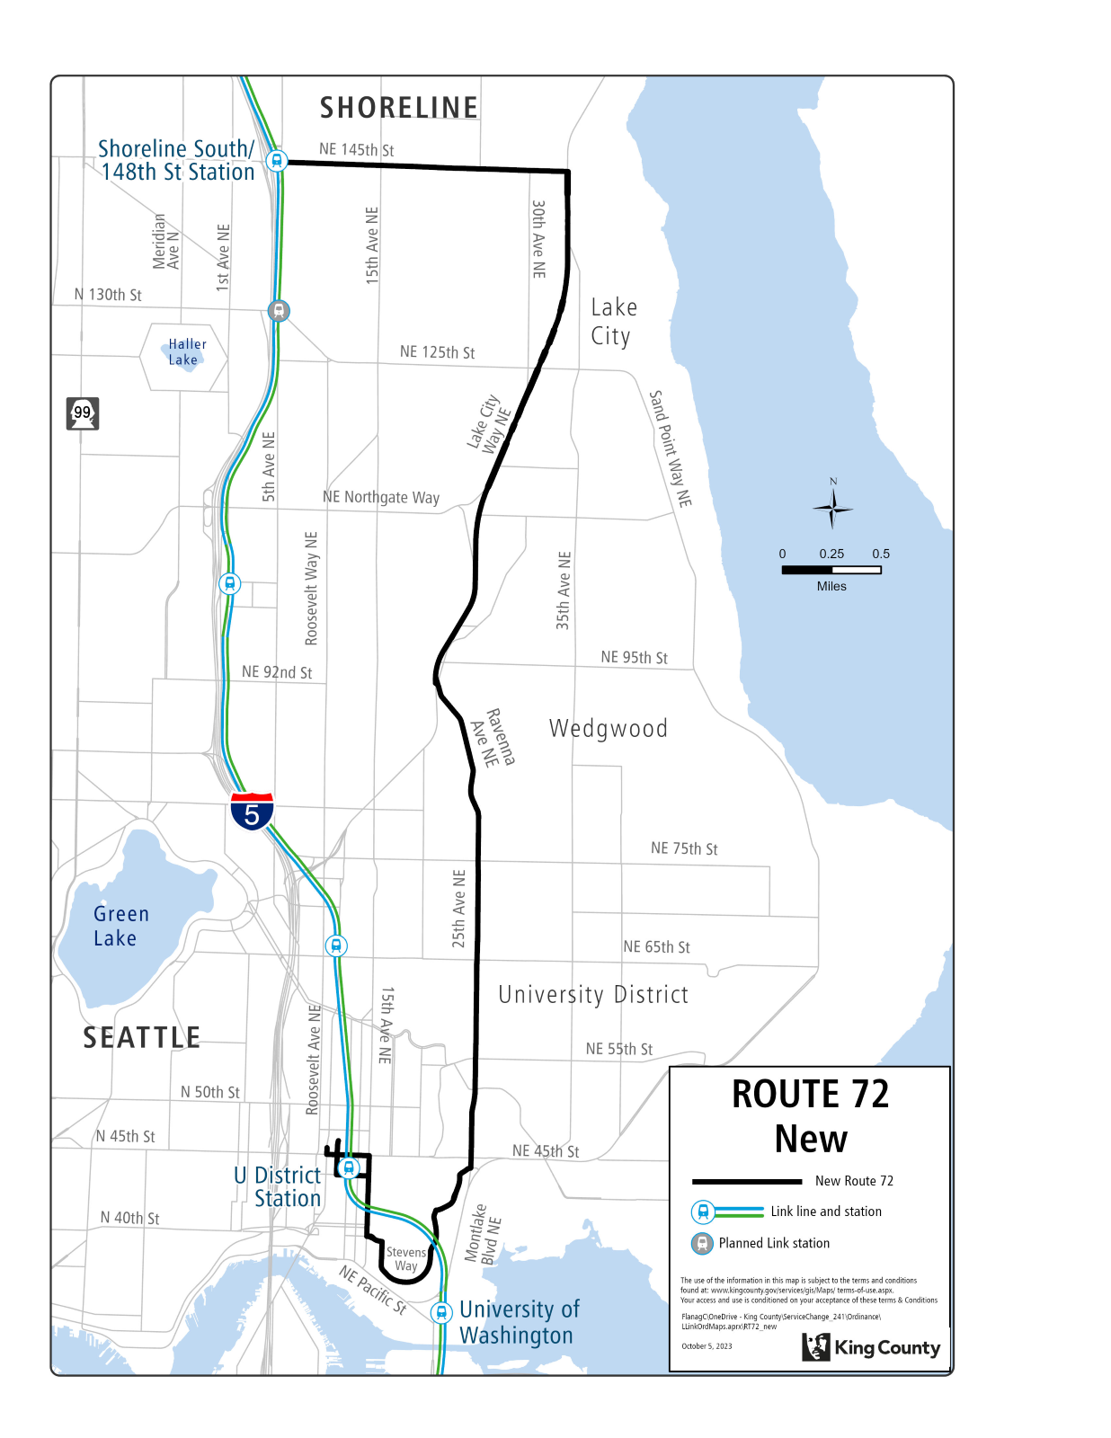

Route: 73 (delete)

OBJECTIVES:

Replacement service for Route 73 will be provided by Routes 67 and 348.
Restructure service to reduce duplication, serve where needs are greatest, and provide better all-day transit service levels in accordance with the Strategic Plan for Public Transportation, 2021-2031, and King County Metro Service Guidelines.

Strategic Plan Strategies:
- Prioritize service in geographic areas that have highly dense, transit-supportive development; a high proportion of priority populations; and limited midday and evening service.
- Develop, evaluate, and adjust products, services, and programs that address barriers and increase mobility, especially among priority populations.
- Deliver mobility services that connect people to jobs and job centers, opportunities, and activities of daily living. Improve service during non-peak periods.
- Be flexible and responsive to changes in demand for service and community engagement.
- Use Metro’s Service Guidelines and performance measures to ensure service investments align with needs and values and build toward Metro Connects.

Service Guidelines
- 1. Network Connections
    - Services should be designed in the context of the entire transit system, which includes local and regional bus routes, Link 1 Line, commuter rail lines, and other modes.
- 2. Multiple Purposes and Destinations
    - Routes are more efficient and successful when designed to serve multiple purposes and destinations rather than specialized travel demands.
  - 4. Route Spacing and Duplication
    - Routes should be designed to avoid competing for the same riders. In general, routes should be no closer than 1/2 mile.
    - Metro should consider transit access in defining a route or route segment as duplicative. Access should be based on the frequency of service.

IMPACTED SERVICE AREA:
Jackson Park, Pinehurst, Roosevelt, University District.

SERVICE CHANGE:
Delete Route 73 to reduce duplicative service. Alternative service will be provided by Route 67, which operates along Roosevelt Way NE between Northgate and U District, and Route 348, which operates on Route 73’s pathway on 15th Ave. NE between NE 145th St. and NE 120th St.

Frequency:
 | Weekday |  |  | Saturday |  | Sunday
 | Peak | Midday | Night | Daytime | Night | Daytime | Night
March 2022 | 20 min | 30 min | - | 30 min | - | 30 min | -
Current | 30-37 min | 52 min | 60 min | 60 min | 60 min | 60 min | 60 min
Proposed | - | - | - | - | - | - | -

Hours of Service:
 | Weekday | Saturday | Sunday
March 2022 | 5:30 AM – 9:45 PM | 7:30 AM – 7:30 PM | 7:30 AM – 7:30 PM
Current | 5:30 AM – 11:15 PM | 6:30 AM – 11:35 PM | 6:30 AM – 11:30 AM
Proposed | - | - | -

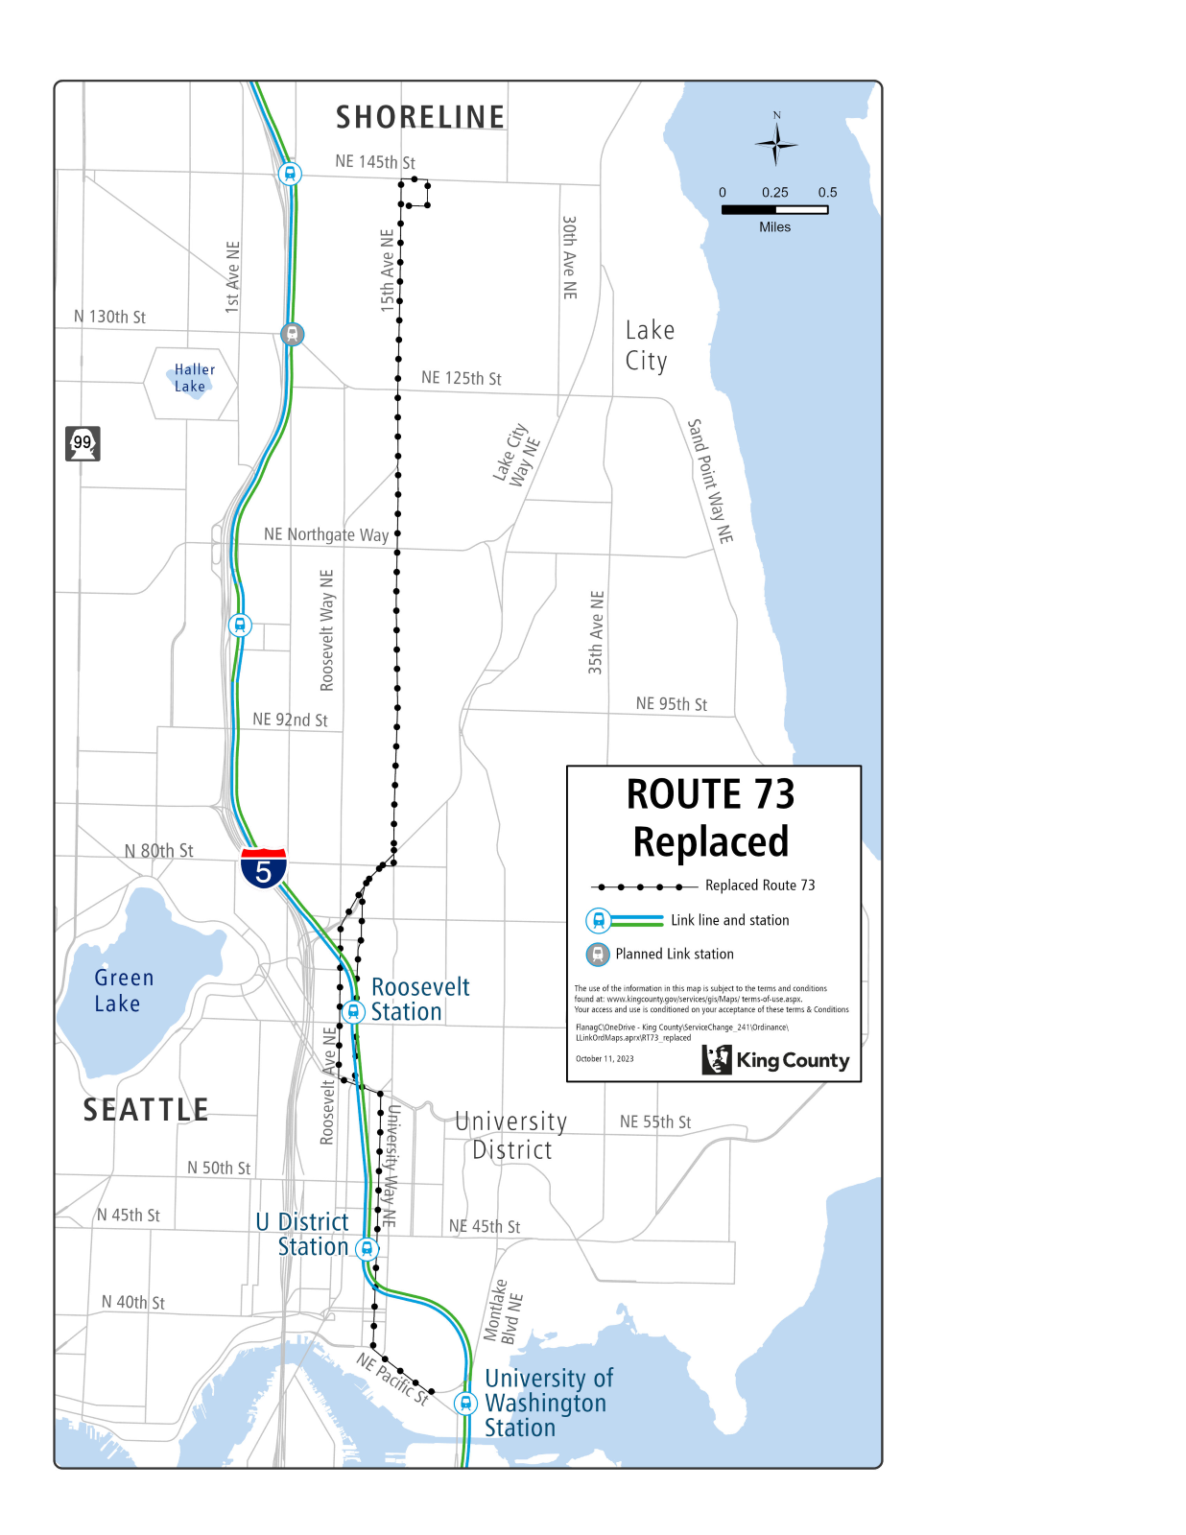

Route: 77 (new)

OBJECTIVES:

Create new route that serves Roosevelt, the University District, Lake City Way, and Bitter Lake to leverage high-capacity transit investments, improve network connectivity and create new east-west connections in accordance with the Strategic Plan for Public Transportation, 2021-2031, and King County Metro Service Guidelines.

Strategic Plan Strategies:
- Prioritize service in geographic areas that have highly dense, transit-supportive development; a high proportion of priority populations; and limited midday and evening service.
- Develop, evaluate, and adjust products, services, and programs that address barriers and increase mobility, especially among priority populations.
- Deliver mobility services that connect people to jobs and job centers, opportunities, and activities of daily living. Improve service during non-peak periods.
- Be flexible and responsive to changes in demand for service and community engagement.
- Use Metro’s Service Guidelines and performance measures to ensure service investments align with needs and values and build toward Metro Connects.

Service Guidelines
- 1. Network Connections
    - Services should be designed in the context of the entire transit system, which includes local and regional bus routes, Link 1 Line, commuter rail lines, and other modes.
    - Metro strives to make transfers easy. Network design should consider locations where transfer opportunities could be provided to improve mobility and efficiency.
    - Where many transfers are expected between services of different frequencies, timed transfers should be maintained to reduce wait times.
- 2. Multiple Purposes and Destinations
    - Routes are more efficient and successful when designed to serve multiple purposes and destinations rather than specialized travel demands.
  - 3. Easy to Understand
    - A simple transit network is easier for riders to understand and use than a complex network.
    - Routes should have predictable and direct routings and should provide frequency and span appropriate to the market served.
    - Routes should serve connection points where riders can connect with frequent services, opening the widest possible range of travel options.
  - 4. Route Spacing and Duplication
    - Services may overlap or be more closely spaced where urban and physical geography makes it necessary, where services in a common segment serve different destinations, or where routes converge to serve regional growth centers. Where services do overlap, they should be scheduled together, if possible, to provide shorter waits along the common routing.

IMPACTED SERVICE AREA:
Roosevelt, the University District, Lake City Way, and Bitter Lake.

SERVICE CHANGE:
Implement new Route 77 after Link 2 Line in operation across Lake Washington between Downtown Seattle and Bellevue, and Sound Transit considers changes to ST Express Route 522. Route 77 will initially provide service between Roosevelt, the University District, Lake City Way and would later extend between Bitter Lake via N 130th St, NE 125th St., and Lake City Way NE upon the opening of 130th St Station on the Link 1 Line and substantial completion of street improvement projects on N 130th St. and NE 125th St.
On weekdays Route 77 will operate every 30 minutes from 5:00 AM to 6:00 AM, every 15 minutes from 6:00 AM to 10:00 PM, and every 30 minutes from 10:00 PM to 1:00 AM. On weekends Route 77 will operate every 30 minutes from 5:30 AM to 6:00 AM, every 20 minutes from 6:00 AM to 9:00 AM, every 15 minutes from 9:00 AM to 10:00 PM, and every 30 minutes from 10:00 PM to 1:00 AM.
Route 77 will be interlined with revised Route 75, meaning riders using both routes will not be required to transfer in the University District.
Frequency:
 | Weekday |  |  | Saturday |  | Sunday
 | Peak | Midday | Night | Daytime | Night | Daytime | Night
March 2022 | - | - | - | - | - | - | -
Current | - | - | - | - | - | - | -
Proposed | 15 min | 15 min | 30 min | 20-15 min | 30 min | 20-15 min | 30 min

Hours of Service:
 | Weekday | Saturday | Sunday
March 2022 | - | - | -
Current | - | - | -
Proposed | 5:00 AM – 1:30 AM | 5:30 AM – 1:00 AM | 5:30 AM – 1:00 AM

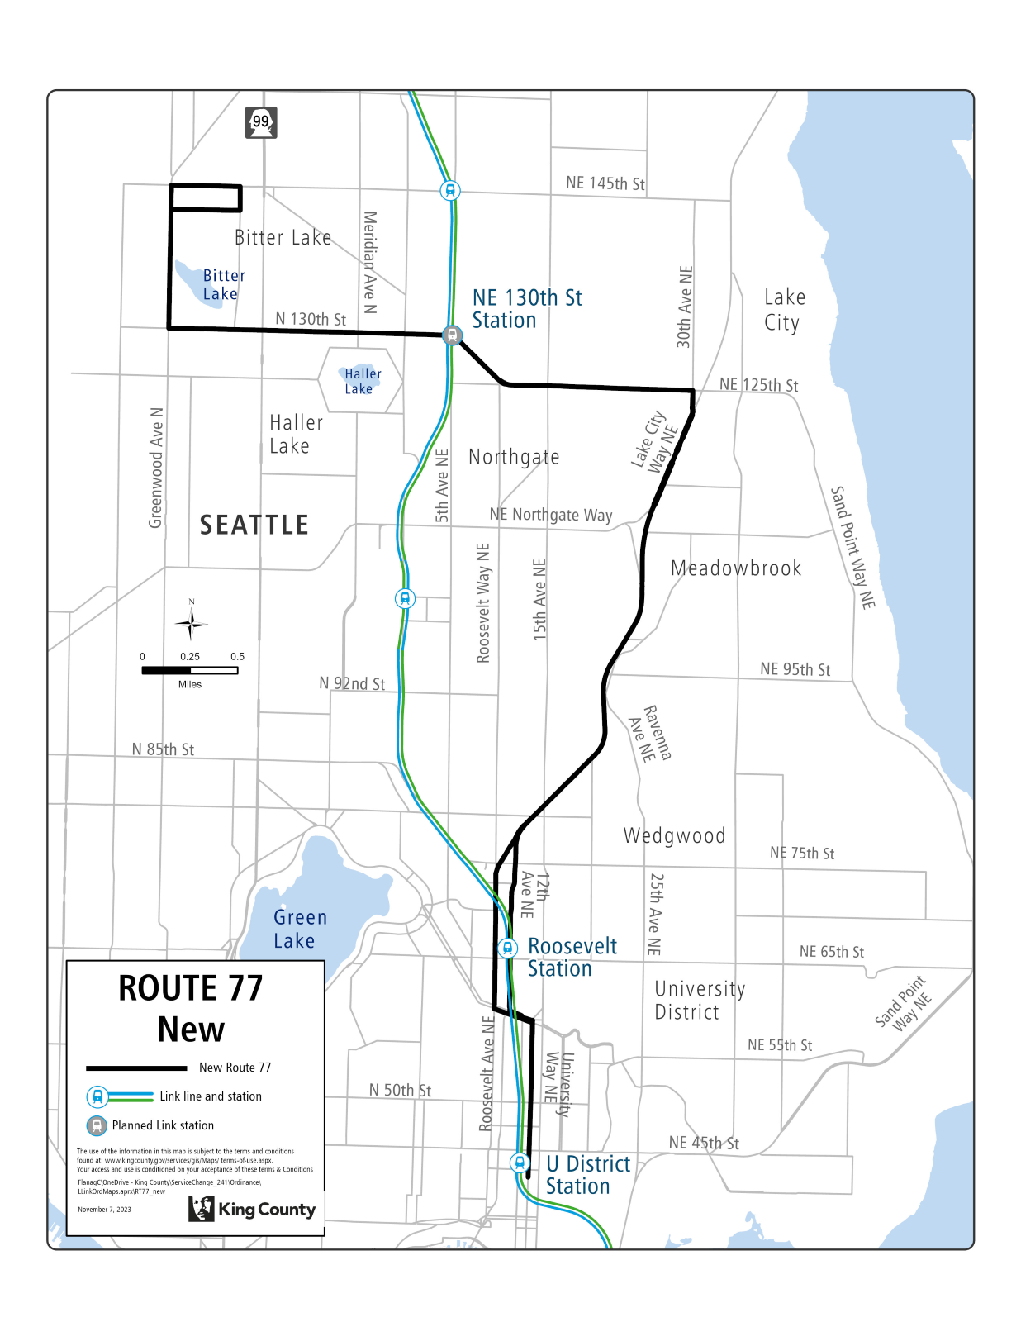

Route: 301 (delete)

OBJECTIVES:
Replacement service for Route 301 will be provided by Routes 303, 333, 348, E Line, and Link 1 Line.
Restructure service to provide better all-day transit service levels in accordance with the Strategic Plan for Public Transportation, 2021-2031, and King County Metro Service Guidelines.

Strategic Plan Strategies:
- Develop, evaluate, and adjust products, services, and programs that address barriers and increase mobility, especially among priority populations.
- Deliver mobility services that connect people to jobs and job centers, opportunities, and activities of daily living. Improve service during non-peak periods.
- Be flexible and responsive to changes in demand for service and community engagement.
- Use Metro’s Service Guidelines and performance measures to ensure service investments align with needs and values and build toward Metro Connects.

Service Guidelines
- 1. Network Connections
    - Services should be designed in the context of the entire transit system, which includes local and regional bus routes, Link 1 Line, commuter rail lines, and other modes.
    - Metro strives to make transfers easy. Network design should consider locations where transfer opportunities could be provided to improve mobility and efficiency.
    - Where many transfers are expected between services of different frequencies, timed transfers should be maintained to reduce wait times.
- 2. Multiple Purposes and Destinations
    - Routes are more efficient and successful when designed to serve multiple purposes and destinations rather than specialized travel demands.
    - Specialized service should be considered when there is sizeable and demonstrated demand that cannot be adequately met by more generalized service.
  - 4. Route Spacing and Duplication
    - Routes should be designed to avoid competing for the same riders. In general, routes should be no closer than 1/2 mile.
    - Services may overlap or be more closely spaced where urban and physical geography makes it necessary, where services in a common segment serve different destinations, or where routes converge to serve regional growth centers. Where services do overlap, they should be scheduled together, if possible, to provide shorter waits along the common routing.
    - Metro should consider transit access in defining a route or route segment as duplicative. Access should be based on the frequency of service.

IMPACTED SERVICE AREA:
Aurora Village, Shoreline, Northgate.

SERVICE CHANGE:
Delete Route 301 to reallocate hours to all-day service. Alternative service will be provided by Routes 303, 333, 348, E Line, and Link 1 Line. The E Line provides an alternative along Aurora Ave N between N 175th St. and Aurora Village Transit Center. Link 1 Line provide an alternative for riders between N 175th St. and Northgate. Route 331 will also connect Link 1 Line and Aurora Village Transit Center. Route 33 will provide along N 175th St.
Frequency:
 | Weekday |  |  | Saturday |  | Sunday
 | Peak | Midday | Night | Daytime | Night | Daytime | Night
March 2022 | 15-20 min | - | - | - | - | - | -
Current | - | - | - | - | - | - | -
Proposed | - | - | - | - | - | - | -

Hours of Service:
 | Weekday | Saturday | Sunday
March 2022 | 4:45 AM – 7:30 AM, 4:00 PM – 6:30 PM | - | -
Current | - | - | -
Proposed | - | - | -

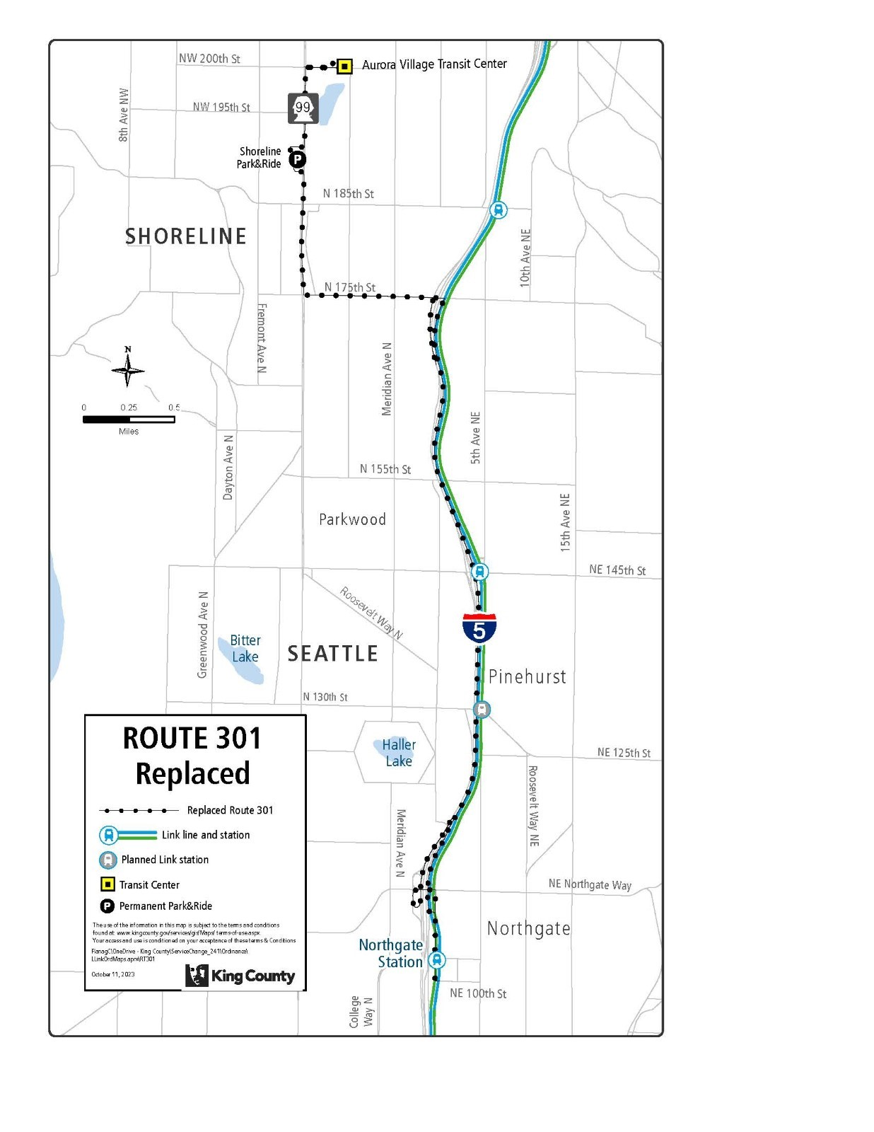

Route: 302 (delete)

OBJECTIVES:
Replacement service for Route 302 will be provided by Routes 303, 322, 331, 348, and Link 1 Line.
Restructure service to provide better all-day transit service levels in accordance with the Strategic Plan for Public Transportation, 2021-2031, and King County Metro Service Guidelines.

Strategic Plan Strategies:
- Develop, evaluate, and adjust products, services, and programs that address barriers and increase mobility, especially among priority populations.
- Deliver mobility services that connect people to jobs and job centers, opportunities, and activities of daily living. Improve service during non-peak periods.
- Be flexible and responsive to changes in demand for service and community engagement.
- Use Metro’s Service Guidelines and performance measures to ensure service investments align with needs and values and build toward Metro Connects.

Service Guidelines
- 1. Network Connections
    - Services should be designed in the context of the entire transit system, which includes local and regional bus routes, Link 1 Line, commuter rail lines, and other modes.
    - Metro strives to make transfers easy. Network design should consider locations where transfer opportunities could be provided to improve mobility and efficiency.
    - Where many transfers are expected between services of different frequencies, timed transfers should be maintained to reduce wait times.
- 2. Multiple Purposes and Destinations
    - Routes are more efficient and successful when designed to serve multiple purposes and destinations rather than specialized travel demands.
    - Specialized service should be considered when there is sizeable and demonstrated demand that cannot be adequately met by more generalized service.
  - 4. Route Spacing and Duplication
    - Routes should be designed to avoid competing for the same riders. In general, routes should be no closer than 1/2 mile.
    - Services may overlap or be more closely spaced where urban and physical geography makes it necessary, where services in a common segment serve different destinations, or where routes converge to serve regional growth centers. Where services do overlap, they should be scheduled together, if possible, to provide shorter waits along the common routing.
    - Metro should consider transit access in defining a route or route segment as duplicative. Access should be based on the frequency of service.

IMPACTED SERVICE AREA:
Richmond Beach, Shoreline, Northgate, First Hill

SERVICE CHANGE:
Delete Route 302 to reallocate hours to all-day service. Alternative service will be provided by Routes 303, 322, 331, 348, and Link 1 Line.
Frequency:
 | Weekday |  |  | Saturday |  | Sunday
 | Peak | Midday | Night | Daytime | Night | Daytime | Night
March 2022 | 35-45 min | - | - | - | - | - | -
Current | 40-45 min | - | - | - | - | - | -
Proposed | - | - | - | - | - | - | -

Hours of Service:
 | Weekday | Saturday | Sunday
March 2022 | 5:30 AM – 7:15 AM, 15:30 PM – 5:45 PM | - | -
Current | 5:35 AM – 5:45 PM | - | -
Proposed | - | - | -
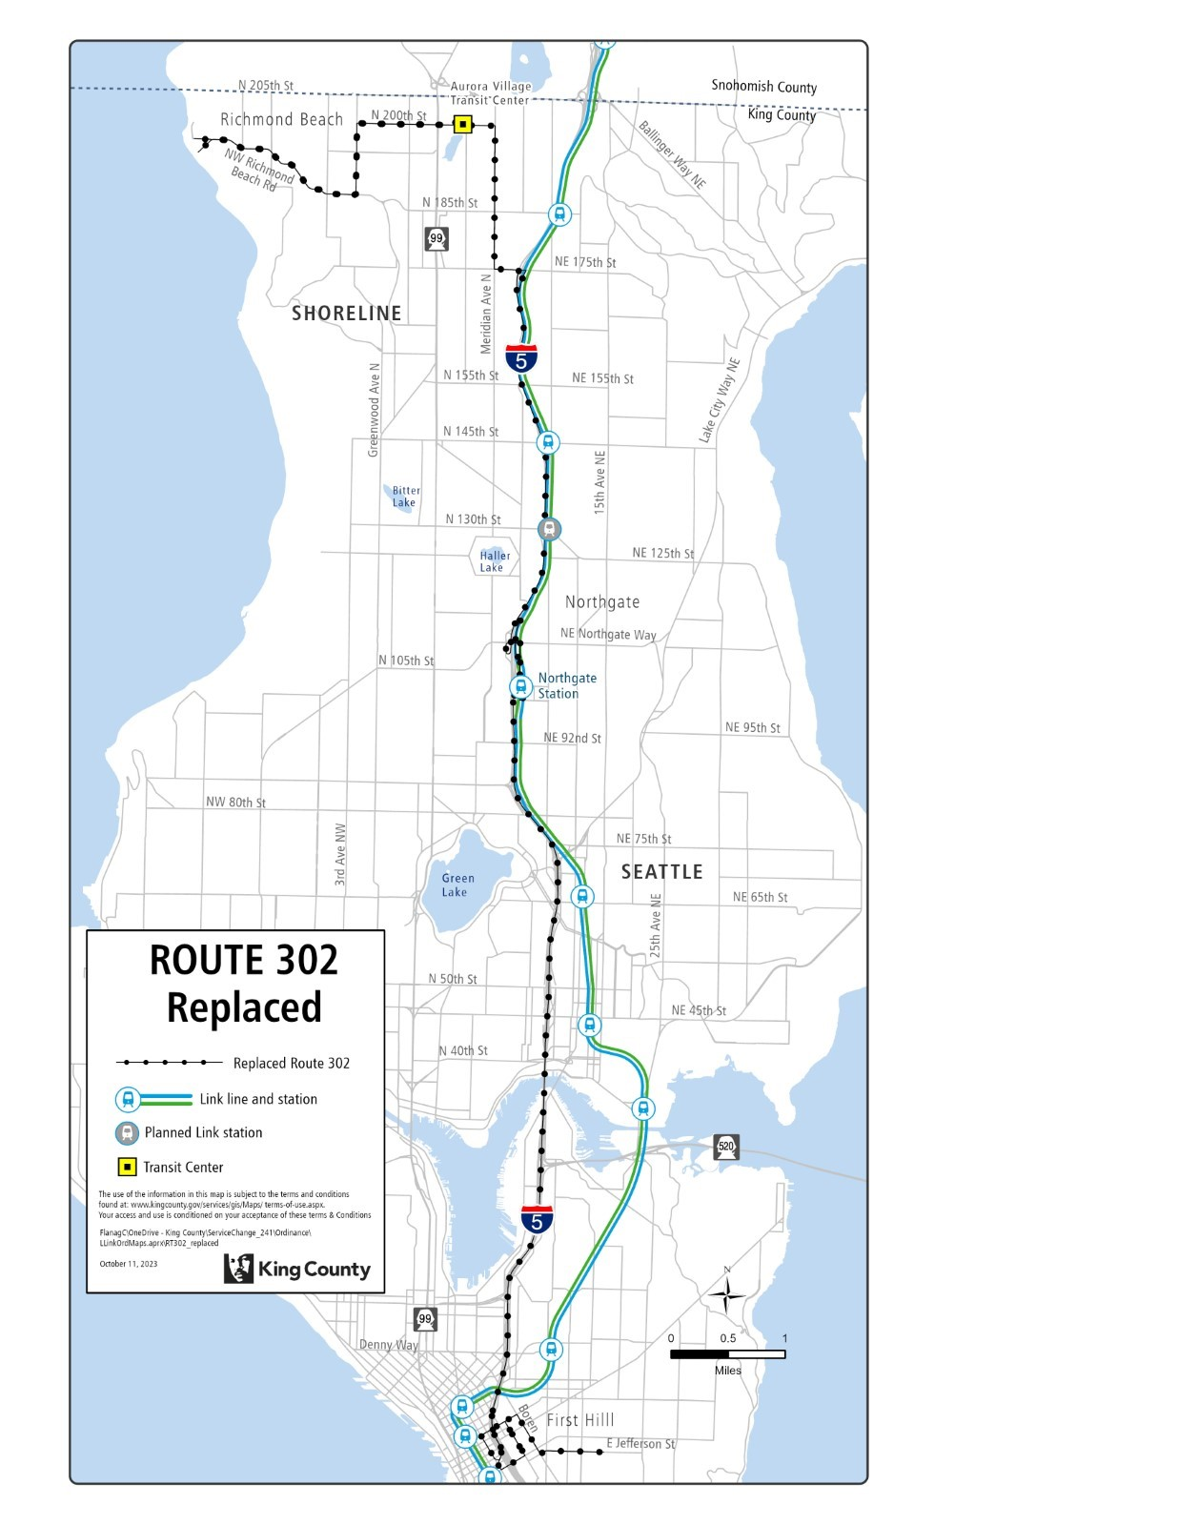

Route: 303 (revise)

OBJECTIVES:
Revise service on Route 303 to serve South Lake Union via Mercer Street before serving First Hill via 8th Ave. and Boren Ave., in accordance with the Strategic Plan for Public Transportation, 2021-2031 and King County Metro Service Guidelines.

Strategic Plan Strategies:
- Prioritize service in geographic areas that have highly dense, transit-supportive development; a high proportion of priority populations; and limited midday and evening service.
- Develop, evaluate, and adjust products, services, and programs that address barriers and increase mobility, especially among priority populations.
- Deliver mobility services that connect people to jobs and job centers, opportunities, and activities of daily living. Improve service during non-peak periods.
- Be flexible and responsive to changes in demand for service and community engagement.
- Use Metro’s Service Guidelines and performance measures to ensure service investments align with needs and values and build toward Metro Connects.

Service Guidelines
- 1. Network Connections
    - Services should be designed in the context of the entire transit system, which includes local and regional bus routes, Link 1 Line, commuter rail lines, and other modes.
    - Metro strives to make transfers easy. Network design should consider locations where transfer opportunities could be provided to improve mobility and efficiency.
    - Where many transfers are expected between services of different frequencies, timed transfers should be maintained to reduce wait times.
- 2. Multiple Purposes and Destinations
    - Routes are more efficient and successful when designed to serve multiple purposes and destinations rather than specialized travel demands.
    - Specialized service should be considered when there is sizeable and demonstrated demand that cannot be adequately met by more generalized service.
  - 3. Easy to Understand
    - A simple transit network is easier for riders to understand and use than a complex network.
    - Routes should have predictable and direct routings and should provide frequency and span appropriate to the market served.
    - Routes should serve connection points where riders can connect with frequent services, opening the widest possible range of travel options.
- 5. Route Directness
    - A route that operates directly between two locations is faster and more attractive to riders than one that takes a circuitous path. Circulators or looping routes do not have competitive travel times compared to walking or other modes of travel, so they tend to have low ridership and poor performance.
    - Directness should be considered in relation to the market for the service. Where a route deviates away from its major path to serve a specific destination, the delay to riders on board the bus should be considered in relation to the ridership gained on a deviation.

IMPACTED SERVICE AREA:
Shoreline, Aurora Village, Northgate, South Lake Union, First Hill

SERVICE CHANGE:
Revise peak-only Route 303 to serve South Lake Union via Mercer Street before serving First Hill via 8th Ave. and Boren Ave., and add one additional trip to each of the AM and PM peak periods.

Frequency:
 | Weekday |  |  | Saturday |  | Sunday
 | Peak | Midday | Night | Daytime | Night | Daytime | Night
March 2022 | 30-40 min | - | - | - | - | - | -
Current | 45-60 min | - | 30 min | - | - | - | -
Proposed | 30 min | - | - | - | - | - | -

Hours of Service:
 | Weekday | Saturday | Sunday
March 2022 | 5:30 AM – 8:00 AM, 3:50 PM – 7:50 PM | - | -
Current | 5:30 AM – 7:50 PM | - | -
Proposed | 5:30 AM – 9:00 AM, 3:50 PM – 7:00 PM | - | -

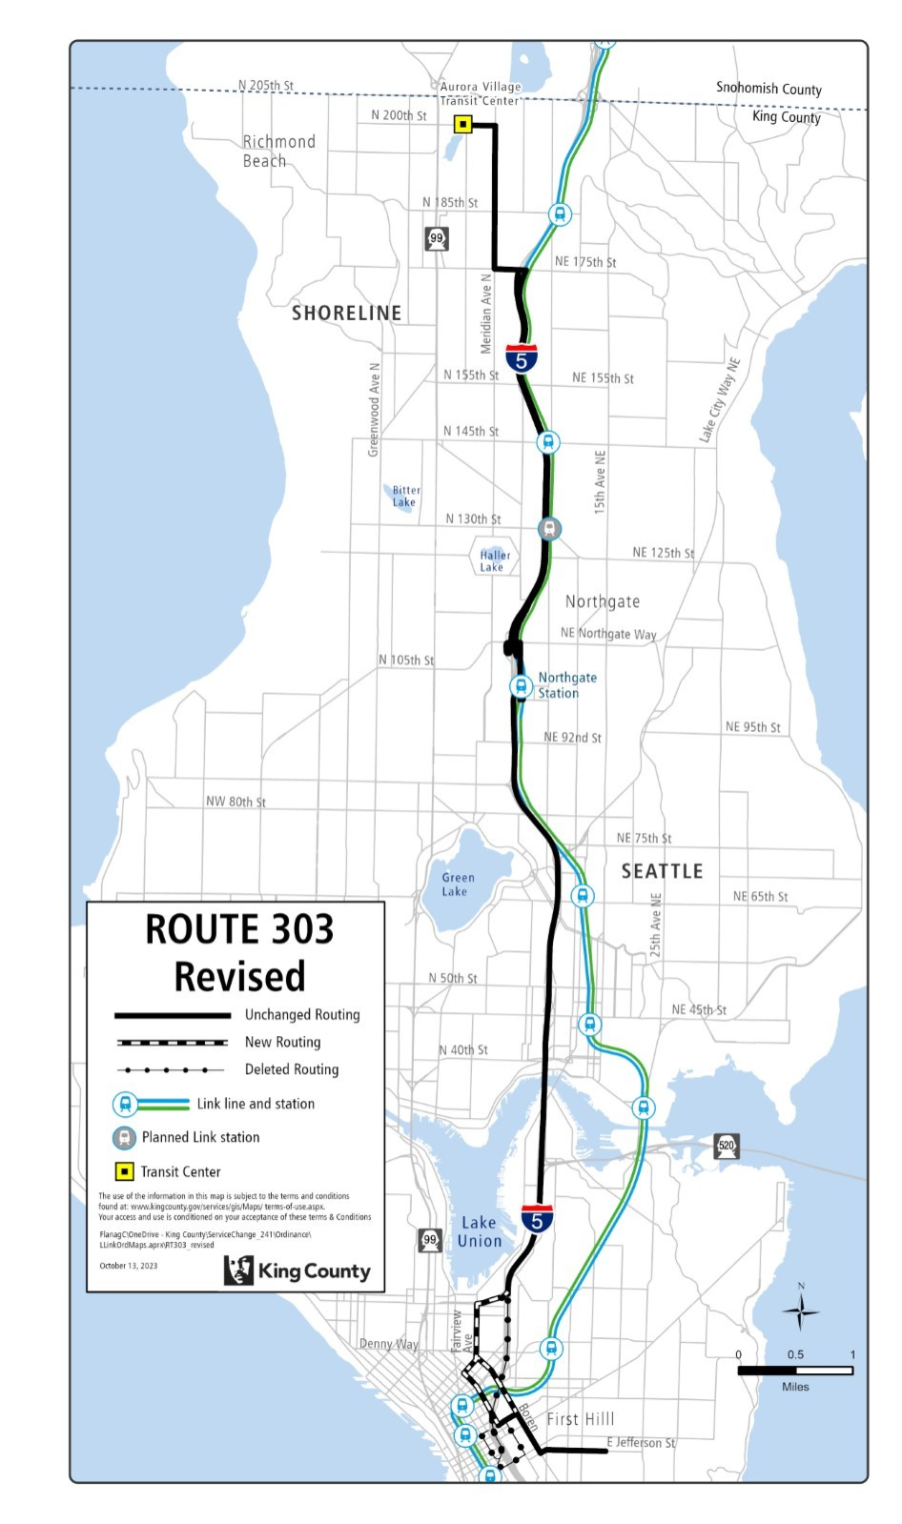
Route: 304 (delete)

OBJECTIVES:

Replacement service for Route 304 will be provided by Routes 331, 333, 348, and Link 1 Line.
Restructure service to provide better all-day transit service levels in accordance with the Strategic Plan for Public Transportation, 2021-2031 and King County Metro Service Guidelines.

Strategic Plan Strategies:
- Deliver mobility services that connect people to jobs and job centers, opportunities, and activities of daily living. Improve service during non-peak periods.
- Be flexible and responsive to changes in demand for service and community engagement.
- Use Metro’s Service Guidelines and performance measures to ensure service investments align with needs and values and build toward Metro Connects.

Service Guidelines
- 1. Network Connections
    - Services should be designed in the context of the entire transit system, which includes local and regional bus routes, Link 1 Line, commuter rail lines, and other modes.
    - Metro strives to make transfers easy. Network design should consider locations where transfer opportunities could be provided to improve mobility and efficiency.
    - Where many transfers are expected between services of different frequencies, timed transfers should be maintained to reduce wait times.
- 2. Multiple Purposes and Destinations
    - Routes are more efficient and successful when designed to serve multiple purposes and destinations rather than specialized travel demands.
    - Specialized service should be considered when there is sizeable and demonstrated demand that cannot be adequately met by more generalized service.

IMPACTED SERVICE AREA:
Shoreline, Richmond Highlands, Bitter Lake, Northgate

SERVICE CHANGE:
Delete Route 304 to reallocate hours to all-day service. Alternative service will be provided by Routes 331, 333, 348, and Link 1 Line

Frequency:
 | Weekday |  |  | Saturday |  | Sunday
 | Peak | Midday | Night | Daytime | Night | Daytime | Night
March 2022 | 30 min | - | - | - | - | - | -
Current | - | - | - | - | - | - | -
Proposed | - | - | - | - | - | - | -

Hours of Service:
 | Weekday | Saturday | Sunday
March 2022 | 6:15 AM – 7:45 AM, 4:00 PM – 6:00 PM | - | -
Current | - | - | -
Proposed | - | - | -

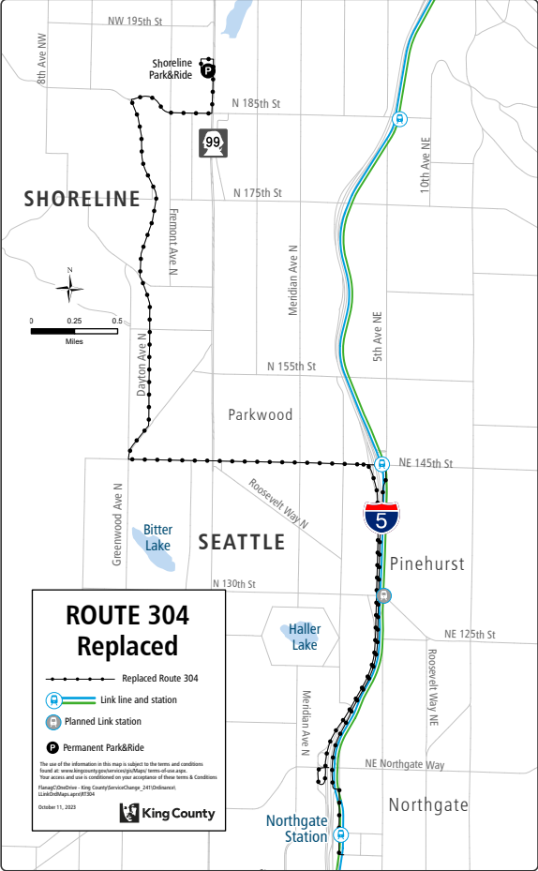
Route: 320 (delete)
OBJECTIVES:
Replacement service for Route 320 will be provided by Routes 322, 61, 522 BRT, and Link 1 Line.
Restructure service to provide better all-day transit service levels in accordance with the Strategic Plan for Public Transportation, 2021-2031, and King County Metro Service Guidelines.

Strategic Plan Strategies:
- Develop, evaluate, and adjust products, services, and programs that address barriers and increase mobility, especially among priority populations.
- Deliver mobility services that connect people to jobs and job centers, opportunities, and activities of daily living. Improve service during non-peak periods.
- Be flexible and responsive to changes in demand for service and community engagement.
- Use Metro’s Service Guidelines and performance measures to ensure service investments align with needs and values and build toward Metro Connects.

Service Guidelines
- 1. Network Connections
    - Services should be designed in the context of the entire transit system, which includes local and regional bus routes, Link 1 Line, commuter rail lines, and other modes.
    - Metro strives to make transfers easy. Network design should consider locations where transfer opportunities could be provided to improve mobility and efficiency.
    - Where many transfers are expected between services of different frequencies, timed transfers should be maintained to reduce wait times.
- 2. Multiple Purposes and Destinations
    - Routes are more efficient and successful when designed to serve multiple purposes and destinations rather than specialized travel demands.
    - Specialized service should be considered when there is sizeable and demonstrated demand that cannot be adequately met by more generalized service.
  - 4. Route Spacing and Duplication
    - Routes should be designed to avoid competing for the same riders. In general, routes should be no closer than 1/2 mile.
    - Services may overlap or be more closely spaced where urban and physical geography makes it necessary, where services in a common segment serve different destinations, or where routes converge to serve regional growth centers. Where services do overlap, they should be scheduled together, if possible, to provide shorter waits along the common routing.
    - Metro should consider transit access in defining a route or route segment as duplicative. Access should be based on the frequency of service.
- 5. Route Directness
    - A route that operates directly between two locations is faster and more attractive to riders than one that takes a circuitous path. Circulators or looping routes do not have competitive travel times compared to walking or other modes of travel, so they tend to have low ridership and poor performance.
    - Directness should be considered in relation to the market for the service. Where a route deviates away from its major path to serve a specific destination, the delay to riders on board the bus should be considered in relation to the ridership gained on a deviation.

IMPACTED SERVICE AREA:
Bothell, Kenmore, Lake Forest Park, Lake City, Northgate, South Lake Union

SERVICE CHANGE:
Delete Route 320 to reallocate hours to all-day service. Alternative service will be provided by Routes, 61, 322, 522 BRT, and Link 1 Line.
Frequency:
 | Weekday |  |  | Saturday |  | Sunday
 | Peak | Midday | Night | Daytime | Night | Daytime | Night
March 2022 | 25-30 min | - | - | - | - | - | -
Current | - | - | - | - | - | - | -
Proposed | - | - | - | - | - | - | -

Hours of Service:
 | Weekday | Saturday | Sunday
March 2022 | 5:30 AM – 9:30 AM, 4:00 PM – 7:40 PM | - | -
Current | - | - | -
Proposed | - | - | -

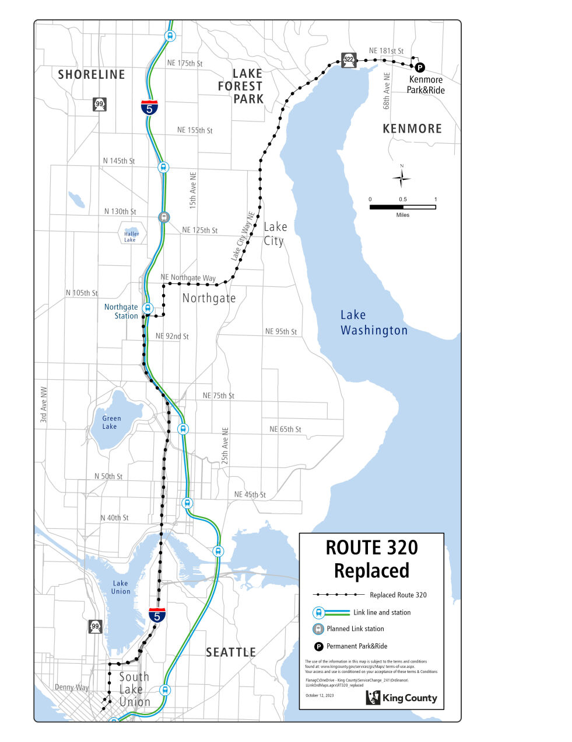

Route: 322 (revise)

OBJECTIVES:
Revise service on Route 322 to serve Northgate Station and South Lake Union via Mercer Street before serving First Hill via 8th Ave. and Boren Ave. in accordance with the Strategic Plan for Public Transportation, 2021-2031 and King County Metro Service Guidelines.

Strategic Plan Strategies:
- Prioritize service in geographic areas that have highly dense, transit-supportive development; a high proportion of priority populations; and limited midday and evening service.
- Develop, evaluate, and adjust products, services, and programs that address barriers and increase mobility, especially among priority populations.
- Deliver mobility services that connect people to jobs and job centers, opportunities, and activities of daily living. Improve service during non-peak periods.
- Be flexible and responsive to changes in demand for service and community engagement.
- Use Metro’s Service Guidelines and performance measures to ensure service investments align with needs and values and build toward Metro Connects.

Service Guidelines
- 1. Network Connections
    - Services should be designed in the context of the entire transit system, which includes local and regional bus routes, Link 1 Line, commuter rail lines, and other modes.
    - Metro strives to make transfers easy. Network design should consider locations where transfer opportunities could be provided to improve mobility and efficiency.
    - Where many transfers are expected between services of different frequencies, timed transfers should be maintained to reduce wait times.
- 2. Multiple Purposes and Destinations
    - Routes are more efficient and successful when designed to serve multiple purposes and destinations rather than specialized travel demands.
    - Specialized service should be considered when there is sizeable and demonstrated demand that cannot be adequately met by more generalized service.
  - 3. Easy to Understand
    - A simple transit network is easier for riders to understand and use than a complex network.
    - Routes should have predictable and direct routings and should provide frequency and span appropriate to the market served.
    - Routes should serve connection points where riders can connect with frequent services, opening the widest possible range of travel options.
- 5. Route Directness
    - A route that operates directly between two locations is faster and more attractive to riders than one that takes a circuitous path. Circulators or looping routes do not have competitive travel times compared to walking or other modes of travel, so they tend to have low ridership and poor performance.
    - Directness should be considered in relation to the market for the service. Where a route deviates away from its major path to serve a specific destination, the delay to riders on board the bus should be considered in relation to the ridership gained on a deviation.

IMPACTED SERVICE AREA:
Kenmore, Lake Forest Park, Lake City, Northgate, South Lake Union, First Hill

SERVICE CHANGE:
Revise peak-only Route 322 to serve Northgate Station and South Lake Union via Mercer Street before
serving First Hill via 8th Ave. and Boren Ave.

Frequency:
 | Weekday |  |  | Saturday |  | Sunday
 | Peak | Midday | Night | Daytime | Night | Daytime | Night
March 2022 | 20-30 min | - | - | - | - | - | -
Current | 26-30 min | - | 60 min | - | - | - | -
Proposed | 30 min | - | - | - | - | - | -

Hours of Service:
 | Weekday | Saturday | Sunday
March 2022 | 5:45 AM – 8:50 AM, 4:00 PM – 7:40 PM | - | -
Current | 5:45 AM - 7:40 PM | - | -
Proposed | 5:45 AM – 8:45 AM, 4:00 PM – 7:00 PM | - | -

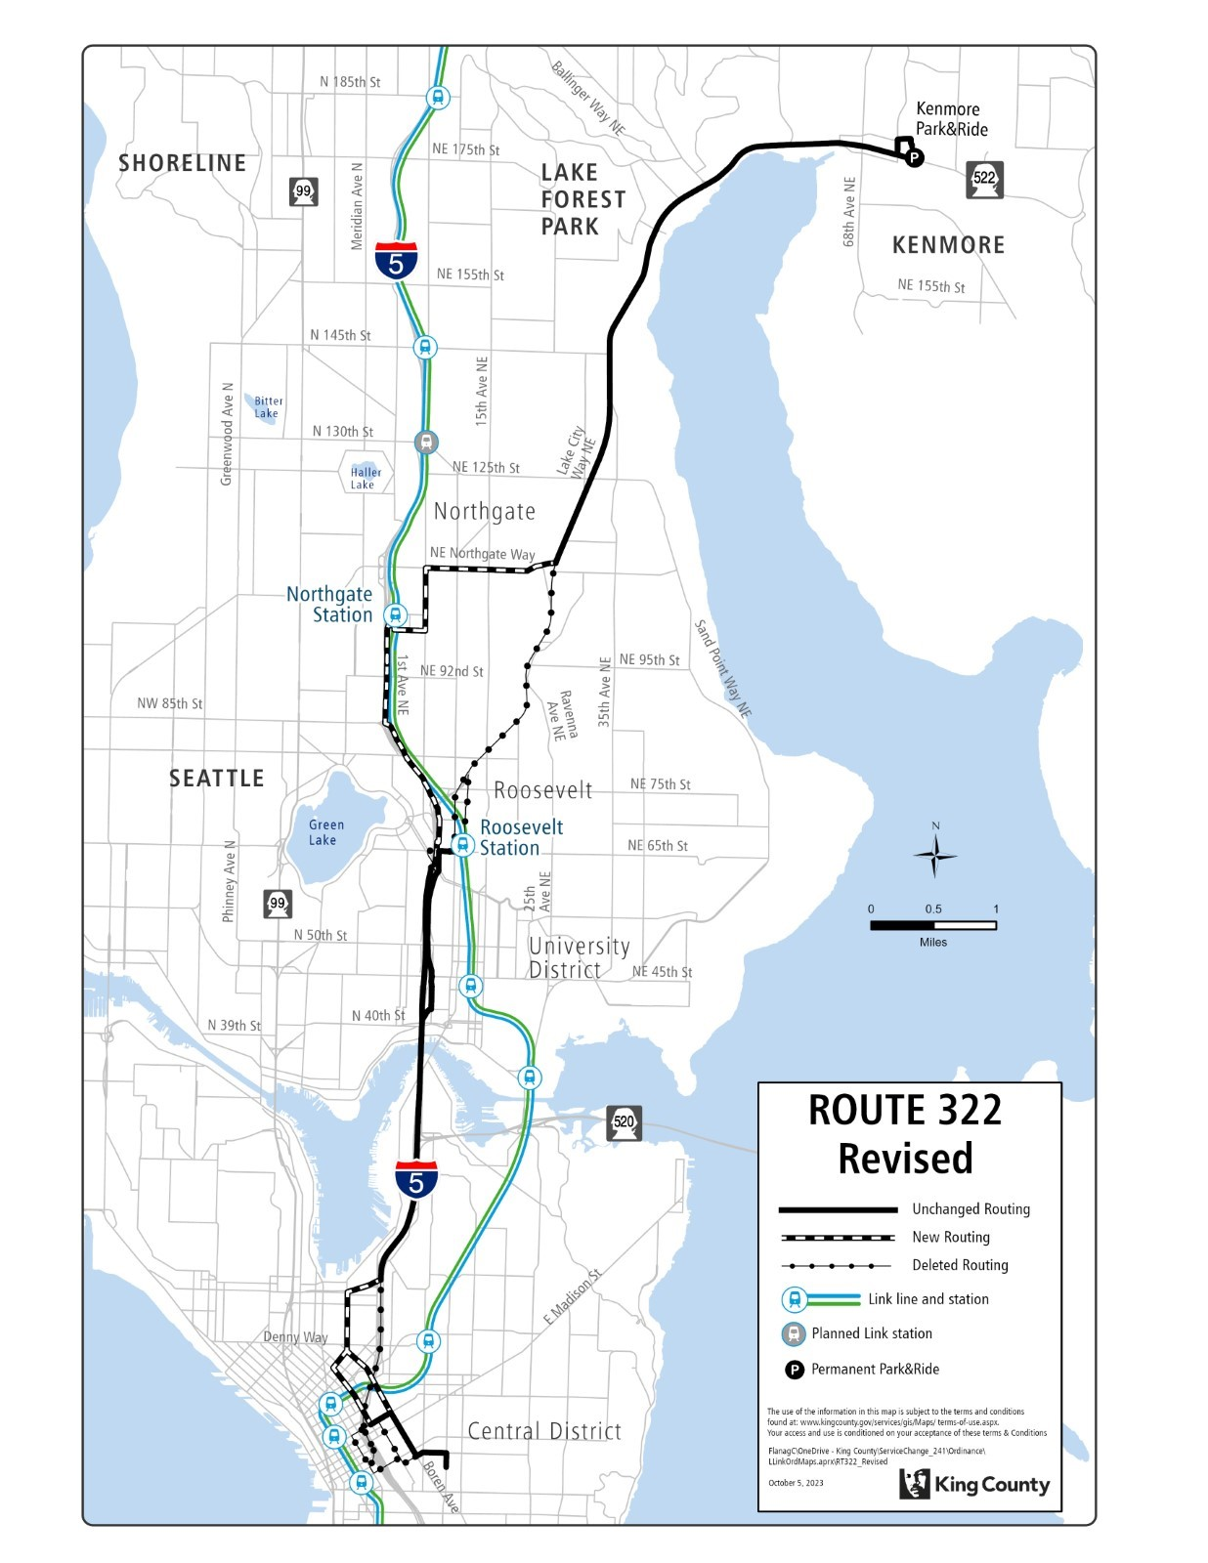

Route: 330 (delete)

OBJECTIVES:
Replacement service for Route 330 will be provided by Routes 65, 72, 333, and 345.
Restructure service to leverage high-capacity transit investments, reduce duplication, and provide new east-west connections and better all-day transit service levels in accordance with the Strategic Plan for Public Transportation, 2021-2031, and King County Metro Service Guidelines.

Strategic Plan Strategies:
- Develop, evaluate, and adjust products, services, and programs that address barriers and increase mobility, especially among priority populations.
- Deliver mobility services that connect people to jobs and job centers, opportunities, and activities of daily living. Improve service during non-peak periods.
- Be flexible and responsive to changes in demand for service and community engagement.
- Use Metro’s Service Guidelines and performance measures to ensure service investments align with needs and values and build toward Metro Connects.

Service Guidelines
- 1. Network Connections
    - Services should be designed in the context of the entire transit system, which includes local and regional bus routes, Link 1 Line, commuter rail lines, and other modes.
    - Metro strives to make transfers easy. Network design should consider locations where transfer opportunities could be provided to improve mobility and efficiency.
    - Where many transfers are expected between services of different frequencies, timed transfers should be maintained to reduce wait times.
- 2. Multiple Purposes and Destinations
    - Routes are more efficient and successful when designed to serve multiple purposes and destinations rather than specialized travel demands.
    - Specialized service should be considered when there is sizeable and demonstrated demand that cannot be adequately met by more generalized service.
  - 4. Route Spacing and Duplication
    - Routes should be designed to avoid competing for the same riders. In general, routes should be no closer than 1/2 mile.
    - Services may overlap or be more closely spaced where urban and physical geography makes it necessary, where services in a common segment serve different destinations, or where routes converge to serve regional growth centers. Where services do overlap, they should be scheduled together, if possible, to provide shorter waits along the common routing.
    - Metro should consider transit access in defining a route or route segment as duplicative. Access should be based on the frequency of service.

IMPACTED SERVICE AREA:
Highland Terrace, Parkwood, Ridgecrest, Briarcrest, Lake City.

SERVICE CHANGE:
Delete Route 330 to reduce duplicative service and provide better all-day transit service. Alternative service will be provided by Routes 65, 72, 333, and 345.
Frequency:
 | Weekday |  |  | Saturday |  | Sunday
 | Peak | Midday | Night | Daytime | Night | Daytime | Night
March 2022 | 60min | 60min | - | - | - | - | -
Current | 60 min | 66 min | 60 min | - | - | - | -
Proposed | - | - | - | - | - | - | -

Hours of Service:
 | Weekday | Saturday | Sunday
March 2022 | 7:30 AM – 7:45 PM | - | -
Current | 6:55 AM – 7:45 PM | - | -
Proposed | - | - | -

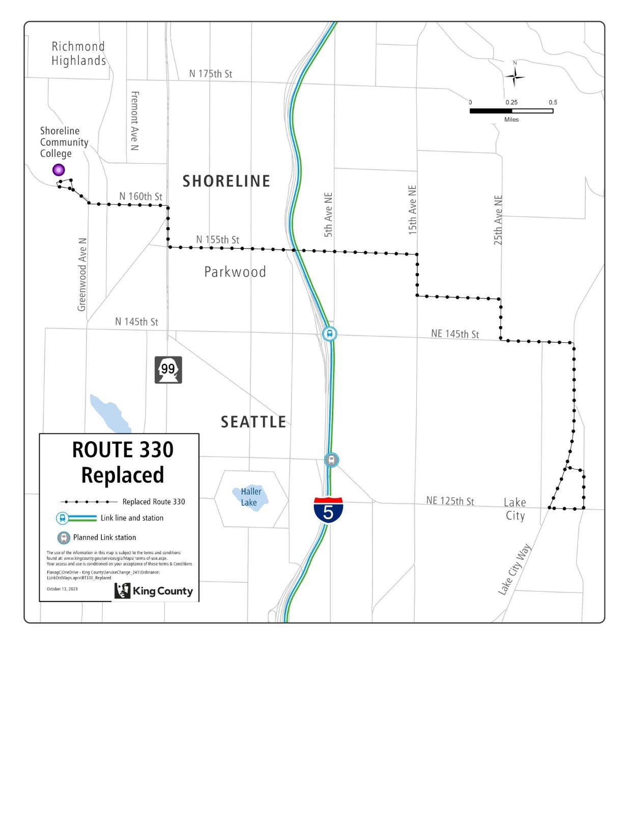

Route: 331 (revise)

OBJECTIVES:
Revise service on Route 331 to make new network connections and match service levels to ridership demand in accordance with the Strategic Plan for Public Transportation, 2021-2031, and King County Metro Service Guidelines.

Strategic Plan Strategies:
- Develop, evaluate, and adjust products, services, and programs that address barriers and increase mobility, especially among priority populations.
- Deliver mobility services that connect people to jobs and job centers, opportunities, and activities of daily living. Improve service during non-peak periods.
- Be flexible and responsive to changes in demand for service and community engagement.
- Use Metro’s Service Guidelines and performance measures to ensure service investments align with needs and values and build toward Metro Connects.

Service Guidelines
- 1. Network Connections
    - Services should be designed in the context of the entire transit system, which includes local and regional bus routes, Link 1 Line, commuter rail lines, and other modes.
- 3. Easy to Understand
    - Routes should have predictable and direct routings and should provide frequency and span appropriate to the market served.
    - Routes should serve connection points where riders can connect with frequent services, opening the widest possible range of travel options.
  - 9. Route Terminals
    - Metro carefully selects the locations where bus routes end and buses wait before starting the next trip (layover). Maintaining existing layover spaces at route terminals is a critical priority to support continued and future service, and expanding layover may be required to support service expansion.
    - Terminals should be in areas where restroom facilities are available for operators, considering the times of day when the facilities would be needed.

IMPACTED SERVICE AREA:
Shoreline, Echo Lake, Lake Forest Park, Kenmore.

SERVICE CHANGE:
Revise Route 331 to serve Mountlake Terrace Station upon Link 1 Line extension to Lynnwood, and extend Route 331 to UW Bothell after Link 2 Line in operation across Lake Washington between Downtown Seattle and Bellevue, and Sound Transit considers changes to ST Express Route 522, and construction along 145th St is substantially complete. Extend span of service to end at 12am on weekdays and 11pm on weekends.

Frequency:
 | Weekday |  |  | Saturday |  | Sunday
 | Peak | Midday | Night | Daytime | Night | Daytime | Night
March 2022 | 20 min | 30 min | - | 30-60 min | - | 30-60 min | -
Current | 24 min | 28 min | 60 min | 43 min | 60 min | 43 min | 60 min
Proposed | 20 min | 30 min | 30-60 min | 30 min | 30 min | 30 min | 30 min

Hours of Service:
 | Weekday | Saturday | Sunday
March 2022 | 6:15 AM – 7:00 PM | 7:00 AM – 7:00 PM | 7:00 AM – 7:00 PM
Current | 6:15 AM – 7:15 PM | 6:55 AM – 7:10 PM | 6:55 AM – 7:05 PM
Proposed | 5:30 AM – 12:00 AM | 6:30 AM – 11:00 PM | 6:30 AM – 11:00 PM

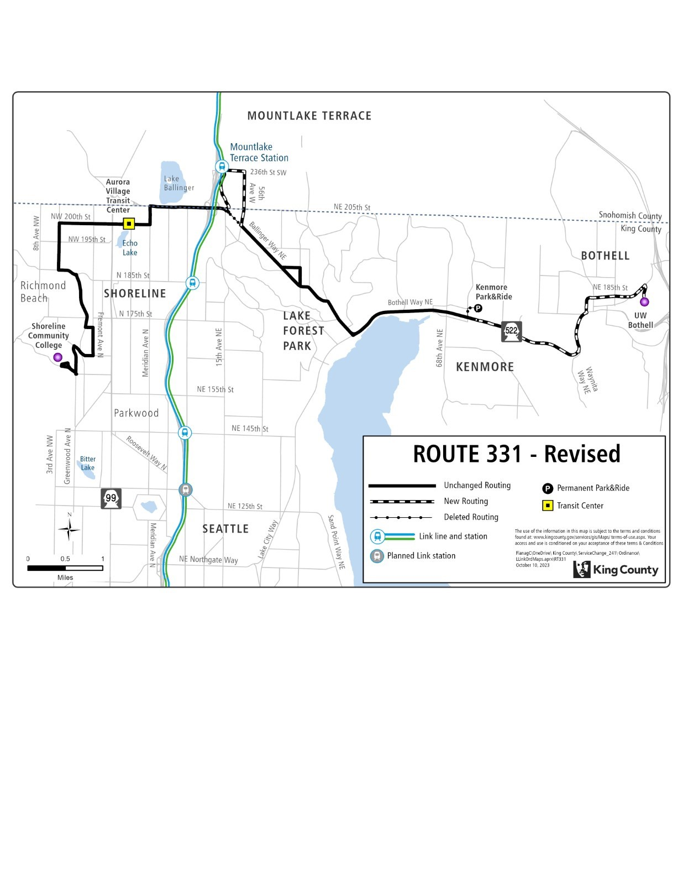

Route: 333 (new)

OBJECTIVES:

Create a new route that serves the Mountlake Terrace Station, North City via 15th Ave. NE and NE 175th St., Shoreline Community College, and Shoreline South/148th Station via Dayton Ave. N and N 145th St. in accordance with the Strategic Plan for Public Transportation, 2021-2031 and King County Metro Service Guidelines.

Strategic Plan Strategies:
- Develop, evaluate, and adjust products, services, and programs that address barriers and increase mobility, especially among priority populations.
- Deliver mobility services that connect people to jobs and job centers, opportunities, and activities of daily living. Improve service during non-peak periods.
- Be flexible and responsive to changes in demand for service and community engagement.
- Use Metro’s Service Guidelines and performance measures to ensure service investments align with needs and values and build toward Metro Connects.

Service Guidelines
- 1. Network Connections
    - Services should be designed in the context of the entire transit system, which includes local and regional bus routes, Link 1 Line, commuter rail lines, and other modes.
    - Metro strives to make transfers easy. Network design should consider locations where transfer opportunities could be provided to improve mobility and efficiency.
    - Where many transfers are expected between services of different frequencies, timed transfers should be maintained to reduce wait times.
- 2. Multiple Purposes and Destinations
    - Routes are more efficient and successful when designed to serve multiple purposes and destinations rather than specialized travel demands.
    - Specialized service should be considered when there is sizeable and demonstrated demand that cannot be adequately met by more generalized service.
  - 3. Easy to Understand
    - A simple transit network is easier for riders to understand and use than a complex network.
    - Routes should have predictable and direct routings and should provide frequency and span appropriate to the market served.
    - Routes should serve connection points where riders can connect with frequent services, opening the widest possible range of travel options.

IMPACTED SERVICE AREA:
Mountlake Terrace, North City, Richmond Highlands, Parkwood

SERVICE CHANGE:
Implement new Route 333, which provide service between the Mountlake Terrace Station, North City via 15th Ave. NE and NE 175th St., Shoreline Community College, and Shoreline South/148th Station via Dayton Ave. N and N 145th St.

Route 333 will operate every 15 minutes from approximately 6:00 AM until 7:00 PM on all seven days of the week. Route 333 will operate every 30 minutes between 5:30 AM and 6:00 AM, and between 7:00 PM to midnight on all seven days of the week.

Frequency:
 | Weekday |  |  | Saturday |  | Sunday
 | Peak | Midday | Night | Daytime | Night | Daytime | Night
March 2022 | - | - | - | - | - | - | -
Current | - | - | - | - | - | - | -
Proposed | 15 | 15 | 30 | 15-30 | 30 | 15-30 | 30

Hours of Service:
 | Weekday | Saturday | Sunday
March 2022 | - | - | -
Current | - | - | -
Proposed | 5:30 AM – 12:00 AM | 5:30 AM – 12:00 AM | 5:30 AM – 12:00 AM

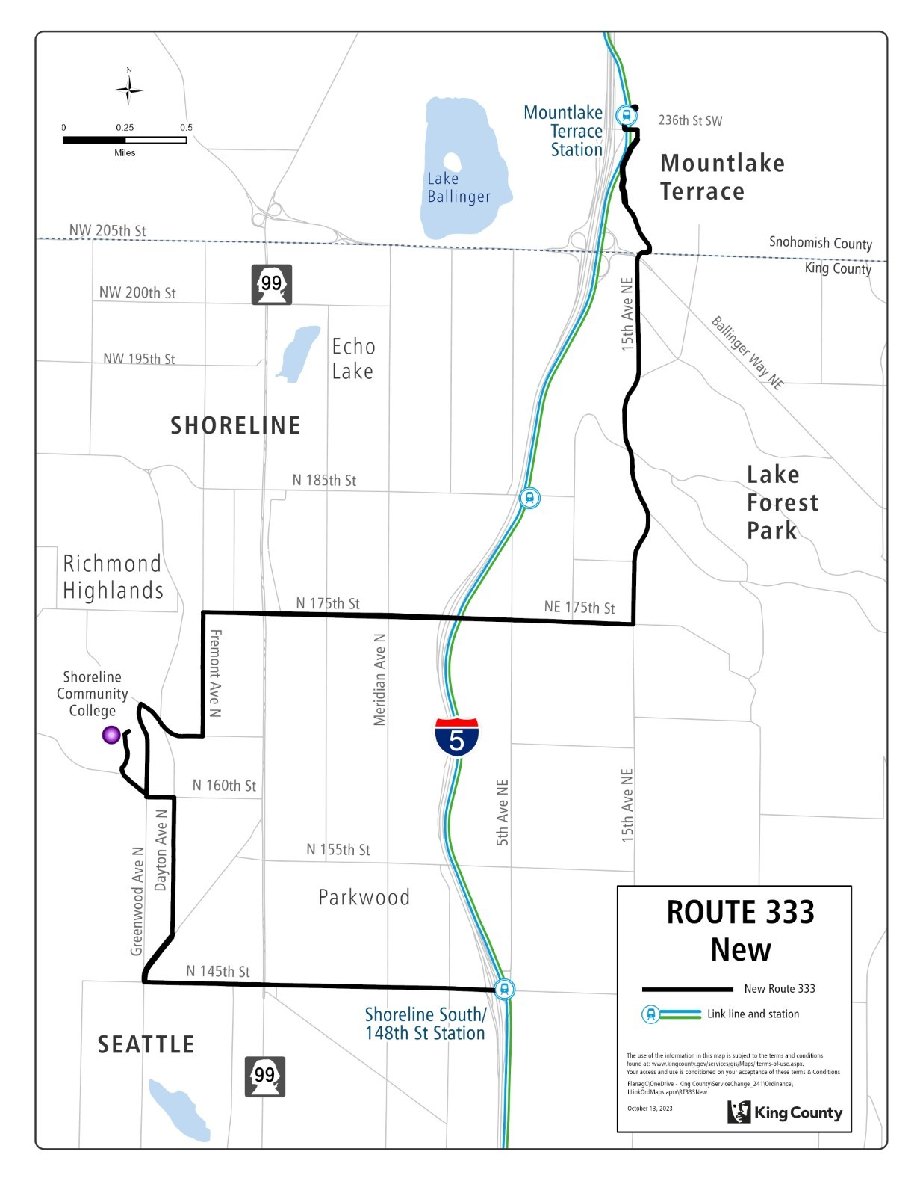

Route: 345 (revise)

OBJECTIVES:

Revise Route 345 to connect with high capacity transit and serve the Shoreline South/148th Station in accordance with the Strategic Plan for Public Transportation, 2021-2031 and King County Metro Service Guidelines.

Strategic Plan Strategies:
- Develop, evaluate, and adjust products, services, and programs that address barriers and increase mobility, especially among priority populations.
- Deliver mobility services that connect people to jobs and job centers, opportunities, and activities of daily living. Improve service during non-peak periods.
- Be flexible and responsive to changes in demand for service and community engagement.
- Use Metro’s Service Guidelines and performance measures to ensure service investments align with needs and values and build toward Metro Connects.

Service Guidelines
- 1. Network Connections
    - Services should be designed in the context of the entire transit system, which includes local and regional bus routes, Link 1 Line, commuter rail lines, and other modes.
    - Metro strives to make transfers easy. Network design should consider locations where transfer opportunities could be provided to improve mobility and efficiency.
    - Where many transfers are expected between services of different frequencies, timed transfers should be maintained to reduce wait times.
- 2. Multiple Purposes and Destinations
    - Routes are more efficient and successful when designed to serve multiple purposes and destinations rather than specialized travel demands.
    - Specialized service should be considered when there is sizeable and demonstrated demand that cannot be adequately met by more generalized service.

IMPACTED SERVICE AREA:
Aurora Village, Shoreline, Bitter Lake, Northgate

SERVICE CHANGE:
Revise Route 345 from its current terminal at Shoreline Community College, to provide service between the Shoreline South/148th Station and Northgate Station via Greenwood Ave. N. and N. 130th St. in the Bitter Lake neighborhood.

Route 345 will operate every 30 minutes from approximately 6:00 AM until 11:30 PM on weekdays but will operate every 20 minutes during peak periods. On weekends, Route 346 will operate every 30 minutes from approximately 6:00 AM until 7 PM and hourly from 7 PM until 11:00 PM.

Frequency:
 | Weekday |  |  | Saturday |  | Sunday
 | Peak | Midday | Night | Daytime | Night | Daytime | Night
March 2022 | 20 min | 30 min | 30 min | 30 min | 60 min | 30 min | 60 min
Current | 20-22 min | 30 min | 60 min | 38 min | 60 min | 38 min | 60 min
Proposed | 20 min | 30 min | 30 min | 30 min | 60 min | 30 min | 60 min

Hours of Service:
 | Weekday | Saturday | Sunday
March 2022 | 6:15 AM – 11:30 PM | 6:30 AM – 11:30 PM | 6:30 AM – 11:30 PM
Current | 6:15 AM – 11:40 PM | 6:30 AM – 11:30 PM | 6:30 AM – 11:30 PM
Proposed | 6:00 AM – 11:30 PM | 6:00 AM – 11:00 PM | 6:00 AM – 11:00 PM
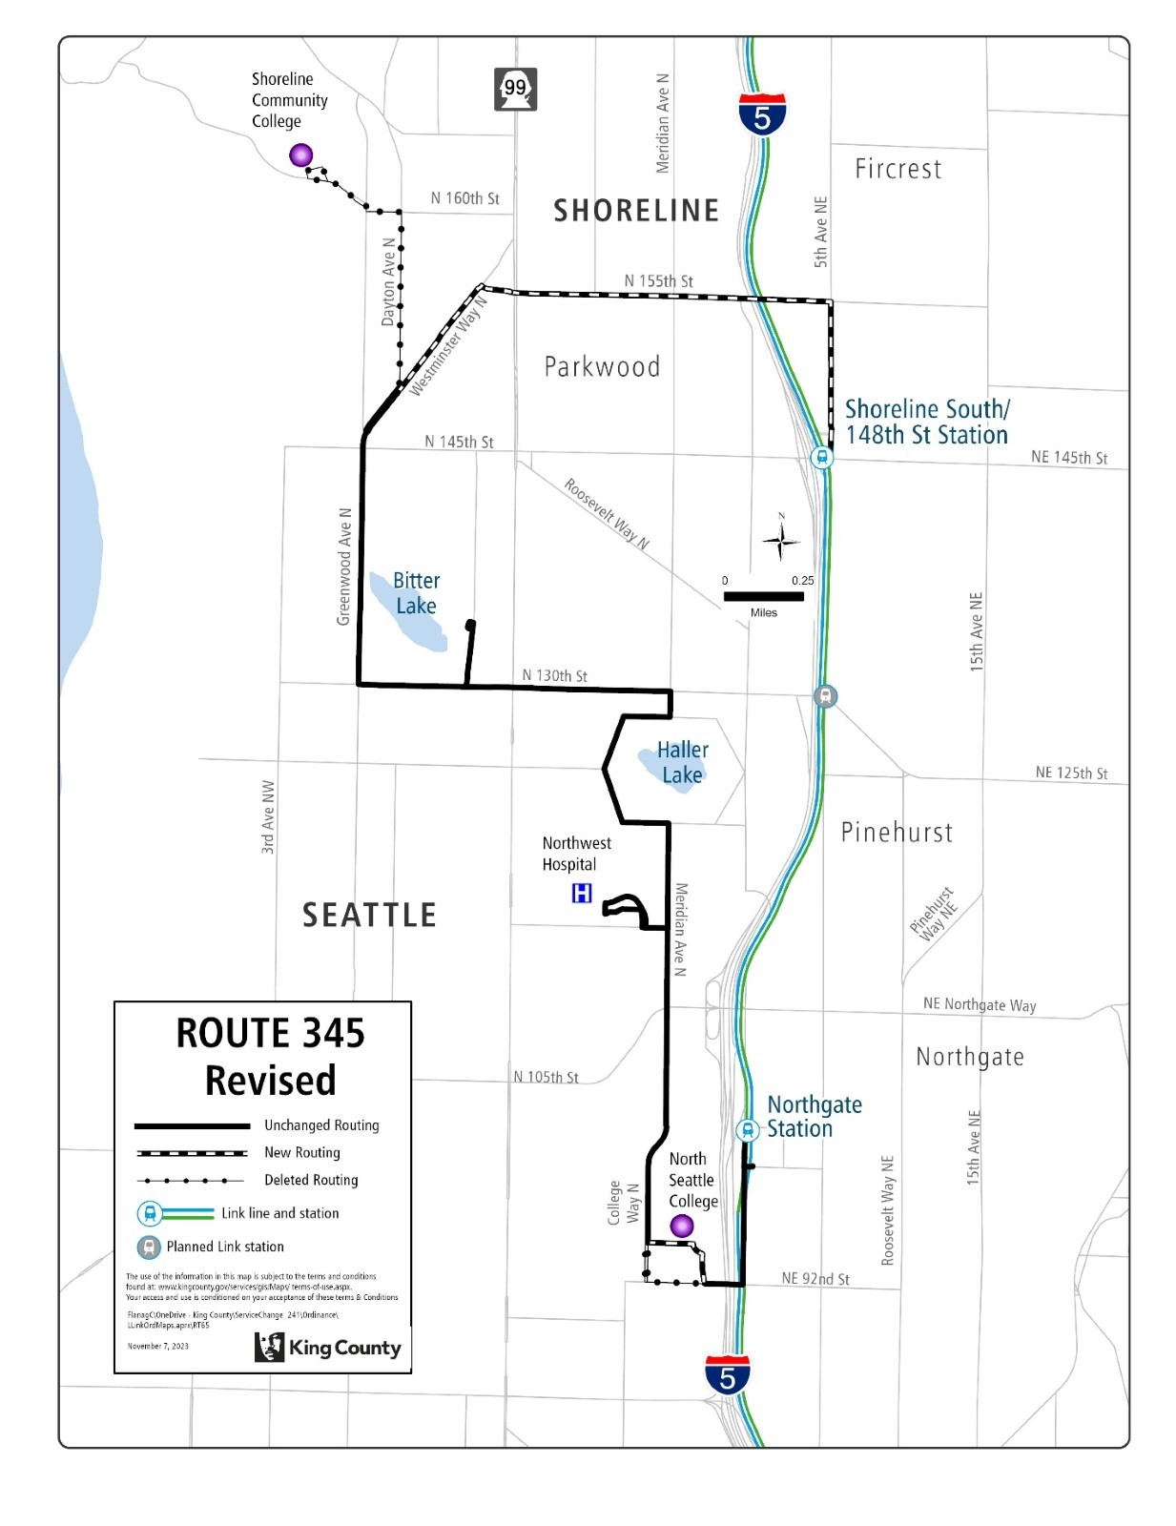

Route: 346 (revise)

OBJECTIVES:

Revise Route 346 to operate between the Aurora Village Transit Center and South Shoreline/148th St. Station via Meridian Ave. N, in accordance with the Strategic Plan for Public Transportation, 2021-2031 and King County Metro Service Guidelines.

Strategic Plan Strategies:
- Prioritize service in geographic areas that have highly dense, transit-supportive development; a high proportion of priority populations; and limited midday and evening service.
- Deliver mobility services that connect people to jobs and job centers, opportunities, and activities of daily living. Improve service during non-peak periods.
- Be flexible and responsive to changes in demand for service and community engagement.
- Use Metro’s Service Guidelines and performance measures to ensure service investments align with needs and values and build toward Metro Connects.

Service Guidelines
- 1. Network Connections
    - Services should be designed in the context of the entire transit system, which includes local and regional bus routes, Link 1 Line, commuter rail lines, and other modes.
    - Metro strives to make transfers easy. Network design should consider locations where transfer opportunities could be provided to improve mobility and efficiency.
    - Where many transfers are expected between services of different frequencies, timed transfers should be maintained to reduce wait times.
- 3. Easy to Understand
    - A simple transit network is easier for riders to understand and use than a complex network.
    - Routes should have predictable and direct routings and should provide frequency and span appropriate to the market served.
    - Routes should serve connection points where riders can connect with frequent services, opening the widest possible range of travel options.

IMPACTED SERVICE AREA:
Shoreline, Aurora Village Transit Center

SERVICE CHANGE:
Revise Route 346, which will provide service between Shoreline South/148th St. Station and Aurora Village Transit Center via Meridian Ave. N. Delete segment south of N. 155th St., which will be covered by new Route 365.

Route 346 will operate every 30 minutes from approximately 6:00 AM until midnight on weekdays. On weekends, Route 346 will operate every 30 minutes from approximately 6:00 AM until 7 PM and hourly from 7PM until 11:15 PM.

Frequency:
 | Weekday |  |  | Saturday |  | Sunday
March 2022 | Peak | Midday | Night | Daytime | Night | Daytime | Night
Current | 20 min | 30 min | 30 min | 30 min | 60 min | 30 min | 60 min
Proposed | 30 min | 30 min | 30 min | 30 min | 60 min | 30 min | 60 min

Hours of Service:
 | Weekday | Saturday | Sunday
March 2022 | 5:15 AM – 11:15 PM | 6:00 AM – 11:30 PM | 6:00 AM – 11:30 PM
Current | 5:15 AM – 11:15 PM | 6:00 AM – 11:30 PM | 6:00 AM – 11:30 PM
Proposed | 6:00 AM – 12:00 PM | 6:00 AM – 11:15 PM | 6:00 AM – 11:15 PM
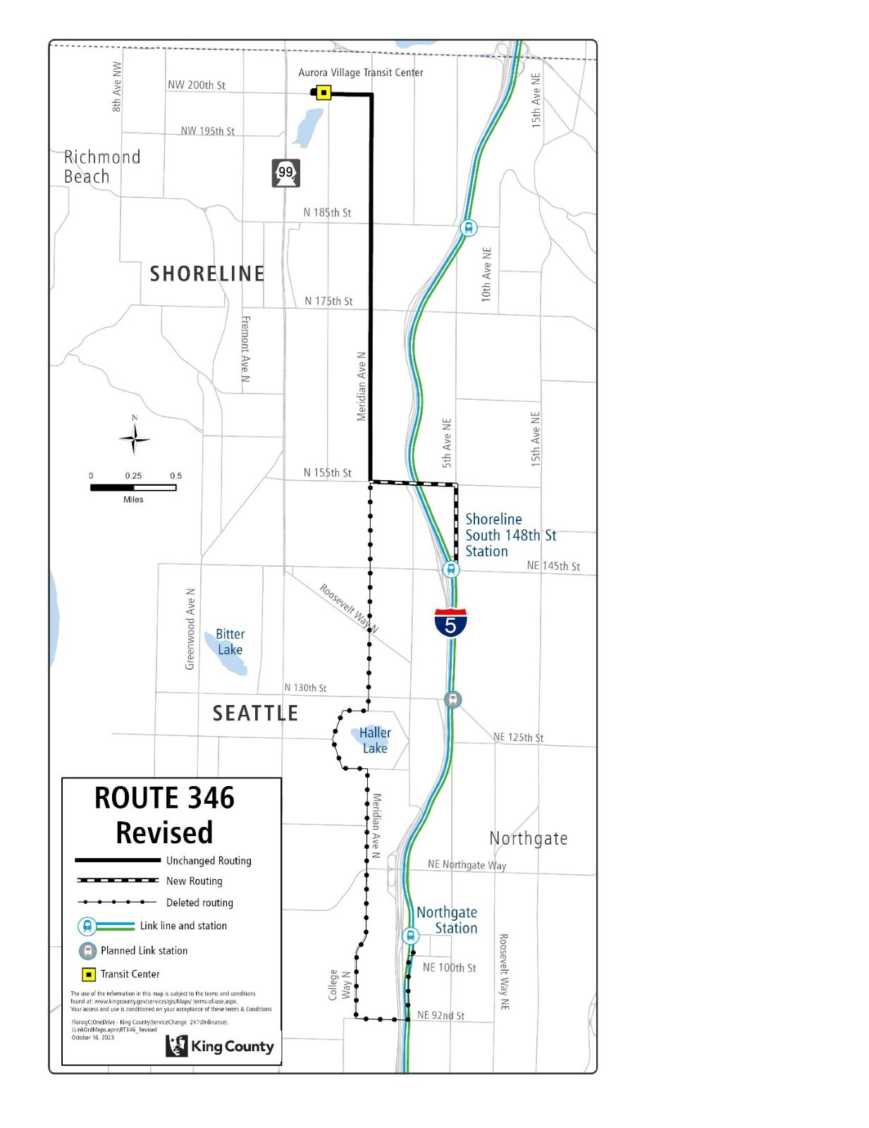

Route: 347 (delete)

OBJECTIVES:
Replacement service for Route 347 will be provided by Routes 333, 348, 365, and Link 1 Line.
Restructure service to leverage high-capacity transit investments, reduce duplication, and provide new east-west connections and better all-day transit service levels in accordance with the Strategic Plan for Public Transportation, 2021-2031, and King County Metro Service Guidelines.

Strategic Plan Strategies:
- Develop, evaluate, and adjust products, services, and programs that address barriers and increase mobility, especially among priority populations.
- Deliver mobility services that connect people to jobs and job centers, opportunities, and activities of daily living. Improve service during non-peak periods.
- Be flexible and responsive to changes in demand for service and community engagement.
- Use Metro’s Service Guidelines and performance measures to ensure service investments align with needs and values and build toward Metro Connects.

Service Guidelines
- 1. Network Connections
    - Services should be designed in the context of the entire transit system, which includes local and regional bus routes, Link 1 Line, commuter rail lines, and other modes.
    - Metro strives to make transfers easy. Network design should consider locations where transfer opportunities could be provided to improve mobility and efficiency.
    - Where many transfers are expected between services of different frequencies, timed transfers should be maintained to reduce wait times.
- 2. Multiple Purposes and Destinations
    - Routes are more efficient and successful when designed to serve multiple purposes and destinations rather than specialized travel demands.
    - Specialized service should be considered when there is sizeable and demonstrated demand that cannot be adequately met by more generalized service.
  - 4. Route Spacing and Duplication
    - Routes should be designed to avoid competing for the same riders. In general, routes should be no closer than 1/2 mile.
    - Services may overlap or be more closely spaced where urban and physical geography makes it necessary, where services in a common segment serve different destinations, or where routes converge to serve regional growth centers. Where services do overlap, they should be scheduled together, if possible, to provide shorter waits along the common routing.
    - Metro should consider transit access in defining a route or route segment as duplicative. Access should be based on the frequency of service.

IMPACTED SERVICE AREA:
Northgate, North City, Mountlake Terrace.

SERVICE CHANGE:
Delete Route 347 to reduce duplicative service and provide better all-day transit service. Alternative service will be provided by Routes 333, 348, 365, and Link 1 Line.
Frequency:
 | Weekday |  |  | Saturday |  | Sunday
 | Peak | Midday | Night | Daytime | Night | Daytime | Night
March 2022 | 20 min | 30 min | 30-40 min | 30-60 min | 60 min | 30-60 min | 60 min
Current | 20-24 min | 30 min | 36 min | 37 min | 60 min | 37 min | 60 min
Proposed | - | - | - | - | - | - | -

Hours of Service:
 | Weekday | Saturday | Sunday
March 2022 | 5:30 AM – 11:30 PM | 6:30 AM – 11:00 PM | 6:30 AM – 11:00 PM
Current | 5:25 AM – 11:35 PM | 6:25 AM – 11:00 PM | 6:25 AM – 11:00 PM
Proposed | - | - | -

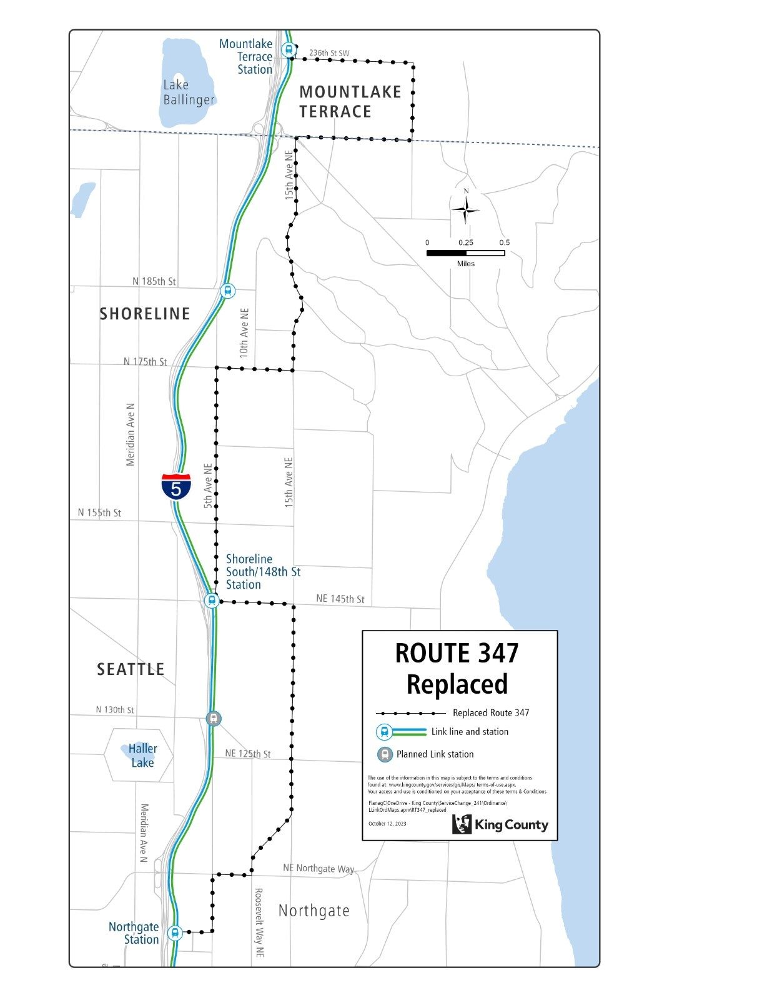

Route: 348 (revise)

OBJECTIVES:
Revise service on Route 348 to make new network connections, match service levels to ridership demand, and secure appropriate layover facilities in accordance with the Strategic Plan for Public Transportation, 2021-2031, and King County Metro Service Guidelines.

Strategic Plan Strategies:
- Develop, evaluate, and adjust products, services, and programs that address barriers and increase mobility, especially among priority populations.
- Deliver mobility services that connect people to jobs and job centers, opportunities, and activities of daily living. Improve service during non-peak periods.
- Be flexible and responsive to changes in demand for service and community engagement.
- Prioritize service in geographic areas that have highly dense, transit-supportive development; a high proportion of priority populations; and limited midday and evening service.
- Use Metro’s Service Guidelines and performance measures to ensure service investments align with needs and values and build toward Metro Connects.

Service Guidelines
- 1. Network Connections
    - Services should be designed in the context of the entire transit system, which includes local and regional bus routes, Link 1 Line, commuter rail lines, and other modes.
- 2. Multiple Purposes and Destinations
    - Routes are more efficient and successful when designed to serve multiple purposes and destinations rather than specialized travel demands.
    - Specialized service should be considered when there is sizeable and demonstrated demand that cannot be adequately met by more generalized service.
- 3. Easy to Understand
    - Routes should have predictable and direct routings and should provide frequency and span appropriate to the market served.
    - Routes should serve connection points where riders can connect with frequent services, opening the widest possible range of travel options.
  - 9. Route Terminals
    - Metro carefully selects the locations where bus routes end and buses wait before starting the next trip (layover). Maintaining existing layover spaces at route terminals is a critical priority to support continued and future service, and expanding layover may be required to support service expansion.
    - Terminals should be in areas where restroom facilities are available for operators, considering the times of day when the facilities would be needed.

IMPACTED SERVICE AREA:
Richmond Beach, Shoreline, North City, Pinehurst, Northgate.

SERVICE CHANGE:
Revise Route 348 to include a short-turn variant so that half of Route 348 trips terminate at Richmond Beach, and the other half terminate between 3rd Ave. NW and 8th Ave. NW. Revise so that the overlapping portion of the route variants has improved frequent all-day service, with extended span of service until 12 AM. Revise to serve the 185th Street Station.

Frequency:
 | Weekday |  |  | Saturday |  | Sunday
 | Peak | Midday | Night | Daytime | Night | Daytime | Night
March 2022 | 20 min | 30 min | 30 min | 30-60 min | 60 min | 30-60 min | 60 min
Current
Proposed | 15 min | 15 min | 30 min | 30 min | 30 min | 30 min | 30 min

Hours of Service:
 | Weekday | Saturday | Sunday
March 2022 | 5:30 AM – 11:00 PM | 6:00 AM – 11:30 PM | 6:00 AM – 11:30 PM
Current | 5:40 AM – 11:05 PM | 5:55 AM – 11:30 PM | 5:55 AM – 11:30 PM
Proposed | 5:30 AM – 12:00 AM | 5:30 AM – 12:00 AM | 5:30 AM – 12:00 AM

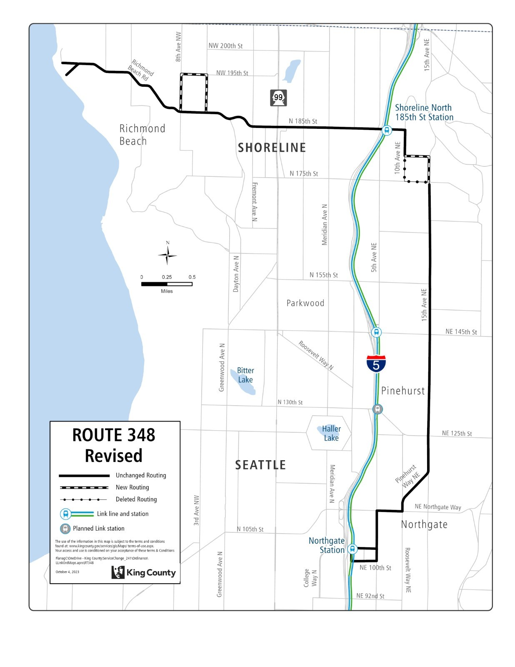

Route: 365 (new)

OBJECTIVES:

Create new route that serves Northgate Station, North Seattle College, NW Hospital, Haller Lake, Shoreline South/148th Station via Meridian Ave. N and N 145th St., and the North Shoreline/185th Station via 5th Ave. NE, in accordance with the Strategic Plan for Public Transportation, 2021-2031 and King County Metro Service Guidelines.

Strategic Plan Strategies:
- Develop, evaluate, and adjust products, services, and programs that address barriers and increase mobility, especially among priority populations.
- Deliver mobility services that connect people to jobs and job centers, opportunities, and activities of daily living. Improve service during non-peak periods.
- Be flexible and responsive to changes in demand for service and community engagement.
- Use Metro’s Service Guidelines and performance measures to ensure service investments align with needs and values and build toward Metro Connects.

Service Guidelines
- 1. Network Connections
    - Services should be designed in the context of the entire transit system, which includes local and regional bus routes, Link 1 Line, commuter rail lines, and other modes.
    - Metro strives to make transfers easy. Network design should consider locations where transfer opportunities could be provided to improve mobility and efficiency.
    - Where many transfers are expected between services of different frequencies, timed transfers should be maintained to reduce wait times.
- 2. Multiple Purposes and Destinations
    - Routes are more efficient and successful when designed to serve multiple purposes and destinations rather than specialized travel demands.
    - Specialized service should be considered when there is sizeable and demonstrated demand that cannot be adequately met by more generalized service.

IMPACTED SERVICE AREA:
North City, Haller Lake, Northgate

SERVICE CHANGE:
Implement new Route 365, which will provide service between Shoreline North/185th St Station and Northgate Station via 5th Ave. NE and Meridian Ave. N.

Route 365 will operate every 30 minutes from approximately 5:00 AM until 11:30 PM on weekdays. Route 365 will operate every 30-60 minutes on weekends from 6:00 AM until 11:30 PM.

Frequency:
 | Weekday |  |  | Saturday |  | Sunday
 | Peak | Midday | Night | Daytime | Night | Daytime | Night
March 2022 | - | - | - | - | - | - | -
Current | - | - | - | - | - | - | -
Proposed | 20 | 30 | 30 | 30 | 60 | 30 | 60

Hours of Service:
 | Weekday | Saturday | Sunday
March 2022 | - | - | -
Current | - | - | -
Proposed | 6:00 AM – 11:30 PM | 6:00 AM – 11:30 PM | 6:00 AM – 11:30 PM
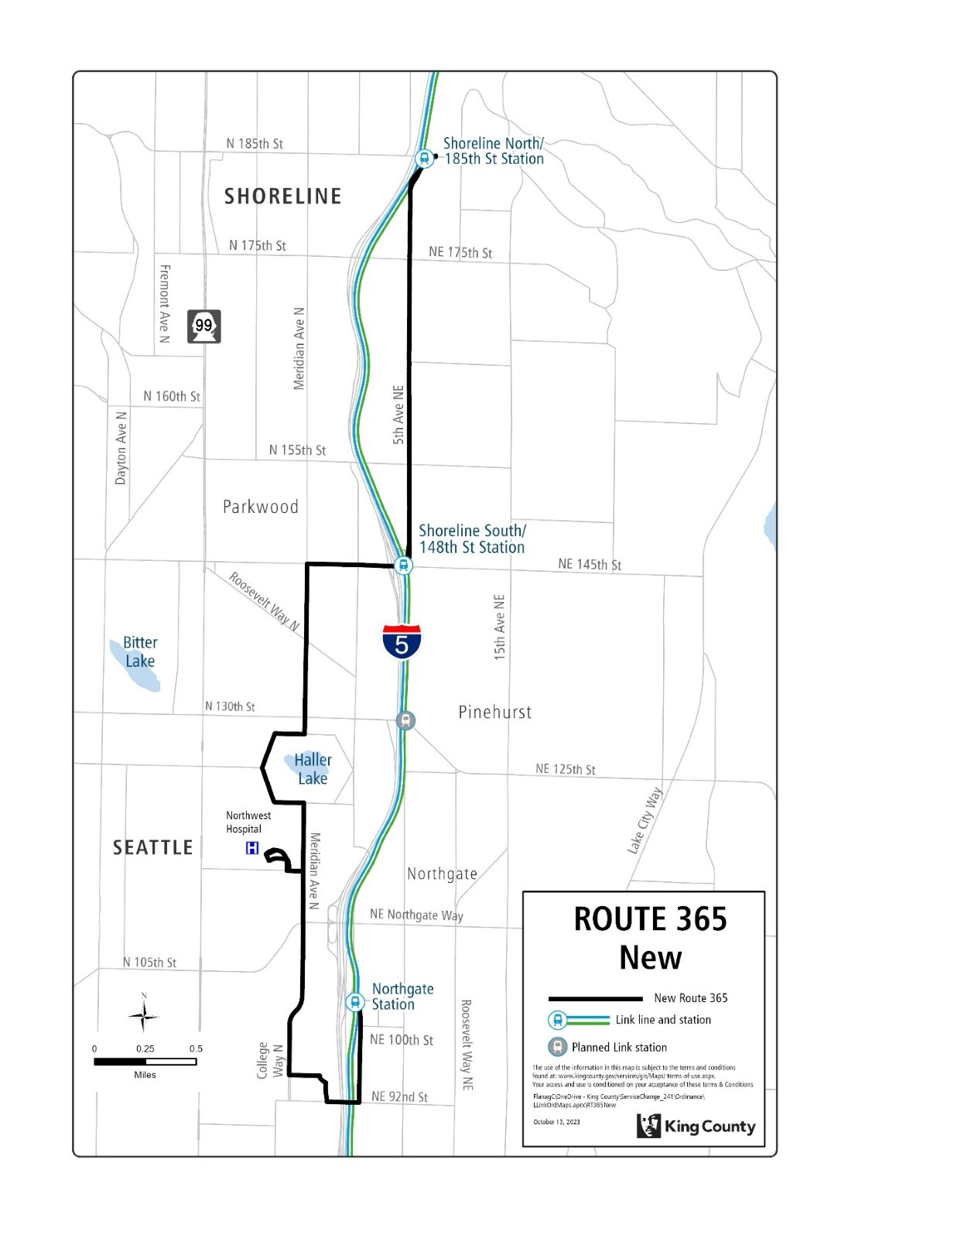

Route: 372 (retain)

OBJECTIVES:

Route 372 will not be deleted, as originally authorized by Ordinance 19751. It will be retained and when Sound Transit opens the Stride S3 Line (522) bus rapid transit line, the route may be reviewed for possible service revisions or deletion via a future service change ordinance.

IMPACTED SERVICE AREA:
Bothell, Kenmore, Lake Forest Park, Lake City, University District.

SERVICE CHANGE:
Retain Route 372 and make no changes to its service. Future changes, such as a reduction in frequency or hours of service or deletion of the route may be considered as part of a service change ordinance when Sound Transit has opened the Stride 3 Line (522) bus rapid transit service.

Frequency:
 | Weekday |  |  | Saturday |  | Sunday
 | Peak | Midday | Night | Daytime | Night | Daytime | Night
March 2022 | 10-15 min | 15 min | 30 min | 15 min | 30 min | 15 min | 30 min
Current | 12-13 min | 14 min | 25 min | 17 min | 30 min | 17 min | 30 min
Proposed | 12-13 min | 14 min | 25 min | 17 min | 30 min | 17 min | 30 min

Hours of Service:
 | Weekday | Saturday | Sunday
March 2022 | 5:00 AM – 1:00 AM | 6:15 AM – 12:30 AM | 6:15 AM – 12:30 AM
Current | 5:05 AM – 1:00 AM | 6:15 AM – 12:35 AM | 6:15 AM – 12:40 AM
Proposed | 5:05 AM – 1:00 AM | 6:15 AM – 12:35 AM | 6:15 AM – 12:40 AM

Map showing Route 372 retained


