Intergovernmental Land Transfer Agreement Between
King County and the City of Auburn

Relating to the Ownership, Operation and Maintenance of Parks,
Open Space, Recreation Facilities and Programs

This Agreement is made and entered into this day by and between the City of Auburn, hereinafter called "City", and King County, hereinafter called "County". Together, the City and the County are referred to herein as the "Parties" or individually as a "Party."

WHEREAS, the City of Auburn is a noncharter code city with a council-mayor form of government, organized pursuant to RCW Title 35A; and

WHEREAS, King County is a home rule charter county and political subdivision of the State of Washington; and

WHEREAS, the City is authorized by RCW 35A.11.050, RCW 35A.67.010 and other laws to own, operate, and maintain parks, open space, and recreation facilities and programs inside its boundaries, and the City desires to expand its holdings for those purposes; and

WHEREAS, the County, under the authority of RCW 36.89.050, King County Resolution 34571 and other federal, state and county laws, has acquired and developed a substantial park, recreation and open space system that depends on the continued operation of its many individual properties and facilities in order to fully serve the needs of the residents of King County and the cities within it; and

WHEREAS, King County Code Section 2.16.045.E(1) and King County Ordinance 14509 contemplate that the County should divest itself of ownership, management, and financial responsibility for parks, open space, recreational facilities and programs inside incorporated areas, other than regional parks and facilities; and

WHEREAS a portion of the County's North Green River Park is located in the City, namely, King County Tax Assessor Parcel No. 3339400855; and

WHEREAS, the City has requested the County transfer this parcel for a future-riverfront park; and

WHEREAS, the County is legally restricted from converting this portion of North Green River Park from its current uses without expending funds to replace the converted facilities; and

WHEREAS, given the legal restriction regarding conversion of the property, the marketability of the property is limited and, as a result, the cost of operating the facility is approximately equal to the value of the property to the County; and

WHEREAS, to the extent the City provides scholarships, reduced fees or other means of assuring access to parks and recreational programming for City residents, the City has a goal of ensuring that such scholarships or other needs-based rates and programs are available to all persons desiring to use the park and recreational programs regardless of residency; and

WHEREAS, it is in the best interest of the public that the City and the County take those actions necessary to meet those desires and to cooperate in any transition to insure a smooth transition and avoid service disruption; and

NOW, THEREFORE, in consideration of the mutual promises contained herein and other good and valuable consideration, the receipt and adequacy of which are hereby acknowledged, and pursuant to RCW Chapter 39.33 and other authorities, the City and the County agree as follows:

- Conveyance of Title
1.1 Within thirty (30) days of execution of this Agreement, or as soon thereafter as practicable, King County shall convey to the City by deed all of its ownership interest in the following park/recreation site, which is described more fully in Exhibit A and illustrated in Exhibit B (the "Property"):

That certain portion of North Green River Park consisting of King County Tax Assessor Parcel No. 3339400855

1.2 The deed to the Property shall also contain the following specific covenants pertaining to use, which covenants shall run with the land for the benefit of the County and the County land that makes up its public park, recreation and open space system. The County and the City agree that the County shall have standing to enforce these covenants, which shall be set forth as follows:

“The City, as required by RCW 36.89.050, covenants that the Property shall be continued to be used for open space, park, or recreation facility purposes or that other equivalent facilities within the County shall be conveyed to the County in exchange therefore."

"The City further covenants that it will not limit or restrict access to and use of the Property by non-city residents in any way that does not also apply to city residents. The City covenants that any and all user fees charged for the Property, including charges imposed by any lessees, concessionaires, service providers, and/or other assignees shall be at the same rate for non-City residents as for the residents of the City."

"The City covenants that it shall place the covenants herein in any deed transferring the Property or a portion of the Property for public park, recreation or open space uses."

1.3 In conveying the Property by deed, the County shall reserve a river protection
easement in substantially the same form attached hereto as Exhibit C.

2. Existing Restrictions, Agreements, Contracts or Permits
The City shall abide by and enforce all terms, conditions, reservations, restrictions and covenants of record at the time of conveyance and/or in the deed of conveyance.

3. Condition of Premises and Responsibility for Operations, Maintenance, Repairs, Improvements, and Recreation Services

3.1 The City has inspected and knows the condition of the Property and agrees to accept the Property in AS IS condition, and to assume full and complete responsibility for all operations, maintenance, repairs, improvements of, and provision of recreational services at, the Property.

3.2 King County does not make and specifically disclaims any warranties, express or implied, including any warranty of merchantability or fitness for a particular purpose, with respect to the Property, and no official, employee, representative or agent of King County is authorized otherwise.

3.3 The City acknowledges and agrees that except as indicated in paragraph 4.2, the County shall have no liability for, and that the City shall release and have no recourse against the County for, any defect or deficiencly of any kind whatsoever in the Property without regard to whether such defect or deficiency was known or discoverable by the City or the County.

4. Environmental Liability

4.1 "Hazardous Materials" as used herein shall mean any hazardous, dangerous or toxic wastes, materials, or substances as defined in state or federal statutes or regulations as currently adopted or hereafter amended.

4.2 Nothing in this Agreement shall be deemed to waive any statutory claim for contribution that the City might have against the County under federal or state environmental statutes that arises from hazardous materials deposited or released on the Property by the County during the County's period of ownership. The City may not, however, assert such a claim to the extent that the City creates the need for or exacerbates the cost of remediation upon which a statutory claim for contribution is based as a result of the City performing construction activities on the Property, changing the configuration of the Property, or changing the use of the Property.

4.3 If the City discovers the presence of hazardous materials at levels that could give rise to a statutory claim for contribution against the County it shall immediately notify the County in writing. Such notice shall in no event be provided more than 10 days after discovery. The parties shall make their best efforts to reach agreement as to which party is responsible for remediation under the terms of this Agreement prior to undertaking any remediation.

4.4 In no event shall the County be responsible for any costs of remediation that exceed the minimum necessary to satisfy the state or federal agency with jurisdiction over the remediation.

5. Indemnification and Hold Harmless

5.1 King County shall indemnify and hold harmless the City and its elected officials, officers, agents or employees, or any of them, from and against any and all claims, actions, suits, liability, loss, costs, expenses and damages of any nature whatsoever, (i) which are caused by or result from a negligent action or omission of King County, its officers, agents and employees in performing its obligations pursuant to this Agreement, and/or (ii) arising from those occurrences related to the Property that occurred prior to the effective date of conveyance of the Property to the City, except to the extent that indemnifying or holding the City harmless would be limited by Section 4 of this Agreement. In the event that any suit based upon such a claim, action, loss or damage is brought against the City or the City and King County, King County shall defend the same at its sole cost and expense and, if final judgment be rendered against the City and its elected officials, officers, agents and employees or jointly against the City and King County and their respective elected officials, officers, agents and employees, King County shall satisfy the same.

5.2 In executing this Agreement, the County does not assume liability or responsibility for or in any way release the City from any liability or responsibility which arises in whole or in part from the existence or effect of City ordinances, rules or regulations. If any cause, claim, suit, action or administrative proceeding is commenced in which the enforceability and/or validity of any such City ordinance, rule or regulation is at issue, the City shall defend the same at its sole expense and if judgment is entered or damages are awarded against the City, the County or both, the City shall satisfy the same, including all chargeable costs and attorney's fees.

5.3 The City shall indemnify and hold harmless King County and its elected officials, officers, agents and employees, or any of them, from and against any and all claims, actions, suits, liability, loss, costs, expenses and damages of any nature whatsoever, (i) which are caused by or result from a negligent act or omission of the City, its officers, agents and employees in performing obligations pursuant to this Agreement, and/or (ii) arising from those occurrences related to the Property that occurred on or after the effective date of conveyance of the Property to the City, except to the extent that indemnifying or holding the County harmless would be limited by Section 4 of this Agreement. In the event that any suit based upon such a claim, action, loss or damage is brought against King County or King County and the City, the City shall defend the same at its sole cost and expense and, if final judgment be rendered against King County and its officers, agents and employees or jointly against King County and the City and their respective officers, agents and employees, the City shall satisfy the same.

5.4 Each Party to this Agreement shall immediately notify the other of any and all claims, actions, losses or damages that arise or are brought against that Party relating to or pertaining to the Property.

5.5 Each Party agrees that its obligations under this Section 5 extend to any claim, demand, and/or cause of action brought by or on behalf of any employees, or agents. For this purpose, each Party, by mutual negotiation, hereby waives, with respect to the other Party only, any immunity that would otherwise be available against such claims under the Industrial Insurance provisions of Title 51 RCW, but only to the extent necessary to indemnify the other Party.

6. Audits and Inspections

Until December 31, 2022, any of either Party’s records related to any matters covered by this Agreement not otherwise privileged shall be subject to inspection, review, and/or audit by either Party at the requesting Party's sole expense. Such records shall be made available for inspection during regular business hours within a reasonable time of the request.

7. Waiver and Amendments

Waiver of any breach of any term or condition of this Agreement shall not be deemed a waiver of any prior or subsequent breach. No term or condition shall be waived, modified or deleted except by an instrument, in writing, signed by the Parties hereto.

8. Entire Agreement and Modifications

This Agreement and its Exhibits sets forth the entire agreement between the Parties with respect to the subject matter hereof. It may be supplemented by addenda or amendments, which have been agreed upon by both Parties in writing. Copies of such addenda and amendments shall be attached hereto and by this reference made part of this Agreement as though fully set forth herein.

9. Duration and Authority

This Agreement shall be effective upon signature and authorization by both Parties. The terms, covenants, representations and warranties contained herein shall not merge in the deed of conveyance, but shall survive the conveyance and shall continue in force unless both Parties mutually consent in writing to termination.

10. Notice

Any notice provided for herein shall be sent to the respective Parties at:

King County: City:

Kevin Brown Daryl Faber
Division Director Director
Parks and Recreation Division Auburn Parks and Recreation
Department of Natural Resources and Parks City of Auburn
201 South Jackson Street, #700 919 9th Street SE
Seattle, WA 98104 Auburn, WA 98002

11. Police Powers Unaffected

Nothing in this Agreement shall diminish the governmental or police powers of the County or of the City.

IN WITNESS WHEREOF, the Parties have executed this Agreement.

King County City of Auburn

___________________________ ____________________________
King County Executive Mayor

___________________________ _____________________________
Date Date

Approved as to Form: Approved as to Form:

___________________________ ______________________________
King County City Attorney
Senior Deputy Prosecuting Attorney

____________________________ ______________________________
Date Date

NOTARY BLOCKS APPEAR ON PAGE 8
NOTARY BLOCK FOR KING COUNTY

STATE OF WASHINGTON )
) ss.
COUNTY OF KING )

On this day personally appeared before me DOW CONSTANTINE, known to me to be the individual that executed the foregoing instrument on behalf of KING COUNTY, a home rule charter county and political subdivision of the State of Washington, and acknowledged the same instrument to be the free and voluntary act and deed of said county for the uses and purposes therein mentioned, and on oath stated that he was authorized to execute the said instrument.

GIVEN under my hand and official seal this ____ day of ___________, 20__.

____________________________________
Notary Public in and for the State of Washington
Type/Print Name:______________________
Residing at___________________________
My Commission Expires________________

NOTARY BLOCK FOR CITY OF AUBURN

STATE OF WASHINGTON )
) ss.
COUNTY OF KING )

On this day personally appeared before me PETER LEWIS, known to me to be the individual that executed the foregoing instrument on behalf of the CITY OF AUBURN, a noncharter code city and municipal corporation of the State of Washington, and acknowledged the same instrument to be the free and voluntary act and deed of said city for the uses and purposes therein mentioned, and on oath stated that he was authorized to execute the said instrument.

GIVEN under my hand and official seal this ____ day of ___________, 20__.

____________________________________
Notary Public in and for the State of Washington
Type/Print Name:______________________
Residing at___________________________
My Commission Expires________________

EXHIBIT A

Legal Descriptions

EXHIBIT B

Illustration of Property

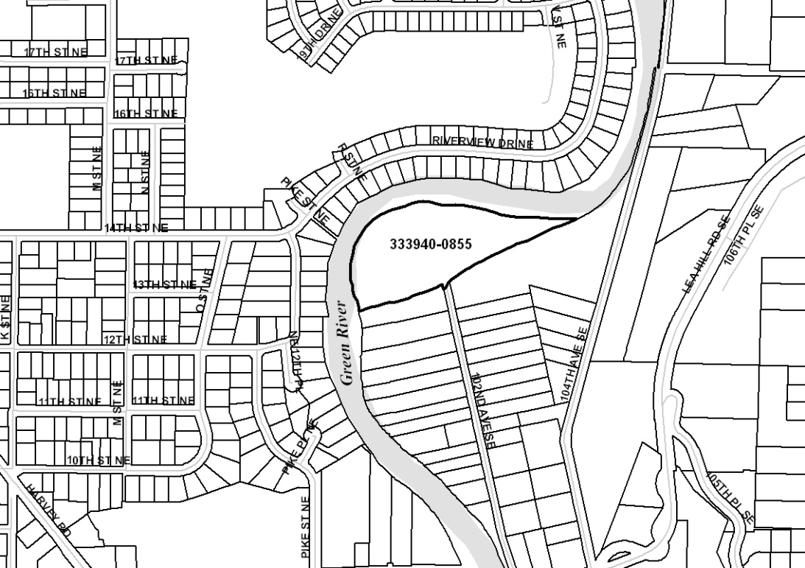

Image below is a color aerial photo of the same area as shown above.

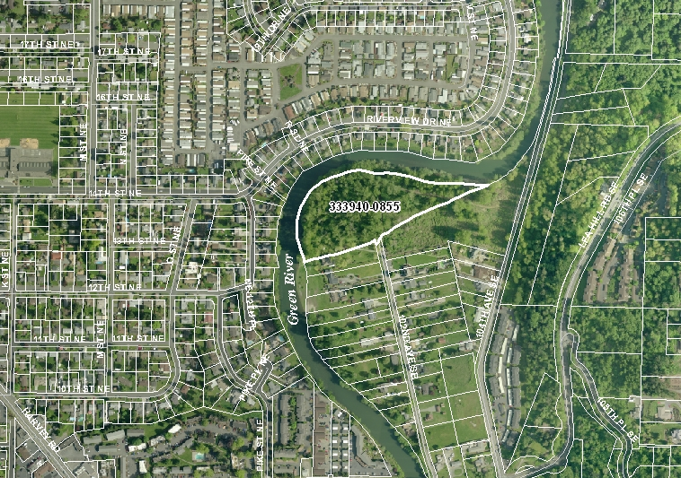
EXHIBIT C

Form of River Protection Easement

AFTER RECORDING RETURN TO:

King County Property Services Division
500A King County Administration Building
500 Fourth Avenue
Seattle, WA 98104

Document Title: River Protection Easement
Reference Number of Related Document:
Grantor(s):
Grantee(s): King County
Legal Description:
Assessor’s Tax Parcel Number:

RIVER PROTECTION EASEMENT

For valuable consideration, receipt of which is hereby acknowledged, the GRANTOR(S),

owner(s) in fee of that certain parcel of land (the “Property”), legally described as follows:
________________________________________________________________________________________________________________________________________________________________________________________________________________________________________________________________________________________________________________________

hereby grant(s) to KING COUNTY, a political subdivision of the State of Washington, its successors and assigns, agents and licensees (GRANTEE), a perpetual and assignable right and easement to inspect, construct, monitor, maintain, repair, operate, patrol, replace, modify, or remove flood related works and all appurtenances thereto, including vegetation, in, under, on, over and upon the following portions of the above described Property:

________________________________________________________________________________________________________________________________________________________________________________________________________________________________________________________________________________________________________________________

Grantee shall have the right at such time as may be necessary and at the Grantee’s sole discretion, to enter upon the Property and to have unimpeded access to, in and through the Easement Area for the purposes of exercising the Grantee’s rights as described herein.

Grantor agrees not to plant non-native vegetation within the Easement Area and not to remove or otherwise alter any improvements installed by Grantee, including any native vegetation that may be planted and any flood protection works that may be constructed, within the Easement Area, without the prior approval of Grantee. Grantor further agrees not to use herbicides within the Easement Area without the prior approval of Grantee. Nothing contained herein shall be construed as granting any license, permit or right, otherwise required by law, to Grantor with respect to the Property and the Easement Area.

For the purposes of this river protection easement, the term “native vegetation” shall mean vegetation comprised of plant species, other than noxious weeds (as identified on the State of Washington noxious weed list found at Washington Administrative Code Chapter 16-750, as amended from time to time), which are indigenous to the coastal region of the Pacific Northwest and which reasonably could have been expected to naturally occur at the site.

Neither Grantor nor Grantee is hereby obligated to future maintenance, repair or other action related to the above-described exercise of easement rights. This river protection easement and/or any flood related works constructed or to be constructed within the Easement Area shall not be construed as granting any rights to any third person or entity, or as a guarantee of any protection from flooding or flood damage, and nothing contained herein shall be construed as waiving any immunity to liability granted to Grantee by any state statute, including Chapter 86.12 of the Revised Code of Washington, or as otherwise granted or provided for by law.

The rights, conditions, and provisions of this easement shall inure to the benefit of and be binding upon the heirs, executors, administrators, and successors in interest and assigns of Grantor and Grantee.

GRANTOR GRANTEE

STATE OF WASHINGTON )
) ss.
COUNTY OF KING )

On this _______ day of ____________, 20___, before me, the undersigned, a Notary Public in and for the State of Washington, duly commissioned and sworn, personally appeared _______________________, to me known to be the individual described in and who executed the foregoing instrument, and acknowledged to me that he/she signed and sealed the said instrument as ______ free and voluntary act and deed for the uses and purposes therein mentioned.

Given under my hand and official seal the ________ day of ______________, 20___.

NOTARY PUBLIC in and for the

State of Washington, residing
at
My commission expires

