STAFF REPORT

Agenda Item: | 7 | Name: | Brandi Paribello
Proposed No.: | 2025-0007 | Date: | February 18, 2025

SUBJECT

Proposed Motion 2025-0007 would approve the Accountability Report for King County Office of Economic Opportunity and Creative Economy (OEOCE).

SUMMARY

In November 2022, the King County Council voted to approve Ordinance 19546, which contained a budget proviso withholding $100,000 until the County Executive transmits a report with six sections of required criteria, each asking for different levels of specificity, along with a motion. The report and motion were transmitted in December 2024, and all sections of criteria required in the proviso were met.

BACKGROUND

Prior to 2014, King County’s Executive Department contained a codified economic development office which was ultimately disbanded and decentralized. The office of the Executive maintained one to two staff members who oversaw economic and workforce development matters from that time until 2023.

In April 2019, the Executive appointed a Creative Economy Strategist with the goal of prioritizing film production and content creation. In July 2020, the Executive appointed an Economic Development and Recovery Director to support various pandemic relief efforts for small businesses and workers. The Economic Development & Recovery Director and the Creative Economy Strategist worked together to develop a countywide economic recovery strategy. On November 15, 2022, the OEOCE was created via Ordinance 19541 and the two positions were housed in that office.

In September through November of 2022, the King County Council deliberated on the 2023-2024 Biennial Budget legislation. When the ouncil passed the legislation on November 15, 2022, it included a proviso (Ordinance 19546, Section 20, Proviso P1) that withheld $100,000 from the OEOCE:

P1 PROVIDED THAT:
Of this appropriation, $100,000 shall not be expended or encumbered until the executive transmits an accountability report related to the office of economic opportunity and creative economy and a motion that should acknowledge receipt of the report and a motion acknowledging receipt of the report is passed by the council. The motion should reference the subject matter, the proviso's ordinance number, ordinance section and proviso number in both the title and body of the motion.

The report shall include, but not be limited to, the following:
- A business plan supporting investments for the office of economic opportunity and creative economy. The plan shall also include a definition of what constitutes a creative economy. The business plan shall include, but not be limited to:
  - both long-term and short-term goals, objectives and strategies of the office;
  - proposed activities to implement the strategies;
  - performance metrics including benchmarks and targets to measure the objectives; and
  - the resources necessary to achieve either the performance benchmarks, performance targets or both;
- Analysis of the results achieved during the 2023-2024 biennium with the addition of both the director of creative economy and director of economic development and economic recovery. As much as feasible, quantitative results shall be provided;
- Assessment of the region's current creative economy market, analysis of the region's creative economy market potential and the rationale for the need for the office of economic opportunity and creative economy to achieve the region's creative economy market potential;
- Quantitative analysis of the results achieved during the 2023-2024 biennium with the investment of the Harbor Island sound stages and a rationale of how the sound stages would be an economic benefit for the county;
- Strategies on how the office of economic opportunity and creative economy will have deliberate focus on historically and currently disadvantaged communities including those communities most impacted by the pandemic and its disproportionate health and economic effects; and
- The office of economic opportunity and creative economy's role in existing county economic development programs such as, but not limited to, the Department of Local Services' economic development and small business assistance programs, Department of Local Services' unincorporated economic alliance program, the lodging tax supported tourism allocations and the Black, Indigenous and People of Color (BIPOC) business and economic resiliency program.
ANALYSIS

The proviso contains six sections that require the report to provide a detailed roadmap of the OEOCE’s goals, strategies, and analysis of its achievements.

Proviso Section A: Business Plan. Section A requires a business plan that defines “creative economy,” sets out the objectives and strategies of the office, describes how the office will implement those strategies, indicates how performance will be measured, and details the resources needed to meet objectives and targets.

A business plan for 2025 is included with the report as an attachment to the motion. The business plan itself does not define “creative economy,” but this term is defined in the report as “those economic sectors based on creative and intellectual assets, rather than traditional commodities or services.”

The attached business plan sets out 12 priorities by initiative or project and includes information on strategies and goals to implement those initiatives or projects, as well as how each aligns with equity and social justice. Descriptions of performance measures and milestones are also included for each. The report itself contains a summary of the information in the business plan.

Proviso Section B. Analysis of Achievements. Section B requires “analysis of the results achieved during the 2023-2024 biennium with the addition of both the director of creative economy and director of economic development and economic recovery.”

The report provides a list of directors’ key accomplishments, a list of how office staff provide support services to small businesses, working creatives, and organizational partners, and examples of how the office partners with outside organizations to accomplish its goals. Further, the report contains a table summarizing quantitative information on each of these activities. A representative sample of the information contained in this table can be found in Figure 1 below.

Figure 1. Representative Sample of OEOCE Activities in Report
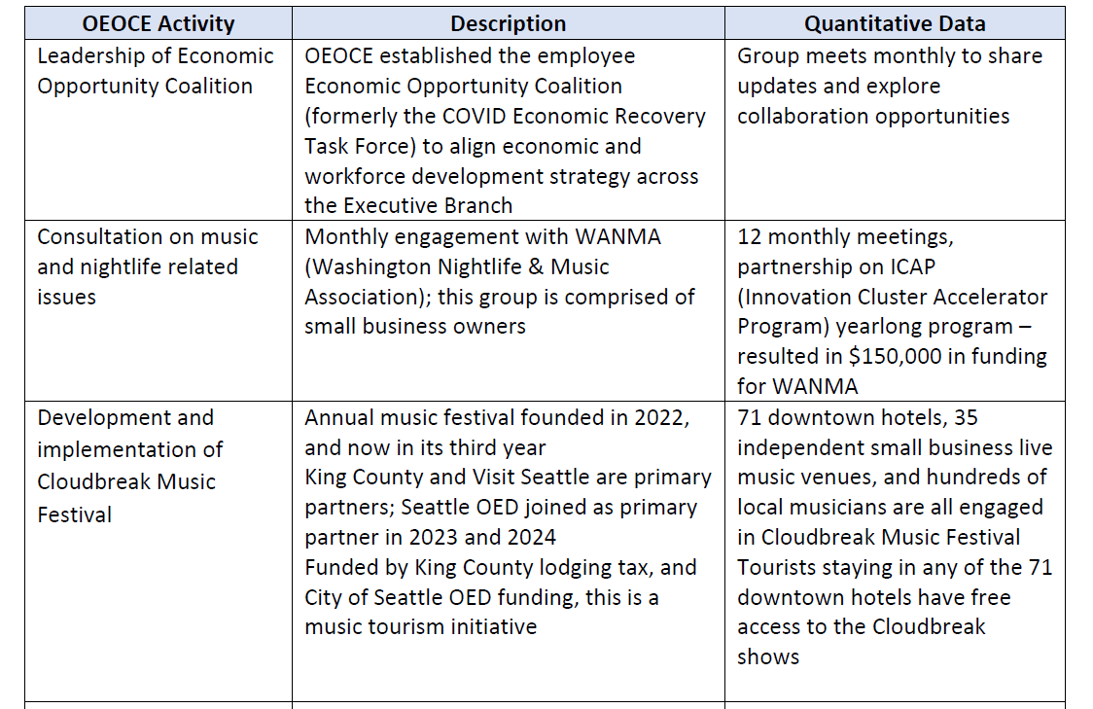

Lastly, the report provides information on “key initiatives,” such as the Cloudbreak Music Festival. This festival was designed by OEOCE, in partnership with Visit Seattle, to assist in the recovery of tourism and music venues in the Seattle area. Other initiatives include funding scholarships for the Power PA (Production Assistant) Course, and Harbor Island Studios.

Proviso Section C. Assessment of Regional Creative Economy Market. Section C requires “analysis of the region's creative economy market potential and the rationale for the need for the office. . .”

This section of the report states that “King County’s creative economy consists of businesses, entrepreneurs, creatives, and nonprofit organizations that utilize a person’s individual creativity as the source for the products and services they bring to life.” The report goes on to cite data from a March 2024, Washington State Department of Commerce study called Creative Washington: Strategic Plan for Growing and Strengthening Washington’s Creative Sector that says Washington’s creative sector contributes approximately $120 billion annually to the state GDP, 74% of which is generated in King County.

Proviso Section D. Quantitative Analysis of Harbor Island Investment. Section D requires “analysis of the results achieved during the 2023-2024 biennium with the investment of the Harbor Island sound stages and a rationale of how the sound stages would be an economic benefit for the county.”

The report indicates that Harbor Island Studios cannot yet be marketed to large productions due to the facility not meeting industry standards for climate control and lighting. However, the report cites data showing that major motion picture productions contribute $250,000 per day on average to a local economy while a one-hour television episode contributes $150,000 per day on average. With regards to smaller productions, the report provides the following information since January 1, 2024: 67 individual productions; 191 total production days; 922 individual cast and crew; and 2,735 total crew days. Of the 67 individual productions, 66 have been comprised of entirely local cast and crew.

Proviso Section E. Strategies for Disadvantaged Communities. Section E requires an explanation of how the OEOCE will have a “deliberate focus on historically and currently disadvantaged communities.”

The report provides significant data on income inequality in King County, by race, as well as information on how these communities were economically affected by the COVID-19 pandemic. It also sets out projects spearheaded by OEOCE to aid economic recovery of disadvantaged communities. Figure 2 below is a representative example of the information in the report.

Figure 2. Representative Sample of OEOCE Projects in Report
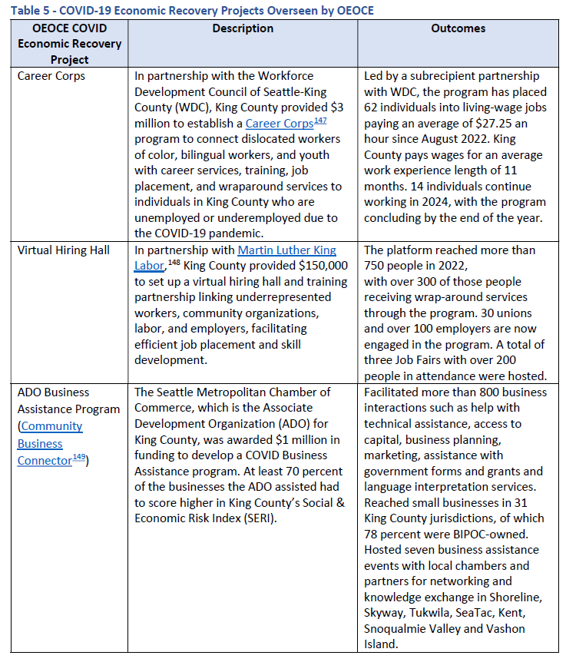

Proviso Section F. OEOCE and Other County Economic Development Programs. Section F requires an explanation of how the OEOCE fits with “existing county economic development programs such as, but not limited to, the Department of Local Services' economic development and small business assistance programs, Department of Local Services' unincorporated economic alliance program” and others.

The report provides detailed information on some of the ways the OEOCE has collaborated with other county economic development programs including, but not limited to:

- OEOCE has consulted with DLS on CLFR programs (e.g. small business grant program, unincorporated economic alliance program), small business outreach (e.g. DLS business roundtable meetings, small business survey question development, fire-impacted business assistance), and policy planning (e.g. minimum wage ordinance, business licensing).
- OEOCE directors collaborate with the DLS Director on a weekly basis at the Executive’s Cabinet meeting, and the OEOCE Economic Development Director holds monthly meetings with the DLS Economic Development Manager.
- OEOCE’s Creative Economy Director fields inquiries from film professionals wishing to locate productions in King County. If a production is seeking a location in unincorporated King County, the Creative Economy Director coordinates with the DLS Roads Division to permit the production.
- The Cloudbreak Music Festival was designed by OEOCE in partnership with Visit Seattle.
- OEOCE, in collaboration with the Seattle Metro Chamber of Commerce (acting as the King County ADO), initiated a trusted messenger business navigator initiative. The Executive Office, and later OEOCE, provided $1 million CLFR proceeds to seed fund what later became the Community Business Connector (CBC) program.
- OEOCE works closely with the DNRP Local Food Economy Manager to manage the Executive’s Local Food Initiative.

Responsiveness of Report to Proviso Requirements. The report appears to meet all requirements of Ordinance 19546, Section 20, Proviso P1.

INVITED

- Ashton Allison, Economic Development Director, Executive Department

ATTACHMENTS

- Proposed Motion 2025-0007 (and its attachments)
- Transmittal Letter
- OEOCE 2025 Business Plan

Accountability Report for King County Office of Economic Opportunity and Creative Economy (OEOCE), pg. 25-35.
Id., pg. 36-38.
Id., pg. 45.
Id., pg. 47-50.
Id., pg. 53.
Id.
Id., pg. 65.
Id., pg. 67.
Id., pg. 65.
Id., pg. 75.
Id., pgs. 79-81.

