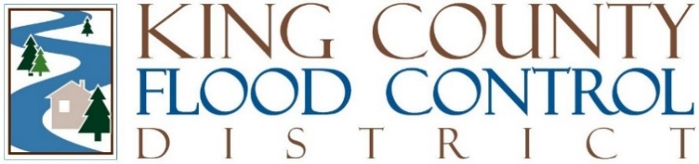

STAFF REPORT

Agenda Item: | 9 | Name: | Michelle Clark
Proposed Legislation: | FCD24-05 | Date: | October 8, 2024

FCD24-05: A Motion adopting a Flood Reduction Facilities Inventory Policy.

Section 9.3 of the 2021 interlocal agreement ("ILA") the King County Flood Control District ("District") and King County ("County") directed the development of a policy for notifying the District of a proposed modification to the County owned flood risk reduction facilities and property commonly referred to as the River Facility Inventory ("RFI"), planned addition or removal of a property interest, or a plan to change or modify an existing property interest. This policy is intended to meet the requirement set forth in Section 9.3 of the ILA.

Background

The County’s RFI includes over 500 flood risk reduction facilities (levees and revetments) as well as property intended for use as flood storage. Timely maintenance and enhancements to the infrastructure in the RFI is critical to comprehensive flood risk reduction in King County. The County, in its role as service provider to the District, updates information about the location and condition of facilities in the RFI informed by regular inspections, post flood damage assessments, development of capital investment strategies, capital project design, modifications to facilities, and application of improved modeling and GIS location technology.

Additionally, the County, primarily in its work supporting the Water Resource Inventory Areas and salmon recovery, is responsible for designing, permitting, and implementing habitat restoration projects that typically entail some elements of flood risk reduction. These projects can involve the modification or removal of an existing flood risk reduction facility within the RFI or related real property interest. Habitat restoration projects can be associated with facilities that are failing or damaged, and/or near the end of their design life. As a result of the habitat restoration projects, facilities are often improved and/or have their design life extended. There is a need to clarify post-project management, inspection, and maintenance responsibilities once construction and site planting are completed.

In accordance with Section 9.3 of the ILA, an intergovernmental staff working group of made up of District staff (executive director, deputy executive director, chief of staff to the District Chair, and District legal counsel) and County staff (Water and Land Resources Division director and deputy director, River and Floodplain Management section manager, and a deputy King County Prosecuting Attorney) met for more than two years to develop the proposed Notification and Approval Procedures for Modifications to Flood Risk Reduction Facilities or Real Property Interests in Inventory ("Inventory Policy").

Inventory Policy

The Inventory Policy creates a process for the County to notify the District of proposed changes to the flood reduction facilities in the County’s RFI. This notification process applies when the County, as owner of the flood reduction facilities, modifies and/or removes facilities outside of its role as service provider to the District. This process alerts the District to potential changes in its obligations to operate and maintain a facility in the RFI.

The County has been notifying the District of modifications to the RFI in compliance with this proposed Inventory Policy since the work group completed its work in April 2024. The Inventory Policy increases transparency for both the implementation of flood risk reduction capital projects and the District’s annual budget.

Approval of this motion and adoption of the Inventory Policy does not require a change to the District’s annual budget.

