REVISED STAFF REPORT

Agenda Item: |  | Name: | Melissa Bailey
Proposed No.: | 2023-0289  2023-0290 | Date:

COMMITTEE ACTION

Proposed Substitute Ordinance 2023-0289.2, which would make a net supplemental appropriation of $473,205 to the Building Repair and Replacement Fund for tenant improvements at the Jefferson Building, passed out of committee on October 11, 2023, with a “Do Pass” recommendation. The Proposed Ordinance was amended in committee with Amendment S1 to add the proposed ordinance number in the body of the ordinance and to correct the budget ordinance referenced. Title Amendment T1 conformed the title to Amendment S1.

Proposed Substitute Ordinance 2023-0290.2, which would authorize the Executive to execute a new lease at an existing location (the Jefferson Building) to support operations of the Department of Public Defense, passed out of committee on October 11, 2023, with a “Do Pass” recommendation. The Proposed Ordinance was amended in committee with Amendment 1 to correct a typo and attach a revised version of the lease. The non-discrimination language in Section 20 of the lease was modified to be consistent with the County Charter.

SUBJECT

Proposed Ordinance 2023-0290 would authorize the Executive to execute a new lease at an existing location, the Jefferson Building, to support operations of the Department of Public Defense.

Proposed Ordinance 2023-0289 would make a net supplemental appropriation of $473,205 to the Building Repair and Replacement Fund for tenant improvements.

SUMMARY

Proposed Ordinance 2023-0290 would authorize a 10-year lease for all four divisions of the Department of Public Defense (DPD) to occupy approximately 21,000 rentable square feet on floors two and three of the Jefferson Building (1401 East Jefferson Street in Seattle). DPD is currently occupying space in this facility under two lease agreements (on floors one, two, three, and four). FMD notes that this consolidation improves DPD’s space efficiency and accommodates projected growth through 2033. This lease would also maintain the practice of having DPD staff located near the Patricia J. Clark Children and Family Justice Center.

The base rental rate is $36.00 per rentable square feet for the first year with a $1.00 per square foot increase annually. The lease also includes a tenant improvement allowance of just over $2.4 million. Completion of the third-floor tenant improvements are estimated to occur by June 1, 2024, and the second-floor tenant improvements are anticipated to finish by September 1, 2024. For the current 2023-2024 biennium, lease costs would only be incurred in 2024 and would be covered by existing appropriation authority.

Proposed Ordinance 2023-0289 would provide a supplemental appropriation of $473,205 needed to complete the tenant improvements.

Staff has prepared technical amendments for both proposed ordinances.
BACKGROUND

Department of Public Defense. The Department of Public Defense (DPD) provides legal counsel and representation to indigent individuals in legal proceedings, including those in Superior and District Courts for King County. DPD is led by the Public Defender, who reports to the Executive, and is divided into four divisions to prevent conflicts of interest. The divisions, which are staffed and housed separately, include:
- Society of Counsel Representing Accused Persons Division (SCRAP);
- Associated Counsel for the Accused Division (ACA);
- Northwest Defenders Division (NDD); and
- The Defender Association (TDA).

These four divisions were nonprofit law firms before they became part of DPD as a result of a lawsuit (the Dolan decision) in July 2013. Their division names are the same or nearly the same as the ones they had when they were nonprofits.

Jefferson Building. Prior to becoming divisions within DPD, some of the nonprofit law firms leased space in the Jefferson Building (1401 East Jefferson Street in Seattle) given its proximity to the Youth Services Center at Alder Street. When King County created DPD, it maintained office space in the Jefferson Building for DPD staff.

In October 2014, the Council approved a ten-year lease for floors one through three of the Jefferson Building for use by DPD, which will terminate on May 31, 2024. In April 2015, the Council approved another lease agreement for DPD on the fourth floor of the Jefferson Building. This fourth-floor lease naturally expired on June 30, 2020, and the county has been leasing the space on a month-to-month basis.

Additionally, the 2021-2022 Biennial Budget Capital Improvement Program included nearly $3 million for tenant improvements related to DPD leases at the Jefferson Building.

ANALYSIS

Lease Agreement (PO 2023-0290). The proposed ordinance, if enacted, would enable the county to execute a new lease (Attachment A) with Jefferson House, LLC for space located at 1401 East Jefferson Street in Seattle.
The 10-year lease would consolidate the DPD divisions, so instead of being on four floors in approximately 30,700 rentable square feet of the Jefferson Building, DPD would be in a remodeled space on two floors (occupying approximately 21,000 rentable square feet on floors two and three). According to the Lease Property Summary, the new "space meets the divisions’ operational needs through improved layout features and modern technology. While the space provides fewer offices than the current configuration, it provides more flexible-use and meeting room space for remote trials, remote depositions, remote hearings, witness preparation, and similar purposes. This consolidation improves the divisions’ space efficiency and accommodates projected growth through 2033."

About 90 DPD employees will occupy this office space. They primarily serve clients at the Patricia J. Clark Children and Family Justice Center (CCFJC), which is one block from the Jefferson Building (see parcel map in Figure 1). For this reason, Facilities Management Division (FMD) notes it is not practical to co-locate these employees with other DPD functions housed in the Dexter Horton Building in downtown Seattle.

Figure 1. Parcel Map

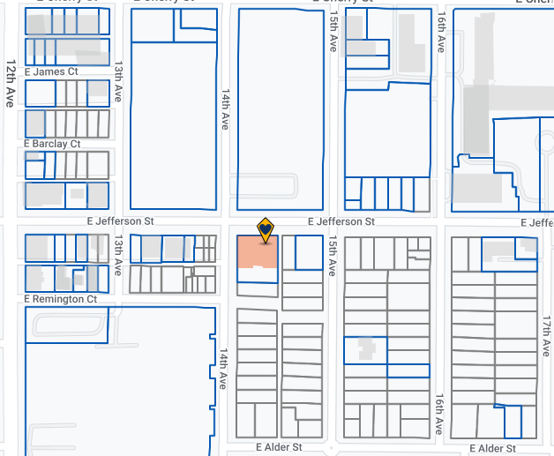
CCFJC

Key Lease Terms. Key terms for the proposed lease are summarized in Table 1.

Table 1. Summary of Key Terms

Term | Description
Duration | 10-year term with two five-year options to extend.
Base Rent | $36.00 per rentable square feet for the first year with a $1.00 per square foot increase annually.
Rentable Square Footage | 21,039 rentable square feet on floors 2 and 3 of the building.
Operational Costs | Pro Rata Share: 44.41%. Lease rate is fully serviced, which means the tenant pays for its share of any increases in property taxes, insurance, and common area maintenance that escalate over the base year estimate (Base Year Lease 2024).
Tenant Improvements | Includes a $2,419,485 tenant improvement allowance.  Completion of the third-floor tenant improvements are estimated to occur by June 1, 2024, at which time DPD will move into the third-floor space. DPD will continue to pay the old lease rate for the second floor until the second-floor tenant improvements are complete, projected September 1, 2024. Full occupancy will occur when both second-floor and third-floor tenant improvements are complete.

Fiscal Impact. Table 2 shows the estimated rent and operating biennial costs for the lease, which would be borne by the General Fund. For the current 2023-2024 biennium, costs would only be incurred in 2024 and would be covered by existing appropriation authority.
Table 2. Estimated Rent and Operating Costs

Biennium | 2023-2024 | 2025-2026 | 2027-2028 | Sum of Outyear Impacts
Rent and Operating Costs | $451,575 | $1,657,617 | $1,747,761 | $5,439,909

Currently, the monthly rate DPD is paying for all four spaces is $62,296.46. The new monthly rate (for the first 12 months) would be $63,117.00. This amounts to about $821 more a month for nearly 9,700 less rentable square footage; however, FMD states this reflects market rate.

Alternatives. FMD states that the negotiated rental rate is a fair market rate. It also notes that: "The Jefferson Building sits in a unique First Hill submarket that is comprised of mostly healthcare and healthcare-oriented product. The typical office rate in healthcare-oriented properties is in the $42.00/SF range. DPD considered other properties outside of the First Hill submarket, such as Capitol Hill and downtown, but the rates were comparable with what the Jefferson was proposing, and, in the end, the Jefferson’s superior location solidified their choice to extend at the current location, notwithstanding the extensive renovation required."

Timing. Council approval is needed by October 31, 2023 to meet the requirements in the lease, which states that the "Landlord shall be entitled to withdraw its signature on this Lease if the KC Ordinance has not been adopted by October 31, 2023."

Legal Review. Council’s legal counsel has completed review of the proposed lease agreement.

Supplemental Appropriation (PO 2023-0289). The supplemental appropriation would provide the additional $473,205 needed to complete the tenant improvements.

According to the Lease Property Summary, the space is not configured to accommodate the separated DPD divisions and their program requirements. The lease includes tenant improvements of approximately 20,000 usable square feet. Each division will have its own entrance, a public reception area, meeting and conference rooms, offices for attorneys, and workstations (allowing for conflict-free representation). Several upgrades are also required to comply with current codes, and FMD notes that the planned HVAC and lighting system upgrades will significantly increase the building’s energy efficiency.

The total cost for the tenant improvement project is about $5.8 million. The landlord is providing a tenant improvement allowance of just over $2.4 million, which leaves $3.4 million for the county to cover. The 2021-2022 Biennial Budget included nearly $3 million to support these tenant improvements; however, they were put on hold during the COVID-19 pandemic. PO 2023-0289 would appropriate the remaining balance needed to support the tenant improvement costs. FMD notes that "the increased costs are based on the fact that the project had to be re-bid and inflation costs of labor and materials were substantially higher in 2023."

AMENDMENT

PO 2023-0289. The supplemental appropriation ordinance for tenant improvements requires both a striking and title amendment. Striking Amendment S1 is a technical amendment that would add the proposed ordinance number and correct the budget ordinance reference. Title Amendment T1 would conform the title to Striking Amendment S1.

PO 2023-0290. Amendment 1 to Proposed Ordinance 2023-0290 is a technical amendment that would correct the street address of the property. Additionally, the non-discrimination section of the lease, Section 20, needs to be modified so it is consistent with the County Charter. See modified language below:
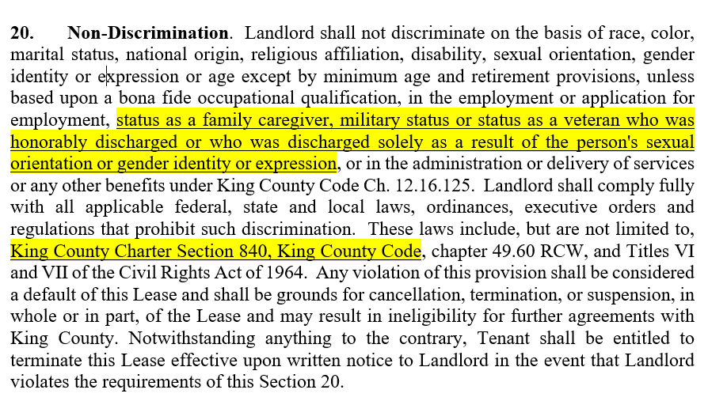

In addition to providing counsel to defendants in King County Superior Court and District Court, DPD also provides public defense services to Seattle Municipal Court under contract with the City of Seattle.
DPD's four divisions occupy space in the Dexter-Horton Building in downtown Seattle and the Jefferson Building in Seattle's First Hill neighborhood. Three divisions (TDA, SCRAP, and ACA) occupy space in the Meeker Street Law Building in downtown Kent, and one division (NDD) has space in the county-owned Kent Valley Professional Center.
Ordinance 17913
Ordinance 18019
Ordinance 19210, Project #1139524
Operating cost estimates are based on eight percent annual CPI adjustments. FMD notes this is its best estimate for operating cost increases in what has been a "fluctuating, uncertain, and inflationary environment."
The sum of outyear impacts is provided for capital projects and agreements. This sum for revenue and expenditures includes all revenues/expenditures for the duration of the lease/other agreement or life of the capital investment.
The Jefferson building was constructed in 1984 and updated in 1994.
Ordinance 19210, Project #139524

