May 7, 2013

SEPTEMBER 2013
PUBLIC TRANSPORTATION SERVICE
CHANGE FOR KING COUNTY

ROUTE: 211

OBJECTIVES:
Improve the transit commuter market from Eastgate and Issaquah Highlands by making service more direct, in accordance with the Strategic Plan for Public Transportation 2011-2021 and King County Metro Service Guidelines:

- Strategic Plan Strategy 3.4.1: Serve centers and other areas of concentrated activity, consistent with Transportation 2040.

- Strategic Plan Strategy 5.1.1: Provide service that is easy to understand and use.

- Strategic Plan Strategy 6.1.1: Manage the transit system through service guidelines and performance measures.
  - Service Design Guideline – A route that operates directly between two locations is faster and more attractive to riders than one that takes a long, circuitous path.

IMPACTED SERVICE AREA:
Issaquah Highlands, Eastgate, South Bellevue, North Mercer Island, and First Hill
SERVICE CHANGE:

To speed up route and make it more attractive to riders commuting from Eastgate and Issaquah Highlands, Route 211 will stop at Eastgate Freeway Station and no longer stop at Richards Road and South Bellevue Park-and-Ride. Alternative service is available on Route 210 between Richards Road and downtown Seattle and on Sound Transit Route 550 between South Bellevue Park-and-Ride and downtown Seattle. From downtown Seattle to First Hill, alternative service is available on routes 2, 3, 4 or 12.
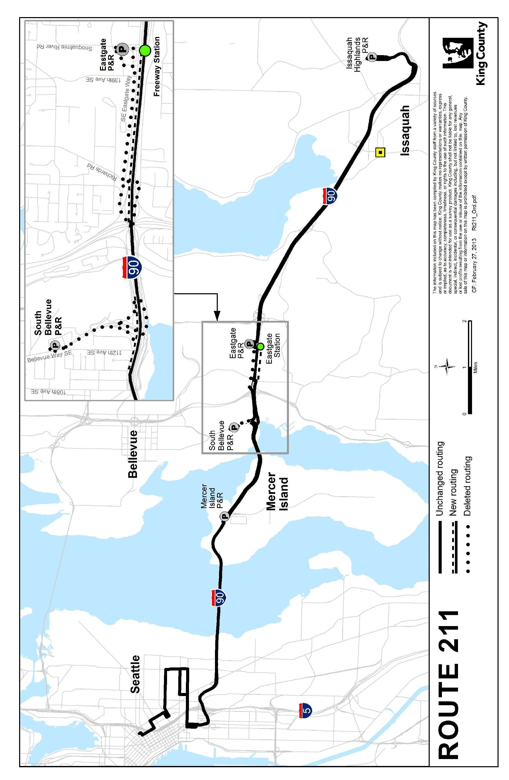
ROUTE: 215

OBJECTIVES:
Improve the transit commuter market from North Bend and Snoqualmie by making service more direct, in accordance with the Strategic Plan for Public Transportation 2011-2021 and King County Metro Service Guidelines:

- Strategic Plan Strategy 3.4.1: Serve centers and other areas of concentrated activity, consistent with Transportation 2040.

- Strategic Plan Strategy 5.1.1: Provide service that is easy to understand and use.

- Strategic Plan Strategy 5.1.3: Improve transit speed and reliability.

- Strategic Plan Strategy 6.1.1: Manage the transit system through service guidelines and performance measures.
  - Service Design Guideline – A route that operates directly between two locations is faster and more attractive to riders than one that takes a long, circuitous path.

IMPACTED SERVICE AREA:
North Bend, Snoqualmie, Issaquah Transit Center, Eastgate, and downtown Seattle
SERVICE CHANGE:

Eliminate Route 215 deviation to Issaquah Transit Center to speed up route and make it more attractive to riders commuting from Snoqualmie and North Bend. Alternative services are available on Route 214 or Sound Transit Route 554 from Issaquah Transit Center into downtown Seattle. From Snoqualmie/North Bend to Issaquah Transit Center, alternative service is available on revised Route 209 or new Route 208.
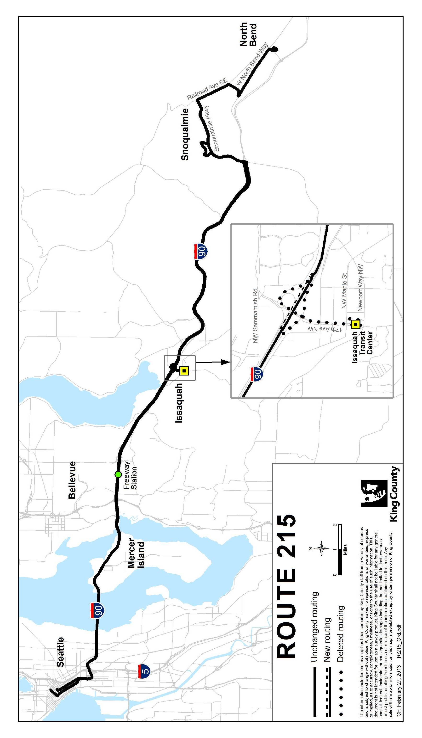
ROUTE: 216

OBJECTIVES:
Revise routing to serve Issaquah Highlands Park-and-Ride to improve route productivity and reduce crowding on Route 218. Restore the eastbound stop at Eastgate Freeway Station (I-90/142nd Place Southeast) as part of the afternoon stop pattern. This stop was removed on February 18, 2013 as an emergency action, pursuant to King County Code 28.94.020 B-2. These changes are consistent with the Strategic Plan for Public Transportation 2011-2021 and King County Metro Service Guidelines.

- Strategic Plan Strategy 3.2.1: Expand services to accommodate the region’s growing population and serve new transit markets.

- Strategic Plan Strategy 3.4.1: Serve centers and other areas of concentrated activity, consistent with Transportation 2040.

- Strategic Plan Strategy 6.1.1: Manage the transit system through service guidelines and performance measures.

IMPACTED SERVICE AREA:
Sammamish, North Issaquah, Eastgate, Mercer Island, downtown Seattle
SERVICE CHANGE:

Revise Route 216 to serve Issaquah Highlands Park-and-Ride via Issaquah Pine Lake Road SE. Alternative service is available between South Sammamish Park-and-Ride and North Issaquah on routes 269 and 927.

Restore service to Eastgate Freeway Station during the afternoon peak period to provide a connection between Eastgate and Sammamish.

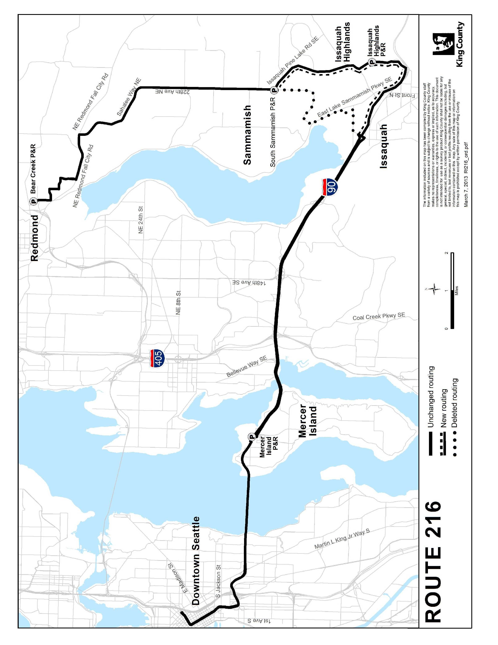
ROUTE: 218

OBJECTIVES:
Reduce crowding and adjust capacity to meet transit commuter demand at Issaquah Highlands Park-and-Ride by redistributing resources within the I-90 corridor. Make permanent the emergency action to remove the eastbound stop at Eastgate Freeway Station (I-90/142nd Place Southeast) as part of the afternoon stop pattern. This emergency action was taken on October 15, 2012, pursuant to King County Code 28.94.020 B-2. These changes are consistent with the Strategic Plan for Public Transportation 2011-2021 and King County Metro Service Guidelines.

- Strategic Plan Strategy 3.2.1: Expand services to accommodate the region’s growing population and serve new transit markets.

- Strategic Plan Strategy 3.4.1: Serve centers and other areas of concentrated activity, consistent with Transportation 2040.

- Strategic Plan Strategy 6.1.1: Manage the transit system through service guidelines and performance measures.
  - Service Design Guidelines – Routes should be designed to avoid competing for the same riders.

IMPACTED SERVICE AREA:
Issaquah Highlands, Eastgate, and downtown Seattle
SERVICE CHANGE:

Convert five AM and nine PM Route 218 trips that deadhead to/from East Base to new Route 219 trips to provide additional capacity for riders traveling beyond Issaquah Highlands Park-and-Ride to destinations in Sammamish. A total of 21 morning and 21 afternoon trips comprised of service on revised Route 216, revised Route 218 and new Route 219 will serve Issaquah Highlands Park-and-Ride.

NEW ROUTE: 219

OBJECTIVES:
Reduce crowding and create capacity to meet transit commuter demand at Issaquah Highlands Park-and-Ride and South Sammamish Park-and-Ride by redistributing resources within the I-90 corridor, consistent with the Strategic Plan for Public Transportation 2011-2021.

- Strategic Plan Strategy 3.2.1: Expand services to accommodate the region’s growing population and serve new transit markets.

- Strategic Plan Strategy 3.4.1: Serve centers and other areas of concentrated activity, consistent with Transportation 2040.

- Strategic Plan Strategy 6.1.1: Manage the transit system through service guidelines and performance measures.

IMPACTED SERVICE AREA:
Sammamish, Issaquah Highlands, Eastgate, downtown Seattle
SERVICE CHANGE:

Establish new peak Route 219 to serve commuters traveling between Sammamish, Issaquah Highlands Park-and-Ride, Eastgate Freeway Station (AM, westbound direction only), and downtown Seattle. Operate five trips during the AM peak period and nine trips during the PM peak period.
