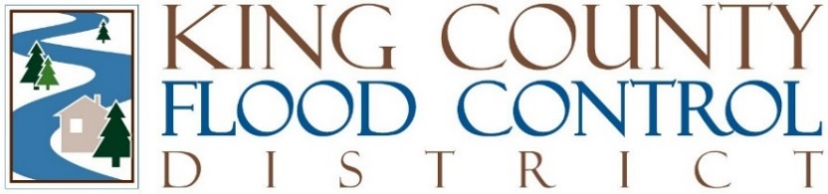

STAFF REPORT

Agenda Item: | 8 | Name: | Steven Schauer
Proposed Legislation: | FCD2024-09 | Date: | June 11, 2024

Proposed FCD Resolution FCD2024-04: A RESOLUTION amending an interlocal agreement with the City of Kent regarding the Lower Russell Road Levee Setback Project.

The King County Flood Control District (District) and City of Kent (City) entered into an interlocal agreement (Agreement) to govern all aspects of the Lower Russell Road Levee Setback Project, to replace an existing levee on the Green River located within the city and to relocate and expand Van Doren’s Park.

After the City approved the design drawings and specifications for the new Van Doren’s Park, per Section 10(b) and (c) of the Agreement, the City requested a specific change to the project involving the conversion of a narrow strip of natural turf to synthetic turf immediately adjacent to the Mount Rainier play structure.

The City’s requested change will result in $81,183.58 of additional project costs. The City has agreed to reimburse the District 50% of the cost for the installation of the synthetic turf, in an amount of $40,591.79, to offset the additional project costs resulting from the City’s request. The District and City have agreed to memorialize the terms of this arrangement as an amendment to the Agreement.

Approval of this amendment provides the necessary avenue for the City to reimburse the District the agreed upon amount of $40,591.79. The amendment has been reviewed by legal counsel.

