The King County Performance Management Work Group
Report to Council
General Government and Labor Relations Committee
August 26, 2008

The passage of the Performance and Accountability ordinance in July 2008 marks an important milestone in King County’s journey to attain the vision of a countywide system of performance management, measurement, and reporting that was developed by the Performance Management Work Group and adopted by council in 2007.
Concurrent with these accomplishments this year, the work group developed new guidelines for agency and department strategic and business planning that will inform the budget preparation process. It also established guiding principles for performance reporting, public engagement, and the integration and coordination of all these activities into the daily business of county agencies and departments.
For 2009, the work group proposes that council should consider agreeing on a method for developing countywide priorities in 2010. That process would likely include a meeting of all separately elected officials and a public engagement component, in which the public contributes to the refinement of priorities and goals.
The work group will continue its efforts to support county agencies and departments in meeting the requirements contained in the Performance and Accountability ordinance.

Mission and Vision
In 2007, the King County Council approved a mission and vision for a countywide system of performance management, measurement, and reporting that appears in the shaded area below. The vision provides for a comprehensive planning and performance management system that links countywide priorities, citizen input, and performance indicators to agency strategic and business plans and performance measures in all branches of county government. Those plans culminate in informing budget decisions that shape the daily operations of King County government.
Mission Statement
King County will develop an effective system of countywide strategic planning, performance measurement and management designed to enhance government accountability, service performance, and resource allocation.
Vision for the Future
The following bullets describe the preferred vision for King County strategic planning, performance measurement and management in the future:
- There is consensus among county leadership that the strategic planning, performance measurement and management system effectively aligns collaborative efforts towards common county goals while respecting the needs of individual agencies to pursue organization goals, and separately elected officials’ obligation to deliver on their commitments to the citizenry.
- Building on current efforts and with input from citizens, elected leaders and policy-makers develop countywide prioritized goals and align services to those goals.
- Performance measures inform and are linked to policy and resource allocation decisions.
- County publicly reports to citizens how well it is meeting its performance goals and engages the citizenry in the countywide performance management program.
- Performance measurement is used by managers for strategic planning, program evaluation, operational improvements, and budgeting.
- Performance measures are not used in a punitive manner but are used to support organizational learning in collaboration with the workforce.

To meet council-adopted goals, the Performance Management Work Group, which is made up of representatives from all branches of county government, recommended the framework for a countywide system, and those recommendations formed the basis for the Performance and Accountability ordinance enacted by the council on July 8.
A graphic depiction of what the new countywide system of performance and accountability would look like is shown in the figure below.
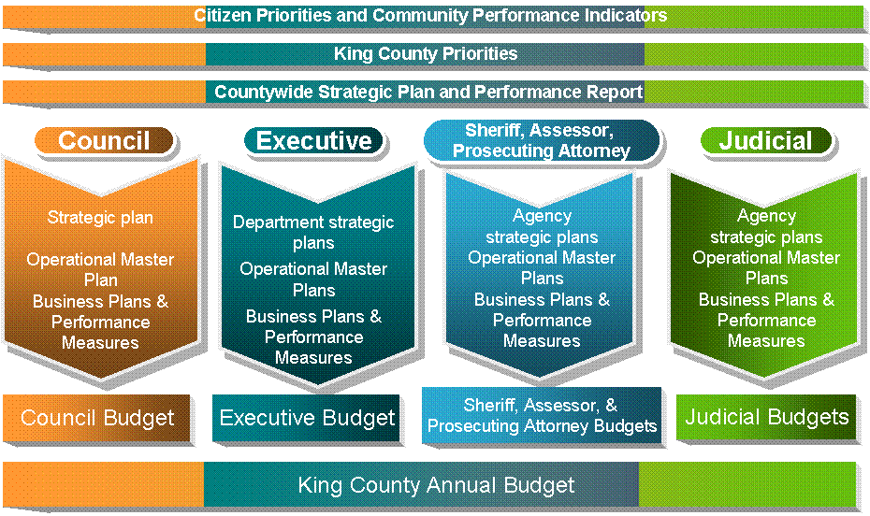

2008 Legislation
On July 8, 2008 King County attained a significant milestone in its efforts to improve countywide performance when the council adopted the Performance and Accountability Ordinance. This important piece of legislation mandates the implementation of the countywide planning and performance management vision that was endorsed by the council and the county’s other elected officials, and designed by the Performance Management Work Group. Specific mandates in this legislation include:
- Countywide Annual Performance Report
(2008 for executive; 2009 countywide)
- Countywide Five-year Strategic Plan (2009)
- Department and Agency Five-year Strategic Plans (2010)
- Annual Business Plans (2008)
Further, the council also passed a motion that makes great strides in improving the county’s transparency to the stakeholders and the public. This motion requires the executive to prepare the following:
- King County Annual Scorecard format for review by council (July 2008)
- Annual State of King County Government report format for review by council (July 2008)
- Integrated Financial Reporting (2009)
Work Group Accomplishments
So far in 2008, the work group continued its efforts according to its council-approved work plan toward the development of the countywide performance management system, principally through four subcommittees. Each of the subcommittees has focused on drafting a set of guiding principles and a deliverable that would move the county forward toward meeting the mandates set forth in the July 8th ordinance and toward implementing a countywide system. The deliverables produced by the subcommittees include:
- Strategic Planning: Guiding principles for agency strategic and business planning focus on creating linkages between countywide plans and performance measures, and agency plans and measures that inform the budget process. The guiding principles have been embodied into new Guidelines for King County Agency Planning and Performance Measurement Processes. These guidelines contain practical definitions of key terms and explain the key components of five-year strategic plans, annual business plans, performance measures, and the linkages among them. They build upon the previous guidelines that have become part of the annual county budget development process since 2005.
- Reporting: Guiding principles for a single countywide performance report that will present community indicators and performance information for all agencies in a format that is easily accessible and understandable to the public.
- Public Involvement: Guiding principles that seek to increase public participation in setting priorities for King County government. The principles describe how county government can facilitate an inclusive oversight process that is comprised of informing, consulting, involving, collaborating and empowering the public. (Note: Ordinance 15896, passed in September 2007, created a volunteer citizen councilor network to enhance citizen participation in county government. This effort is known as the Countywide Community Forums program.)
- Coordination and Integration: Guiding principles to integrate and coordinate the major components and key activities of the countywide performance measurement, management, citizen engagement, and reporting systems.
All these deliverables provide practical guidance for how the county can move forward to accomplish the mandates of the Performance and Accountability ordinance.
Plans for 2009
The Performance Management Work Group plans to move forward as directed by council to support the implementation of the Performance and Accountability ordinance. Implementation of the ordinance mandates will require the collaborative efforts of council and separately elected officials, the work group, agencies, and departments. Suggested activities for 2009 are summarized in this section.
Council, Separately Elected County Officials
The council and separately elected county officials have important roles in supporting the county’s attainment of the vision for performance management and need to actively participate in the county executive’s process to develop the countywide strategic plan. In 2009 county leadership should agree on a process for developing a set of countywide priorities and goals for 2010.
A suggested countywide approach could include:
- An interactive process that involves the Performance Management Work Group and high level staff of the county’s elected officials to develop materials and information necessary to support countywide priority and goal setting,
- An annual meeting among all elected officials to establish a statement of countywide priorities and goals,
- A public engagement component whereby the public contributes to the refinement of those priorities and goals by using any number of outreach methods that could include but is not limited to the Countywide Community Forums, focus groups, and/or advisory committees, and
- Between five-year updates, a process where the strategic plan can be revised and updated as needed by the county executive in consultation with the public and elected officials.
Work Group
The King County Performance Management Work Group will support county leadership’s efforts and work with the executive’s performance management director to develop specific processes to meet the requirements of the new legislation for countywide:
- Strategic Planning
- Performance Reporting
- Public Engagement Processes, and
- Performance Management
In 2009 the work group will expand group membership so that all executive departments are represented and follow council direction to:
- Advise on implementation of a countywide performance management and accountability system.
- Provide a collaborative forum among county peers on performance management and measurement and coordinate with potential partners outside of King County government.
- Advise on the county's training curriculum on performance management and measurement.
- Explore collaboration with public engagement efforts within the county such as the Countywide Community Forums program.
- Advise on new developments in the field and potential opportunities to improve the county's performance management and accountability system.
Agencies and Departments
Agencies and departments are key players in making progress towards the Countywide Performance Management system. In 2009, their focus will be to:
- Begin to develop strategic plans, and
- Make a conscious effort to link to countywide priorities.
Summary and Acknowledgements
In summary, the Performance Management Work Group appreciates the council’s support for these efforts and looks forward to fulfilling your direction to facilitate the implementation of King County’s performance management vision.
We would like to acknowledge the efforts of work group members.
Cheryle Broom, Auditor | Marty Lindley, DCHS | David Randall, Council
James Bush, Council | Rochelle McKenzie, District Court | Saroja Reddy, Council
Bob Cowan, OMB | Rich Medved, Assessor | Marti Reinfeld, Executive
Tricia Crozier, District Court | Kate Moriarty, OIRM | David Reynolds, Superior Court
Elisa Elliott, Sheriff’s Office | Kimberley Nuber, Council | Toni Rezab, DAJD
Larry Evans, Council | Ron Perry, Auditor | Linda Ridge, Superior Court
Richard Gelb, DNRP | Shawn Ledford, Sheriff’s Office | Paul Sherfey, Superior Court
Bonnie Glenn, PAO | Pat Hamacher, Council | BrynDel Swift, Council
Bill Greene, DOT | Michael Jacobson, Executive | Samuel Downing, Council
Caroline Whalen, DES | Chris Veit, SMG/Columbia

