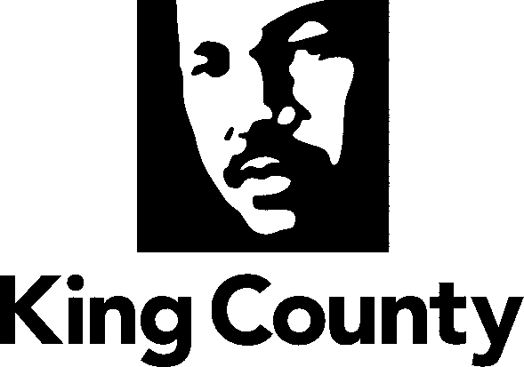

Checklist and Summary of Changes for the attached
Collective Bargaining Agreement

Name of Agreement
International Brotherhood of Electrical Workers, Local 77 (Departments: Transportation (Road Services), King County Information Technology, Natural Resources and Parks, Public Health) and Memorandum of Agreement

Labor Negotiator
Jim Meith

Prosecuting Attorney’s Review | Yes
Document Tracking System Routing Form; Motion or Ordinance | Yes
Executive Letter | Yes
Fiscal Note | Yes
Six Point Summary | Yes
King County Council Adopted Labor Policies Contract Summary | Yes
Ordinance | Yes
Original Signed Agreement(s) | Yes
Does transmittal include MOU/MOA? X1 | Yes

Six Point Summary of changes to the attached agreement:
1. The majority of the language in this agreement mirrors that of the previous agreement.

2. These agreements contains the same wage provisions as the Memorandum of Agreement by and between King County and the King County coalition of labor unions addressing the 2011 budget crisis including the cost-of-living adjustments for 2012, 2013, and 2014.

3. Language was added to the agreement continuing the $90 boot allowance for employees in the Roads Division established by the Council pursuant to Ordinance 15870 in 2007 effective through July 31, 2010.

4. Adds language regarding the ability to reopen negotiations, if necessary, in conjunction with the implementation of a common biweekly payroll system and countywide standardization of Fair Labor Standards Act work weeks.

5. There are also grammatical and other minor revisions that clarify and/or bring the language into agreement with actual current practice.

6.

