STAFF REPORT

Agenda Item: | 7 | Name: | Mary Bourguignon
Proposed No.: | 2025-0147 | Date: | June 17, 2025

SUBJECT

Proposed Ordinance 2025-0147 would establish the Locally Preferred Alternative (LPA), including the alignment and station locations, for Metro’s RapidRide K Line between Kirkland and Bellevue, and would authorize a service level commitment for the line.

SUMMARY

Metro currently operates eight RapidRide lines (A-H), and is working to develop four more lines (I, J, K, R) for planned openings between 2027 and 2031.

Prior to construction of each RapidRide line, the County establishes a Locally Preferred Alternative (LPA), which sets the alignment (pathway) and station locations. An adopted LPA is needed for Metro to apply for federal grant funding, as well as to work with local jurisdictions on capital investments for a new RapidRide line.

Proposed Ordinance 2025-0147 would establish an LPA for the RapidRide K Line. The LPA would follow an approximately 16-mile north south corridor parallel to I-405 between Bellevue and Kirkland, connecting Totem Lake Transit Center, Kirkland Way Park & Ride, Kirkland Transit Center, South Kirkland Park & Ride, Bellevue Transit Center / Bellevue Downtown Station, Bellevue College, and Eastgate Park & Ride, following portions of existing routes 239, 245, 250, 255, and 271. The LPA would identify locations for 70 stations along the route (one northbound and one southbound at each of 35 intersections). See Attachment B to Proposed Ordinance 20215-0147 for a map of the proposed alignment and station locations.

Proposed Ordinance 2025-0147 would also authorize service level commitment for the first five years of service on the K Line, if required for federal grant funding.

Amendment 1 would add more detail to the Statement of Facts section, including references to the adopted 2021 Metro Connects long-range plan.

BACKGROUND

RapidRide Implementation. RapidRide is the name of Metro’s bus rapid transit service. RapidRide lines offer high frequency service; faster, more reliable trip times using speed and reliability improvements, such as exclusive lanes and/or transit signal priority at intersections; improved stations, with shelters and real-time information signs; all-door boarding; and red/gold branded buses and facilities.

Metro currently operates eight RapidRide lines (A-H), and is working to develop four more lines (I, J, K, R) for planned openings between 2027 and 2031. For each RapidRide line, the Council establishes a Locally Preferred Alternative (LPA) prior to construction to identify the alignment (pathway) and station locations for the new line; and adopts a service change ordinance prior to the line’s opening to approve the span and frequency of service, as well as the allocation of service hours to the route.

Table 1 lists the existing RapidRide lines, as well as those currently under development, showing the LPA and service change ordinance numbers for each.

Table 1. Rapid Ride Lines (Operating and Planned)
Line | Pathway | LPA  Ordinance | Service Change Ordinance | Start Date
A | Federal Way to Tukwila | 16725 | 16844 | Oct 2010
B | Bellevue to Redmond | 16725 | 17100 | Oct 2011
C | Westwood Village to South Lake Union | 16725 | 17320 | Sept 2012
D | Crown Hill to Downtown Seattle | 16725 | 17320 | Sept 2012
E | Aurora Village to Downtown Seattle | 17391 | 17584 | Feb 2014
F | Burien to Renton | 17391 | 17584 | June 2014
G | Madison Valley to Downtown Seattle | 19012 | 19750 | Sept 2024
H | Burien to Downtown Seattle | 18894 | 19422 | Mar 2023
I | Renton to Auburn | 19098 | -- | 2027
J | Downtown Seattle to U District | 19312 | -- | 2027
K | Kirkland to Bellevue | PO 2025-0147 | -- | 2030
R | Rainier Beach to Downtown Seattle | TBD | -- | 2031

Metro Connects, Metro’s long-range plan, indicated that Metro would be operating 10 RapidRide lines (A-J) by 2026; 13 to 15 lines (including the K and R lines) by the mid- to late-2030s; and 19 to 23 lines by 2050. Metro Connects required the development of a RapidRide Prioritization Plan to organize in tier order the lines to follow K and R.

K Line early planning. In 2014, after opening the first six RapidRide lines, Metro began working with local jurisdictions and partner agencies to develop a plan for the next set of RapidRide lines to be developed. This planning effort informed the 2017 Metro Connects long-range plan. The Metro Connects RapidRide Expansion Report (Appendix G to the 2017 Metro Connects) summarized the process by which potential RapidRide lines were assessed based on productivity, social equity, and geographic value; identified 24 candidate lines; and, from the list of candidate lines, proposed 13 new RapidRide lines for development as part of the Metro Connects 2025 Network.

That list of 13 future RapidRide lines included corridor #1027 (later named the K Line), which covered Totem Lake, Bellevue, and Eastgate, and was served by Routes 234, 235, and 271.

Later in 2017, in response to provisos in the County’s 2017-2018 biennial budget ordinance requiring Metro to describe the process for implementing the next set of RapidRide lines, the Executive transmitted a report that described plans for the 13 RapidRide lines to be developed by 2025. The report stated that the G and H lines would be the first to be developed and that the remaining 11 lines would follow, with all 13 lines in service by the end of 2026, and with service for the K Line (corridor #1027) targeted for 2023.

In 2018, Metro revised its RapidRide development timeline, submitting a technical memo during the Council’s deliberations on the Executive’s proposed 2019-2020 biennial budget that outlined plans to implement seven new RapidRide lines by 2027, with 13 to be delivered later. Start of service for the K Line was targeted for 2025.

As part of the 2019-2020 budget, the K Line received an appropriation of $3 million for preliminary design work. Metro’s capital improvement plan (CIP) identified future planned requests for development of the K Line, including $4.5 million expected to be proposed for the 2021-2022 biennium and $57.9 million expected to be proposed for the 2023-2024 biennium. The CIP noted that Metro anticipated beginning K Line construction in 2024 for a planned start of service in 2025.

Pandemic-era pause on K Line planning. In September 2020, the Executive transmitted a proposed 2021-2022 biennial budget that reflected the significant declines in revenue, ridership, and fare recovery Metro had experienced during the first year of the pandemic. The proposed budget included a reduction in both operating and capital expenditures for Metro, including a reconsideration of the status and schedule for the RapidRide lines that were being planned. For the K Line, the 2021-2022 budget proposed that, because preliminary design work had been only partially completed prior to the onset of the pandemic (work on the K Line had reached 1% design) and because of the uncertainty around future capital funding, the K Line would be removed from the CIP, work on the K Line would be paused, and no further capital appropriations would be made until a new implementation timeline could be developed.

In response to the proposal to pause work on several of the planned RapidRide lines, including the K Line, the Council added a proviso requirement to the 2021-2022 budget ordinance that asked Metro to transmit a RapidRide Restart Report by March 30, 2022.

Restart of K Line planning. In December 2021, the Council adopted an update to the Metro Connects long-range plan. The 2021 Metro Connects indicated that 10 RapidRide lines (A-J) would be expected to be in operation by 2026; 13 to 15 lines, including the K Line, to be in operation by the time of the Metro Connects Interim Network (mid to late 2030s); and 19 to 23 lines to be in operation by the time of the 2050 Network.

In March 2022, the Executive transmitted the RapidRide Restart Report the Council had requested by proviso. The report stated that, prior to pausing work on the K Line, Metro had drafted a tentative preferred alignment from Totem Lake Transit Center to Eastgate Park & Ride in coordination with the cities of Bellevue and Kirkland and local community members. As part of this effort, Metro had begun to identify capital investments that would be needed, including station locations, roadway upgrades, intelligent transportation system elements, and access to transit improvements. The report stated that Metro’s plan had been to move toward 10% conceptual design, but that work was paused at the 1% stage after the pandemic began.

The RapidRide Restart Report stated that, after pausing work, Metro had resumed some planning efforts for the K Line during 2021, allocating $600,000 for alternatives analysis and design, including identifying key improvements along the corridor, conducting initial assessments of conformity with local jurisdictions’ code and regulatory requirements, and developing capital cost estimates ($80-$103 million in 2021 dollars). The report concluded with the recommendation that Metro wait to proceed with additional planning work until funding could be programmed into Metro’s budget and CIP for both capital and future operating costs, as proceeding in a segmented manner might require work to be redone.

In November 2022, during its review of the 2023-2024 biennial budget, the Council appropriated $7 million for K Line development, with the stated goal that the K Line would proceed with project design with the aim of starting service as soon as possible. To track progress, the Council added a proviso requirement requiring Metro to brief the Regional Transit Committee (RTC) no later than November 30, 2023, on progress on the planning and design of the K Line, and that K Line progress be included in the RapidRide Prioritization Plan that was due to the RTC and Council by June 30, 2024.

In October 2023, Metro briefed the RTC on K Line progress as required, stating that the K Line had been included in Metro’s 10-year financial plan at $120 million, and that work on the K Line was underway to advance to 10% design, re-engage with community partners, develop a constrained scope and budget, identify funding sources including possible grant funding, and establish a delivery schedule and methodology. Metro stated that it was developing a proposed LPA in advance of applying for federal grant funding. Metro affirmed the goal of opening the K Line as early as 2030.

In June 2024, Metro transmitted the RapidRide Prioritization Plan, which stated that the K Line had been included in Metro’s six-year Capital Improvement Program at $120 million, with delivery planned for as early as 2030. The RapidRide Prioritization Plan also responded to the requests for information about the K Line’s development included in the 2023-2024 budget proviso, stating that, during 2024 and 2025, Metro would:

- Re-engage with the community to build on 2019-2020 engagement efforts;
- Select preferred speed and reliability improvements and multimodal connections and develop a proposed LPA;
- Submit the LPA to the Council for review and approval;
- Complete 10% design deliverables;
- Apply for FTA Small Starts grant funding; and
- Begin the federal environmental review process.

The RapidRide Prioritization Plan stated that Metro’s goal was for final design for the K Line to be completed by 2027, with construction between 2028 and 2030.

ANALYSIS

Proposed K Line Locally Preferred Alternative. Proposed Ordinance 2025-0147 would establish the Locally Preferred Alternative (LPA), including the alignment and station locations, for the K Line.

Approval of the LPA would allow Metro to complete design of the capital improvements proposed for the K Line, prepare grant applications, begin environmental review and permitting, and plan for construction. Service on the RapidRide K Line would be established by the Council through a service change ordinance approximately six months prior to the opening of the line.

As proposed, the K Line would travel 16 miles from Totem Lake Transit Center to the Kirkland Way Park & Ride, Kirkland Transit Center, South Kirkland Park & Ride, Bellevue Transit Center / Bellevue Downtown Station, Bellevue College, and Eastgate Park & Ride following portions of existing routes 239, 245, 250, 255, and 271.  The LPA would identify 70 station locations along the route (one northbound and one southbound at each of 35 identified intersections).  The map to the right shows the proposed K Line alignment and station locations. More detailed information can be found in Attachments A and B to Proposed Ordinance 2025-0147, in Attachment 1 to this staff report. | 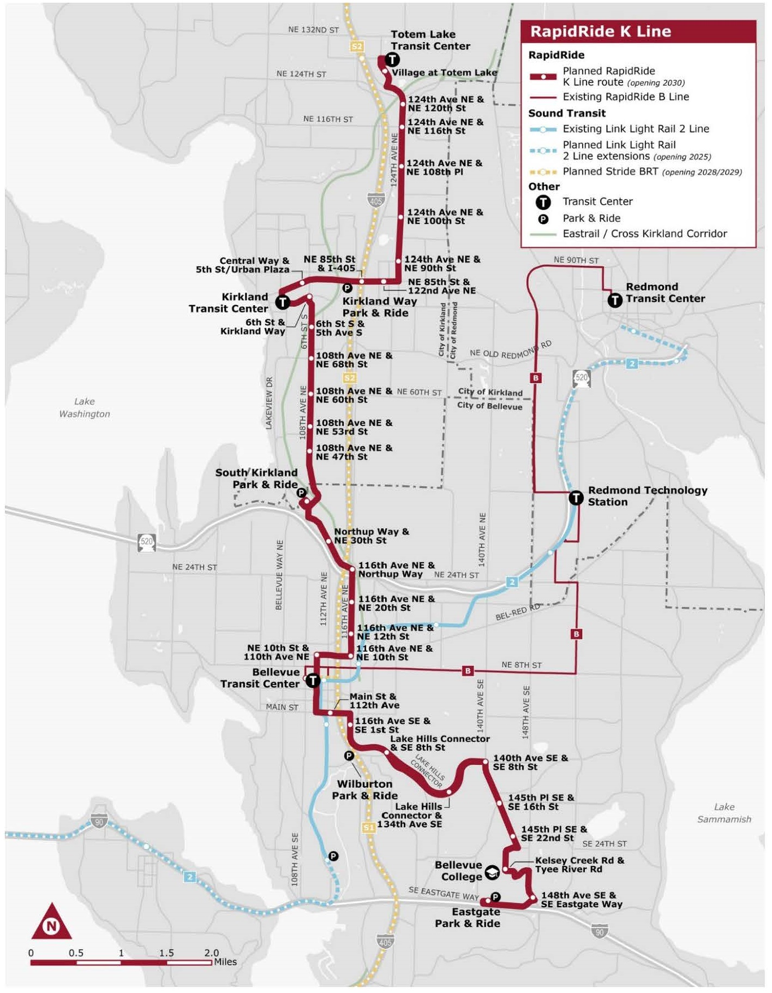

Proposed Ordinance 2025-0147 would also authorize a commitment to service levels for the first five years of service on the K Line, if required for federal grant funding.

The K Line Locally Preferred Alternative Report, which is Attachment A to Proposed Ordinance 2025-0147, describes the proposed RapidRide project, including the routing (described above), service plan, corridor improvements, community engagement, major decision points, and estimated capital costs.

Service Plan. The K Line Locally Preferred Alternative Report notes that the K Line is expected to operate in alignment with RapidRide standards. The span of service would be from 4:30 am to 12:30 am on weekdays and 5:30 am to 12:30 am on weekends. Frequency would be every 10 minutes during weekday peak hours; 15 minutes during middays, evenings, and weekends; and 30 minutes during late evening hours.

Section 4 of Proposed Ordinance 2025-0147 authorizes the Executive to enter into a service level commitment if required as a condition of federal funding. The service level commitment would be limited to the first five years of service on the K Line. Previous RapidRide line LPAs also authorized service level commitments as a requirement of applying for federal grant funding.

Proposed corridor improvements. The K Line Locally Preferred Alternative Report identifies potential capital investments along the route. These corridor improvements include a variety of smaller proposed changes, such as curb modifications and signal coordination, but primarily focus on more significant investments to improve speed and reliability for buses (19 locations), to improve access to transit for passengers (11 locations), and to develop improvements at the route’s stations (70 locations).

- Speed and reliability improvements include converting a traffic lane to a bus-only lane, installing transit queue jumps or transit signal priority at intersections, or widening streets to allow buses to travel and turn more easily. The report notes that the goal in making these improvements is a 15 to 30% travel time reduction compared to running a local transit service on the same streets during the pm peak period without these improvements. With improvements proposed at 19 locations, the report estimates a total travel time reduction of 45.7 minutes along the 16-mile length of the K Line’s route.

- Access to transit improvements include installing sidewalks or protected bicycle lanes along the K Line route; upgrading street crossings with crosswalks, curb ramps, or reduced turning radii; or installing beacons or other signals to help people safely cross the street. The K Line LPA proposes a total of 11 locations for access to transit improvements: five in Kirkland and six in Bellevue.

- Station improvements will result in a total of 70 stations for the K Line (one northbound and one southbound at each of 35 identified intersections, with 18 in Kirkland and 17 in Bellevue). This will require adding 16 new stations and upgrading or consolidating more than 50 additional stops or stations. Each RapidRide station will include accessibility features, a shelter, destination signs, lighting, all-door boarding, and safe street crossings. The report notes that each station will be designed in coordination with the local jurisdiction, meaning that, in some cases, a station would be integrated into an existing structure rather than developed as a stand-alone facility.

Community Engagement. The K Line Locally Preferred Alternative Report summarizes three phases of community engagement that occurred between late 2019 and early 2025. More detailed information can be found in the K Line Community Engagement Summaries.

- Phase 1 (Fall 2019) focused on an assessment of community needs and priorities for RapidRide service between Kirkland and Bellevue. This phase built on engagement efforts that had been conducted as part of the North Eastside Mobility Project (NEMP) restructure of transit service in East King County that was implemented at the Spring 2020 service change. Community feedback during this phase led to preliminary routing concepts within Bellevue and Kirkland, as well as preliminary proposals for K Line station locations, speed and reliability investments, and access to transit improvements.

- Phase 2 (Summer 2024) focused on conceptual planning for the new RapidRide line. During this phase, Metro reintroduced the project after its pandemic-era pause and gathered feedback on station locations, as well as priorities for access to transit and roadway improvements. This phase of community engagement included discussions about routing choices (such as the decision to locate service on 110th Avenue NE in Downtown Bellevue), station locations, and the level of transit priority to be achieved with planned speed and reliability improvements.

- Phase 3 (Winter 2025) focused on sharing a draft LPA with local partners and community members prior to transmittal to Council. Engagement focused on the specific alignment and station location recommendations to be included in the proposed LPA, as well as the location and magnitude of speed and reliability investments and access to transit improvements.

The cities of Kirkland and Bellevue have submitted letters of support for the proposed LPA. These letters can be found at Attachment 5 to this staff report.

Major decision points. The K Line Locally Preferred Alternative Report summarizes the major geographic areas for which routing or capital investment recommendations were made following community engagement and coordination with the cities of Bellevue and Kirkland. These include the LPA recommendations for:

- The recommended K Line routing through the Village at Totem Lake, including the location of the northern terminus of the line and the modifications that are recommended to address pinch points and parking conflicts on 120th Avenue NE.

- Speed and reliability improvements to be implemented on NE 85th Street and 124th Avenue NE, as well as along 108th Avenue NE in Kirkland.

- Routing decisions in Downtown Bellevue, with the proposal that the K Line travel along 110th Avenue NE to maximize connections to light rail, the RapidRide B Line, and future I-405 Stride bus rapid transit.

Estimated capital costs. The K Line Locally Preferred Alternative Report provides an estimated capital cost to construct the proposed LPA at $105.9 million in 2025 dollars. This capital estimate includes stations, speed and reliability investments, access to transit improvements, and communication system improvements (such as real-time-arrival signs at stations). The capital estimate does not include fleet costs.

Table 2 shows the funding plan currently proposed to meet the estimated capital costs for K Line development:

Table 2. RapidRide K Line Funding Plan (as of 2025)

Funding Source | Amount
Metro and local funding partners | $45.8 million
FTA Small Starts grant | $51.9 million
Other Federal (CMAQ) | $8.2 million
Total | $105.9 million

The fiscal note submitted with Proposed Ordinance 2025-0147 (see Attachment 4 to this staff report) indicates that the 2026-2027 budget is anticipated to propose $14.1 million in appropriation authority for the project and that the 2028-2029 budget is anticipated to propose $8.9 million in appropriation authority. As noted above, construction is anticipated to begin in 2028.

Metro states that the remaining $19.5 million of local funding is anticipated to be proposed for appropriation in 2030-2031, which is not shown in the fiscal note. Metro notes that this remaining funding would be used for the completion of construction and closeout, which often extends beyond the start of revenue service.

Next steps. Establishing an LPA with alignment and station locations for the RapidRide K Line, along with a service level commitment, would be consistent with the Council’s actions for prior RapidRide lines. Establishing an LPA is also a requirement to apply for federal funding for the capital investments proposed for the K Line. As with other RapidRide lines that have relied on Federal grant funding, implementation of the K Line would be dependent on Metro’s successful application for an FTA Small Starts grant.

AMENDMENTS

Amendment 1 would add information to the Statement of Facts section, including references to the adopted 2021 Metro Connects long-range plan, as well as to the pause and then restart of work on the K Line in response to the pandemic.

ATTACHMENTS

- Proposed Ordinance 2025-0147 (and Attachments A and B)
- Amendment 1
- Transmittal Letter
- Fiscal Note
- Letters of Support

INVITED

- Pierce Canser, Transit Supervisor-Service Development, Metro Transit Department
- Ryan Whitney, Program Manager, Metro Transit Department
- Lluvia Ellison-Morales, Communications Specialist, Metro Transit Department
- Amanda Pleasant-Brown, Government Relations Administrator, Metro Transit Department

Route 271 will be deleted when the East Link transit restructure (Ordinance 19899) is implemented.
Ordinance 19367
KCC 28.94.020.B requires that any service change that changes 25% or more of a route’s weekly service hours or moves a stop location by ½ mile or more must be approved by the Council.
Ordinance 19367
Since Metro Connects was adopted, the start date for the RapidRide J has moved from 2026 to 2027.
The Metro Connects Interim Network is envisioned for the completion of the Ballard and West Seattle Link light rail extensions (for costing purposes, estimated at 2035).
Motion 16659
Ordinance 18449 (Metro Connects was updated in 2021 via Ordinance 19367. The updated Metro Connects commits to the development of the K Line.)
Ordinance 18449, Attachment A, Appendix G
The 2017 Metro Connects identified two future bus networks: a 2025 Network and a 2040 Network. The 2021 Metro Connects identifies an Interim Network (mid- to late 2030s) and a 2050 Network.
Ordinance 18409, Section 132, Provisos P4 and P5
Motion 14956
The G Line opened for service in September 2024.
The H Line opened for service in March 2023.
Revised Program Delivery Schedule Technical Memo, 10-12-18, presented to Council 2019-2020 budget panel “Move King County” (link)
Ordinance 18835, Fund 3641, Project 1134292
Ordinance 19210, Section 113, Proviso P1, as amended by Ordinance 19364, Section 86, Proviso P1
Ordinance 19367
Since Metro Connects was adopted, the start date for the RapidRide J has moved from 2026 to 2027.
Ordinance 19367, Attachment C, pp. 23, 100.
The Interim Network is envisioned for the completion of the Ballard and West Seattle Link light rail extensions (for costing purposes, estimated at 2035). Metro staff have stated that the Interim Network was intentionally associated with transit expansion milestones, rather than specific dates, because these milestones are what prompt major Metro service restructures. Updates to reflect changes in Sound Transit’s plans will be made through future updates to Metro Connects, as well as service change proposals.
Motion 16153
The RapidRide Restart Report stated that the capital cost estimates developed in 2021 would need to be updated because of construction cost inflation.
Ordinance 19546
Ordinance 10546, Section 114, Proviso P4
Ordinance 19367 required Metro to develop a RapidRide Prioritization Plan to identify the tiers of RapidRide Lines to be developed. It was transmitted in June 2024 and accepted via Motion 16659.
2023-B0102 (link)
Motion 16659
Federal Transit Administration, Capital Investment Grants Program (New Starts, Small Starts, and Core Capacity Improvements) (link)
United States Environmental Protection Agency, National Environmental Policy Act Review Process (link)
Route 271 will be deleted when the East Link transit restructure (Ordinance 19899) is implemented.
The K Line Locally Preferred Alternative Report estimates round trip travel time of 139 minutes, which translates to an estimated 69.5 minutes on average to travel from one end of the route to the other.
K Line Community Engagement Summary Phase 1 (link), K Line Community Engagement Summary Phase 2 (link), K Line Community Engagement Summary Phase 3 (link)
Ordinance 18944. The NEMP restructure was approved by the Council in July 2019.
According to the K Line Locally Preferred Alternative Report, “With an estimated round trip travel time of 139 minutes and 28 minutes for layover and recovery, K Line’s cycle time will be approximately 167 minutes. The K Line will require 17 buses in operation. An additional four buses may be needed to serve as spares, for a total of 21 vehicles.”
CMAQ = Congestion Mitigation and Air Quality Improvement Program (link)
Ordinance 19367

