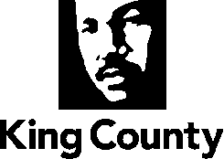

EXECUTIVE RECOMMENDED PLAN

Maple Valley Urban Growth Area
Area Zoning and Land Use Study

I. OVERVIEW
The 2020 Comprehensive Plan Midpoint Update Scope of Work includes an analysis of potential urban growth area boundary changes near the City of Maple Valley. The Scope directs the following:

Work with the City of Maple Valley to consider amendments to the Urban Growth Area boundary for five parcels adjacent to Maple Ridge Highlands to facilitate transference of city-or water district owned parcels with storm water detention ponds or water tanks into the City’s corporate boundary.

The subject properties consist of five parcels located in the rural area on the border of the City of Maple Valley. These five parcels are located adjacent to the Maple Woods section of the Maple Ridge subdivision...

II. POLICY CONTEXT

Maple Ridge Highlands is a neighborhood located at the south end of Maple Valley. The neighborhood became an official part of the city of Maple Valley with annexation in 2009. The community is surrounded by King County open space. This subdivision and open space was created as a condition of the development of Maple Ridge Highlands through the King County Four-to-One program. The Four-to-One program allows land owners to move 20 percent of their land (i.e. the “one”) into the urban growth area in which urban housing densities like Maple Ridge Highlands are allowed, and the remaining 80 percent (i.e. the “four”) is permanently added to the King County Open Space system (four acres of public open space is set aside for every one acre of developed land).

The subject properties total approximately three acres. Three of the parcels are owned by the city, and two are owned by water districts. Five of the parcels contain storm water detention ponds or water tanks used for utility purposes. One parcel is split by the Urban Growth Area boundary.

The Comprehensive Plan contemplates that rural uses do not include primarily urban serving facilities, see R 201(i):

R 201 It is a fundamental objective of the King County Comprehensive Plan to maintain the character of its designated Rural Area. The Growth Management Act specifies the rural element of comprehensive plans include measures that apply to rural development and protect the rural character of the area (Revised Code of Washington 36.70A.070 (5)). The Growth Management Act defines rural character as it relates to land use and development patterns (Revised Code of Washington 36.70A.030 (15)). This definition can be found in the Glossary of this Plan. Rural development can consist of a variety of uses that are consistent with the preservation of rural character and the requirements of the rural element. In order to implement Growth Management Act, it is necessary to define the development patterns that are considered rural, historical or traditional and do not encourage urban growth or create pressure for urban facilities and service.

Therefore, King County’s land use regulations and development standards shall protect and enhance the following attributes associated with rural character and the Rural Area:
a. The natural environment, particularly as evidenced by the health of wildlife and fisheries (especially salmon and trout), aquifers used for potable water, surface water bodies including Puget Sound and natural drainage systems and their riparian corridors;
b. Commercial and noncommercial farming, forestry, fisheries, mining, home-occupations and home industries;
c. Historic resources, historical character and continuity important to local communities, as well as archaeological and cultural sites important to tribes;
d. Community small town atmosphere, safety, and locally owned small businesses;
e. Economically and fiscally healthy Rural Towns and Rural Neighborhood Commercial Centers with clearly defined identities compatible with adjacent rural, agricultural, forestry and mining uses;
f. Regionally significant parks, trails and open space;
g. A variety of low density housing choices compatible with adjacent farming, forestry and mining and not needing urban facilities and services;
h. Traditional rural land uses of a size and scale that blend with historic rural development; and
i. Rural uses that do not include primarily urban serving facilities.

A Comprehensive Plan policy related to parcels split by the Urban Growth boundary allows for redesignation to all urban area:

U-103 Parcels that are split by the Urban Growth Area boundary line should be reviewed for possible redesignation to either all urban area or all Rural Area or Natural Resource Lands taking into consideration: a. Whether the parcel is split to recognize environmentally sensitive features; b. The parcel's geographic features; c. Whether the parcel will be added to an adjoining city's Potential Annexation Area; d. The requirements of interlocal agreements, or the requirements of King County plans.

III. BACKGROUND INFORMATION

Maps

Vicinity
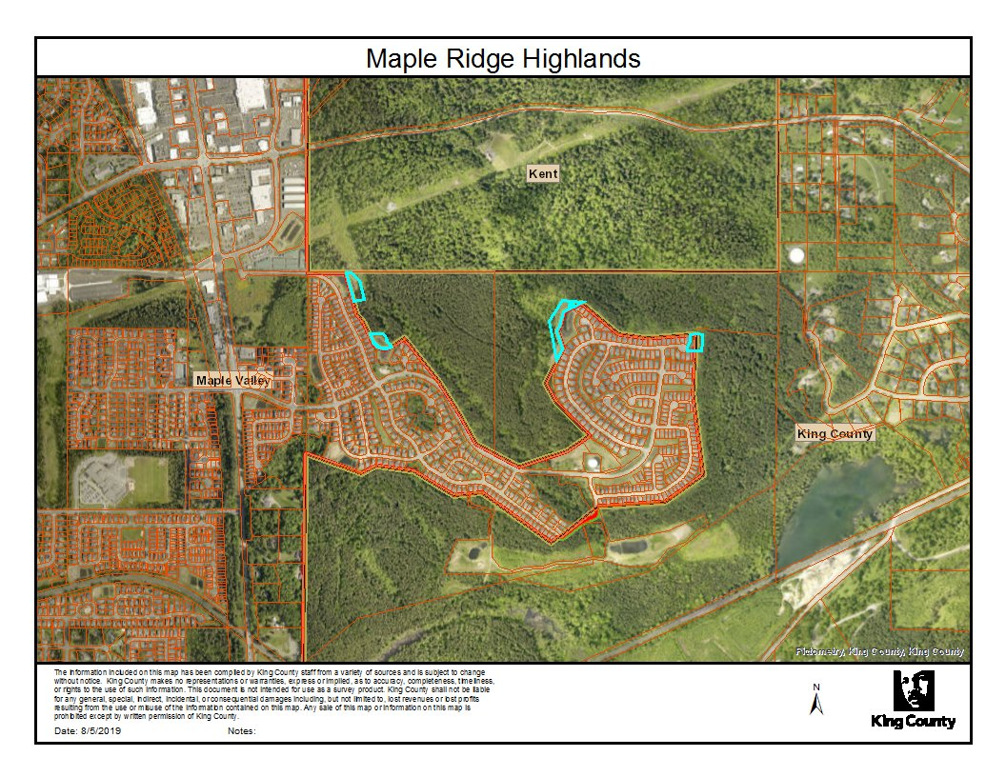

Zoning
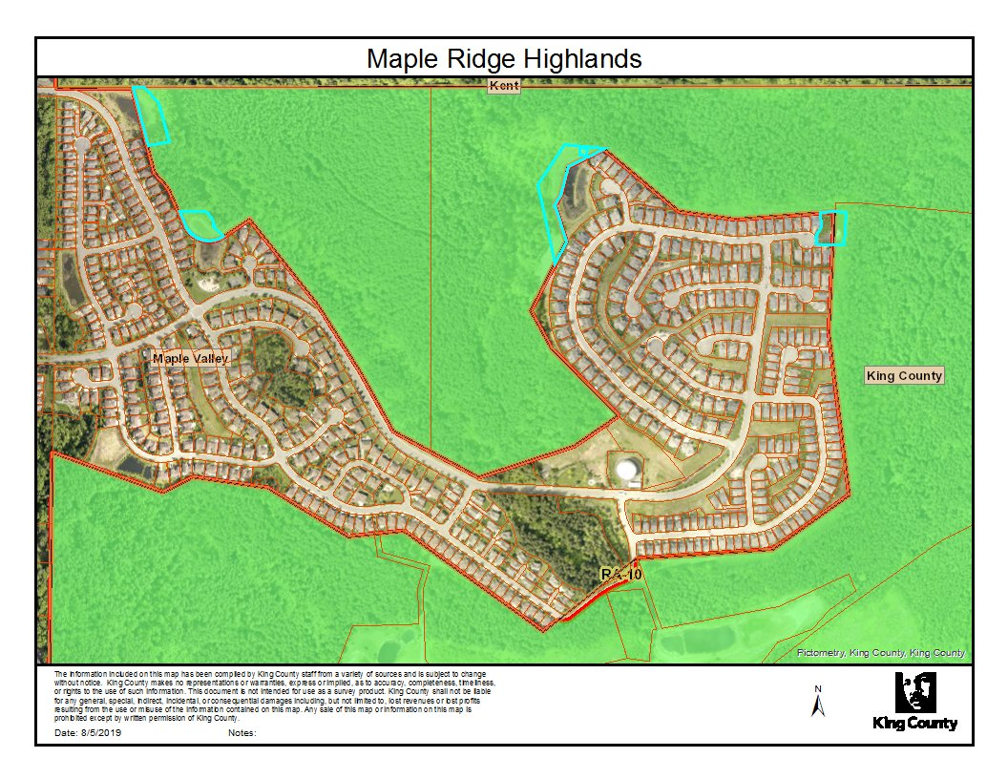

Land Use
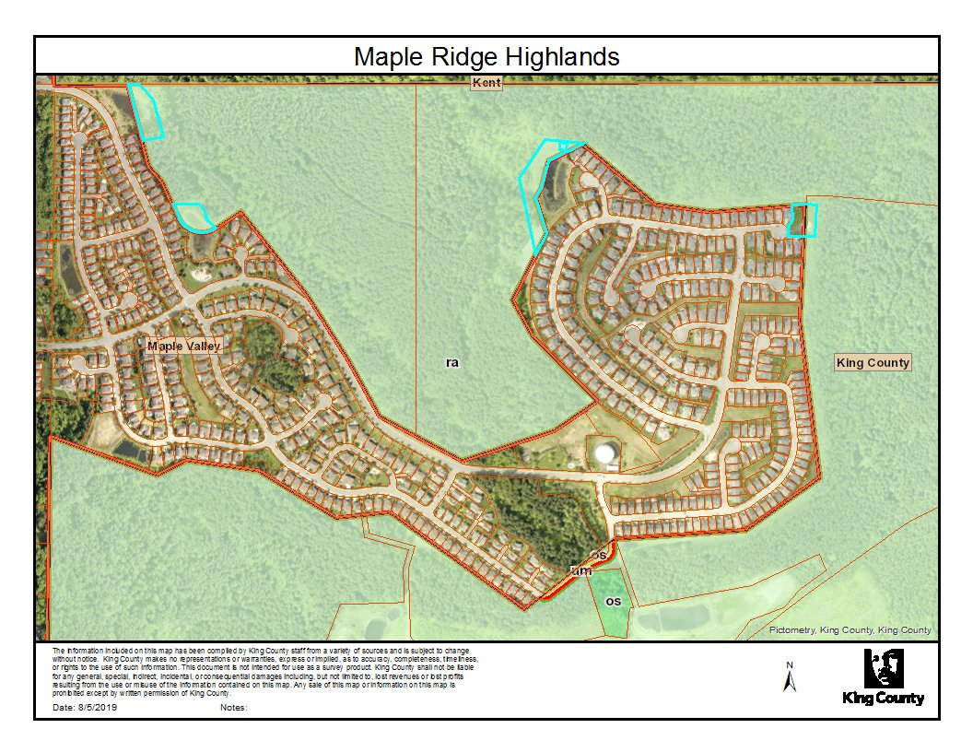

Parcel Information
The five utility-related parcels are as follows:
- 5104512280 (City of Maple Valley, Tract L1)
- 5104512290 (City of Maple Valley, Tract L2)
- 5104540740 (City of Maple Valley, Tract L3)
- 5104540760 (Soos Creek Water & Sewer District, Tract S1)
- 5104532070 (Covington Water District, Tract C2)

Land Use Information
Three of the parcels are designated RA-10, rural area one dwelling unit per ten acres, and are owned by the City of Maple Valley. One parcel is designated RA-10 and is owned by the Soos Creek Water District. One parcel is owned by the Covington Water District. Each of these five parcels contain storm water detention ponds or water tanks used for utility purposes. One parcel split by the Urban Growth Boundary.

IV. INFRASTRUCTURE
All of the stormwater detention ponds serve residents in the urban area. The storm water parcels are accessible either directly off city streets or nearly adjacent to city streets:
- Two of the parcels are accessible off Maple Ridge Way SE
- One parcel is accessible off of SE 281st Way
- One parcel is accessible off of 254th Ct SE
- One parcel is accessible off of SE 274th Place

V. ENVIRONMENTAL
There are limited environmental constraints on these parcels. And, per communication with the City, the uses on these parcels would continue and none would be proposed for development.

VI. COMMUNICATION WITH STAKEHOLDERS

Communication with the City of Maple Valley
The City of Maple Valley was contacted by King County staff as a part of the outreach for this study. The city supports adjustments to the Urban Growth Area boundary to bring the storm water detention facilities and utility parcels that serve the City into the city limits. The City expressed its intent to work with the County to annex the parcels after they are brought into the Urban Growth Area, and retain them in perpetuity as stormwater ponds and water district facilities serving the subdivision.

Communication with the Soos Creek Water and Sewer District
County staff contacted the Soos Creek Water and Sewer District as a part of the outreach for this study and invited their feedback. The water district responded that they do not have any concerns with the proposal at this time.

Communication with Covington Water District
County staff contacted the Covington Water District as a part of the outreach for this study and invited their feedback. The water district responded that they do not have any concerns with the proposal at this time.

VII. CONCLUSION & RECOMMENDATION

Conclusion
Staff analysis has determined that the impact of these Urban Growth Area boundary technical adjustments to align property boundaries for public-owned and public-serving facilities are de minimus and support the change.

Recommendation
Adjust the Urban Growth Area boundary to bring the following five parcels with storm water detention facilities and facility parcels that are either outside the Urban Growth Area or split by it into the City of Maple Valley city limits to preserve continuity of facilities that serve the City of Maple Valley:
- 5104512280 (City of Maple Valley, Tract L1)
- 5104512290 (City of Maple Valley, Tract L2)
- 5104540740 (City of Maple Valley, Tract L3)
- 5104540760 (Soos Creek Water & Sewer District, Tract S1)
- 5104532070 (Covington Water District, TR C2)

When the parcels are brought into the Urban Growth Area, a land use designation and zoning classification will need to be established until the parcels are annexed into the City of Maple Valley, as discussed previously. The following is proposed.
- Land Use: The proposed land use is Other Parks/Wilderness.
- Zoning: The proposed zoning is UR (Urban Reserve).

These are intended as short-term placeholders that will exist with the parcels between the time of County Council amendment of the Urban Growth Area and the City of Maple Valley annexation of the parcels.

VIII. NEXT STEPS
Given that these map amendments impact the Urban Growth Area boundary and City boundary, there are additional steps that would be connected to the map changes. These include the following:
- Establish an Interlocal Agreement to have the stormwater detention pond parcels annexed to the City. This should follow the interlocal annexation method.
- Following annexation, the City would amend its City boundary.

To the extent practicable, these steps should occur in a timeframe consistent with County Council adoption of the map amendments.

page intentionally left blank

