STAFF REPORT

Agenda Item: | 6 | Name: | Kendall Moore  Rick Bautista
Proposed No.: | 2012-B0045 | Date: | March 20, 2012

SUBJECT

There are scheduled three special meetings out in the County at which the public will be providing their comments to the Executive's proposed 2012 updates to the king County Comprehensive plan ("KCCP"). Historically, many comments at those public meetings are directed at area zoning studies performed by the Executive staff in support of the Executive’s recommendations for land use and zoning map amendments. Therefore, in order to provide the members with a background of those items, this staff report provides just a general overview relating to the King County Docket Reports and Area Zoning studies.

Further analysis of the map amendments will be undertaken at a later TREE briefing (currently scheduled for June 19, 2012).

DOCKET REPORTS
Pursuant to KCC 20.18.140, any interested party may submit proposed changes to the KCCP and the implementing development regulations. Requests are submitted via the County’s docket system, established in 1998. Additionally, pursuant to KCC 20.18.050, property owners may submit through the docket system, site-specific land use map amendments.
The docket is open continuously. However, to qualify for consideration in the next year's comprehensive plan review, a docket request must be received by June 30. By December 1, DDES is to respond to all docket requests in the previous cycle, advising the requester if the Executive is going to include the request as part of his recommended comprehensive plan updates. Also by December 1, the docket items submitted in the previous 12 months (June to June) are compiled into the annual docket report transmitted to the Council.
In the annual docket report, Executive staff provides a docket summary, outlining each docket request submitted and a synopsis of the Executive staff's recommendation. Also included are the letters responding to each docket request.
In accordance with the notice requirements required in KCC 20.18, those who made docket requests in 2008 through 2011, and those within 500 feet of properties identified in the Executive's transmitted area zoning studies have been notified of the meeting dates when TREE will be receiving briefings on the proposed updates to the KCCP.

Attachment 1 of the staff report is a matrix providing a description of each of the items included in the four docket reports. In addition, the matrix provides information about subsequent actions (if any) related to the each docket request.

AREA ZONING STUDIES AND MAP AMENDMENTS

The Executive proposal includes eleven Area Zoning ("AZ") studies. The following is a brief analysis of each study and the corresponding map amendment (if any):

AZ 1 - Map Amendment 1: (West Hill)

AZ Study

The owner of a commercial laundry requested a land use and zoning map revision in order to redevelop and expand onto an adjacent, small lot. The laundry sits on sits on property designated Commercial Business and zoned CB-SO (Community Business with a Special District Overlay). Although the small lot is designated UM (Urban Residential Medium (4-12 units per acre)) and zoned R-6 (six units per acre), it is already developed with a structure that (1) has commercial office use and (2) shares a common wall with the existing laundry on the adjacent lot. In addition, a hedge separates that lot from adjacent residential-zoned properties.

In recommending approval of the request, the Executive concludes that:

- The normal perception of the subject property is that it is already commercial-zoned property due to the existing uses and its structural connection to the existing commercial laundry, and
- Due to its orientation towards the adjacent commercial uses, it is not reasonable to expect the lot to be redeveloped as a single-family residence.

Map Amendment

The proposed map amendment would make the necessary map revisions to effectuate this recommendation and apply Special District Overlay SO-050 (pedestrian-oriented commercial development – see also KCC 21A.38.050) that currently applies on all other property within this commercial center.

ISSUE: None at this time.
AZ 2 - Map Amendment 4: (Soaring Eagle)

AZ Study

The proposal would change the land use designation from OS (King County Open Space) to OP (Other Parks/Wilderness) and zoning from RA-5-SO (Rural, five acres with a Special District Overlay) to UR-P (Urban Reserve with P-suffix), for a 29.9-acre parcel that is part of the 600-acre Soaring Eagle Park.

The purpose of the land use change is to include this 29.9 acre portion of Soaring Eagle Park within the Urban Growth Area and Potential Annexation Area of the City of Sammamish. This will allow the City to annex the subject property and develop it with an active recreation city park. It is expected that a latter time, the ownership of the parcel will be transferred from King County to the City and an interlocal agreement would ensure that this property to be permanently kept in park use.

The Executive recommended approval noting that since this proposal is not a request for additional development capacity, and the transfer is subject to a park transfer agreement, it fully complies with applicable policy (Policy U-104). Furthermore, the transfer will result in a public benefit in the form of a city park with restrooms served by public sewers.

Map Amendment

The proposed map amendment would re-designate and rezone a 29.9-acre portion of the larger 600-acre Soaring Eagle Park and updates the Interim Potential Annexation Area ("PAA") Map to include the land within the City of Sammamish PAA.

In addition, a condition of a park transfer interlocal agreement and a zoning P-Suffix condition will permanently ensure that use of the site is limited to parks and park facilities.

ISSUE: None at this time.

AZ 3: (Sammamish Valley)

AZ Study

This study is in response to a 2010 docket request submitted by the City of Woodinville. The City's request involves two property groups in the Sammamish Valley. Both property groups are outside of the Urban Growth Area ("UGA") and both are adjacent to the Agricultural Production District ("APD"), except for one parcel, tax number 1026059031, approximately 6 of its 8 acres are located within the APD (and zoned A-10).

The northern property group consists of ten parcels located south of NE 171st Street, west of 140th Place NE. With the exception noted above for parcel 1026059031, each parcel is designated Rural and zoned RA-5.

The properties of this northern group have been the subject of three recent area zoning studies, with the most recent conducted in 2005. That 2005 study was performed in response to a Growth Management Hearings Board decision that called upon the County to align its zoning to match that of the APD boundary. During the Council's consideration of the 2005 study, several the property owners requested that the Urban Growth line be adjusted southward from Woodinville to align with the eastern edge of the APD and then extend eastward to 140th Ave. NE. Their stated goal was to have their properties included within the UGA so that sewer service could be extended onto their properties. The request was not approved.

The southern group of properties is located on the west side of 148th Ave. NE, just north of NE 145th Street. This is a group of three parcels (tax numbers 1526059056, 1526059052 and 1526059051); each parcel is less than 2 acres in size. These properties are designated Rural and, although not located within the APD, are zoned A-10.

The Executive has noted the following reasons for recommending that the request not be approved:

- The City does not contend it lacks the capacity under its existing land use plans and zoning to accommodate the household and employment targets established by the CPPs. Instead, the City contends that its proposed re-designations would create (1) create an "institutional gateway" with medical office buildings on the northern property group and (2) expand their existing Tourism District on the southern property group,

- The City does not made any distinction between the proposed properties and any other similarly situated rural properties that also abut the City. Presumably then, any rural property that abuts the City could also be vulnerable in the future to the same pressures for increased development and a precedent would be set if the requested urban land use and zoning requested in this docket were approved.

- Protection of the APD and nearby Rural Areas is a matter of regional importance and the loss of any part of the adjacent rural buffer would bring additional pressure to bear or urban development.

Maps

The following maps are for informational purposes only. As the Executive is not recommending any changes, the maps are from the AZ study to indicate the location of the properties.

ISSUE: The docket request was submitted on behalf of the City of Woodinville. Council staff has requested of Executive staff any materials submitted as part of that docket request and will provide their analysis of that material later. Council staff will also review the City’s recently passed Resolution No. 414, supporting the docket request. All Councilmembers received a copy of this resolution from the City via email and the resolution will be included as part of the Council’s pubic comment record for this comprehensive plan review.

In addition, Council staff will review land uses of those properties within the APD that are adjacent to the properties proposed to be added to the UGA. This analysis may help inform on the issue of whether the City's proposed uses would indeed cause harm to the long-term stability of the APD.

Council staff notes that there appears to be a potential issue in regards to the southern property group, wherein A-10 zoning is used on these three Rural-designated parcels. The seeming disconnect between land use designation and zoning may run counter to the Hearings Board decision, which called upon the County to apply a zone category on property in a manner consistent with the underlying land use designation. Based on a review of adjacent properties, the more appropriate zoning would be RA-5 (one house per five acres).

The Executive staff noted in the AZ study that the property owners for these 3 parcels did not submit the docket request for this change. Additionally, as the properties are in the Rural Area and already less than 2 acres each, they could not be subdivided anymore.

AZ 4 - Map Amendment 7: (Pacific Raceways)

AZ Study

During deliberations of the 2000 KCCP update, a 300-foot conservation easement was discussed for the purpose of buffering Little Soos (actually Soosette) Creek from the impacts of development on the Pacific Raceways site. However, as part of the 2000 KCCP update, no conservation easement was conditioned on any land use/zoning change. The property owner has dedicated no conservation easement. As members are aware, the owner of Pacific Raceways is pursuing options to significantly update of the facilities and operations at the track, which includes the need for a second road to the property.

In May 2011, the Council included the following directions in the scope of work for the 2012 KCCP update:

“Conduct an area zoning study of parcels 1021059002, 1021059008 and 0321059190 as follows:

(1) Establish a conservation easement that averages at least 300 feet from the ordinary high watermark along the east side of Little Soos Creek. In establishing the conservation easement, ensure that areas of high ecological value are given special consideration;

(2) If necessary, modify the underlying zoning in the area of the conservation easement to be consistent with the purposes of the easement;

(3) Consider rezoning of a small portion of northwest corner of parcel 102105-9002 from RA-5 to IndustriaI - consistent with conservation easement along the Little Soos Creek and consistent with the Industrial zoning on the rest of the parcel; and

(4) Consider rezoning parcel 032105-9190 from RA-5 to Industrial, if necessary to allow for an ingress and egress easement to access parcel 102105-9002.”

Council staff notes that the following is only a very brief overview of the area zoning study, which can be found in the member binders (Volume One, Tab 4, pp. 28-42).

The primary focus of this AZ study was upon the importance of protecting the natural processes and features that ultimately contribute to protecting the water quality in Soosette Creek. By protecting the critical areas around the Creek, as well as the habitat and species, the intended effect is to preserve the Creek’s high ecological value.
The AZ study provides an in-depth evaluation of existing code relating to critical areas, known site information, and the wetland study (Sewall) conducted in the Soosette Creek ravine area. Based on the evaluation of this information, the Executive recommends a conservation easement described as follows:

"a. A conservation easement that extends to 50 feet beyond the top of the steep slope and landslide hazard area on both sides of Soosette Creek (see Appendix 2);

b. In areas where the top of slope/landslide area and the 50-foot area that extends beyond the top of the steep slope is less than 300 feet from the ordinary high water mark of the Soosette Creek, the conservation easement will extend no less than 300 feet from the ordinary high water mark (see Appendix 2); and

c. Revegetation of currently disturbed areas with native tree and shrub species will be required. These areas could include the dirt bike trail located on the steep slope and other areas in the steep slope/landslide hazard area or the 50-foot area that extends beyond the steep slope that are determined to be disturbed. These areas will be field located once the easement is established."

The AZ study’s secondary focus was to apply zoning; wherein land within the conservation easement would be zoned RA-5 and land outside of that easement would be zoned I-P. Dedication of the aforementioned conservation easement on land under Pacific Raceway ownership would be a "pre-effective" condition to be satisfied before any of the zoning changes would become effective.

ISSUE: Council staff would highlight two areas for Council consideration.

Width of Conservation Easement - The Executive-proposed conservation easement adjacent to Soosette Creek will exceed in many places, the 300-foot width that had been contemplated as part of the 2000 KCCP updates, as well as, during the discussions about such an easement in the 2011 Scoping Motion. The Executive’s proposed conservation easement will always exceed 300 feet. The following map illustrates what is noted above.

Council staff notes that, the code allows development within 50 feet of the top of slope, if impacts can be mitigated and structural stability assured. However, the conservation easement, which would extend 50 feet beyond the top of slope, would preclude development be allowed within 50 feet of the top of slope, under any circumstance. Whether or not to include the 50 feet from the top of slope within the conservation easement will be a key policy choice.

Map Amendment text

The following map illustrates the area Pacific Raceways affected by this AZ study and accurately reflects the proposed changes. However, Council staff believes that the Executive-proposed map amendment text does not clearly articulate the intent of the study recommendations, both in terms of map revisions and implementation of the conservation easement, and that Council may want to consider amended text to read as follows:

"Amend the King County Zoning Atlas as follows:

- Change the zoning for any portion of parcels 1021059002, 1021059008, and 1021059003, within the conservation easement described below, from Industrial (I-P) to Rural (RA-5):

- Retain the current RA-5 zoning for any portion of parcel 0321059190 that is within an area consistent with the conservation easement described below.

- Change the zoning on the remaining RA-5 portions of parcels 1021059002 and 0321059190, approximately 1.6 acres, to Industrial (I-P) and apply the following P-Suffix condition (SC-PO-2):
The site is limited to racetrack uses only; no other industrial uses are allowed which are not permitted by Conditional Use Permits File Nos. A-71-0-81 and L08CU006. The Rural land use designation will remain; should the racetrack use be terminated, this property should continue to be designated Rural and the zoning shall revert to RA-5.
The zoning amendments shall not become effective until the property owner of Pacific Raceway has recorded a permanent conservation easement with King County that meets the following criteria, on all of the land under Pacific Raceway ownership:

- The conservation easement shall extend the greater of either (1) three hundred feet from the ordinary high water mark on both sides of Soosette Creek or (2) fifty feet beyond the top of the steep slope or landslide hazard area of Soosette Creek;

- The conservation easement shall be re-vegetated using native tree and shrub species within any currently disturbed areas."

AZ 5 - Map Amendment 2: (Reserve Silica)

AZ Study

This study is in response to a 2010 docket request on a 402-acre property formerly used for silica mining. County policy calls for redesignation of depleted mining sites to a land use and zoning classification compatible with surrounding properties, and for reclamation of the mining site. The property owner indicates the resource on the site – silica/sand - has been removed to the extent practical, and mining operations are being completed. There is an approved reclamation plan for this property and reclamation is underway.

The property lies on the border between the Rural Area and the Forest Production District ("FPD"). It is a multi-sided property. Three sides are adjacent to the FPD and the other sides by the Rural Area. On about 322 acres of the site, both the land use designation and the zoning are Mining. The remaining 80 acres have both a Forest land use designation and are zoned for Forest.

The docket request proposed redesignation of 322 acres of the property from Mining to Rural; and rezoning it from Mining to RA-10 zoning (1 house per 10 acres). The docket request also proposed that the remaining 80 acres keep their current Forest land use designation and zoning.

Since the mining operation on the site is being completed, the Executive agrees that there is no need to retain the existing Mining (M) zoning. However, the Executive recommends denying the proposed redesignation and rezone to Rural, and rather, putting the entire property within the FPD (with the requisite zoning). The Executive recommendation is based on the conclusion that the addition of subject property to the adjacent FPD: (1) results in a more logical and regular boundary for the FPD; and (2) is consistent with Policy R-688 since:

- The property is adjacent to the FPD on three sides and a designated mining site,
- Residential development on the property could result in conflicts with adjacent forestry and mining activity, wherein new residents may complain about the noise and other impacts from these resource activities,
- Resource operators may complain about increased traffic from new homes, and Residential development may also bring pressure to bear on other adjacent resource-designated properties for residential development.

Map Amendment

- Retain the existing Forest zoning on the southern 80 acres of the site.
- Replace the existing Mining (M) land use and zoning on the remainder of the subject property with a Forest land use designation and Forest (F) zoning.
- Delete the Reserve Silica site from the Mineral Resources map and table in Chapter 3 of the KCCP.
- Include the entire 402 acre site within the Forest Production District.

ISSUE: None at this time. Council staff has been informed that the docket proponents have or will be providing members with information to support their proposal, based on the premise that using the land for forestry purposes may not be economically feasible. Council staff has requested a copy of this information and will provide their analysis later in the committee review process.

AZ 6 - Map Amendment 3: (Taylor Mountain)

AZ Study

The proposal would include the eight County-owned open space-designated parcels within the Forest Production District and rezone each from RA-10 (one house per ten acres) to the Forest (F) zone.

The study area is part of Taylor Mountain Forest, which is owned and managed by King County Parks. After the County purchased the Taylor Mountain Forest its land use designation was changed to Open Space, but the zoning was not changed. About one third of the property was zoned Forest (F), and the remaining two thirds, which is the study area, was zoned Rural Area (RA).

The land is adjacent to the Forest Production District, and except for a portion of lot 0522079001, is encumbered with a United States Forest Service Forest Legacy Program forest conservation easement. This easement extinguishes the development rights of the property covered by the easement; therefore, the RA-10 zoning is inconsistent with the development restrictions the conservation easement creates for those parcels covered by it.

Under the Forest Legacy Program, the land must be managed for forest stewardship, including timber management purposes. To that end, Taylor Mountain Forest is classified as a “working forest” King County Park site pursuant the 2010 King County Open Space Plan.

In the AZ study’s recommendation, the Executive staff note that the amendment recognizes the County’s intent to manage property for long-term forestry and open space purposes.

Making the change will bring the zoning into compliance with the underlying land use designation, the development restrictions already on the property and how the property is actually used.

Map Amendment

- Retain the existing Open Space Land Use designation,
- Include the parcels in the Forest Production District, and
- Reclassify from RA-10 to F

ISSUE: None.

AZ 7 - Map Amendment 5: (Snoqualmie Mining Site)

AZ Study

This AZ study was in response to a 2011 docket request from the City of Snoqualmie to remove a portion of parcel 2024089017 and parcel 2024089020 from the Snoqualmie Rural City UGA.

Both of these properties contain a long-term mining operation. As part of its request, the City submitted written evidence that the property owner, Weyerhaeuser, supports the request. In its docket request, the City points out that “these (mining) parcels should remain in King County jurisdiction and be classified as mineral resource lands that are not already characterized by urban growth and have long-term significance for the extraction of minerals under RCW 36.70A.170.”

In the AZ study’s recommendation, it is noted:

- The KCCP land use map designates the portion of the mining operation on the subject property that is outside and adjacent to the Rural City UGA as Mining, but shows a portion of the mining operation within the Rural City UGA. The current designation appears to conflict with KCCP policy R-510, which calls for land designated Rural City UGA to be planned and developed with urban uses, not mining activity.

- Consistent with KCCP policy R-676, the subject property should be identified as a mining site, and not be included in the Rural City UGA and designated for annexation by the City of Snoqualmie.

Map Amendment

- Re-designate two mining parcels from Rural City UGA to Mining, and
- Retain current M-P and I-P zoning

ISSUE: None.
A

Z 8 - Map Amendment 6: (Fall City Subarea Plan)

AZ Study

This study was the result of, in great part, several docket requests submitted in recent years (2008-2010) to activate potential commercial zoned areas existing in Fall City (a designated Rural Town) or from requests for new commercial zoning. The Executive rejected these requests because the 1999 Fall City Subarea Plan and the KCCP both include a policy that requires an alternative wastewater disposal method or sewer service as a prerequisite for activation of potential commercial zoning or any new commercial zoning.

Under current policies, rezone requests, such as those in the 2008-2010 dockets to actualize the potential commercial zoning on properties within the business district have been consistently denied because sewer service is not available for Fall City and will likely not be available for the foreseeable future. Additionally, it is unknown when or if an alternative wastewater method will be available.

This study (conducted throughout 2011) analyzes and proposes changes to applicable KCCP and 1999 Fall City Plan policies that would allow for commercial zoning in the commercial district to be activated. The Executive recommends allowing property owners who are able to get Health Department approval for on-site waste disposal system to develop their property consistent with zoning; thereby uncoupling the requirement for a new wastewater method from the ability to actualize commercial zoning within the Fall City downtown commercial district. The Executive proposes the following changes to the Fall City Policy L-4 and KCCP policy CP-937:

L-4 Fall City’s existing commercial and industrial land base should be retained. ((Future expansion of the business district is provided for in this Plan through potential Community Business zoning, which may be realized through an area-wide rezone initiated by the King County Council once alternative wastewater treatment systems or public sewers are available.)) The downtown Fall City business district is included within a Special District Overlay (SDO). All property within this SDO is designated and zoned for commercial development. New development within the SDO is subject to Seattle-King County Health Department approval of the on-site septic system. When and if an alternative waste disposal method or self-contained sewer system becomes feasible, it shall be designed to serve only the designated downtown commercial district. No direct connection to the Metro sewer system is permitted.

CP-937 Fall City is an unincorporated rural town which should have overall residential densities of one to four dwelling units per acre. ((Potential commercial zoning adopted in the 1999 Fall City Subarea Plan may be actualized through an area-wide rezone initiated by the King County Council once alternative wastewater treatment systems or public sewers are available.)) The downtown Fall City business district is included within a Special District Overlay (SDO). All property within this SDO is designated and zoned for commercial development. New development within the SDO is subject to Seattle-King County Health Department approval of the on-site septic system. When and if an alternative waste disposal method or self-contained sewer system becomes feasible, it shall be designed to serve only the designated downtown commercial district. No direct connection to the Metro sewer system is permitted.

The Executive’s proposal would also add as new text to follow both the L-4 and CP-937 policies:

"It is important to note that a self-contained sewer system is a system that does not directly connect to the Metro system. A self-contained sewer system shall be designed and built to only serve the Fall City downtown business district."

Code Amendments

The Executive proposes that a new Special District Overlay ("SDO") for rural business districts be established in the County Code and apply this SDO to the Fall City downtown business district. This Special District Overlay, which is contained in Section 25 of Proposed Ordinance 2012-0103 and will be reviewed in greater detail later in the Council review process, includes:

- A list of permitted and conditional uses for all property within the Overlay, replacing the permitted use table in King County Code Chapter 21A.08, and
- Design standards for new construction are also required.

Map Amendments

Although no land use map amendments to Rural Town boundary are recommended, the Executive proposes to modify zoning in the commercial district within the boundary of the proposed SDO area, as shown on the following maps.

ISSUE: No substantive issues at this time. Council staff will be looking at harmonizing the references to business and commercial as used in the policies proposed for amendment, as well as the correct naming for “Metro sewer system.”

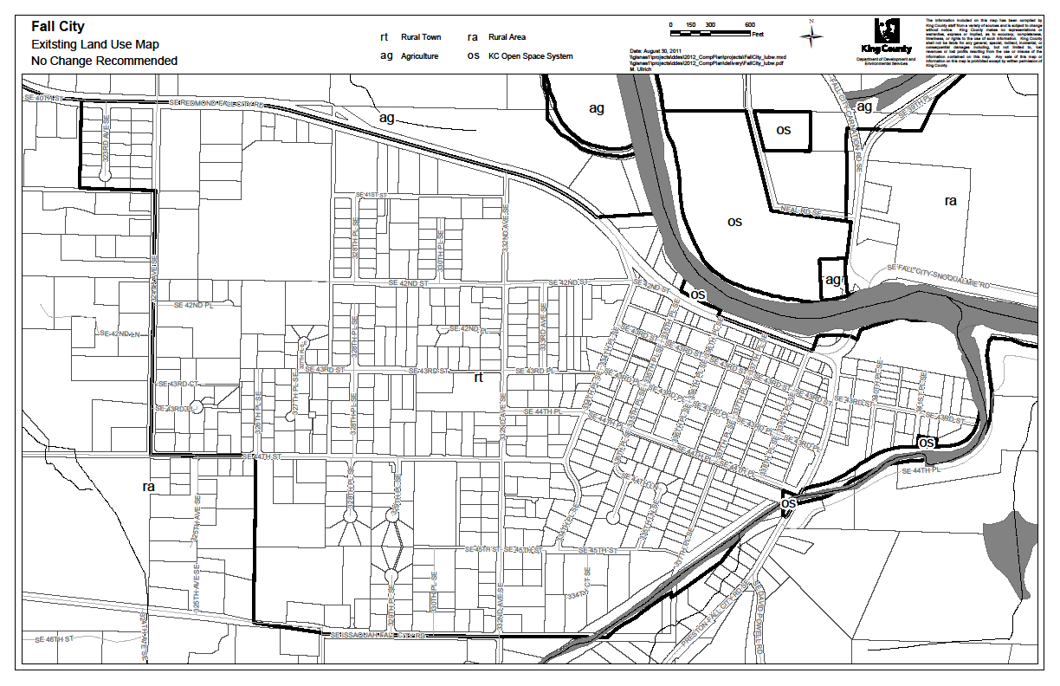

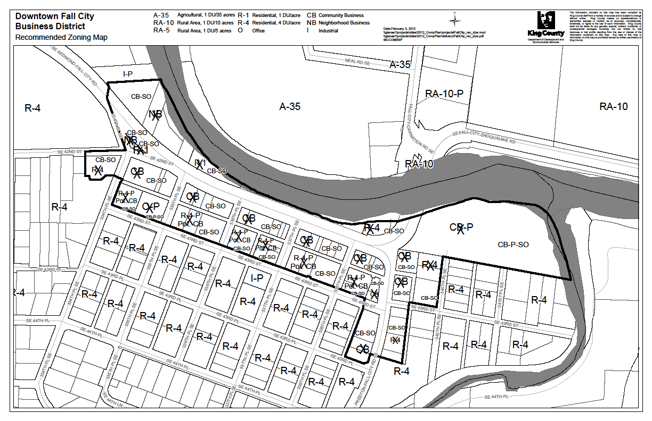

AZ 9 - Map Amendment 8: (UGA Technical Corrections)

AZ Study

This study addresses a King County Department of Transportation review, under Policy T-205 (below), that determined 12 segments of King County road rights-of-way (“ROW”) are not correctly designated on the KCCP Plan land use map for the purposes of efficient future road maintenance. In eight cases, the ROW segment should be included within the UGA so that the adjacent city will have long-term maintenance responsibility. In three cases, the ROW segment should be included in the Rural Area, since King County will continue to have maintenance responsibility. One case involves two segments; one should be designated Rural and the other Urban to clarify maintenance responsibility between King County and the City of Redmond.

T-205 Any segment of a county roadway that forms the boundary between the Urban Growth Area and the Rural Area shall be designed and constructed to urban roadway standards on both sides of such roadway segment.

The Executive recommends approval, noting that the amendments (1) do not affect private property and (2) to facilitate maintenance of right of way by the appropriate jurisdiction.

Map Amendments – There are 17 map amendments, but due to their number, no maps are attached to this staff report, rather can be found in the member binders (Volume One, Tab 4, pp 74-85).

Redesignate from Rural to Urban:
- 148th Ave SE, adjacent to Auburn
- 212th Ave SE, west of Black Diamond
- NE Union Hill Road, east of Redmond
- Lake Sawyer road SE, west of Black Diamond
- SE Old Petrovitsky Road, east of Renton
- SE 281st Way, east of Maple Valley
- SE 288th Street, south of Maple Valley
- SE 440th Street, north of Enumclaw
- SR 203 at NE 140th Street, south of Duvall.

Redesignate from Urban to Rural:
- 196th Ave NE, east of Redmond
- SE 142nd Street, south of North Bend
- SE 150th Street, south of North Bend
- SE Green Valley Road, northeast of Auburn

ISSUE: None at this time. Council staff reviewing the Transportation chapter have been requested to review these proposed amendments. Any issue that they may identify will be reported back to the committee later in its review.

AZ 10: (Highway 18 – Interstate 90 Interchange) -

AZ Study

This area zoning study was conducted in response to a 2010 docket request for properties along Snoqualmie Parkway at the intersection of SR-18 and I-90. This docket, submitted on behalf of the City of Snoqualmie and the owners of about 85 acres of land immediately north of the SR-18/I-90 intersection, requests an urban land use designation for the interchange area for the purpose of commercial development. These properties are currently designated as Rural and zoned RA-5.

In seeking justify the revision, the proponents:

- Cite recent amendments to the Growth Management Act (RCW 36.70A.110, which they interpret to allow expansion of the UGA when an individual city conducts a study that determines that there is a shortage of land for commercial, industrial or institutional purposes, and
- Rely on a consultant study (prepared at the City’s direction) to determine whether such a shortage of available land exists within Snoqualmie, and whether there are reasonable measures that could be undertaken by the City to alleviate any shortfall of land capacity. The consultant study identified a need for 25 acres of additional commercial development, 20 acres of additional land for institutional uses, and the need for a site for a new park and ride lot. In its "reasonable measures” analysis the study concluded that the identified need for new commercial and institutional land could not be accommodated within the existing UGA.

The Executive reviewed the consultant study and recommended denial of the request, noting that:
- The existing neighborhood retail center was downsized from 17 acres to 11 acres by means of a plan amendment by the city,
- Despite the modification of its development standards in 2005 to allow a broader range of retail uses, no new retail uses have emerged to locate within the center (which remains about 1/3 vacant), and
- The currently vacant land is indicative of a lack of demand which does not support the presumed lack of retail capacity.

Another central premise of the consultant study is that the City’s policy goal of capturing two-thirds of its "retail leakage", and the claim that retail leakage, caused by a lack of commercial land, is valid justification to expand the UGA.

The Executive responds that:

- The concept of retail leakage is not even mentioned as a criterion to evaluate proposed UGA changes in either the GMA or CPPs, and
- The case has not been made (and probably cannot be made) that there is existing unmet demand to support additional commercial land within Snoqualmie.

Map Amendment – None. The following map is for informational purposes only. As the Executive is not recommending any changes, the map is from the AZ study to indicate the location of the properties.

ISSUE: None at this time. The Executive recommendation is based largely upon their review of the consultant study, which was not included with the Executive transmittal. Council staff has requested copies of this consultant study (and any other materials submitted by the City) and review such documents will be part later analysis. In addition, the City has submitted comments (via e-mails to the Councilmembers that are now part of the record) relating to how the City’s proposal complies with recent changes to the GMA, specifically RCW 36.70A.110. Council staff notes that the city led the effort to have the revisions passed by the legislature.

AZ 11: (Vashon Town Plan)

AZ Study

This study was initiated at the behest of representatives of the Maury/Vashon Island Community Council ("MVCC") who have been meeting over the course of the past 12 to 18 months to develop a recommended update of the Vashon Town Plan ("VTP"). At the start of their process, it had been hoped that a series of specific recommendations would be available for consideration as part of the 2012 KCCP update. However, the MVCC did not submit materials in time for inclusion in the Executive transmittal.

What has been submitted by the MVCC, and noted in the study, are general recommendations to revise sections of the VTP. The Executive recommendation is to (1) support the general recommendations developed by the community and (2) continue to monitor progress until the MVCC submits its complete proposal to King County.

Map Amendment - None

ISSUE: None at this time because the study is primarily an informative overview of the MVCC planning efforts. The general recommendations described above have not been finalized into any proposed revisions to the current KCCP policies relating to Vashon/Maury Island. Staff will continue to monitor the progress of the MVCC in achieving its objective to include updates in the 2012 KCCP Update.

ATTACHMENTS

- Docket Report Summary Matrix

KCC 20.18.040 governs whether a site specific land use amendment may be taken up in an annual review or because the docket request proposes substantive changes to language in the Comprehensive Plan or proposed to move the UGB,
This study was initiated after the Executive's October 7, 2011 public review draft was released for comments. Therefore, as it was not part of the Executive's draft, the public's ability to comment on it will be during the period that the Council will be reviewing the KCCP.
U-104: "Rural properties that are immediately adjacent to a city and are planned or designated for park purposes by that city may be redesignated to urban when the city has committed to designate the property in perpetuity in a form satisfactory to the King County Council for park purposes and: a. The property is no more than 30 acres in size and was acquired by the city prior to 1994; b. The property is no more than 30 acres in size and receives county support through a park or recreation facility transfer agreement between King County and a city; or c. The property is or was formerly a King County park and is being or has been transferred to a city."
The northern property group consists of the following parcels: 1026059031; 1026059171; 1026059094; 1026059166; 102605TRCT; 1026059032; 1026059158; 1026059099; 1026059166; 102605UNKN
Prior to the realignment ordered by the Hearings Board, RA-5 zoning extended into the APD on several parcels
The Executive's area zoning study is limited in scope to the issues listed above and did not other issues related to the operation and potential future redevelopment of the Pacific Raceway operation.
The suggested bolded text updates the reference to the current permits and deletes the prior reference to "SIR SUP." This suggested change would also require amendment to the P-suffix to update from SIR to the these CUPs.
R-688 King County should work with the State Department of Natural Resources to ensure that mining areas are reclaimed in a timely and appropriate manner. Reclamation of mining sites in the Forest Production District should return the land to forestry. Where mining is completed in phases, reclamation also should be completed in phases as the resource is depleted. When reclamation of mining sites located outside of the Forest Production District is completed, the site should be considered for regesignation to a land use designation and zoning classification compatible with the surrounding properties.
The study also documents other community concerns such as those raised by the two groups (Fall City Community Association and Fall City Residents for Rural Preservation) that conducted meetings or surveys during this same period. Although these other efforts are related, they did not have immediate impact on the Executive’s recommendations, so are not discussed further in the staff report. Additional information relative to the two groups can be found in the member binders (Volume One, Tab 4, pp 57-59).
Although the study discusses one provision of Policy R-508 (relating to alternative wastewater technology), Council staff believe that the most applicable revisions are to Policy L-4 of the 1999 Fall City Subarea Plan and the corresponding KCCP policy CP-937. Both policies link future commercial rezones to the existence of an alternative wastewater disposal system or a sewer system.
After the docket for this current proposal was submitted, a representative of a property owner pointed out that the three tax lots at the east margin of the study area, totaling about 20 acres, are no longer part of the proposal. This modification has no effect on the findings and conclusions of the area zoning study.
Council staff notes inclusion of these properties into the UGA was proposed by the Executive and rejected by Council in 2008. The current proposal is very different from the unsuccessful 2008 proposal in two ways: - Instead of institutional uses such as a hospital or a community college with ancillary commercial development, commercial development is now the primary use that is proposed, and - There is also no proposal for the use of transfer of development rights using a four to one transfer ratio.
Water - A new section addressing water issues within the VTP specifically noting the imbalance between the zoning and the amount of water available for undeveloped properties. Job Nursery - A new section addressing the need to promote a healthy, sustainable and thriving rural town business community. Bicycles And Alternative Transportation - A new section encouraging use of alternative modes of transportation. Rural Town Design - Revised to: - Include new guidelines encourage architectural design that complements the character of existing neighboring historic buildings, - Implement a design review process, - Incorporate sustainable design features and construction materials, - Not allow use of Parking Reduction Zone incentive when a historic structure is demolished for new construction. Signage - A new section addressing signage for businesses to maintain the unique rural character and reflect a small town personality. Historic Preservation – Revised to reflect the minimal changes/activity relating to cultural resources and historic preservation and the collaboration between community organizations and the King County Historic Preservation Program

