DownTOWN EMERGENCY SERVICES CENTER
1811 Eastlake FACILITY
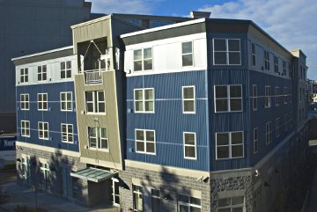
1811 Eastlake opened in 2005. It houses 75 homeless men and women with chronic alcohol addiction. It is the first of its kind in Washington to address the needs of homeless chronic alcoholics who are the heaviest users of publicly-funded crisis services.
Awards
- Home for Every American Award, Interagency Council on Homelessness, 2008
- Maxwell Award for Excellence, Fannie Mae Foundation and the Partnership to End Longterm Homelessness, top national honor 2008.
- Exemplary Program Award for Service Innovation, King County, 2007
- Annual Award, Washington Co-Occurring Disorders Inter-agency Advisory Committee (CODIAC), 2007
Evaluation
In order to evaluate the effectiveness of 1811 Eastlake, DESC collaborated with Drs. G. Alan Marlatt and Mary Larimer, nationally recognized experts in substance abuse research, and their team at the Addictive Behaviors Research Center of the University of Washington.
A grant from the Robert Wood Johnson Foundation funded an evaluation on the first three years of operation. This study examined the relationship between residing in permanent supportive housing in two salient domains: variables related to quality of life and the suppressed use of crisis services. We anticipate it will have far-reaching impact on the conventional thinking regarding housing this population.
Findings from the study were published in the April 1, 2009 edition of the Journal of the American Medical Association. Read highlights from the study.

