Property Summary
Project Background

The RapidRide I Line project will provide high-quality bus rapid transit service connecting Renton, Kent, and Auburn. It will connect to the regional transit network to improve access to destinations across the region. The I Line is one part of a larger system-wide approach to improve transit access in South King County, and will increase transit speed, reliability, and passenger carrying capacity. The three jurisdictions include regionally designated Growth Centers, as defined by the Puget Sound Regional Council’s VISION 2050 growth plan, multiple areas of high population and employment concentration, and are some of the largest and most diverse communities in King County. The vision for I Line was developed in part from the 2019 Renton-Kent-Auburn Area Mobility Plan and input from key stakeholders and the three primary jurisdictions. This vision set the groundwork for the Locally Preferred Alternative and the I Line Alignment Ordinance (#19098), which was adopted by the King County Council in April 2020.
The project will serve the transportation needs of communities that have been historically underserved – South King County communities have some of the highest proportions of low-income and minority populations in King County, as is detailed in Metro’s Mobility Framework Report and referenced in the I Line Locally Preferred Alternative Report. Large portions of the project corridor are distant from higher-speed, more reliable, and competitive transit service, such as Link Light Rail and other existing RapidRide lines. The Route 160, which currently serves the future I Line corridor, provides mobility to 1.6 million riders each year – that averages out to 5,000 trips per weekday and nearly 3,000 per weekend day. As with previous RapidRide lines, we expect ridership for the I Line to grow after launch, projecting up to 8,500 weekday trips by 2040. The I Line will deliver improved services along with increased passenger comfort along this corridor similar to what is experienced in the areas already served by RapidRide or Link service.

Property Acquisition Detail – Tax Parcel Number 322305-9135

As part of this project, certain property rights, including the property that is the subject of the proposed condemnation Ordinance, identified as tax parcel number 322305-9135, must be acquired to construct a new RapidRide station near a new mid-block pedestrian crossing. This parcel is owned by spouses Sea Main Chan and Yilin Chan. Construction of the I Line requires a small, 144 square foot permanent acquisition from the property along with a 1,397 square foot temporary easement for construction and restoration on the Chan property, described below in more detail.

Metro’s consultant, Real Estate Consultants NW, initiated negotiations for King County to acquire the property on February 1, 2022. The consultant continued to attempt negotiations through March 15, 2023. During this timeframe, Metro and its representatives made more than 20 attempts, through emails and other written communication, to provide project information and requests to meet with the property owner, each of which were rejected. Acquisition best practices, according to the International Right of Way Association, include meeting in person with property owners whenever practical to present an offer and to provide detailed responses to any owner questions and concerns. As a result of the property owner’s refusal to meet with Metro’s consultant and Metro staff, communication with the property owner and King County have been limited to email exchanges.

Metro staff made several additional attempts to communicate with and negotiate with the property owners once the consultant felt she had reached impasse with the property owner. The property owners continued to decline to meet with Metro personnel, including via in-person, by telephone, or online video meetings. Metro’s staff provided responses to the property owners’ stated concerns and addressed questions via email correspondence with no response, through July of 2023.

On November 2, 2023, Metro’s Capital Planning Manager sent a detailed letter to the property owner with a request to re-engage and open a line of communication and negotiation between them and Metro. This correspondence is attached as “Attachment A”. As of the writing of this document, Metro has received no response to the Capital Planning Manager’s letter. The responsiveness of the property owner has steadily declined, no longer responding to any contact attempts made by King County or its representatives. Consequently, after exhaustive attempts to negotiate the proposed property rights spanning over 23 months and 20 attempts beginning in February of 2022, negotiations to acquire the property are at an impasse with the property owner. At the same time, it is Metro’s desire to keep an open line of communication with the property owners, with the hope of continuing good faith negotiations to acquire property rights by negotiated agreement.

Tax Parcel Number 322305-9135
To upgrade and replace the existing bus stop located at 108th Ave SE and SE 186th St, Metro needs to acquire property rights from Tax Parcel number 322305-9135. The property is owned by spouses Sea Main Chan and Yilin Chan. The property is located on the northwest corner of 108th Ave SE (SR 515), and SE 186th Street, in the City of Renton. The parcel consists of 10,018 square feet. The property is improved with a single-family residence.

The property rights necessary for the construction, operation, and maintenance of the RapidRide station are 114 square feet of public Right of Way as a fee acquisition, and 1,397 square feet of temporary construction easement, depicted below and in attachments in more detail. This station is being added as part of a new station pair sited in accordance with Passenger Facilities Upgrade Report for the I Line RapidRide. This station was planned to be near the new mid-block pedestrian crossing that will make it safe for pedestrians to cross the street between the two passenger stations. The crossing location was approved by representatives from the Washington State Department of Transportation (WSDOT) and the permitting jurisdiction, the City of Renton, and meets WSDOT’s standards based on traffic volume, number of lanes, and posted speed limit for the affected roadway. The amount of property being acquired is determined by the fact that the new station will include a passenger shelter, as required by the FTA for all passenger stations constructed by this project. Engineers considered whether using a smaller passenger facility would have less impact on the property, but the amount of property needed to build a station at this location did not vary based on shelter size.

After reaching impasse in negotiations with the property owner and reviewing the technical design decision documentation, Metro staff affirmed that acquiring the Chan property is necessary to construct critical project improvements. Metro will continue attempting to communicate with the property owner and continue trying to acquire the property through negotiated settlement as this legislation is considered if the property owners reach out upon receiving notification of the pending legislation. Acquisition through condemnation will only be used as a last resort to maintain the project schedule and goals.

Name: Sea Main Chan and Yilin Chan
ROW File No.: R-47
Tax Parcel Number: 322305-9135
Depiction of Permanent Acquisition and Temporary Construction Easement
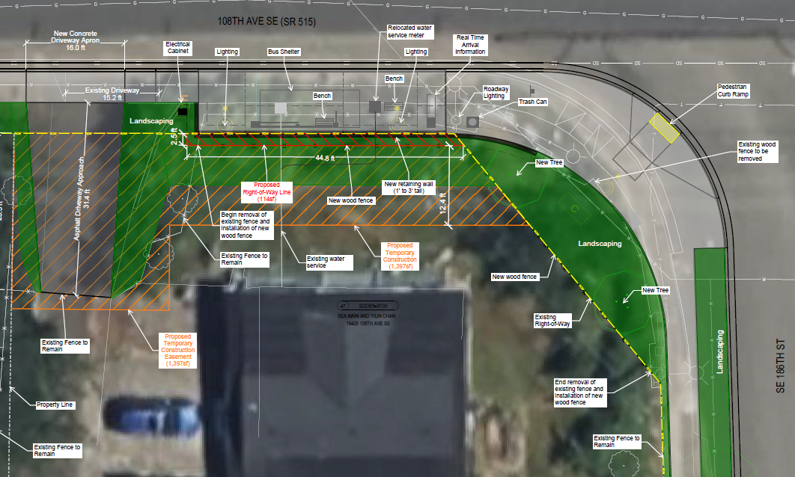

The property is located on the northwest corner of 108th Ave SE (SR 515), and SE 186th ST., in the City of Renton. The parcel consists of 10,018 square feet. The property is improved with a single-family residence.
In the depiction above, the existing public right of way is shown as the yellow dashed line. The proposed acquisition of public right of way measuring 114 square feet is shown in red hatched linework and is approximately 2.5 feet in width and 44.8 feet in length. The temporary construction easement consists of 1,397 square feet and is shown in orange hatched linework.
Attachments:
- Letter/response from Capital Planning Section Manager, Hannah McIntosh.
- Exhibits and graphic renderings.

Puget Sound Regional Council, VISION 2050 [LINK]; Centers [LINK]
King County Council, Ordinance 19098, April 28, 2020 [LINK]
King County Metro, Mobility Framework Report, October 2019 [LINK]

