STAFF REPORT

Agenda Item: | 28 | Name: | John Resha
Proposed No.: | 2010-B0178  2010-RPT0172 | Date: | September 14, 2010
Invited: | Katie Chalmers, Department of Transportation  Victor Obeso, Department of Transportation, Transit Service Development Manager

SUBJECT

A briefing on the workplan, scope and schedule of the Transit Division's evaluation of replacement technologies for the trolley bus system.

COUNCIL PRIORITIES

The trolley bus system is an integral part of King County's transit system. Replacement of this technology through an evaluation of available technologies advances the Council's 2010 priorities of Mobility for People, Goods and Services, Environmental Sustainability, and Financial Stewardship.

BACKGROUND

The King County trolley fleet is reaching the end of its useful life and is scheduled for retirement in 2014. Questions regarding replacing the vehicles and overall technology have been raised in the community, in the Transit Division, and with Council. These questions received heightened attention following the 2009 Transit Performance Audit that cited savings potential for use of diesel technologies, but recommended that transit should consider "all relevant factors" in its decision process.

As a result, Council included Proviso P4 in Ordinance 16717, Section 131 stating:

By September 1, 2010, the executive shall transmit a scope, schedule and work program developed in collaboration with council, for a 2011 trolley replacement alternatives study that identifies:

- the alternative bus propulsion technologies to be evaluated,
- the policy issues and choices associated with replacement alternatives,
- provisions for public input, and
- provisions for council input and monitoring.

The scope, schedule and work program required to be submitted by this proviso must be filed in the form of a paper original and an electronic copy with the clerk of the council, who shall retain the original and provide an electronic copy to all council members.

On August 27, 2010, the Executive transmitted 2010-RPT0172 in response to this budget proviso.

ANALYSIS

The Executive transmitted a work program that includes scope and policy issues, schedule, technologies for evaluation, and public and council involvement.

Development of this report involved engagement of an Interagency Working Group consisting of Transit Division, Executive, Council and City of Seattle staff for discussion of key concepts for inclusion in the evaluation.

Scope
Critical to this work program is the preliminary vehicle propulsion technology review conducted with input from an Interagency Working Group. As a result of the review, Table 1: Vehicle Propulsion Review Summary is provided in the report and below:

Table 1: Vehicle Propulsion Review Summary
Technologies | Feasibility for Study
Diesel | No further evaluation – Similar to Hybrids with greater environmental impact
Diesel-Electric Hybrid | Evaluate – reworked to accommodate grades
Electric Trolley | Evaluate – with propulsion back up
Electric Battery | No further evaluation – Not commercially available and reduced travel range
Compressed Natural Gas | No further evaluation – High costs and greater environmental impacts than hybrids
Hydrogen Fuel Cell | No further evaluation – Not commercially available, high costs, reduced travel range and reduced reliability

The report identifies nineteen individual evaluation points in the areas of:
- Vehicle and System Assessment and Costs – Analysis of the performance and lifecycle cost;
- Service Network – Analysis of the network impacts;
- Environmental Assessment – Analysis of the environmental impacts;
- Funding – Analysis of impacts on funding including local, state and federal grants; and
- Legal Review – Analysis of legal issues.

Schedule
The evaluation and procurement timeline is summarized within the report as follows:

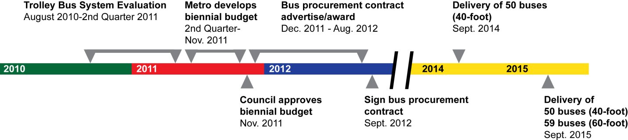

Key to this timeline will be the 2012-2013 budget proposal, which would include acquisition of a replacement fleet for the trolley bus system.

Public and Council Involvement
As the trolley system has generated significant public interest, the report also summarizes a broad multi-pronged approach to public involvement involving the internet, public meetings, outreach presentations, direct feedback and media briefings. The Transit Division also plans to conduct a public review of the evaluation results in the second quarter of 2011.

The Transit Division is also committed to maintaining and working with the Interagency Working Group throughout the evaluation process.

AMENDMENTS

None at this writing.

ATTACHMENTS

- Executive Transmitted Report 2010-RPT0172

