WASTEWATER CONSTRUCTION
Analyst: Jenny Giambattista

 |  | 2025 Proposed |  | 2026-2027 Projected |  | 2028-2029 Projected
Revenues |  | $359,207,900 |  | $855,928,140 |  | $1,617,131,339
Expenditures |  | $359,207,900 |  | $855,928,140 |  | $1,617,131,704
Major Revenue Sources: Proceeds from Bond Sales, Revolving Fund/Public Works Fund loans, Commercial Paper etc.

Description

The Water Quality Construction capital budget of the Wastewater Treatment Division (WTD) finances construction, maintenance, upgrade, and expansion of the wastewater system physical plant, including treatment facilities and the conveyance system. Over recent biennia, the regional system has been focused on constructing the Combined Sewer Overflow (CSO) projects required by a consent decree between King County and the federal Environmental Protection Agency and Department of Justice, and the Washington State Department of Ecology. Additionally, the agency is continuing its work on the Conveyance System Improvement and Treatment Planning programs, to assure the capacity of the conveyance and treatment system to meet the demands of regional growth, and facility maintenance. However, as the system continues to age, the two larger regional plants (West Point and South Plant) and hundreds of miles of interceptor pipeline that were completed in the 1960s and expanded in the 1970s and 1990s, and the Brightwater regional plant that was completed in the 2010s, the need for maintenance, repair and upgrade of facilities is becoming more urgent. WTD is accelerating its Asset Management program in response, focusing on both treatment plant and interceptor pipeline evaluation, repair, upgrade, and replacement. Meanwhile, the Washington Department of Ecology has taken a regulatory action requiring wastewater generators of nitrogen, which is the chemical element that can accelerate the growth of algae in the marine environment, to limit discharges according to the terms of a state-issued permit.

Summary of Proposed Budget and Changes

The 2025 proposed budget includes 50 capital projects and an appropriation request of $359.2 million. The requested projects reflect a mix of new and continuing projects with most projects not seeking full appropriation. In June, the Council approved a rate increase of 5.75%, with substantial increases projected for future years; much of those increases are driven by expansion of the Water Quality Construction capital budget.

The Water Quality Construction budget is categorized according to major “portfolios” to delineate the primary functions that the budget addresses. The largest expenditures are for Asset Management (repair and upgrade of mechanical systems requiring rehabilitation) and Regulatory (responding to state and federal regulatory mandates or consent decrees) investments; others include Capacity Improvements (expanding pipelines and treatment facilities in anticipation of growing capacity needs), Resiliency (strengthening structures to withstand flooding, seismic events or other natural disasters), and Resource Recovery (capturing resources generated by wastewater processing such as biogas or recyclable water for productive use or sale).

Listed below are the 2025 proposed appropriations for selected CIP projects in each of the major WTD capital portfolios:

Asset Management $214.4 million Selected Projects
- West Point Electrical Improvements: $56.8 million
- West Point Critical Gate Refurbishment: $75.9 million
- Ovation Evergreen Control Systems Lifecycle Management Program: $16 million
- West Point EPS Isolation Gate Rehabilitation: $17 million
- Research Vessel Replacement: $1.1 million

Regulatory ($49.6 million) Selected Projects
- Elliott West CSO Control Planning and Alternatives: $18.3 million
- Mouth of Duwamish Facility Plan: $15.5 million
- CSO Control and Improvement: $4.1 million

Capacity Improvement ($24.8 million) Selected Projects
- Black Diamond Trunk Capacity Upgrade: $14.6 million
- Soos Creek Cascade Relief interceptor Upgrade: $6.1 million
- West Point Digestion Capacity Expansion $2.9 million

Operational Enhancements ($2.7 million) Selected Projects
- Technology Assessment and Innovation Project: $2.8

Resiliency ($22.1 million)
- Climate Adaptation Planning Program: $4.2 million
- West Point Primary Sedimentation Area Roof Structure: $8.4 million
- West Point Passive Weir for Emergency Bypass: $9.6 million

Resource Recovery ($43.2 millions) Selected Projects
- Brightwater Reclaimed Water Storage: $35.9 million
- West Point Biogas Utilization Project: $5.5 million

Key Issues

Issue 1 – Large Increase in Capital Project Spending

As shown in Figure 1 below, planned expenditures over the six-year CIP Spending forecast are increasing significantly. According to WTD, the 2024 estimated total capital expenditure will be $327.3 million; projected expenditures for 2025 are expected to be around $448 million an increase of 37% for the coming year. WTD reports it update its expenditure updates once 2024 expenditures are analyzed and project forecasts are updated.

Updates: WTD’s capital expenditures are expected to quadruple from 2018 to 2030 going from $231 million in 2023 to about $925 million by 2030. The CIP expenditure forecast can directly impact rate setting. If WTD projects expenditures higher than can be achieved, there is a risk of seeking revenues (rates) at a level beyond what is needed in a given year. WTD has never experienced such growth and is working to accurately model expenditures and the required number of FTEs necessary to implement such an ambitious expansion in their CIP portfolio. There are many variables which can impact the delivery of such a large capital portfolio, including construction and labor market conditions.

Given the significant increase in WTD’s capital portfolio, Council staff asked for information on WTD’s capital oversight processes. WTD provided details on the processes in place to provide portfolio, program, and project oversight for CIP investments through a tiered internal governance structure.

Updates: Given the significant increase projected in WTD’s capital expenditures and the associated FTE increases, the Council may wish to direct Council staff to work with WTD to develop reporting requirements which would allow the Council to monitor, at a high level, progress in meeting the expenditure and hiring targets.

Figure 1
Proposed 2025 Budget 6-Year Spending CIP

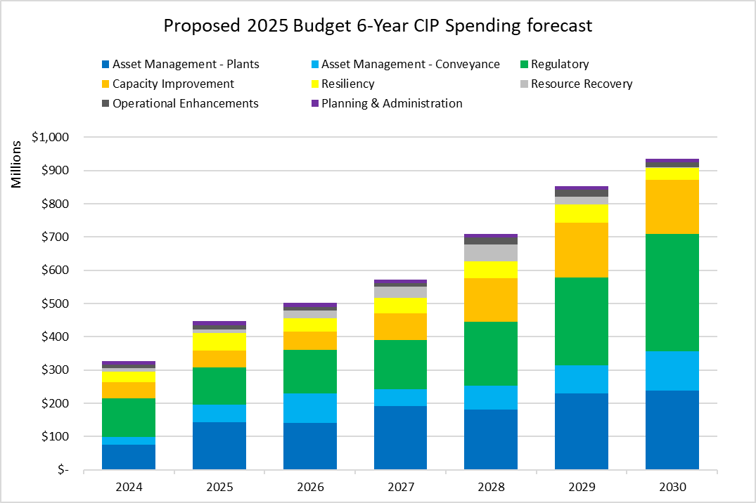

Issue 2 – High Risk Capital Projects

King County Code 4A.130.030 tasks the County Auditor with annually reviewing capital projects expected to cost over $25 million and recommending projects to be designated as “risk monitored projects (RMP)” to the County Council. The Auditor recommends projects to be designated RMP if they are at higher risk of being late or over budget at significant cost, or if delays to the project could have a significant impact. The County Council or the Executive may designate a capital project as “RMP” by letter to the County Council. For 2024, the Council has not yet designated projects as RMP.

According to the Auditor’s Office, designating a project as RMP enhances transparency on project performance by requiring project managers to provide additional project information for decision makers about project status and significant changes to scope, schedule, and budget. When a project is designated RMP, the Auditor can send updates to the Council and Executive on the status of the project. For 2024, the Auditor’s Office recommended four projects for risk monitoring. Two of the four projects are included in WTD’s proposed six-year CIP. The Auditor selected these WTD projects because of the potential impacts that delays could have on the community served by these projects. Below, council staff have included a summary of the two WTD projects recommended for Capital Project Risk Monitoring.

Sammamish Plateau Diversion Project (2025 Appropriation $417,000; Total expected cost $101 million). The Sammamish Plateau Diversion (SPD) project would add regional conveyance system capacity to manage some wastewater flows from the East Lake Sammamish area. The Wastewater Treatment Division (WTD) previously placed the project on hold for two years, resulting in the project completion date moving out from 2028 to 2030. Sammamish Plateau Water placed a development moratorium in a portion of the District for seven months in 2021. The District hired and WTD paid for a consultant study to identify interim improvements in the local system until the SPD can be constructed. WTD and the District entered into a cost-share agreement in 2021 to split the costs for funding the agreed upon interim improvements. While the SPD project has restarted, it faces barriers such as permitting in critical areas and land acquisition needs, which could further impact project delivery. Timely completion of the SPD project is necessary to ensure sufficient capacity in the regional wastewater system to serve new growth.

Black Diamond Trunk Capacity Upgrade (2025 Appropriation $14.6 million; Total expected cost $167 million). The Black Diamond Trunk Capacity Upgrade project would increase the capacity of the existing sewer trunk line to meet King County’s 20-year peak flow standard and serve significant new growth within the City of Black Diamond. Currently, the majority of pipe reaches within the Black Diamond trunk line have less than a 10-year level of service, which will continue to degrade as development occurs. Risks the project faces include the need for permitting for multiple stream crossings and lack of internal staff capacity. Timely completion of the capacity upgrade is necessary to ensure sufficient capacity in the regional wastewater system to serve growth in the City of Black Diamond.

Response to Council Inquiries

Question 1: Provide more information on Brightwater reclaimed water storage Project.

Answer: The primary goal of this project is to install a reclaimed water storage tank along with necessary disinfection improvements at the Brightwater Treatment Plant. This project will improve reliability of the existing permitted capacity of the Brightwater reclaimed water system. The current reclaimed water system has experienced frequent outages, which has been a challenge to meeting obligations to WTD’s current reclaimed water customers while meeting WTD’s reclaimed water permit. These outages are primarily due to permit non-compliance related to chlorine residuals in the reclaimed water and stops in production of the reclaimed water due to interruptions in wastewater supply during daily maintenance activities at the Brightwater Influent Pump Station. The chlorine concentration in the reclaimed water has not always been within the acceptable range, leading to disruptions in service. By adding the storage capacity, chemical addition, and enhancing system controls, we can better manage the chlorine levels, ensuring more reliable service and fewer interruptions.

WTD currently sells recycled water to three customers in the Sammamish Valley, and truck fill customers occasionally. The water is primarily used for irrigation. The project does not include distribution line extensions.

WTD reports this project is consistent with the following provisions in The Regional Wastewater Services Plan (K.C.C. 28.86.100) Water reuse policies (WRP), some of which are highlighted below.

WRP-1: King County shall actively pursue the use of reclaimed water while protecting the public health and safety and the environment. The county shall facilitate the development of a water reuse program to help meet the goals of the county to preserve water supplies within the region and to ensure that any reclaimed water reintroduced into the environment will protect the water quality of the receiving water body and the aquatic environment.

WRP-3: Recycling and reusing reclaimed water shall be investigated as a possible future significant new source of water to enhance or maintain fish runs, supply additional water for the region's nonpotable uses, preserve environmental and aesthetic values and defer the need to develop new potable water supply projects.

WRP-12: King County shall retain the flexibility to produce and distribute reclaimed water at all treatment plants including retaining options to add additional levels of treatment.

WRP-13: King County shall continue to evaluate potential funding of pilot-scale and water reuse projects, in whole or in part, from the wastewater utility rate base.

Community engagement activities are being planned as part of the SEPA and permitting processes. This community engagement is anticipated to start in early 2025.

If this project is not done, WTD reports King County will be unable to meet the ongoing needs of the existing reclaimed water customers, require continued payment by King County for supplemental potable water to a reclaimed water customer, hinder SCAP efforts to reduce Sammamish River withdrawals affecting salmon in the Sammamish River, and reduce diversion of nutrients from Puget Sound that could be used beneficially for irrigation to grow plants instead.

WTD reports the following work has been on the project thus far: The project completed selection of a recommended alternative in 2022. This selected alternative includes two construction packages. The first package (Package 1) involves replacing reclaimed water diversion valves and chemical dosing pumps. These replacements are intended to address reliability issues related to these specific pieces of existing equipment. Package 1 is currently in construction. The second package of improvements (Package 2) includes the storage tank and disinfection system components. The team is nearing completion of preliminary design of the second package. The team has also completed initial virus removal testing of the existing membrane bioreactor equipment at the plant to determine how much more they can contribute to disinfection of the reclaimed water and reduce the amount of other disinfection methods used.

WTD reports the following major milestones for 2025: Preliminary design of Package 2 is anticipated to be completed in 2024, and the project is scheduled for its baseline presentation with division leadership in October. If the baseline scope and schedule are approved, the 2025 milestones include construction completion of Package 1, 60% design completion of Package 2, land use permit application for Package 2, and additional testing of the membrane bioreactors.

Question 2: How much of the increase in CIP expenditures is due to building more things versus inflation?

Answer: WTD provided the following response: “Most of the increase is due to building more infrastructure. The recent historical inflation is reflected in the cost estimates of projects that are nearing construction early in the 6-Year period. For active projects, especially those nearing construction, cost estimates are regularly updated at points along the design lifecycle, particularly prior to construction bidding. Those recently updated cost estimates do reflect recent increases in materials and labor costs that have risen significantly over the last several years. Due to the way that cost estimates are developed and structured, it is difficult to parse out how much of the overall cost estimate is directly attributable to the recent historic inflation. Inflation to project costs in future years reflects the annual capital inflation assumption of 3%.”

King County Auditor’s Office Recommendations on Capital Project Risk Monitoring (June 26, 2024)

