STAFF REPORT

Agenda Item: | 8 | Name: | Mary Bourguignon
Proposed No.: | 2022-B0092 | Date: | September 21, 2022

SUBJECT

Today’s briefing will provide an overview of how flexible services are planned, piloted, and evaluated.

SUMMARY

Flexible services are defined as transportation services that are tailored to meet specific community needs and operate without a fixed route. These types of services may or may not serve designated stops or hubs, depending on service design, and they are typically deployed in communities that lack the infrastructure, density, or land use to support fixed-route bus service.

Flexible services are planned and implemented by Metro following criteria outlined in the adopted Service Guidelines. Specifically, the Service Guidelines provide guidance on planning flexible services, adding flexible services, evaluating flexible services, and reducing flexible services.

During today’s briefing, Metro staff will provide information on how the flexible services program was established; the policy basis for flexible services; current flexible services, including types of services, locations, and performance; marketing of flexible services; innovative and new features; evaluation of flexible services; and decision-making and life cycle of a pilot program.

BACKGROUND

Metro’s flexible services are defined in its adopted policy documents as transportation services tailored to meet specific community needs that operate without a fixed route. Flexible services may or may not serve designated stops or hubs, depending on service design. They are typically deployed in communities that lack the infrastructure, density, or land use to support fixed-route bus service.

Flexible services are identified in Metro’s adopted policy documents as one of the categories of service Metro offers. These “service types,” which are defined based on the level of service a route provides, are Very frequent/RapidRide, Peak Frequent, Local, Hourly, Peak-only, and Flexible services. Flexible services include community shuttles, community vans, DART (Dial-a-Ride) service, and other on-demand services.

Flexible services are planned and implemented by Metro following criteria outlined in the adopted Service Guidelines. Specifically, the Service Guidelines provide guidance on planning flexible services, adding flexible services, evaluating flexible services, and reducing flexible services.

Figure 1, below, which is from the adopted Service Guidelines, outlines the process through which a flexible service is identified, developed, piloted, and evaluated.

Figure 1.
Life Cycle of a Pilot Project

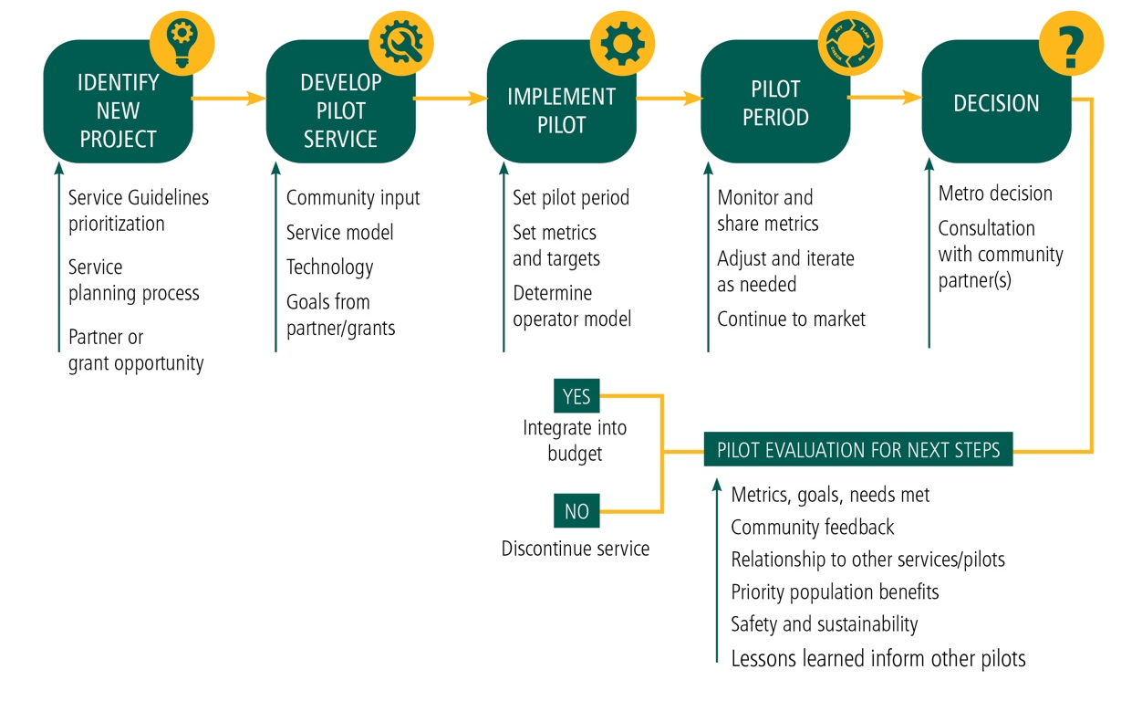

During today’s briefing, Metro staff will provide more information about Metro’s existing flexible services, as well as how flexible services are planned, piloted, marketed, and evaluated.

INVITED

- Brian Henry, Transportation Planner, Service Planning, Metro Transit Department
- Casey Gifford, Transportation Planner, Research and Innovative Programs, Metro Transit Department

ATTACHMENTS

- Metro presentation

King County Metro Policy Updates, Technical Report A, July 2021 (transmitted as ancillary material to the policy documents adopted through Ordinance 19367) (link)
Ordinance 19367, Attachment B
King County Metro Policy Updates, Technical Report A, July 2021 (transmitted as ancillary material to the policy documents adopted through Ordinance 19367) (link)
Ordinance 19367
Metro On-Demand Services (link)
Ordinance 19367, Attachment B
Ordinance 19367, Attachment B, p. 30

