April 18, 2013

SEPTEMBER 2013
SNOQUALMIE VALLEY ALTERNATIVE SERVICE
DEMONSTRATION PROJECT FOR KING COUNTY

SNOQUALMIE VALLEY ALTERNATIVE SERVICE
DEMONSTRATION PROJECT

OBJECTIVES:
Develop and implement alternative transportation services that meet mobility needs in the Snoqualmie Valley at a lower operating cost consistent with the Strategic Plan for Public Transportation 2011-2021 and the Five-Year Implementation Plan for Alternatives to Traditional Transit Service Delivery.

- Strategic Plan Strategy 2.1.1: Design and offer a variety of public transportation products and services appropriate to different markets and mobility needs.

- Strategic Plan Strategy 2.1.2: Provide travel opportunities for historically disadvantaged populations, such as low-income people, students, youth, seniors, people of color, people with disabilities, and others with limited transportation options

- Strategic Plan Strategy 2.1.3: Provide products and services that are designed to provide geographic value in all parts of King County

- Strategic Plan Strategy 2.1.4: Seek to provide to the general public an extensive range of transportation alternatives to regular fixed route-transit, such as ridesharing and other alternative or “right-sized” services.

- Strategic Plan Strategy 6.2.3: Develop and implement alternative public transportation services and delivery strategies.

- Strategic Plan Strategy 6.2.4: Provide alternative or “right-sized” services in the context of overall system financial health and the need to reduce, maintain or expand the system.

- Five-Year Implementation Plan for Alternatives to Traditional Transit Service Delivery - Opportunities for alternative service delivery exist where population density is low and fixed-route services may not be cost-effective. It may make more sense to meet travel needs in the area with alternative products like carpools and vanpools, community-access transportation, employer transportation programs, flexible transit services, shared taxis, and taxi scrip.

IMPACTED SERVICE AREA:
Duvall, Carnation, Fall City, Snoqualmie, North Bend and unincorporated areas of King County in the Snoqualmie Valley.
Community Collaboration Process

Per Motion 13736, the Council directed Metro to demonstrate alternative services to traditional fixed route service using the community collaboration planning process outlined below.

- Use our service guidelines to identify current services that may be candidates for replacement with an alternative service. The first step is to analyze the productivity of each route in the system. Routes with productivity in the lowest 25 percent will be analyzed for possible elimination, restructuring, or other remediation.
Result: Using the Service Guidelines, Metro identified Routes 209, 224, and 311 as having productivity in the lowest 25%, and therefore analyzed them for possible elimination, restructuring, or other remediation to fund alternative services.

- Where a route has been identified for possible replacement with an alternative service, Metro will meet with community stakeholders to identify existing transportation providers, service gaps, and mobility needs. Metro will find out from users of the existing fixed-route bus service how and why they use the service, what other transportation options might be available to the community, and what connections to the public transit network the current users need to maintain.
Result: Starting in October 2012, Metro met with community stakeholders to identify existing transportation providers, service gaps, and mobility needs. Stakeholders included existing bus riders, local jurisdictions, local community organizations and business associations, service providers, schools, medical facilities, employers, and the general public. Metro found out how existing fixed-route bus service is used, what alternative transportation might be available to the community, and what connections to the public transit network the current riders need to maintain.

- Metro will propose two or three alternative service options, based on the following criteria:
- The ability to expand access to travel options for residents in the community
- How well the option maintains the public’s access to “important trips”—e.g., the trip to ongoing, critical medical services
- Maintenance or improvement of social equity and geographic value
- Cost-effectiveness

Result: Based on community feedback and the criteria referenced above, Metro developed a set of alternative service options that expand and improve access to travel options for residents in the community, maintain existing connections to the fixed-route transit network, and provide cost effective service. The final proposal revises Routes 209, 224 and 311, as described herein, to partially fund the alternative service demonstration project:

- Communities may propose an option that is different or modified from what Metro proposes. This is also the opportunity for implementation partners to formalize their commitment to a service.
Result: Metro worked closely with the community to refine the alternative service options and identified two partners in the Snoqualmie Valley that are committed to working with Metro to implement the alternative service. The first partner is Snoqualmie Valley Transportation, an existing local transportation service provider that Metro will contract with to implement the alternative service demonstration project. The second partner is the Snoqualmie Tribe, who will be contributing $50,000 annually for the next five years to help fund the alternative service.

- Metro will choose one or more alternative products for implementation.
Result: Metro will implement a new alternative product called the Snoqualmie Intra-Valley Shuttle as described herein. Additionally, Metro will implement existing alternative products such as VanPool and VanShare.

- Using the service change ordinance process, Metro will seek the approval of the King County Council to eliminate fixed-route services in the candidate area in order to fund the alternative service demonstration.
Result: Metro is using the service change ordinance process to seek approval of the King County Council to revise fixed-route services in the Snoqualmie Valley in order to fund the alternative service demonstration project. The proposed revisions to the fixed-route transit network will produce approximately 3,300 annualservice hours and together with the Snoqualmie Tribe’s contribution can be reinvested in the new Snoqualmie Intra-Valley Shuttle.

- Metro will create regular reports on the alternative service(s) provided, and will evaluate the alternative service(s) annually for future funding.
Result: Metro will create regular reports on the alternative service demonstration project and will evaluate the alternative service annually for future funding and/or revision. The framework for the consideration and evaluation of alternative services will be established in the 2013 update of Metro’s Strategic Plan for Public Transportation

Snoqualmie Intra-Valley Service

The purpose of the demonstration is to test an alternative service delivery method that expands mobility options for the communities within the Valley at a lower cost than provided by current services.

Snoqualmie Intra-Valley Shuttle will connect Duvall and North Bend, via Carnation, Fall City, and Snoqualmie Monday through Friday from approximately 6:00 a.m. to 7:00 p.m, about every 90-minutes. The service will have demand response areas with variable routing in Duvall and North Bend. The level of service identified herein will be monitored, and frequency and span of service may be adjusted to respond to use and changing needs in the Snoqualmie Valley.

The Snoqualmie Valley Intra-Valley Shuttle will be a proof-of-concept demonstration that shall be operated for at least five years. The purpose of the demonstration period is to determine if the new service type is providing mobility as designed, to ensure the community model is stable and sustainable and to fully evaluate the new service type. Furthermore, the five year period will provide assurance to the jurisdictions and communities within the Snoqualmie Valley of Metro’s commitment to maintain the last public transit connection in the Duvall to Fall City portion of the corridor, per the guidance of the Strategic Plan for Public Transportation.

King County Metro’s Access and Community Access Transportation service in the impacted area will continue as currently operated during this demonstration project.

Snoqualmie Intra-Valley Shuttle will:
- Be open to the general public
- Include fixed route segments and a demand response area in Duvall and North Bend
- Operate on a regular schedule with timed connections to Route 224 in Duvall
- Be outside the ORCA regional fare system
- Not have a Metro route number
- Have a suggested donation on intra-valley trips
- Not be given a Metro timetable or be part of Metro’s Online TripPlanner.

Metro shall contract Snoqualmie Intra-Valley Shuttle to a qualified local service provider for a period of five years, with an opportunity to extend the service agreement for an additional five years. Any revenue produced by the operation of this service will be deducted from reimbursement requests to Metro. The service provider shall comply with the American with Disabilities Act and King County standards for insurance, drug testing, workers compensation insurance, driver training, performance monitoring, and reporting.

Metro shall report to the council annually on the performance and lessons learned from the Snoqualmie Valley demonstration project. At a minimum, Metro shall report the number of boardings, the cost per boarding, and the level of satisfaction among riders of the alternative service. These performance measures shall be compared to the fixed-route services that the demonstration replaces and will be evaluated for suitability for future demonstration projects.
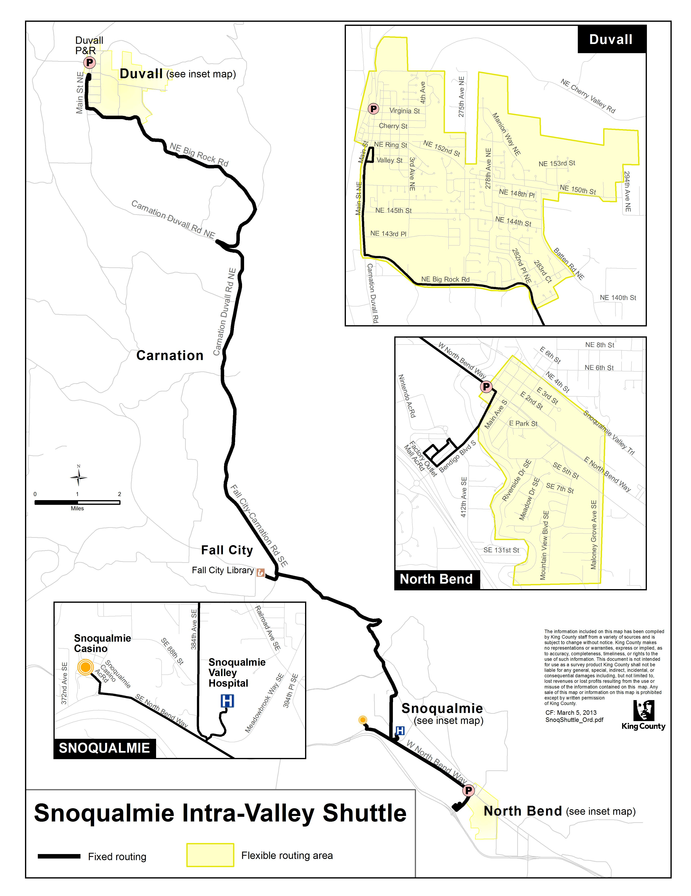
revisions to the snoqualmie valley fixed route traNsit network:

NEW ROUTE: 208

OBJECTIVES:
Improve service to the growing transit market at Snoqualmie Ridge and implement alternative transportation services that meet different mobility needs at a lower operating cost consistent with the Strategic Plan for Public Transportation, 2011-2021 and the Five-Year Implementation Plan for Alternatives to Traditional Transit Service Delivery.

- Strategic Plan Strategy 2.1.1: Design and offer a variety of public transportation products and services appropriate to different markets and mobility needs.

- Strategic Plan Strategy 3.2.1: Expand services to accommodate the region’s growing population and serve new transit markets.

- Strategic Plan Strategy 3.4.1: Serve centers and other areas of concentrated activity, consistent with Transportation 2040.

IMPACTED SERVICE AREA:
North Bend, Snoqualmie, and Issaquah
SERVICE CHANGE:

Establish new Route 208 to provide reverse peak direction, midday, evening and Saturday service between North Bend and Issaquah via the City of Snoqualmie and Snoqualmie Ridge.

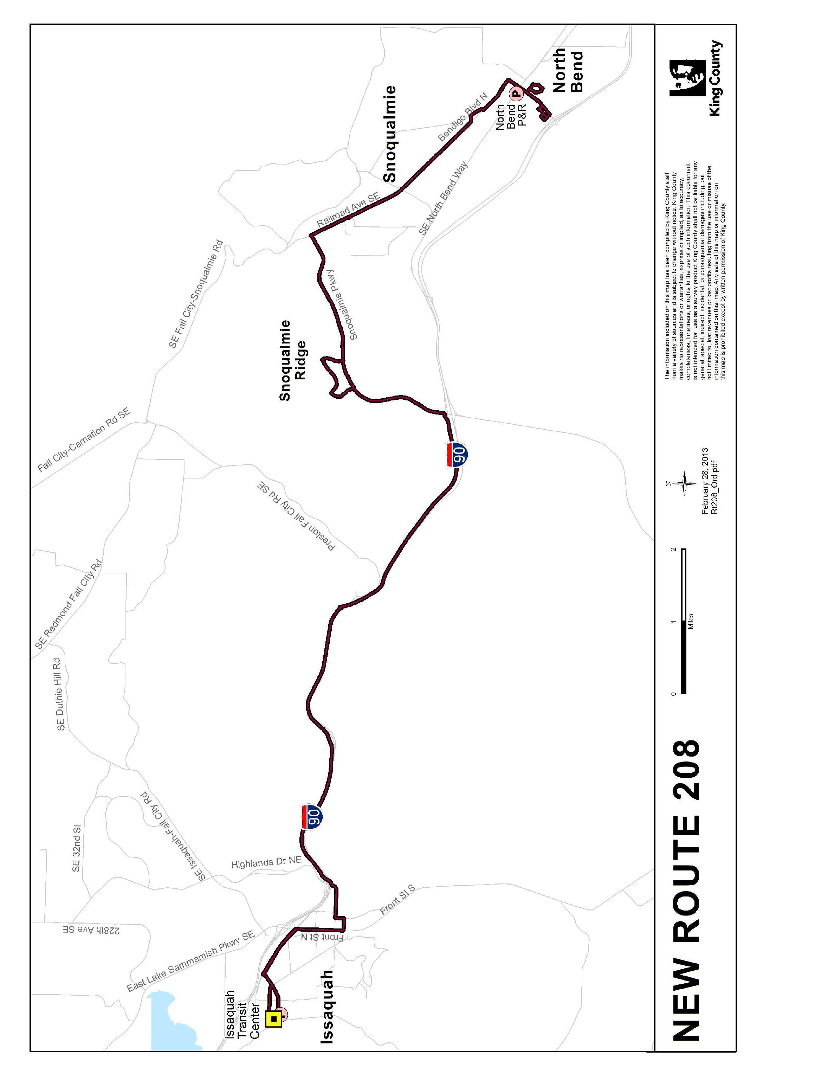

ROUTE: 209

OBJECTIVES:

Improve the productivity of Metro Transit’s network of bus routes by eliminating or reducing low performing routes according to the Strategic Plan for Public Transportation 2011-2021 and King County Metro Service Guidelines and the Five-Year Implementation Plan for Alternatives to Traditional Transit Service Delivery.

- Strategic Plan Strategy 2.1.1: Design and offer a variety of public transportation products and services appropriate to different markets and mobility needs.

- Strategic Plan Strategy 2.1.2: Provide travel opportunities for historically disadvantaged populations, such as low-income people, students, youth, seniors, people of color, people with disabilities, and others with limited transportation options

- Strategic Plan Strategy 2.1.3: Provide products and services that are designed to provide geographic value in all parts of King County.

- Strategic Plan Strategy 6.2.1: Continually explore and implement cost efficiencies, including operational and administrative efficiencies

IMPACTED SERVICE AREA:
North Bend, Snoqualmie, Fall City, Preston, Issaquah, and unincorporated areas adjacent to Fall City-Snoqualmie Road and Preston-Fall City Road.
SERVICE CHANGE:

Eliminate deviation to Boalch Avenue NW and NW 14th Street. Revise Route 209 to provide three morning and three afternoon peak direction trips between North Bend and Issaquah Transit Center via Fall City-Snoqualmie Road and Preston-Fall City Road.

Alternative service will be provided between Fall City and Snoqualmie on the Snoqualmie Intra-Valley Shuttle, as outlined herein. No replacement service will be available on Preston-Fall City Rd SE in the off-peak.

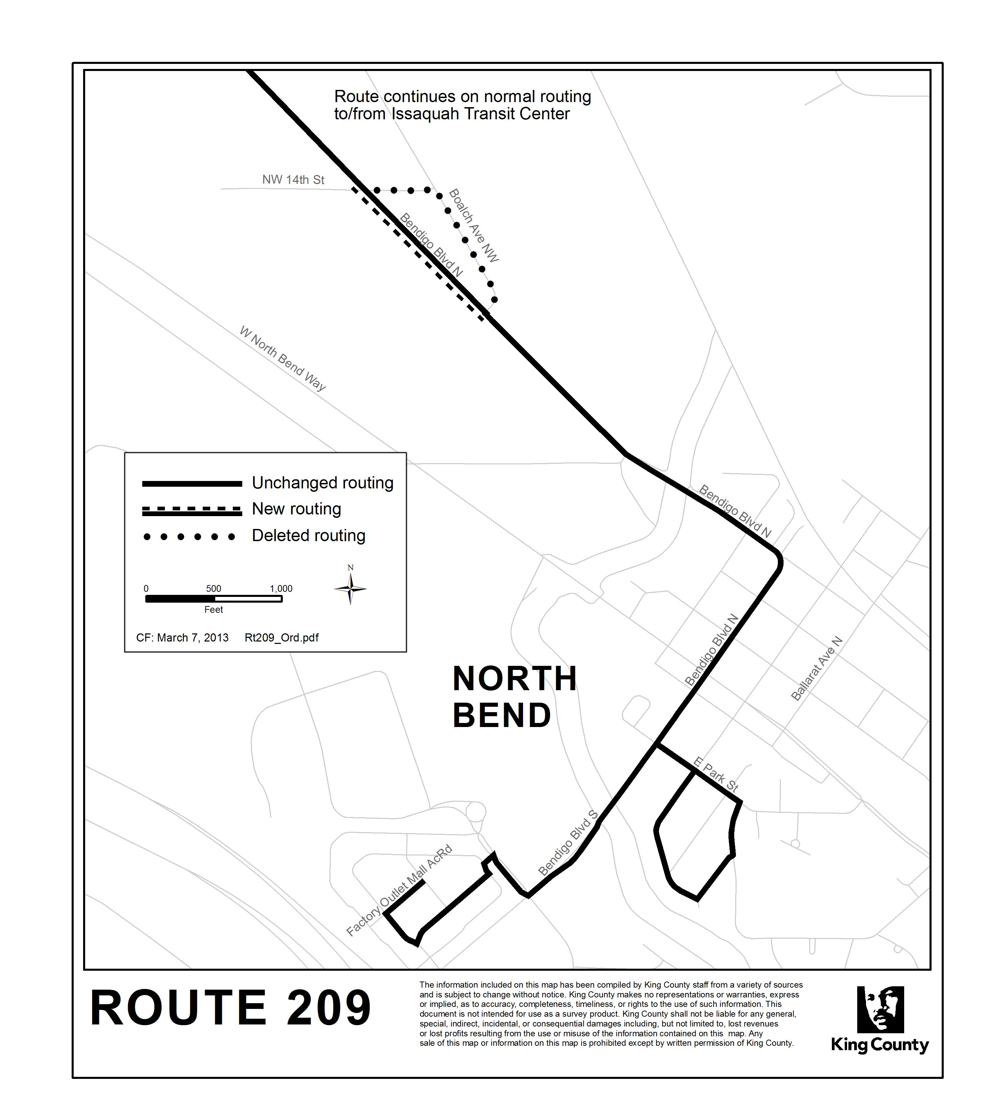
ROUTE: 224

OBJECTIVES:
Improve service to the growing transit market at Redmond Ridge and develop and implement alternative transportation services that meet different mobility needs at a lower operating cost consistent with the Strategic Plan for Public Transportation, 2011-2021 and the Five-year Implementation Plan for alternatives to traditional transit service delivery.

- Strategic Plan Strategy 2.1.1: Design and offer a variety of public transportation products and services appropriate to different markets and mobility needs.

- Strategic Plan Strategy 2.1.2: Provide travel opportunities for historically disadvantaged populations, such as low-income people, students, youth, seniors, people of color, people with disabilities, and others with limited transportation options

- Strategic Plan Strategy 2.1.3: Provide products and services that are designed to provide geographic value in all parts of King County.

- Strategic Plan Strategy 2.1.4: Seek to provide to the general public an extensive range of transportation alternatives to regular fixed route-transit, such as ridesharing and other alternative or “right-sized” services.

- Strategic Plan Strategy 3.4.1: Serve centers and other areas of concentrated activity, consistent with Transportation 2040.

- Strategic Plan Strategy 4.2.1: Operate vehicles and adopt technology that has the least impact on the environment and maximizes long-term sustainability.

- Strategic Plan Strategy 6.1.1: Manage the transit system through service guidelines and performance measures.
- Strategic Plan Strategy 6.2.1: Continually explore and implement cost efficiencies, including operational and administrative efficiencies

IMPACTED SERVICE AREA:
Fall City, Carnation, Duvall, Redmond, and Redmond Ridge
SERVICE CHANGE:

Revise Route 224 to operate between Duvall and Redmond with expanded routing in Redmond Ridge. Increase number of trips from 13 to 20 on a 90-minute headway. Alternative service will be provided between Duvall and Fall City on Snoqualmie Intra-Valley Shuttle, as outlined herein.

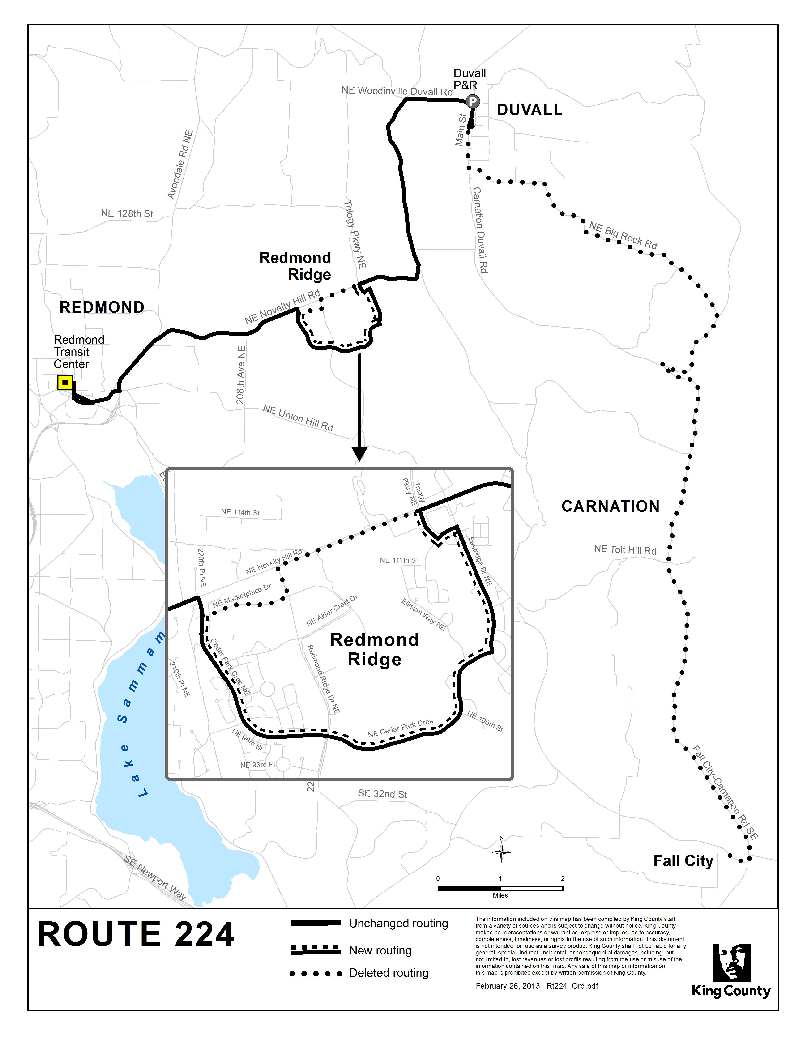
ROUTE: 311

OBJECTIVES:
Improve the productivity of Metro Transit’s network of bus routes by eliminating or reducing low performing routes or route segments according to the Strategic Plan for Public Transportation, 2011-2021 and King County Metro Service Guidelines:

- Strategic Plan Strategy 6.1.1: Manage the transit system through service guidelines and performance measures.
  - Performance management – Productivity measures identify routes where performance is strong or weak as candidates for addition, reduction or restructuring.
  - Service Design Guideline for Route Spacing and Duplication – Routes should be designed to avoid competing for the same riders

- Strategic Plan Strategy 6.2.1: Continually explore and implement cost efficiencies, including operational and administrative efficiencies

IMPACTED SERVICE AREA:
Woodinville, Cottage Lake, Duvall, and unincorporated areas adjacent to Woodinville-Duvall Road
SERVICE CHANGE:

Eliminate the Route 311 segment between Woodinville and Duvall. Alternative service between Duvall and Seattle is available on routes 224 or 232 connecting to Sound Transit Route 545 at the Redmond Transit Center. From Duvall to Woodinville, alternative service is available on Route 232 connecting to Route 931. Alternative services such as VanPool, VanShare and carpooling are also available. Metro will promote these alternative commute options and facilitate ridematching to existing Route 311 riders.

