STAFF REPORT

Agenda Item: | 7 | Name: | Jake Tracy
Proposed No.: | 2024-0261 | Date: | March 19, 2025

SUBJECT

Proposed Ordinance (PO) 2024-0261 would authorize the Executive to enter into an interlocal agreement (ILA) with the City of Shoreline to implement a program of using transferrable development rights (TDR credits) from unincorporated King County for development within the City.

SUMMARY

PO 2024-0261 would authorize the Executive to enter into an ILA with the City of Shoreline to implement a program of using TDR credits from unincorporated King County for increased development within the City.

The ILA would establish receiving areas within the City of Shoreline for which TDR credits could be used for increased residential density or reductions in structured parking requirements. TDR credits from all eligible sending areas in unincorporated King County could be transferred to the City of Shoreline.

The agreement would commit the City to accepting at least 20 TDR credits, and would stipulate that the City must purchase 185 TDR credits from the County’s TDR Bank before accepting any TDR credits from another source.

The County would be required to provide the City with 25% of the net revenue from sale of each TDR credit for use in providing infrastructure and amenities in the receiving area. The ILA would also suggest that the County provide up to $1 million in conservation futures tax funding to the City for acquisition of public open space and parks, but only if recommended by the Conservation Futures Advisory Committee and approved by the Council through budget deliberations.

The agreement would be good for 25 years, unless extended by the parties.

BACKGROUND

King County adopted a transfer of development rights program ("the TDR program") in 2001 to transfer residential density from eligible sending sites to eligible receiving sites through a voluntary process that permanently preserves urban, rural, and resource lands that provide a public benefit. The TDR provisions are intended to supplement land use regulations, resource protection efforts, and open space acquisition programs and to encourage increased residential development density or increased commercial square footage, especially inside cities, where it can best be accommodated with the least impacts on the natural environment and public services. Since 2001, the TDR program has protected more than 147,500 acres of rural area and resource lands.

The TDR Program is governed by K.C.C. 21A.37. Eligible sending sites are:
- Designated agricultural production district or forest production district and zoned accordingly;
- Designated in the Comprehensive Plan as rural area, zoned RA, and meeting the state definition of open space or farm and agricultural land;
- Designation as a regional trail or open space site;
- Habitat for endangered or threatened species;
- Designated urban separator or zoned R-1; or
- Zoned R-4 through R-48 and approved for conservation futures tax (CFT) funding.

Eligible receiving sites are:
- Unincorporated urban sites zoned R-4 through R-48;
- RA-2.5-zoned properties;
- Sites in Snoqualmie Pass Rural Town through the inclusionary housing program; and
- Cities.

The County operates a TDR Bank to assist in the implementation of the TDR program by bridging the time gap between willing sellers and buyers of development rights by purchasing and selling development rights, purchasing conservation easements, and facilitating interlocal TDR agreements with cities in King County through the provision of amenity funds. TDR credit sales through the TDR Bank are required to be at or above the fair market value of the TDR credits.

For TDRs sold by the TDR Bank to be used in cities, the County and the City are required to have an executed ILA and the City must have enacted legislation to implement the program for the receiving area.

K.C.C. 21A.37.140, quoted below, includes the requirements for TDR ILAs.

“B.1. At a minimum, each interlocal agreement shall:
a. describe the legislation that the receiving jurisdiction adopted or will adopt to allow the use of TDR;
b. identify the receiving area;
c. require the execution of a TDR extinguishment document in conformance with K.C.C. 21A.37.080; and
d. address the conversion ratio to be used in the receiving site area.
2. If the city is to receive any amenity funds, the interlocal agreement shall establish the amount of funding and the amenities to be provided in accordance with K.C.C. 21A.37.150.I. Such an interlocal agreement may also indicate that a priority should be given by the county to acquiring TDRs from sending sites in specified geographic areas. If a city has a particular interest in the preservation of land in the rural area or a natural resource land, or in the specific conditions on which it will be preserved, then the interlocal agreement may provide for periodic inspection or special terms in the conservation easement to be recorded against the sending site as a preacquisition condition to purchases of TDRs within specified areas by the TDR bank.
C. A TDR conversion ratio for development rights purchased from a sending site and transferred to an incorporated receiving site area may express the amount of additional TDRs in terms of any combination of units, floor area, height, or other applicable development standards that may be modified by the city to provide incentives for the purchase of TDRs.”

King County can provide money for amenities in receiving areas through the TDR program, as referenced above and outlined in an ILA. Amenities may include “the acquisition, design, or construction of: public art, cultural and community facilities, parks, open space, trails, roads, parking, landscaping, sidewalks, other streetscape improvements, transit-related improvements, affordable housing for households whose income is at or below area median income, which, for the purposes of this subsection C., is the median household income for the TDR receiving area as established by the United States Department of Housing and Urban Development, adjusted for household size, or other improvements or programs that facilitate increased densities on or near receiving sites.”

In 2024, The City of Shoreline adopted Ordinance 1009, which adopted a Transfer of Development Rights Program authorizing and prioritizing sending sites from unincorporated King County for use in designated areas within the City.

ANALYSIS

PO 2024-0261 would authorize the Executive to enter into an ILA with the City of Shoreline to implement a program of using TDR credits from unincorporated King County for increased development within the City. The ILA is Attachment A to the PO and contains the following substantive provisions.

Receiving Area and Exchange Rates. Exhibit A to Attachment A shows the eligible receiving areas, as shown in the blue-outlined areas of Figure 1 below.

Figure 1. Eligible Receiving Areas in the City of Shoreline

The ILA would establish the following exchange rates for TDR credits, as shown in Exhibit B, which reflects Shoreline Municipal Code 20.50.800

Table 1. TDR Credit Exchange Rates
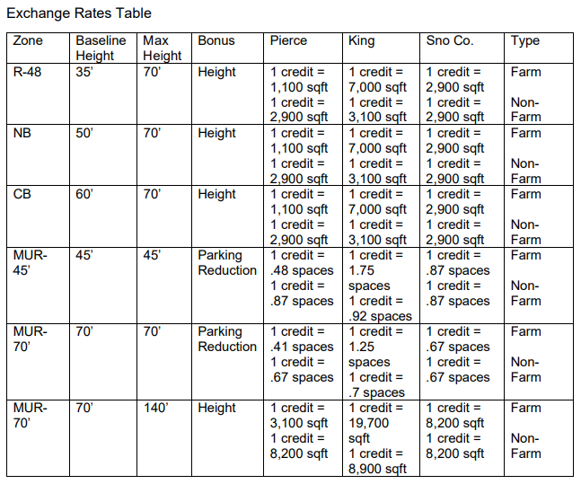

City of Shoreline Responsibilities. The City would agree to accept at least 20 TDR Credits from King County, to be used for increased building height or reductions in structured parking requirements in the Receiving Area shown in Figure 1, pursuant to the TDR conversion ratios shown in Table 1. The receiving area ratios could be modified by mutual agreement between the City and the County. Note that, while the agreement describes the increased height as “increased density,” and increased height can be used to increase residential density, this is not a given. Increased height could also be used to provide the same number of units at larger sizes, rather than more units.

The City would also agree to purchase at least 185 TDR credits from the TDR Bank and use those credits for the purposes outlined in Table 1 before buying credits from any other sellers.

The City would develop a notification and reporting process by which it would notify the County that it has approved the use of TDR credits in a development project, and report each year on the number and location of credits used.

King County Responsibilities. The County would be required to facilitate and pursue qualification and certification of sending sites in unincorporated King County and require easements on said properties. It would also be required to operate the TDR Bank and administer sales to developers in receiving areas.

King County would also be required to provide amenity funding, and be encouraged to provide conservation funding, as discussed below.

Amenity Funding. As discussed in the background section of this staff report, King County code allows the County to provide funding for various amenities in receiving areas through execution of an ILA. The proposed ILA would require that the County, through the TDR Bank, provide the City with 25% of the net revenue for each TDR credit used in the receiving area, after 15% of gross revenue has been retained for administrative costs. The funding must be provided to the City with 60 days of TDR credit sale. All code-allowed amenity uses (listed in the Background section of this staff report) would be eligible to receive this funding. The County could choose to provide additional amenity funding.

Conservation Futures Funding. The agreement would state that, if recommended by the Conservation Futures Advisory Committee and included in enacted appropriations legislation, the County will provide up to $1 million in conservation futures tax funding to the City for acquisition of public open space and parks to “support a healthy, resilient, and sustainable community” in the Receiving Area. In accordance with K.C.C. 26.12.025, money would need be used for one of the following eligible purposes:

- Parks, open space, gardens, or gateways;
- Wildlife habitat;
- Salmon habitat and aquatic resources;
- Scenic resources;
- Historic or cultural resources;
- Urban passive-use natural area/greenbelt;
- Park, open space or natural corridor addition; or
- Passive recreation opportunity in area with unmet needs.

The City would become eligible for this funding 60 calendar days after 20 TDR Credits have been purchased from the Bank, but no sooner than January 15, 2026.

Other Provisions. The agreement would be in effect for twenty-five years, unless terminated earlier or renewed. It contains legal language around evaluation and monitoring, indemnification, and other general terms.

AMENDMENT

Amendment 1 would replace Attachment A, the ILA, with a new version of the attachment that makes technical and clarifying changes, including updating the receiving area map to remove extraneous data, adding hyperlinks, adding the most recent version of code provisions, and making changes to phrasing to match Executive intent.

INVITED

- Nicholas Bratton, Transfer of Development Rights Program Manager, Department of Natural Resources and Parks

ATTACHMENTS

- Proposed Ordinance 2024-0261 (and its attachment)
- Amendment 1 (and its attachment)
- Transmittal Letter
- Fiscal Note

K.C.C. 21A.37.010.A.
Except those sold under a TDR for affordable housing program.
K.C.C. 21A.37.150
SMC 20.50.800
The ILA says “from any other Sending Area,” but Executive staff have confirmed that the intent is that the credits be purchased from the bank before being purchased from private sellers.

