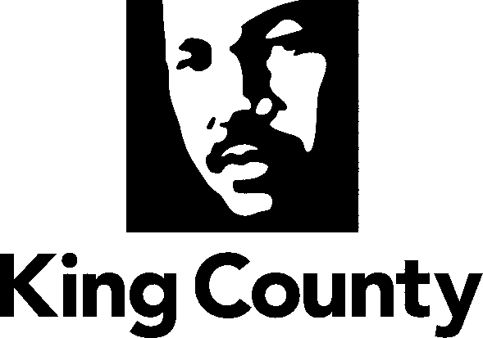

Metropolitan King County Council
REGIONAL TRANSIT COMMITTEE

STAFF REPORT

AGENDA ITEM: 9 DATE: September 16, 2009

PROPOSED NO. 2009-0535 PREPARED BY: Arthur Thornbury

SUBJECT: Amendments to the Transit Strategic Plan and the Transit Program Financial Policies

SUMMARY: The Transit Division will brief the committee on executive-proposed amendments to current transit policies related to elements of the executive-proposed budget to be transmitted to the council on September 27th.

BACKGROUND: The 2010-2011 Transit Budget will set the direction of county response to the economic recession that has created a large and growing gap between transit revenues and expenditures. In addition, the biennial budget will be the first opportunity to implement the recommendations of the Transit Performance Audit which will presented to the committee today. The executive has transmitted a package of legislation for council consideration to related to initiatives that will be assumed in the budget he transmits on September 27th and which the council will revise and adopt by Thanksgiving. Of the four pieces of legislation transmitted on September 3rd, one, Proposed Ordinance 2009-0535, would amend existing transit policies and has been referred to the RTC.

Today, Transit Division staff will present the proposed policy changes to the committee, describing them in the larger context of the other budget-related transit legislation which has been referred to other council committees. Consideration of possible amendments and committee action on Proposed Ordinance 2009-0535 will take place at the October meeting of the RTC.

Related Legislation
2009-0534 This proposed ordinance, which has been referred to the Budget and Fiscal Management Committee, would amend the section of the 2006 Transit Now legislation (Ordinance 15582) which limited expenditure of Transit Now sales tax revenues to specific categories transit investments:
- Rapid Ride bus rapid transit service and capital facilities in five identified corridors
- Service on routes operating in any of thirty designated high ridership core service corridors
- Service partnerships jointly funded by King County and cities or private employers/institutions
- Service for Rapidly Developing Areas defined by subsequent legislation
- Improvements to non-fixed route service (e.g. ACCESS, vanpools etc.) and non-motorized transit access capital projects

Under this proposal, some Transit Now revenues could be used to support existing non-Transit Now service that would otherwise be cut in response to the current revenue shortfall.

2009-0536 This proposed ordinance, which has been referred to the Physical Environment Committee, would establish the corridors within which four Rapid Ride bus rapid transit routes would operate:
- Pacific Highway South
- Bellevue-Redmond
- West Seattle-Downtown Seattle
- Ballard-Uptown

2009-0537 This proposed motion, which has been referred to the Budget and Fiscal Management Committee, would indicate the council’s intent, by later legislation, to authorize a property tax levy of five and one-half cents per thousand dollars of assessed value, for transit purposes.

Proposed Amendments to the Transit Strategic Plan
The proposed changes to the Transit Strategic Plan are contained in Attachment A to the legislation. Attachment A is the entire strategic plan document with the proposed changes shown in strikeout/underline format. While the proposal focuses on amendments to the service implementation strategies in Section 6, mostly technical changes are proposed elsewhere to bring the plan text up to date, reflecting circumstances which have changed since plan adoption in 2007. However, since the September 3rd transmittal of 2009-0535, the executive has decided to limit his proposed changes to the budget-related strategies of Section 6 and has informally provided a new substitute Attachment A which does not change any other section of the adopted plan. Section 6 of this substitute Attachment A is attached to this staff report and the entire substitute Attachment A will be distributed at the committee meeting.

The executive is proposing the following major amendments (with corresponding text changes) to Section 6 of the Transit Strategic Plan:

Page 6-1 | - Amend Strategy IM-1 to remove the specific service investment targets for High Ridership Routes and Service to Developing Areas  - Revisit the commitment to expand ACCESS paratransit service beyond the geographic requirements of the Americans with Disabilities Act  Note: this change is proposed to reflect lower-than-projected Transit Now revenues and to facilitate the proposed expenditure of these revenues to minimize cuts to existing non-Transit Now service.
Page 6-5 | Replace the Transit Now Phasing Schedule in Exhibit 6-2 with one that defers High Ridership/Core and Developing Areas expenditures while continuing planned Rapid Ride and Service Partnership expenditures.
Page 6-8 | Add provisions to the service implementation strategy (IM-3) to create a new category of service reductions whereby service cuts for the next three years would be considered suspensions to be restored to each subarea at the level removed rather than according to the service allocation formula which assigns 20 percent of new service to the Seattle/North King County Subarea and 40 percent to the other two subareas.

Proposed Amendments to the Transit Program Financial Policies
The financial policies are reviewed annually by the RTC and adopted by the council. The Transit Performance Audit found that a number of the policies are out of date and recommended a major update to the entire document. While the executive has proposed a narrow update focusing on two budget-related policies, the RTC could add a major update to its 2010 work program.

The executive is proposing two changes to the financial policies:
Policy I. C. Thirty-Day Cash Operating Reserve Temporarily (through 2014) replace the requirement that the Transit Division maintain a one month emergency operating reserve with a two-week reserve, thereby allowing a greater portion of revenues to be used to address the projected budget gap.

Policy IV. B. Fares This policy would be modified to uncouple planning for future fare increases from projections of inflation. The Transit Division maintains a six-year financial which includes assumed future fare increases as part of balancing projected expenditures and revenues. The current policy links those fare increase assumptions in the financial plan to estimated rates of inflation but specifically states that this is solely for planning purposes and that other factors will contribute to a decision to actually raise fares. The proposed amendment would allow the Transit Division to build fare increase assumptions into its financial plan independent of any inflation estimates though inflation would continue to be one factor considered.

ATTACHMENT:
- Proposed Ordinance 2009-0535
- Executive Letter of Transmittal, dated September 3, 2009
- Excerpt from Substitute Attachment A: Section Six, Transit Strategic Plan
- Attachment B, Transit Financial Policies

ATTENDING:
Victor Obeso, Supervisor, Service Development Section
David Hull, Supervisor, Service Planning, Transit Division

