Supplemental information on Question 1 from Batch 6 (March 12, 2025)
- See below for the requested detailed information on the levy investments in the Woodland Park Zoo and Seattle Aquarium.

Woodland Park Zoo
Can you provide data on whether the current levy helped to increase access to these venues?
As a requirement for receiving proceeds from the King County Parks Levy the Woodland Park Zoo (WPZ) provides King County an annual report setting forth a summary of zoo operations and the service provided for the preceding year, along with a general summary of the WPZ’s operations and financial accounting for all funds, including use of levy proceeds and a listing of all projects that were funded by levy proceeds.
Below is a summary of visitor data in 2023, which is the last reporting year submitted by WPZ. Please note that data for 2024 will be provided to King County no later than May 31, 2025. A copy of the most recent annual report (2023) has been provided as an attachment titled “WPZ 2023 King County Parks Levy Annual Narrative and Spending Report.pdf”.
- Total attendance: 1,347,579
- Community Access Program free admission tickets distributed to community organizations across King County: 378 partners; 80,768 tickets
- Member households in King County: 20,898
- Number of students and chaperones who visited the zoo at no cost with Levy-supported free group admissions on school field trips: 18,615 ($193,411)
- Levy – supported transportation reimbursements for school field trips: 97 Schools ($53,212)
- King County Library Museum and Park Passes redeemed: 1,182
In addition to annual reporting requirements, the Woodland Park Zoo presents to the Parks Levy Oversight Board each year as part of the Board’s review of King County expenditures of levy proceeds. More information about how WPZ spends levy proceeds can be found by reviewing the meeting materials of the Parks Levy Oversight Board:
- 2023 Review of Levy Expenditures: Meeting 3 (October 13, 2024)
- 2022 Review of Levy Expenditures: Meeting 3 (October 12, 2023)
- 2021 Review of Levy Expenditures: Meeting 4 (November 9, 2022)
- 2020 Review of Levy Expenditures: Meeting 4 (October 26, 2021)
In addition to annual reporting to King County and presentations to the Parks Levy Oversight Board, WPZ has provided additional data on how it increases access through its programming and activities.

Overview of public benefits to King County (2020-2024)
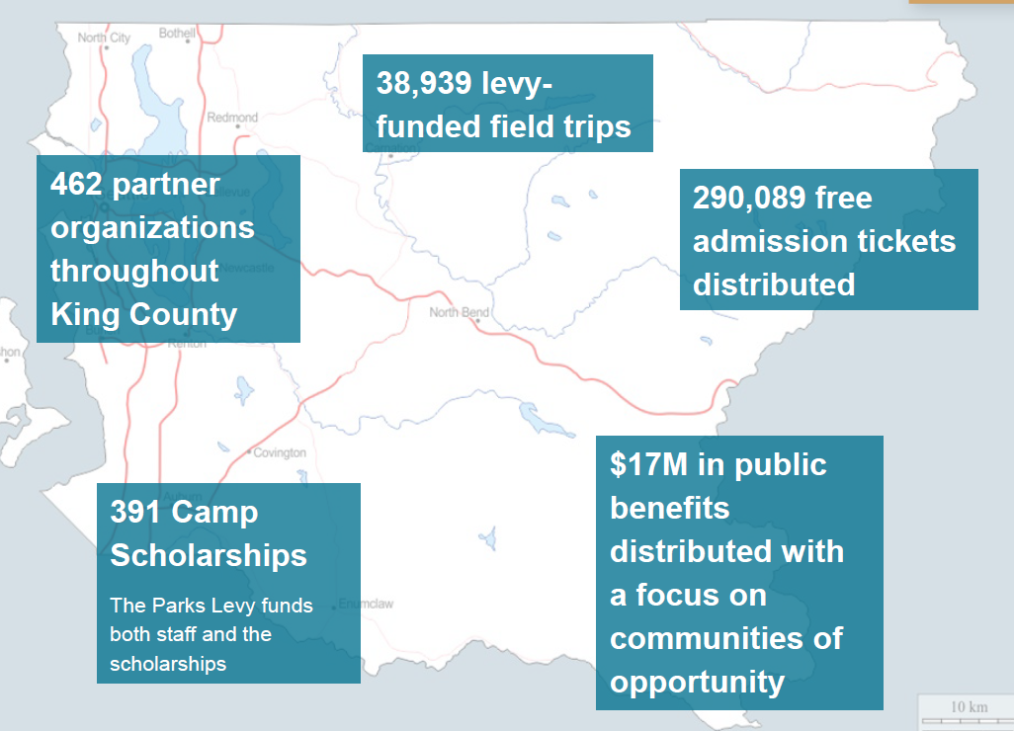
Overview of visitors (2020-2024)
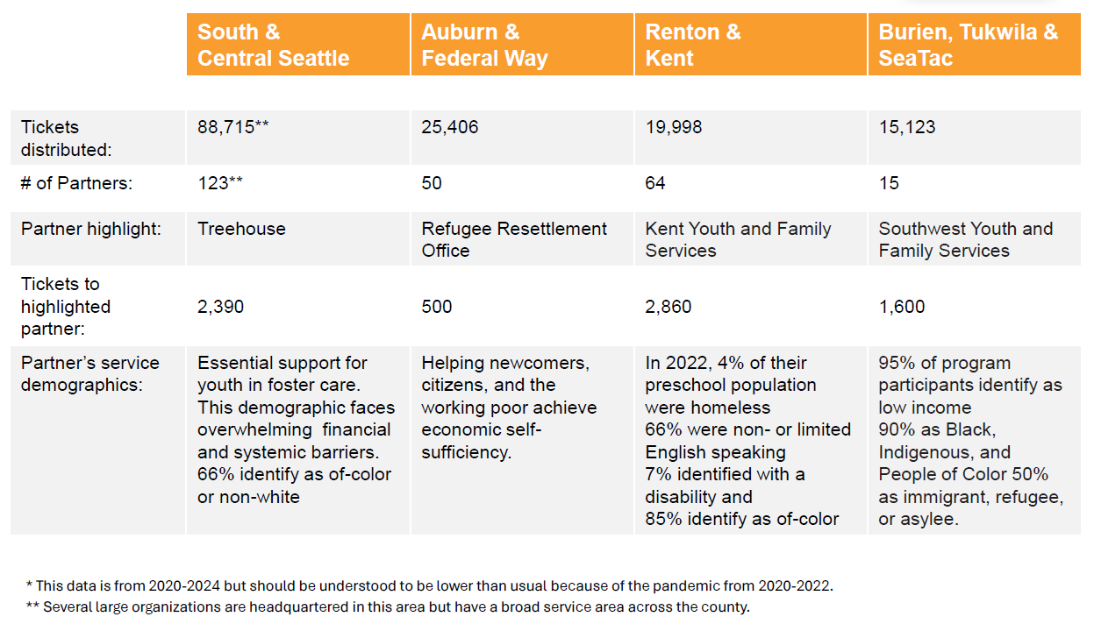

What is the plan going forward to increase access to these venues? How can we better address equitable access to these venues? What information do you have on this?
WPZ has informed Parks that it will continue to support the ongoing projects/activities to increase access to the community that are currently funded by levy proceeds as described above. Parks recommends a direct request to WPZ for any additional detail on the proposed future levy period,
Please provide more detail about what current levy money has been spent on and what proposed levy money would be spent on (for example, zoo annual reports).
Below is a detailed summary of levy proceeds that were spent by WPZ in the most recent annual report (2023). Proposed levy proceeds will be spent on programs and activities that align with current and future efforts towards environmental education with an emphasis on accessibility to traditionally underserved areas and communities including people with disabilities, horticulture and maintenance of buildings and grounds, conservation of threatened species, and development of conservation and education strategies to mitigate impacts to animals and habitats from climate change.
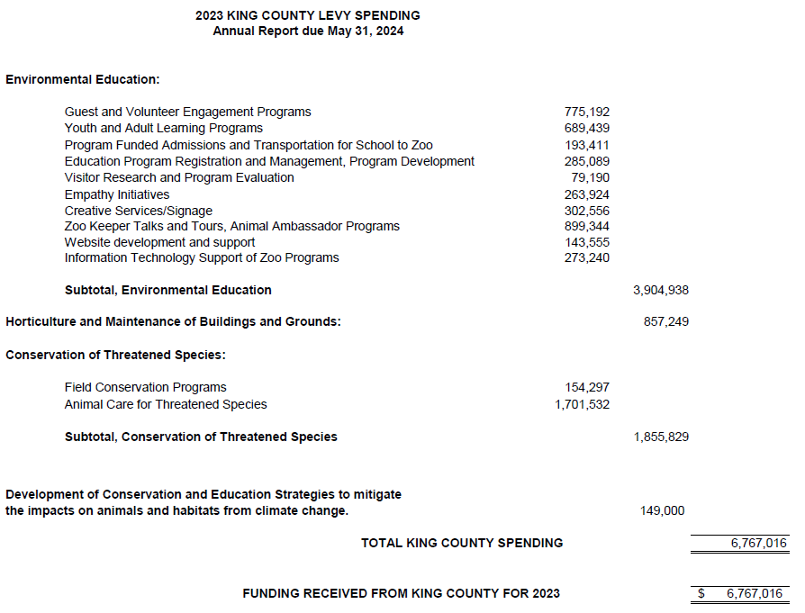

Please provide more information on who is using the programs and how aware they are of them. What visitor/usage data do you have? Where do the users come from?
More detailed information about where users come from can be found in the most recent annual report and information provided above.

Seattle Aquarium
Can you provide data on whether the current levy helped to increase access to these venues?
As a requirement for receiving proceeds from the King County Parks Levy, the Seattle Aquarium (“Aquarium”) provides King County an annual report setting forth a summary of the operations of the Aquarium and the services provided at the Aquarium for the preceding year, along with a general summary of the Aquarium’s operations and a complete financial accounting for all funds. This includes the use of levy proceeds used in the Ocean Pavilion project which opened to the public in August 2024.
The levy commitment in the current King County Parks Levy was $8 million solely towards the construction of the new Ocean Pavilion. Data on how these levy proceeds helped increase access to the Aquarium through this project can be found in the most recent annual report (2023) which has been provided as an attachment titled, “2023 Seattle Aquarium Summary.pdf”. This includes a summary of overall annual admissions to the Aquarium which can be found below. In 2023 the Aquarium welcomed over 850,000 guests and expect to see 1.2 million visitors in future years with the new Ocean Pavilion.
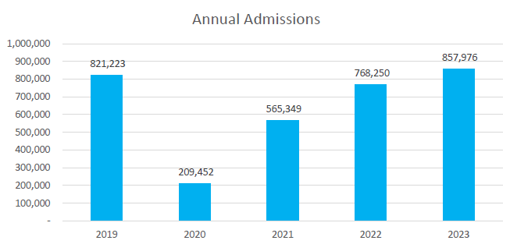
In addition to annual reporting requirements the Aquarium presents to the Parks Levy Oversight Board each year as part of the Board’s review of King County expenditures of levy proceeds. More information about how the Aquarium spends levy proceeds can be found by reviewing the meetings materials of the Parks Levy Oversight Board:
- 2023 Review of Levy Expenditures (presentation slides): Meeting 3 (October 13, 2024)
- 2022 Review of Levy Expenditures (meeting minutes): Meeting 3 (October 12, 2023)
- 2021 Review of Levy Expenditures (meeting minutes): Meeting 4 (November 9, 2022)
- 2020 Review of Levy Expenditures (meeting minutes): Meeting 4 (October 26, 2021)

- What is the plan going forward to increase access to these venues? How can we better address equitable access to these venues? What information do you have on this?
The future King County Parks Levy will support the Aquarium’s existing efforts to address equitable access through environmental education with an emphasis on accessibility to traditionally underserved areas and communities including people with disabilities. More detailed information about these existing programs and activities can be found in the most recent annual report. Current versus estimated data of future visitors provided by the Seattle Aquarium is summarized below.
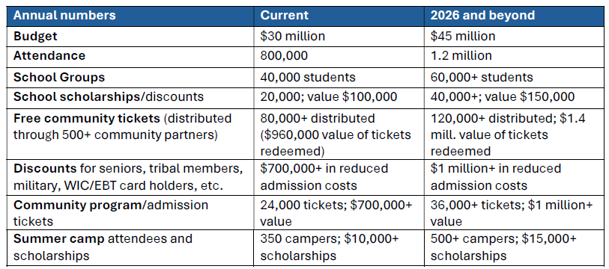
- Please provide more detail about what current levy money has been spent on and what proposed levy money would be spent on (for example, zoo annual reports).
The current levy provided $8 million towards the construction of the Ocean Pavilion which opened to the public in August 2024. Below is a detailed summary of levy proceeds that were used by the Aquarium in the most recent annual report (reference documents are attached, “Ocean Pavilion 2023 Financial Report - revised - 06.20.2024.pdf” and “King County Parks levy letter for 2023 OP expenditures.pdf”).
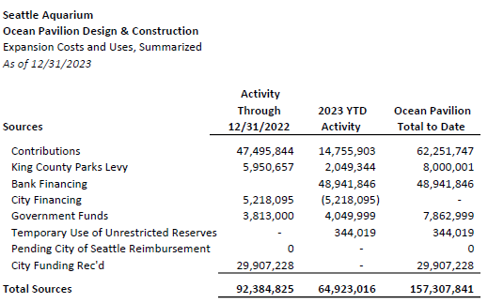
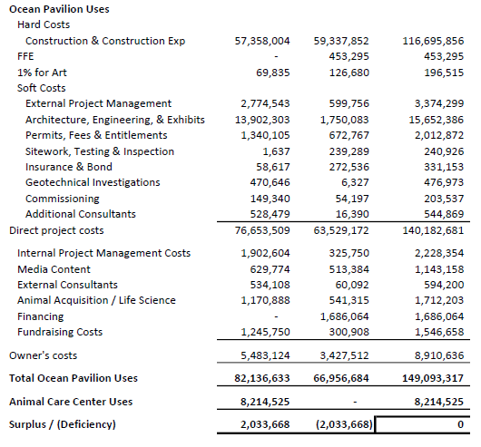
The proposed King County Parks Levy will change the Aquarium’s levy commitment from capital projects to supporting the Aquarium’s existing efforts towards environmental education with an emphasis on accessibility to traditionally underserved areas and communities including people with disabilities, maintenance of buildings and grounds, conservation of threatened species, and development of conservation and education strategies to mitigate impacts to animals and habitats from climate change.

Please provide more information on who is using the programs and how aware they are of them. What visitor/usage data do you have? Where do the users come from?
More detailed information about where users come from can be found in the most recent annual report and information provided above.

