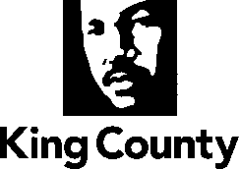

Metropolitan King County Council
Committee of the Whole

STAFF REPORT

Agenda Item: | 9 | Name: | Mac Nicholson
Proposed No.: | 2024-0287 | Date: | Oct 21, 2024

SUBJECT

Proposed Motion (PM) 2024-0287 would establish the King County 2025 State Legislative Priorities.

SUMMARY

PM 2024-0287 would establish the King County 2025 State Legislative Priorities. Currently, the PM does not have the State Legislative Priorities document attached, which will be inserted via amendment as Attachment A prior to final adoption.

BACKGROUND

The Council and the Executive work together through their respective government relations staff to develop policy positions that direct the state legislative advocacy program. These policies are formalized in the King County State Legislative Priorities.

The 2025 Regular Legislative Session is a 105-day session that begins on Monday, January 13, 2025.

ATTACHMENTS

- Proposed Motion 2024-0287

