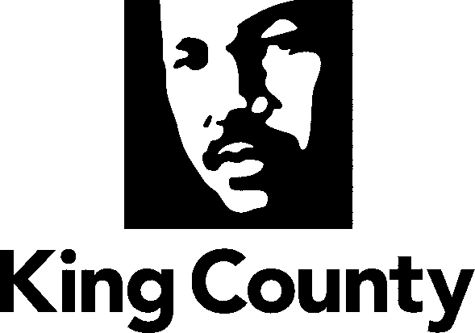

Office of the King County Executive
401 Fifth Avenue, Suite 800
Seattle, WA 98104
    - Fax 206-296-0194
TTY Relay: 711
www.kingcounty.gov

March 5, 2010

The Honorable Bob Ferguson
Chair, King County Council
Room 1200
C O U R T H O U S E

Dear Councilmember Ferguson:

The enclosed supplemental appropriation of $679,000 is associated with the Accountable Business Transformation (ABT) program and would fund a combination of data cleanup, contract migration and policy development work that must be completed by the Finance and Business Operations Division (FBOD) as part of the conversion to a new financial system. FBOD plans to hire a team of 12 Term Limited Temporary (TLT) positions starting in April 2010 to complete the critical work, with funding provided from FBOD’s fund balance savings generated in 2009. I am requesting Council action on the ordinance by end of the first quarter of 2010 in order to meet the upcoming schedule for the ABT Program.

On January 1, 2011, the ABT program plans to implement Oracle EBS, a new countywide financial system that will standardize and streamline operations and business practices. This system will replace two legacy financial systems, ARMS and IBIS, which are not integrated and have different data structures and business processes. In order to successfully implement Oracle EBS, the county must align the data sets in ARMS and IBIS and must scrub the legacy data to ensure that the new system has clean data values prior to conversion. In addition, contracts in the legacy systems must be evaluated prior to migration to match the new contract toolset in Oracle, which will enable agencies to address their purchasing needs when the new system is launched next year.

Financial systems are dependent upon key data sets for accurate and efficient processing and reporting of financial transactions. These data sets include account coding, general ledger structures, contracts, invoices, fixed assets, catalogues and records for vendors, customers and suppliers. IBIS and ARMS have structured these data sets differently. Migration to a new, single financial system with the ABT program will require these data sets to be standardized, streamlined, and aligned with each other in a manner which supports conversion to Oracle EBS

The policies and procedures for using and maintaining the data in the new financial system will also be different from those in the two legacy systems. For instance, supplier and customer records have different naming conventions, contract and purchase orders are structured differently and are managed with different policies and procedures, and invoicing and receipts are transacted through different business processes. To attain the maximum benefits realization, FBOD will update or implement new policies and procedures in order to leverage the opportunities for business process improvements in the new Oracle EBS system.

As the lead business agency for the new financial system, FBOD has the responsibility to complete this data scrubbing and conversion work. The ABT program’s scope of work anticipated that this critical work would need to be completed and funded by FBOD. In October 2009, FBOD retained a consultant to size the data scrubbing effort that the ABT Detailed Implementation Plan identified for FBOD to complete in support of Oracle EBS. The consultant identified seven data sets that need to be scrubbed and migrated and estimated the level of effort and precision required to scrub each data set. Based on this analysis and additional review conducted by FBOD staff, we have identified 300,000 data records that must be scrubbed and prepared for migration.

It is important to point out that the scope of this supplemental request is separate from the Council’s December 2009 approval of ABT contingency funds. The December 2009 request focused on the additional resources that would be necessary in FBOD and other agencies to shift the “go-live” date to January 1, 2011 for the simultaneous rollout of the new financial system and the initial phase of the new biweekly payroll system. The December 2009 request did not include the separate work of this supplemental request associated with data scrubbing and contract migration.

Council action on the ordinances during the first quarter of 2010 will enable FBOD staff to complete the work consistent with the schedule for the ABT Program. If you have questions regarding this proposed legislation, please call Ken Guy, Director of the Finance and Business Operations Division, at 263-9254 or Nancy Laswell, Business Process Change Manager, Finance and Business Operations Division, at 263-9401.

Sincerely,

Dow Constantine
King County Executive

Enclosures

cc: King County Councilmembers
ATTN: Tom Bristow, Chief of Staff
Anne Noris, Clerk of the Council
Fred Jarrett, Deputy County Executive, Office of the Executive (EO)
Rhonda Berrey, Assistant Deputy County Executive, EO
Toni Rezab, Deputy Director, Office of Management and Budget
Caroline Whalen, Acting County Administrative Officer, Department of Executive
Services (DES)
Bob Cowan, Deputy Program Sponsor, Accountable Business Transformation
(ABT), DES
Ken Guy, Director, Finance & Business Operations Division (FBOD), DES
Manny Ovena, Program Manager, ABT, DES

