KING COUNTY
DEPARTMENT OF ADULT AND
JUVENILE DETENTION

INDEPENDENT
MONITORING TEAM REPORT

IMPLEMENTATION OF ORDINANCE 18637
RESTRICTIVE HOUSING

REPORTING PERIOD:
JULY 2020 – JUNE 2021

August 10, 2021

Kathryn Olson
Change Integration Consulting, LLC
www.change-integration.com
kathryn.olson@change-integration.com
206.890.5932

Bob Scales
Police Strategies, LLC
www.policestrategies.com
bob@policestrategies.com
206.915.8683
TABLE OF CONTENTS

Executive Summary...................................................................................................................................2

I. Introduction...................................................................................................................................3

A. Ordinance 18637...........................................................................................................4

B. Overview of Restrictive Housing Monitoring Criteria,
Sample Recommendations from Prior Monitoring Reports, and
Focus of Current Report…………………………………………………………….……5

C. Methodology....................................................................................................................7

II. DAJD Restrictive Housing Policies, Juvenile Division Behavior Management System, and Approaches to Avoid Use of Restrictive Housing.................................8

A. DAJD Restrictive Housing Policies.........................................................................8

B. Behavior Management System and Approaches to Avoid Use of Restrictive Housing....................................................................................................10

III. Restrictive Housing Data Tracking....................................................................................12

A. Juvenile Division: Tracking Restrictive Housing...........................................13

B. Adult Divisions - KCCF and MRJC:
Tracking Restrictive Housing................................................................................25

IV. Programming and Access to Education, Defense Bar, Probation Counselors, and Social Service Providers................................................................................................26

A. Education, Programming and Social Services in the Juvenile
Division...........................................................................................................................26

B. Education, Programming, and Social Services in the Adult
Divisions.........................................................................................................................28

V. Transferring AAOs to Adult Facilities...............................................................................29

VI. Conclusion....................................................................................................................................30

King County Department of Adult and Juvenile Detention
Independent Monitoring Team Report
Implementation of Ordinance 18637 – Restrictive Housing
Reporting Period: July 2020 – June 2021

Executive Summary

This is the independent monitoring team’s third report, covering the period July 2020 - June 2021, assessing progress by the King County Department of Adult and Juvenile Detention (DAJD) in implementing King County Council Ordinance 18637, which limits the use of restrictive housing (also called “solitary confinement”) for juvenile detainees.

Ordinance 18637 prohibits restrictive housing for disciplinary purposes and only can be used when necessary to prevent imminent and significant physical harm to the juvenile or others and less restrictive alternatives were unsuccessful. The Ordinance applies to youth detained in DAJD’s juvenile detention facility, youth who turn 18 while in juvenile detention and are transferred to an adult facility (Adult Age Outs), and those over the age of 18 who are in a DAJD adult facility on a juvenile probation/parole matter.

DAJD has developed processes to track and evaluate whether policy requirements for placement, review, and assessment of each instance of restrictive housing were met. Although initially there was limited on-site access due to COVID-19 precautions, the assessment for this reporting period included document review, interviews, meetings, observations, and data analysis.

Under a settlement, restrictive housing information is shared quarterly with Columbia Legal Services (CLS). Records for the last two quarterly reports in 2020 and the first two quarterly reports for 2021 were reviewed in light of the information shared with CLS to confirm that it appeared to accurately reflect restrictive housing events for each relevant period of time.

The current monitoring report provides analysis of restrictive housing data for events that occurred July 2020 – June 2021 and discusses efforts underway to implement an electronic Jail Management System, train staff on alternative cognitive behavior tools for use in responding to negative behavior by youth, and a team project aimed at bringing DAJD into compliance with RCW 13.22 (HB2277) by December 1, 2021, with a number of the monitoring team’s earlier recommendations, such as development of reintegration plans for youth in restricted housing, expected to be addressed through that work.
KING COUNTY
DEPARTMENT OF ADULT AND JUVENILE DETENTION INDEPENDENT MONITORING TEAM REPORT
IMPLEMENTATION OF ORDINANCE 18637 – RESTRICTIVE HOUSING
JULY 2020 – JUNE 2021

I. INTRODUCTION

This is the third report from the independent monitoring team engaged to assess progress being made by the King County Department of Adult and Juvenile Detention (DAJD) to implement King County Council Ordinance 18637, which places restrictions on the use of restrictive housing for juveniles detained in DAJD facilities. This report addresses DAJD’s implementation efforts July 2020 – June 2021.

The last restrictive housing monitoring report, covering January – June 2020, noted the many unexpected challenges DAJD encountered during that six-month period. Very soon after moving into the new Children and Family Justice Center (CFJC) facility, DAJD joined the rest of King County in implementing COVID-19 related restrictions, while also responding to flooding on the facility’s first floor caused by a water main rupture. At the start of the current reporting period, on July 25, 2020, after weeks of protests following the murder of George Floyd, Seattle demonstrators broke through a fence in the construction area next to the new CFJC facility, started a fire, broke windows, and damaged numerous personal vehicles in the employee parking lot. CFJC suffered a second flood in the fall of 2020.

Staff turnover remains high, as 16 Juvenile Detention Officers (JDOs) left employment at the CFJC in 2020, with another 13 resigning as of August 5, 2021. While DAJD has been able to hire replacements for many of those who left, the turnover has impacted morale among some JDOs and other staff who remain and the continual onboarding of new JDOs requires significant time and resources.

Throughout these environmental and staffing challenges, DAJD has aimed to keep personnel and detainees safe and secure, while providing youth with educational, recreational, and other programming opportunities, and respecting restrictive housing mandates.

A. Ordinance 18637

Ordinance 18637 (the Ordinance) prohibits the restrictive housing of certain youth/juveniles in King County’s detention facilities, except when based on the youth’s behavior, restrictive housing is necessary to prevent imminent and significant physical harm to the youth or others and less restrictive alternatives were unsuccessful.

The Ordinance applies to: (a) all juveniles held in detention at the Children and Family Justice Center (CFJC): (b) youth who turn 18 (Age Out) while at the CFJC and are transferred to an adult facility; and (c) youth who are older than 18 and are booked on a juvenile probation/parole matter. DAJD uses the term “Adult Age Outs” (AAOs) for juveniles covered by the Ordinance though detained at the King County Correctional Facility (KCCF) or Maleng Regional Justice Center (MRJC).

The Ordinance defines “restrictive housing” as, “the placement of an incarcerated person in a locked room or cell alone with minimal or no contact with persons other than guards, facility staff, and attorneys.” Use of restrictive housing of youth for disciplinary or punishment purposes is prohibited, though short-term placement of youth in individual cells for purposes of facility or living unit security issues or for other short-term safety and maintenance issues is permitted.

Juveniles detained in a King County detention facility also must be given reasonable access to the defense bar, juvenile probation counselors, social service providers, and educators in a timely manner. Finally, the King County Council directed the King County Executive to engage an independent monitor to assess and report on DAJD’s implementation of the Ordinance.

B. Overview of Restrictive Housing Monitoring Criteria, Sample Recommendations from Prior Monitoring Reports, and Focus of Current Report

The independent monitoring team was engaged to evaluate whether DAJD’s Adult and Juvenile Divisions meet the criteria required by King County law and policy regarding restrictive housing, including:
- DAJD’s reporting on the number of times, and for how long, restrictive housing, as defined in County policy, was used during the evaluation.
- DAJD’s reporting on each incident that warranted restrictive housing.
- DAJD’s documented use of restrictive housing as defined under the policy, and whether such use complied with applicable policy, including:
  - Whether the initial placement, and any subsequent decision to continue placement, was clearly documented and necessary to prevent imminent and significant physical harm to the juvenile or adult age out, or other and less restrictive alternatives were unsuccessful.
  - An evaluation of whether required supervisory reviews provided sufficient information and met the policy criteria.
  - An evaluation of whether required medical and mental health reviews occurred.
- Evaluation of the level of programming provided to youth in juvenile and adult facilities, including interviews with program providers.
- Evaluation whether youth had full access to education as required by law, including interviews with educational providers.
- Evaluation whether youth had reasonable access to the defense bar, probation counselors and social service providers in a timely manner, consistent with appropriate security measures and maintaining public safety as required by and defined in county policy, including interviews with providers.
- Consult with representatives of the King County Juvenile Detention Guild (Department of Adult and Juvenile Detention – Juvenile Detention) representing employees in the Department of Adult and Juvenile Detention Juvenile Division on any issues with implementation.
- An assessment of the progress by DAJD’s Juvenile Division on implementing the prior monitor recommendations selected to be implemented in the Monitoring reports issued in September 2018 and January 2019.

The monitoring team’s first report covering the period July - December 2019 provided an update and evaluation of restrictive housing related policies and procedures and discussed the Juvenile Division’s Behavior Management System, approaches to avoiding the use of restrictive housing, detained youth access to programming, education, and services, and the AAO transfer process. Recommendations addressed issues such as: whether the King County Council should amend the Ordinance to except youth in their rooms voluntarily or engaged in one-on-one programming from the definition of restrictive housing; ways to enhance youth activity and restrictive housing tracking forms; the need to create an exit plan for any youth placed in restrictive housing, with input from Juvenile Detention Officers (JDOs) and medical and mental health staff; and integration of restrictive housing policies and procedures with the Behavior Management System.

The January – June 2020 report addressed some of these same issues, although with more in-depth discussion regarding the use of restorative practices at CFJC, the impacts of COVID-19 restrictions on programming and educational opportunities for youth at the CFJC and AAOs in the adult jails, and an initiative in the Adult Divisions aimed at reducing restrictive housing for all adult inmates. The monitoring team’s recommendations included: that there be a reset of the Juvenile Division’s restorative practices program and that individual case management plans be developed; that documentation provide specific and thorough details of behavior resulting in restrictive housing and noted again the need for an explicit reintegration plan; and, that the Adult Divisions provide more specific information about programs available to AAOs, that support services now provided on an informal basis be formalized, and that educational opportunities for AAOs, limited by COVID-19 impacts, be reinstituted. The monitoring team’s prior two reports also highlighted data trends observed in analyzing incidents when youth were placed in restrictive housing, engaged in one-on-one programming, or were confined to their rooms for other reasons.
The current report provides an overview of significant efforts being made by the Juvenile Division to move towards evidence-based therapeutic behavioral responses. Some provisions of the new Washington State law on solitary confinement of juveniles were noted in the last report and are also discussed below, with further information on DAJD’s implementation of the law planned for the July 2021 – June 2022 report. Similarly, DAJD currently is implementing the Jail Management System (JMS) for collecting, tracking, and analyzing comprehensive data related to the day-to-day management of detainees in DAJD facilities, and though there is some discussion about JMS in this report, information on the transition to JMS as it relates to monitoring restrictive housing will be covered in the next report. In addition to revisiting COVID-19 impacts on programming and educational opportunities for youth and AAOs and noting trends in the data analyzed, the current report also includes brief examples of particularly challenging behavior that resulted in restrictive housing or one-on-one programming that also lasted longer than average.

C. Methodology

As in previous reporting periods, the evaluation of DAJD’s policy implementation and use of restrictive housing during the period July 2020 – June 2021, was conducted through a review of documents, data analyses, observation of detention center practices, interviews, and meetings. Access to DAJD’s facilities due to COVID restrictions was limited throughout much of the reporting period, and video conferencing and telephone calls were used for some interviews and meetings.

While by no means a complete list, examples of documents reviewed for the restrictive housing monitoring process since July 2019 include: King County Council Ordinance 18637; Washington State legislation enacted in 2020, Juvenile Solitary Confinement, Chapter 13.22 RCW (HB2277); “Model Policy for Reducing Confinement and Isolation in Juvenile Facilities,” developed by the Washington State Department of Children, Youth & Families, as required by RCW 13.22.030; DAJD policies on restrictive housing and Adult Age-Out Inmates; DAJD organizational charts; prior monitor’s reports on Ordinance 18637; informational handbooks for detainees in DAJD Juvenile and Adult Divisions; quarterly self-monitoring reports on restrictive housing for Columbia Legal Services; juvenile and adult facilities behavior management forms and reference documents; King County Executive Orders and reports on Auto Declines, juvenile justice services, and related matters; CFJC detainee intake and screening documents; Youth Accountability Checklists; health clinic youth monitoring forms; CFJC Restrictive Housing Assessment forms; King County and other jurisdictions’ write-ups about Zero Youth Detention and COVID impact statements and data; and, DAJD reports and supporting material provided to King County Council. The monitoring team strives to stay up to date on research and best practices in this area, including regular review of Juvenile Detention Alternatives Initiative standards, reports, and related documents; publications concerning room confinement issues generally and with regards to other detention facilities; and research articles on use of restorative practices with youth and alternative approaches in responding to negative behavior.

Meetings, interviews, and observations since the monitoring team began its work in 2019 have included: DAJD management, facility commanders, supervisors, Juvenile Detention Officers (JDOs), and administrative staff; representatives of the defense bar, social service providers, schoolteachers working with detained youth, program providers, representatives of the King County Juvenile Detention Guild, and youth and AAO detainees. The monitors also observed detainees on-site engaging in a variety of educational, programming, and other activities, with an emphasis on the CFJC this reporting period, given the relatively few AAOs in Adult Division facilities, the more limited programming and observational opportunities, more restrictive access in the jails due to COVID, and the lack of reported incidents of restrictive housing involving AAOs.

II. DAJD RESTRICTIVE HOUSING POLICIES, JUVENILE DIVISION BEHAVIOR MANAGEMENT SYSTEM, AND APPROACHES TO AVOID USE OF RESTRICTIVE HOUSING

A. DAJD Restrictive Housing Policies

DAJD adopted new policies addressing restrictive housing in the Adult Divisions in April 2019 and in the Juvenile Division in early May of 2019. As required by Ordinance 18637, the policies provide that the placement of youth or AAOs into restrictive housing is prohibited unless, based on the youth or AAO’s behavior, it is necessary to prevent imminent and significant physical harm to them or others, and there are no less restrictive alternatives. Both policies state that restrictive housing is not to be used for disciplinary purposes.

Restrictive housing related policies for both the Juvenile and Adult Divisions were discussed in detail in the monitoring team’s reports for July – December 2019 and January – June 2020. The policies provide that a youth/AAO is deemed to pose a risk justifying restrictive housing if their behavior creates a risk of imminent and significant physical harm to the youth/AAO or others. This might include behaviors such as threats to staff or peers, physically aggressive behavior, or a major destruction of property or facility disturbance, where such behavior creates a risk of imminent and significant physical harm to the youth/AAO or others.

The monitoring team has stressed the importance of identifying the specific behavior(s) leading to restrictive housing and explaining how the behavior creates a risk of imminent and significant physical harm, and the DAJD has made significant progress along these lines. A new Restrictive Housing Assessment Checklist form implemented in July 2020 provides guidance to encourage documentation of the specifics involved and JDOs, supervisors, and other staff continue to improve in providing more detail about the events resulting in restrictive housing. Detailing the specifics about the youth’s behavior and how it amounts to a risk of imminent and significant physical harm is crucial to determining if placement in restrictive housing meets the requirements of the Ordinance and DAJD policy, along with new policies which will be developed under RCW 13.22 (HB2277).

Another issue that the monitoring team has raised previously concerns the fact that neither the Juvenile nor Adult Divisions’ policies set a limit of using restrictive housing for no more than 4 hours within 24 hours, as provided in the Ordinance. As discussed in the last report, the Washington State law on Juvenile Solitary Confinement provides that a juvenile may only be placed in isolation or room confinement (as defined under RCW 13.22.010) if the total time is limited to 4 hours within a 24 hour period, unless a longer period is necessary due to subsequent or multiple incidents, and if the reason is documented, there is an individualized plan for reintegration, and the facility superintendent authorizes each 4 hour extension. The state law requirement that there be an individualized plan for reintegration of a youth in restrictive housing, also is in line with the monitoring team’s earlier recommendation on point.

The monitoring team’s first report discussed alternative terminology used for “restrictive housing,” noting that the Ordinance uses the term “solitary confinement,” in referring to the prohibition of placing a detainee in a locked room or cell alone with minimal contact with persons other than JDOs, staff, and attorneys, unless a certain level of behavior is demonstrated or threatened. The monitoring team’s second report followed up with an overview of terminology used in RCW 13.22 (HB2277). As DAJD takes steps to implement the new state law, consideration should be given to the adoption of the same terminology used in RCW 13.22, for the sake of consistency, ease in learning the new requirements, and to facilitate the data gathering and reporting required under RCW 13.22.050 and 13.22.060.

B. Behavior Management System and Approaches to Avoid Use of Restrictive Housing

The DAJD Juvenile Division’s Behavior Management System (BMS) was reviewed extensively in the monitoring team’s first report. The BMS uses a system of responding to youth behavior with an approach that is trauma informed and emphasizes incentives and rewards for desired behavior. Rewards, such as an extended bedtime, can be earned for meeting behavior expectations, with youth who attain higher levels being honored with more privileges.

While the Juvenile Division’s approach to managing behavior of detainees leads with an incentive-based approach, it also provides for a response progression to help youth regulate behavior and hold them accountable for conduct that presents a security issue. The scale provides for initial attempts to interrupt problematic behavior through a verbal intervention, Time Out (up to 30 minutes), and Cool Down (up to 2 hours). If the youth’s behavior is still not regulated, they might lose certain privileges or be required to engage in a range of restorative activities, such as writing about feelings and events that triggered the unacceptable behavior or problem-solving with their peers or staff.

As they did during earlier reporting periods, the CFJC Juvenile Detention Guild expressed concerns about the effectiveness of the Behavior Management System, including restorative interventions, and frustration that they no longer have the option to discipline youth by requiring that they spend time alone in their rooms.

Both JDOs and youth expressed frustration about repetitive assignments and the lack of restorative work that fits the range of psychological and social issues experienced by detained youth. Juvenile Division staff had intended to develop the restorative practices approach more fully, while also considering alternative interventions such as Cognitive Behavior Therapy and Dialectic Behavior Therapy. While responding to COVID-19 and other challenges over the past year slowed progress in further developing restorative options and alternative therapeutic responses when youth engage in unacceptable behavior, some important steps have been taken recently.

First, DAJD received grant support to purchase a resource called “The Carey Guides,” a set of handbooks for JDOs and other staff to use as they work with detained youth to address skill deficits and develop more successful coping strategies. The Guides rely on evidence-based practices such as cognitive behavioral interventions, social learning theory, and risk reduction strategies to address topics such as antisocial thinking, antisocial associates, problem solving, motivation, impulse control, and substance abuse. The handbooks and digital tools are specifically designed for correctional professionals, do not require a high level of training and have shown promising results in at least two research studies cited by the publisher. What appears to be a useful guide was issued in August 2020 spotlighting successful strategies used by agencies that have implemented the Carey Guide program, including ways to facilitate access to the tools and the importance of intentional messaging throughout the implementation process.

Another important step taken by the DAJD’s Juvenile Division is initiation of a project to identify the steps and processes necessary to come into compliance with RCW 13.22 (HB2277), since temporary assignment to Restoration Hall to help youth regulate their behavior is not supported under the new law. The project will be guided by an outside facilitator, involve representatives throughout CFJC, and has a goal to complete the work by December 1, 2021. While the final scope of work for the project is still being refined, topics that might be covered include evidence-based therapeutic behavioral responses; development of reintegration plan indicators to use when a youth is placed in restrictive housing; workflow process, staff (including JDOs) roles and communication regarding reintegration, using a multidisciplinary approach; and review and revision of related policies and procedures. The project is an important and complex undertaking, but DAJD has been working on issues underlying RCW 13.22 (HB2277) since it amended policies and practices under Ordinance 18637, the project team has the experience and expertise to work through the tasks involved, and the project management approach being used will help pave the way to success.

III. RESTRICTIVE HOUSING DATA TRACKING

As this report is being finalized in early August 2021, DAJD is rolling out its electronic Jail Management System (JMS), with a phased approach planned for the Juvenile Division and a goal to complete the roll out by the end of September 2021. Up until now, both the Juvenile and Adult Divisions have relied on handwritten entries on various forms to record and track restrictive housing, with staff persons providing checks and balances to confirm the documentation. Staff consult other sources when information is unclear or missing and analyze the data from various perspectives. The paper tracking system has been time consuming to complete and review, with JDOs, supervisors, and staff from throughout the Juvenile Division involved in managing the process. The Department will greatly benefit from the JMS’s electronic framework to record, measure, and track key performance indicators related to restrictive housing.

During this reporting period, supervisors have more promptly and consistently reviewed daily checklists completed by the JDOs and restrictive housing related paperwork to correct missing or misinformation, and provided more immediate corrective feedback to JDOs, as needed. Recognizing that JMS will offer a new, more streamlined approach moving forward, the summary provided below describes the process used in tracking and reviewing restrictive housing data in the Juvenile and Adult Divisions during the July 2020 – June 2021 reporting period. Information on trends observed in some of the restrictive housing data also is noted.

A. Juvenile Division: Tracking Restrictive Housing

In the Juvenile Division, youth are assigned to a living hall based on an assessment of numerous factors when they enter detention. Hall assignment might later change, based on CFJC’s fluctuating daily population, the need to separate youth discovered to have outside affiliations or who are engaged in conflict, or other factors. A single hall in CFJC can have anywhere from one to sixteen youth, with each assigned to an individual room. Each hall has a common area where youth gather for meals, to watch TV, play cards or board games, or engage in other social activities, and a small outdoor courtyard for playing ball or other games. There is also a classroom for school and programming in each hall, along with smaller rooms for private meetings, such as with a mental health professional, and for phone calls or video conferencing with family or counsel. There are regularly scheduled activities outside of a youth’s assigned hall in the facility’s gym and library, along with visits to the Health Clinic or Juvenile Court located in the same building.

Two Juvenile Detention Officers (JDOs) are assigned to each hall, with other officers serving as “rovers” to relieve JDOs as needed, to escort a youth to the Health Clinic or for court appearances, or for other purposes outside the hall. JDOs check on each youth every 15 minutes during daytime hours, noting on the Youth Accountability Checklist (YA Checklist) form each youth’s activity at the time of the check. The YA Checklist form uses a system of 21 codes to record the range of activities and programs in which a youth might be involved, and includes behavioral response codes for a time out, cool down, or restrictive housing, all of which require a written explanation. If a youth is in the Health Clinic, a separate monitoring checklist is used, which later is attached to the corresponding daily YA Checklist for each hall. Checklists for each of three shifts for each of the halls are collated daily, with supervisors and the Chief of Operations reviewing the forms as described earlier.

Youth Accountability Checklist Codes
1. Rest Period | 8. Health Clinic | 15. Intake
2. Unit | 9. Transport | 16. Restoration Hall
3. Gym | 10. Pass | 17. 1 on 1 Programming
4.School | 11. Chaplain Visit | *TO – Time Out
5. Library | 12. Courtyard | *CD – Cool Down
6. Visitation | 13. A-Hall Visit | *V – Voluntarily in Dorm
7. Court | 14. Rec. Dept. | *RH – Restrictive Housing

JDOs also maintain daily log sheets that are bound into Logbooks organized by month and hall, in which a variety of entries are made, such as the number of youths assigned to a unit, significant incidents that occurred during a shift, or information about incentives earned or behavioral issues for an individual youth. Other forms, such as Roster Notes, also provide a means for supervisors to communicate across shifts concerning behavioral responses with specific youth or other important information, document which JDOs worked each shift, and provide other details.

If a youth is placed in a cool down that lasts an hour or more, which should be evident from the YA Checklist, the Restrictive Housing Assessment Checklist form (RH Checklist) is initiated by the JDO, and the supervisor is to be notified. Under current policy, a cool down can last up to two (2) hours. If the youth’s behavior presents a risk of imminent and significant physical harm to self or others at the end of this two-hour period, as determined by the JDO and supervisor, the youth can be placed into restrictive housing, which means that youth continue to stay in their room. The youth’s observed behavior leading to the need for restrictive housing, along with other details such as the date and time restrictive housing started and ended, are noted on the form. The RH Checklist also lists the various kinds and schedule for the required assessments depending on the length of time a youth is in restrictive housing, including review by the Chief of Operations, a mental health professional, and a medical professional.

A Program Manager reviews all YA and RH Checklists on a weekly basis and, if information is missing or the events surrounding an instance of restrictive housing are not clearly described, will check Logbooks or other sources for clarification. Juvenile Division and DAJD management also regularly review the documentation.

Data related to each instance of restrictive housing is collated and summarized for quarterly reports submitted to Columbia Legal Services, per settlement of a lawsuit involving related issues. The reports provide details about restrictive housing events, instances when a youth and JDO engaged in one-on-one programming, and situations when a youth was in restrictive housing for reasons unrelated to behavior, such as for unanticipated, short-term staff unavailability.

Because youth activities and behavior responses are tracked through handwritten entries on the YA Checklist, the RH Checklist, and other forms, evaluating the reasoning, timing, and required assessments for each instance of restrictive housing is very labor intensive, involving many hundreds of pages of information each month.

The documentation described above was reviewed to confirm the data DAJD reported to Columbia Legal Services July 2020 – June 2021. Scores of different handwriting samples from JDOs, supervisors, and staff are represented in the paperwork related to restrictive housing, making the review process challenging at times. However, DAJD reports appear to accurately summarize instances of restrictive housing as originally documented or as later clarified during the internal review process.

The Juvenile Division organizes restrictive housing information into three categories: (1) instances when a youth presented a significant and imminent risk of harm to self or others (barring allowed exceptions); (2) instances when youth engaged in one-on-one programming with JDOs, outside their room, including time in Restoration Hall when other youth are not present; and, (3) instances when the reasons youth were in restrictive housing were not behavior related and were not preceded by a cool down period. The following sections describe trends observed with the Juvenile Division restrictive housing data in each of these three categories.

  - Restrictive Housing in DAJD Juvenile Division
2019, 2020, and January – June 2021
Number of Instances and Average Number of Minutes Involving
Risk of Imminent and Significant Physical Harm

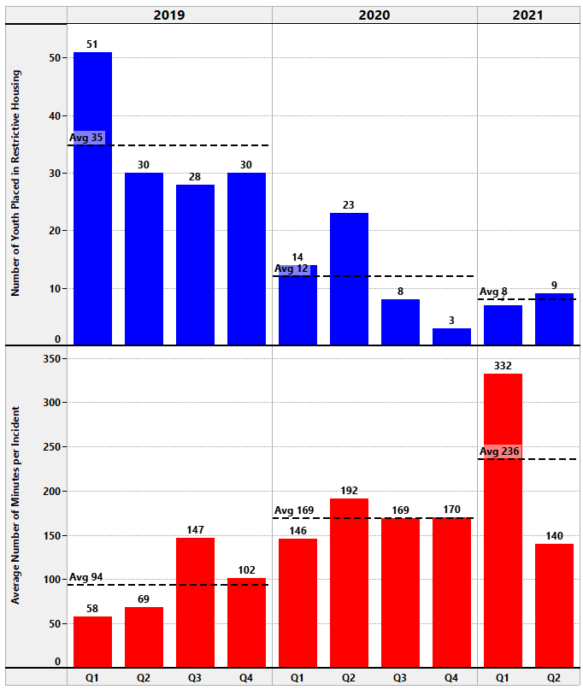
As illustrated in graph 1.1, the trend in the total and average number of Juvenile Division restrictive housing events related to the imminent and significant risk of physical harm continued to demonstrate an overall decline from the first reporting period (July – December 2019), through the second 6-month period (January – June 2020), to the current reporting period (July 2020 – June 2021).

While the total number of events increased from the last six months of 2020 to the first six months of 2021 (11 events July – December 2020 versus 16 during January – June 2021), the average is still below that seen in 2019 and 2020. However, the uptick in the number of events in the first six months of 2021 takes on more significance when considering the average amount of time youth spent in restrictive housing during the same time – in the last six months of 2020, youth averaged 169 minutes in restrictive housing each incident as compared to an average of 236 minutes in the first half of 2021, or an average of 1 hour and 7 minutes longer. This increase in the average time spent in restrictive housing during the January – June 2021 period is largely due to the increased average time in Q1 2021, with a drop from an average of 332 minutes to 140 minutes by Q2 2021, which is the lowest average time seen since Q4 2019.

There are at least a couple of possible explanations for the increase in the number of restrictive housing events and the average amount of time spent in restrictive housing observed in the first two quarters of 2021, though given the many changes and challenges taking place, it is difficult to determine a specific cause. First, on March 29, 2021, five youth were involved in one event in which they all refused to return to their rooms after being dismissed from a school class and tensions escalated as they refused to follow directives from staff. They each spent over six and a half hours in restrictive housing, which raised the number of incidents for that Quarter since each youth is included in the overall number and greatly contributed to an increase in the average time spent in restrictive housing. Also, as noted in the DAJD report to Columbia Legal Services for 1st Quarter 2021, the daily population of youth detained in the CFJC rose to an average of 26, as compared to averaging just 19 youth per day in 4th Quarter 2020. This can impact the amount of time staff can offer individualized attention to the youth and might have meant staff were not immediately available to facilitate problem-solving for all five youth in restrictive housing, nor were there enough staff to offer one-on-one programming to each of the involved youth.

.

1.2 Restrictive Housing in DAJD Juvenile Division – 2019, 2020, and Q1 & Q2 2021
Reasons Documented for Instances Involving
Risk of Imminent and Significant Physical Harm

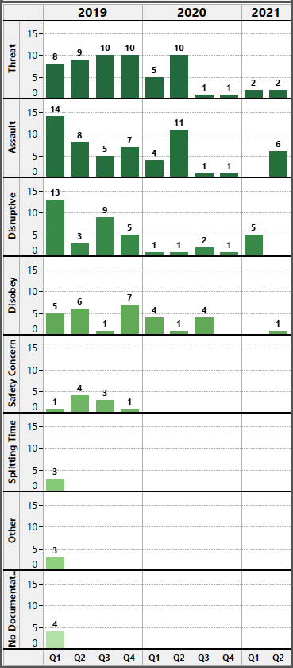
As illustrated in graph 1.2, there was an increase in assaults and disruptive behavior as the reasons documented for the need to place youth in restrictive housing in the first six months of 2021. The five incidents of disruptive behavior were all tied to the event on March 29, 2021 discussed above, in which five youth all refused to return to their dorms after being dismissed from a school class and refused to follow staff directives, with escalating tensions making restrictive housing necessary to prevent imminent and significant physical harm to the youth or others, as determined by the staff involved. Factors such as the known behavioral history of the involved youth and opportunity to escalate the situation are considered. For example, one of the five youth involved in the event on March 29th had refused to follow directions and, becoming more agitated, physically assaulted a DAJD staff member by violently punching them. Another juvenile involved in the March 29th event had been in a gang related physical altercation with multiple peers at the CFJC two months earlier. Similarly, four of the six incidents of assault resulting in restrictive housing in the first six months of 2021 involved a single event on June 10, 2021, in which a youth planned and then initiated a physical assault against a peer and other youth joined in the fight. As previously discussed, when multiple youth are involved in a behavioral event creating actual or imminent and significant physical harm to youth or others, there might not be the staff resources to provide one-on-one programming, more immediate individualized problem solving, or alternative interventions to avoid placement of the youth in restrictive housing.

One detainee included in graph 1.2, was placed in restrictive housing twice during the 2nd Quarter of 2021, first for verbally threatening staff with bodily harm and then ten days later, refusing to follow directions and then throwing a shoe at a staff member after attempting to throw a chair at them.

1.3 Restrictive Housing in DAJD Juvenile Division – 2019, 2020, and Q1 & Q2 2021
Reasons Documented for Instances Involving
Risk of Imminent and Significant Physical Harm
Assaults and Threats

 | Assaults |  | Threats
 | Peer | Staff | Peer | Staff | Self
2019  Q1 – Q4 | 27 | 7 | 15 | 21 | 1
2020  Q1 – Q4 | 15 | 2 | 11 | 6 | 0
2021  Q1 & Q2 | 3 | 3 | 0 | 4 | 0

In considering the data reported in 1.3, it is important to keep in mind that the ADP for youth in detention in 2019 was nearly twice as high as the ADP for July 2020, which can contribute to assaults, threats, and other unacceptable behavior as discussed above. Peer-to-peer assaults and threats leading to restrictive housing were more common than assaults and threats involving staff up until the first six months of 2021. JDOs have expressed concern about an increase in assaults on staff and any staff assault is unacceptable. Though there was only one more assault involving staff in the first half of 2021 as compared to 2020 that resulted in restrictive housing, other assaults on staff have taken place and are closely tracked outside of the documentation and data reviewed for restrictive housing monitoring. Of course, if assaults on staff continue through 2021, it would represent a more concerning increase. And these assaults on staff combined with threats against staff help explain the perception among some JDOs that there is a heightened security risk involved.

1.4 Restrictive Housing in DAJD Juvenile Division – 2019, 2020, and Q1 & Q2 2021
Whether Assessments Completed for Instances Involving
Risk of Imminent and Significant Physical Harm

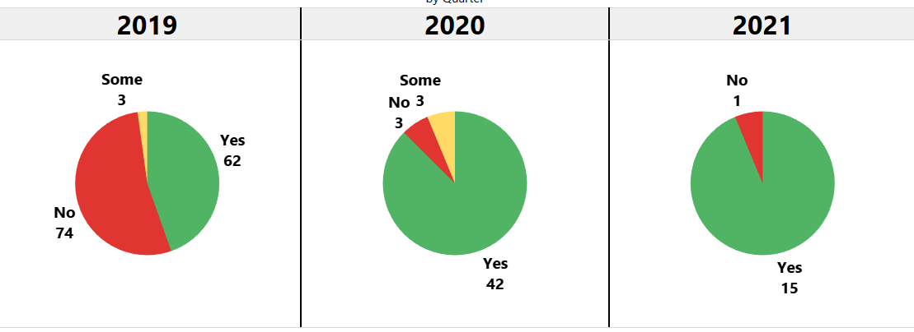

Staff indicated that supervisors are reviewing restrictive housing documentation closer in time to the underlying event and are counseling JDOs if mistakes are made, with the Chief of Operations also involved in reviewing the entire process and making more immediate corrections, where necessary. In reviewing and confirming the circumstances surrounding restrictive housing events related to both a risk of physical harm and one-on-one programming, the monitoring team made note of a number of examples where the level of detail had greatly improved. The Restrictive Housing Assessment Checklist was updated in July 2020 following input from staff to make it more user friendly. The move to electronic data entry and tracking through JMS is just now rolling out and is expected to make the process of completing restrictive housing documentation all the easier.

2.1 Restrictive Housing in DAJD Juvenile Division – 2019, 2020, and Q1 & Q2 2021
Number of Instances and Average Minutes Involved
One-On-One Programming

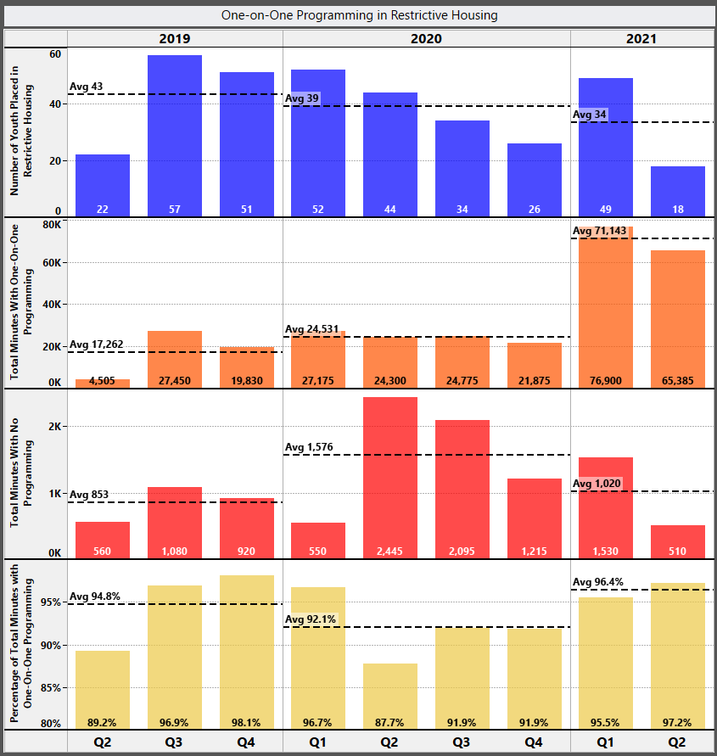

As with instances of restrictive housing, the number of one-on-one incidents and average amount of time in one-on-one programming increased in the first two quarters of 2021. The increase in average daily population during the 1st Quarter 2021 might be a contributing factor. Some youth engage one-on-one with staff on assigned restorative work to help them understand their behavior triggers or to work through feelings such as those related to a family visit or upcoming court hearing. Youth sometimes do not quickly self-regulate and seem to benefit from time with a staff member in one-on-one programming before rejoining the rest of the youth. One-on-one programming might be the only alternative available when the court orders that certain youth are kept separate, such as when gang affiliation could be an on-going concern in detention. Other times, the behavior of two or more youth requires that they be separated while working on self-regulation, before they can effectively problem solve. Female and male detainees are housed separately and if there is only one detained female, she will experience more time engaged in one-on-one programming. However, even if one-on-one programming helps develop trusting relationships, would be therapeutic, or facilitate learning for the youth, it meets the definition of restrictive housing under the Ordinance and must be documented and assessed through the same process as events involving risk of physical harm.

Reviewing incident descriptions underlying one-on-one programming during 2nd Quarter 2021, there were several events that resulted in an unusually high amount of time spent in one-on-one or split programming. These events involved multiple juveniles engaged in peer-to-peer altercations, made plans to attack a peer, or made other bodily threats. DAJD invested significant time and resources to developing alternative approaches to intervene with two of the youth involved, who also assaulted and threatened staff members.

3.1 Restrictive Housing in DAJD Juvenile Division – 2019, 2020, and Q1 & Q2 2021
Number of Instances and Minutes Involved
Reasons Other than Risk of Physical Harm or One-on-One Programming

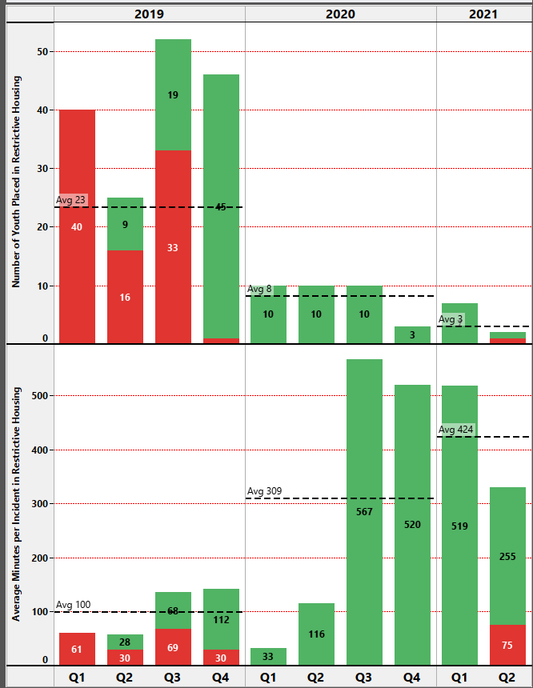

Other than a slight uptick in 1st Quarter 2021, the average number of incidents of restrictive housing that is not related to youth presenting an imminent and significant risk of harm or engaged in one-on-one programming continued to drop during this reporting period. The data in 3.1 represents restrictive housing incidents related operational needs, including facility or living unit security issues or for other short-term safety and maintenance purposes, which are permitted under the Ordinance. Looking to 3rd Quarter 2020 by way of example, all ten incidents represented in 3.1 relate to the COVID-19 intake quarantine for newly admitted youth lasting longer than the usual 72-hours, due to factors such as a small group of females arriving within days of each other and needing to alternate time out of their dorm while avoiding contact with male detainees and a youth who had a scheduled release from secure detention soon after their quarantine ended, so was kept in the quarantine unit to avoid potential exposure with other youth. While the average amount of time spent in restrictive housing for reasons unrelated to the risk of physical harm or one-on-one programming increased significantly during this reporting period, most events involved related to COVID-19 impacts, including the need for an extended quarantine as discussed above or because of related staff shortages.

B. Adult Divisions - KCCF and MRJC: Tracking Restrictive Housing

As described in earlier monitoring reports, the DAJD Adult Divisions tracking of restrictive housing for Adult Age Outs (AAOs) differs than in the Juvenile Division. The adult jails use a system of publishing daily lists of AAOs, that provide booking information, jail location, and other brief details about the detainee which are distributed to facility supervisors and managers. During the July 2020 – June 2021 reporting period, the average number of AAOs per quarter for the KCCF and MRJC combined were:
- 3rd Quarter 2020: 5
- 4th Quarter 2020: 4
- 1st Quarter 2021: 4
- 2nd Quarter 2021: 5

The adult facilities have reported relatively few instances of restrictive housing for AAOs since the monitoring team became involved two years ago. During the current reporting period, there was one instance reported in 3rd Quarter 2020 of AAO restrictive housing lasting 3 minutes. During the 1st Quarter 2021, as a precautionary measure in managing the spread of COVID-19, two AAOs were placed in medical housing for 3 days and 16 hours. Though the AAOs were not in restrictive housing, the placement was more restrictive than the general population, so was reported for transparency. During 2nd Quarter 2021, there were severe staffing shortages at KCCF, resulting in all individuals on four floors of the facility being assigned to their cells for approximately four hours. Though the event was reported, under the Ordinance, it would not constitute prohibited restrictive housing. Thus, because there was only one instance of restrictive housing during this reporting period and it lasted only 3 minutes, this report does not include charts and other data analysis for AAOs experiencing restrictive housing.

In 2020, the Adult Divisions convened a Multi-disciplinary Team (MDT) comprised of a Sergeant, a Corrections Program Specialist (Classification), and a Psychiatric Evaluation Specialist, to conduct on-going reviews of inmates in long-term restrictive housing and maximum security to assist in reintegrating them into the least restrictive housing appropriate while maintaining safety and security of staff, inmates, and communities. The intent was to roll out a phased implementation plan to offer broad evidence-based programming, services, and treatment to these inmates. Grant-based funding provided for security desks and chairs to be used in the initiative, but due to COVID-19 manufacturing delays, are not scheduled for delivery until September 2021. However, it was reported that King County Council did not provide the funding requested to cover other employee and material costs
required to fully implement the programming, services, and treatment contemplated by the MDT.

IV. PROGRAMMING AND ACCESS TO EDUCATION, DEFENSE BAR, PROBATION COUNSELORS, AND SOCIAL SERVICE PROVIDERS

The DAJD Juvenile Division programming and educational services generally meet or exceed standards, as described in all three previous independent monitor reports. Youth and staff indicated youth has access to the defense bar, probation officers when assigned, and visitors, by phone or video conferencing. Also, as previously addressed in earlier reports, providing a similar level of programming and educational opportunities for AAOs in the adult jail facilities is considered cost prohibitive and is further challenging due to COVID imposed restrictions.

- Education, Programming, and Social Services in the Juvenile Division

As noted in the January – June 2020 monitoring report, when COVID-19 restrictions began, it was difficult for volunteers, teachers, and others to lose direct access to the youth. From the perspective of Juvenile Division staff, it was challenging to have significantly more responsibility in meeting programmatic and educational goals without outside resources. Everyone was concerned with ensuring that detained youth continue to receive an education and that there were a sufficient number and variety of programming opportunities to keep youth engaged.

As previously described, CFJC received support to acquire webcams and microphones, so that the classroom in each unit could be equipped for remote academic instruction and programming. Systems had to be devised with remote education and programming to account for the need to keep certain detained youth separate from each other, for court ordered separations, when there are both male and female detainees, or for other reasons.

While many programs were put on hold due to COVID-19, others pivoted over time to work with youth remotely. Because this reporting period covers the late spring and early summer months of 2021, when restrictions were lifted in some areas, the following list includes activities that were only recently available, along with others that were continually in place despite COVID-19 impacts. Though not included on the list, the CFJC also provides birthday and holiday celebrations for detained youth, and for those who maintain an honors level in their behavior, a monthly take-in dinner.

CFJC Volunteer, Recreation, & Contractor Programs
AKA Music Program | KCLS 3-D Pens
Art Classes with Stephanie | KCLS Game-On
Awareness Circle Health Classes | KCLS Hip Hop
Boyz2Men Discussion Groups | KCLS Photography
Boyz2Men One-on-One | KCLS Poetry
Chaplain Chat Meals | KCLS The Residency
Chaplain Christian and Muslim Services | KCLS Webinar
Chaplain In-Person Visits | KUOW RadioActive Podcasts
Chaplain Quran Study | Pongo Teen Writing
Chess Club | SU/UW Know Your Rights Law Clinic
Clifford Johnson – Get to Know the Author | Sweat, Pain & Gain Fitness Sessions
FLASH Health Program | Time Capsule Art Project
Haircuts by licensed barber
IF Project Discussion Groups | Alcoholic Anonymous Remote Meetings
IF Project One-on-One Sessions
While each of these programs offer important learning and engagement opportunities for detained youth, the KUOW RadioActive podcast is highlighted here for its unique approach. RadioActive is an NPR KUOW program to connect young people to public radio journalism and help them gain skills in storytelling through hands-on workshops. A two-day virtual podcasting workshop was held at the CFJC in April 2021, during which seven youth produced three audio stories about their experiences in detention. The workshop provided an opportunity for individual youth to publicly share their personal experiences and insights, including some poignant comments and tacit advice about how to avoid criminal activity and detention.

B. Education, Programming, and Social Services in the Adult Divisions
As noted above, AAOs constitute a very small subsection of the adult population of detainees, with an average of 4-5 AAOs throughout the current reporting period. Providing AAOs with education, programming, and services at the level available to youth detained at CFJC is not considered feasible given the substantial investments in new or expanded facilities and staff that would be required.

DAJD’s ability to offer educational and programming opportunities for AAOs was further impacted by COVID-19 restrictions, as initially discussed in the last monitor’s report. Previously, Seattle Public Schools taught a GED program for AAOs at the downtown jail facility and Kent School District provided instructional plans for AAOs at the MRJC. The Adult Divisions also contracted with Seattle Central College for GED instruction and testing. As COVID-19 restrictions went into place, the school districts initially were unable to offer any teaching support in the adult jails. Limited educational opportunities became available again at some point after the school year started in fall 2020, though there are no group classes or one-on-one independent study options. AAOs wanting to continue with their high school education receive instruction packets and work on their assignments on their own, with teacher meetings (up to an hour) taking place through a window in the jail’s visitation area. The Kent School District provided computers for use by students at the MRJC and supported visits from tutors, since only one teacher was available (as compared to two Seattle School District teachers available for KCCF). However, staff indicated that the inability of staff, teachers, and providers to engage more directly has been discouraging for everyone, particularly the AAOs.
In addition to discontinuing group educational classes and independent study, group programming is not currently being held since DAJD does not have the infrastructure necessary to support remote group services. There is variation in the options available at any given time, but the following provides a sample of programs offered to AAOs and other inmates through DAJD’s Adult Divisions during restrictions under COVID-19:

KCCF Programs | MRJC Programs
- High School Completion  - High School 21+  - Incarcerated Veterans Reentry Services  - Job Training  - Various Faith-based Groups | - Job Training  - High School Completion  - Incarcerated Veterans Reentry Services  - Tutoring Program

Pre-COVID, adult jail staff met with AAOs soon after their transfer from the juvenile facility, to discuss educational and programming options. Due to fewer staff being available and distancing requirements, information exchange now takes place through the “kite” system, a process of using different colored forms (“kites”) for various non-emergency services available at the jails. AAOs can indicate their interest in educational opportunities and general categories of programs by filling out a white kite, with a response expected within three business days.

V. TRANSFERING AAOS TO ADULT FACILITIES

The monitoring team’s July – December 2019 report highlighted the prior monitor’s recommendation that privileges earned by a youth at the juvenile facility should transfer with them when they turn 18 and move to one of DAJD’s adult jails as an AAO. The last report noted that the Adult and Juvenile Divisions had identified leads to work on this and related issues. Despite whatever complexities existed, DAJD now has developed a system for AAOs to have any rewards they accrued at CFJC transferred as credit to be used in the commissary. This is an important step to have taken, as it helps youth at the juvenile facility who are approaching their 18th birthday stay engaged and motived to comply with behavior expectations despite their imminent move to an adult jail.

VI. CONCLUSION

DAJD is in the middle of implementing the JMS, with different challenges in the Juvenile and Adult Divisions in rolling out the system. However, once all personnel are trained and feel a level of mastery in using JMS, the process of reporting, collecting, and analyzing restrictive housing and related data should benefit from the move away from the current paper and pen approach to compiling information.

In addition, the Juvenile Division is starting a major project to bring its restrictive housing policies and practices into compliance with RCW 13.22, which provides limits on the use of solitary confinement for juveniles that extend beyond the mandates of the Ordinance, along with data collection and reporting requirements. The effort includes identification of alternative behavioral responses that are evidence-based and therapeutic and development of an approach to use in reintegrating youth placed in restrictive housing, both of which will require a review of staff roles, responsibilities, and communication expectations regarding the process. Once the project team completes its work by the end of 2021, DAJD should have policies and protocols in place to assure compliance with RCW 13.22 but will also meet several of the monitoring team’s earlier recommendations and ideas raised in the current report.

Finally, the Juvenile Division is preparing to roll out a new set of cognitive behavioral tools offered through “The Carey Guides” to be used with youth detained at CFJC. It will require concerted planning and collaboration to successfully train and support use of these tools by JDOs and other staff. Planning and implementation should be considered in the context of the project team’s efforts to bring DAJD into compliance with RCW 13.22, offering JDOs and other staff a comprehensive approach to learning about alternative behavioral responses while also working towards compliance with the new law.

Clearly, moving these efforts forward will be a priority for the DAJD Juvenile Division over the next four to six months, at a minimum. Given all the change taking place now or soon, some of which addresses earlier recommendations, the monitoring team is not offering any new recommendations in this report. Instead, as DAJD endeavors to implement the JMS, develop a plan to bring the Department into compliance with RCW 13.22, and train staff on alternative responses to problematic behavior using “The Carey Guides,” the monitoring team will conduct a comprehensive review of all recommendations regarding restrictive housing dating back to August 2018 to determine which have been satisfied, which are no longer relevant, and which recommendations require follow-up. In the coming months, the list will be reviewed with DAJD and prioritized, in the context of the significant changes that will already be taking place.

Independent monitoring team members are Kathryn Olson and Bob Scales. They have deep and broad background and expertise in law; the criminal justice system; law enforcement operations, policy, training, labor relations, and community relations; records auditing; advising on data tracking and reporting systems; juvenile justice; reducing racial/ethnic disparities in the criminal justice system; knowledge of PREA and JDAI, trauma informed care, and impacts on policies and practices; restorative justice techniques; and federal, state and local government and criminal justice organizations. They have worked in a wide range of jurisdictions with multiple stakeholders and strive to foster accountability and transparency in the monitoring and reporting process. .
https://www.king5.com/article/news/local/protests/washington-seattle-king-county-police-brutality-protests-demonstrations-saturday/281-59dc25b7-12d1-4adf-b439-a2e9163eb1e8
The Ordinance uses the term “solitary confinement,” though DAJD adopted the term “restrictive housing,” which previously had been used by the Adult Division. The Ordinance makes clear that its mandates apply regardless of the terminology used (e.g., room confinement, segregated housing, restrictive housing, etc.). RCW 13.22.010 (HB2277) introduces another taxonomy of terms related to solitary confinement.
The King County Signature Report, December12, 2017, Ordinance 18637, provides a list of explanations for enacting Ordinance 18637, including reference to studies “on the psychological effects of solitary confinement on juveniles suggest that isolation may interfere with essential developmental processes, lead to irreparable damage and increase the risk of suicide ideation and suicide.” King County’s Zero Youth Detention Road Map also has an objective of ensuring that detained youth receive trauma-informed care. To support this approach, the County participates in the Juvenile Detention Alternatives Initiative (JDAI) and relies on JDAI standards.
The former juvenile detention facility, the Youth Services Center (YSC), closed in early 2020 and juvenile detainees were moved to the CFJC. Thus, though the Ordinance and early reports use the term “YSC” in reference to the juvenile detention facility, this report uses “CFJC.”
The DAJD Adult Division and prior monitoring reports initially referred to AAOs as “Juvenile Ordinance Inmates (JOIs).”
DAJD previously contracted with a different restrictive housing monitor who issued reports in August 2018 and January 2019 for the period July – December 2018. The earlier monitor identified concerns such as issues with restrictive housing documentation, inconsistencies in how restrictive housing was applied, misalignment between the Juvenile and Adult Divisions’ classification system, and a lack of data tracking. In her January 2019 report, the prior monitor concluded that DAJD had made substantial policy changes in line with the Ordinance and that DAJD leaders were invested in further improvements, but noted continuing issues, including the lack of data collection and analysis. More detailed summaries of these observations, related changes by DAJD, and links to her reports can be found in the monitoring team’s reports for July – December 2019 and January – June 2020.
While the prior monitor favorably reviewed draft changes to Adult Divisions Policy 6.03.011 - Inmate Classification and Discipline, the final policies on restrictive housing for both the Adult and Juvenile Divisions were not adopted until after the monitor’s January 2019 report. Policy changes largely reflect policy related recommendations that had been made by the prior monitor.
Note a slight difference in how restrictive housing is defined under the two policies: the Adult Divisions define it as “The placement of an AAO in a locked room or cell, alone, with minimal or no contact with others – other than corrections, program or medical staff, and attorney of record,” while the Juvenile Division uses the definition, “The placement of a youth in a locked room or cell, alone, with minimal or no contact with people other than detention staff or attorneys.”
Providing such detail will also help reduce the inordinate amount of time spent by staff after the fact ascertaining information about the event from other sources for reporting and other purposes.
RCW 13.22.020(2)(a)(i).
RCW 13.22.020(2)(a)(i)(B).
July – December 2019 report, beginning p. 13.
While certain restorative assignments are intended to be repeated, as repetition is needed for the brain development required to build new coping skills. However, if that is the case, some JDOs, youth, and others might not appreciate the principle.
https://careygrouppublishing.com/FAQ-About-the-Carey-Guides-and-BITS.pdf (citations omitted).
Id.
https://careygrouppublishing.com/docs/Carey-Group-Publishing-Implementation-Success-Stories-2020.pdf
This project was preceded by a series of interactions with staff across the Juvenile Division who met to discuss changes that had taken place under the King County Ordinance on restrictive housing and requirements under RCW 13.22 (HB2277), with staff contributing ideas about how to move forward with implementation.
In-person visits in a centralized area of the CFJC had been limited due to COVID restrictions, but as of August 6, 2021, are being allowed, though video visitation is still being encouraged. https://kingcounty.gov/depts/jails/juvenile-detention/visiting-juvenile-detention.aspx.
Previously, checks were conducted every 20 minutes during regular sleeping periods, though this was changed to 15-minute intervals for all shifts as of April 2021, to align with JDAI best practice recommendations. See e.g., https://www.cclp.org/wp-content/uploads/2016/06/JDAI-Detention-Facility-Assessment-Standards.pdf
Notifying the supervisor at the one-hour mark allows them to confer with the JDO and decide and document whether there is a need for restrictive housing before the two- hour limit for a cool down is reached. Beginning as early as January 2020, the monitoring team has observed that there are many instances where staff began filling out the RH Checklist during a youth’s cool down, but the remainder of the form is not completed because the youth rejoined their peers or engaged in one-on-one programming with staff instead of transitioning to restrictive housing, as confirmed through spot checks of YA Checklists.
Because the minutes in restrictive housing as reported take into account periods of time excepted from the definition, such as short-term facility maintenance or shift changes, the precise amount of time a youth was confined to their room was not always easily verified, though any differences would have been relatively minor.
Note that the categories of behavior included in graph 1.2 were created by the monitoring team based on the description of events involved as a means of analyzing instances of restrictive housing. Distinction between disruptive and disobedient youth behavior might not be so clearly delineated by Juvenile Division staff in completing restrictive housing assessments.
In DAJD’s presentation to the King County Council Law and Justice Committee on September 2, 2020, the Department reported that the Juvenile Division’s ADP was 43 in 2019, went down to 27 in response to COVID-19 and admission changes, and was 22 by July 2020.
The graphs presented throughout rely on data reported by DAJD for 2019 and Q1 & Q2 2020. Because some data was not captured initially, as DAJD developed its restrictive housing policy, procedures, and tracking forms, information from the 1st quarter and April 2019 regarding one-on-one programming is not presented in the graph.
It is difficult for some officers and staff to understand the lack of an exception in the definition of restrictive housing for a lone female detainee and this adds to their frustration in completing the documentation involved.
Similar to the situation involving lone female detainees who are deemed to be in restrictive housing despite the lack of any other females with whom they could socialize some staff are frustrated with restrictive housing paperwork for one-on-one programming that helps youth build trusting relationships with staff.
See the Independent Monitoring Team Restrictive Housing Report covering the period January – June 2020 for a short summary of frustrations youth and AAOs experience in waiting for callbacks from defense counsel.
The Consejo Counseling & Referral Service, A.P.O.Y.O. began July 13, 2021, and will be discussed in the next monitoring report. More information also will be provided about a mock Olympics program at CFJC that coincided with the summer Olympics that took place in late July and early August 2021.
KCLS stands for King County Library System.
Audio recordings of the three sessions can be found at: https://www.kuow.org/stories/three-stories-from-youth-in-detention
Job training resources have been impacted by COVID-19 and the two current providers have prioritized the training of inmates aged 24 – 34 years old, which excludes AAOs who unlikely are to be detained in a King County jail long enough to reach age 24.

