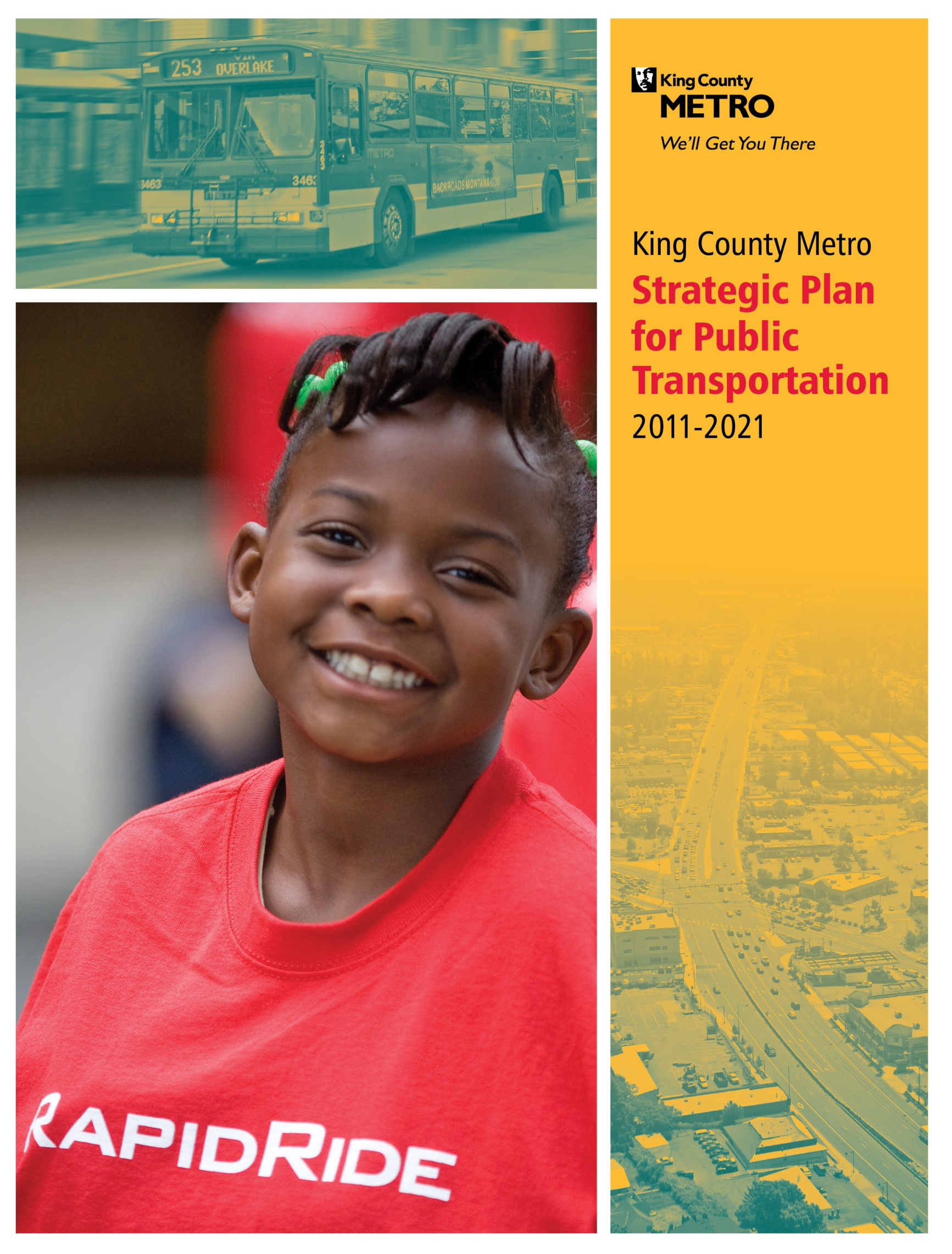
Attachment A
June 15, 2011
17143

Letter from the General Manager
Dear Friends,
I am pleased to present the King County Metro Strategic Plan for Public Transportation 2011-2021. This is the latest in a series of visionary plans Metro has used to imagine the future we want for public transportation, and then achieve it.
Metro’s last major strategic planning effort resulted in the 2002-2007 Metro Six-Year Development Plan, which had updates in 2004, 2007, and 2009. At the time this earlier plan was written, communities and employment centers were growing around the county, and traffic congestion had become one of the region’s foremost problems. The 2002 plan set the stage for Metro to enhance mobility by serving more people throughout the King County and by connecting to more destinations.
The 2002 plan led to a number of successful initiatives. Metro extended service to new locations and restructured several local transit networks to boost productivity and better match service with the destinations people wanted to reach. We helped launch a regional fare payment system, ORCA, making it easier for people to travel by bus, train, light rail and ferries throughout the region. We worked to procure hybrid articulated buses so we could carry more passengers while reducing emissions. We attracted new riders by making buses and bus stops more accessible, developing park-and-ride facilities, and expanding employee commute programs. And we took Metro service to a higher level by launching RapidRide, a new generation of service designed to keep people moving throughout the day on heavily used corridors. Metro accomplished all this and more despite two financial downturns that constrained our ability to grow.
People responded positively to the changes we made. Metro set ridership records in three consecutive years, culminating with 118 million rides in 2008 and outpacing growth in jobs, population, and vehicle miles traveled in King County. As a result of our successes, public transportation has become a more robust and better-integrated part of the Puget Sound region’s transportation system.
Now that we have reached this stage, what challenges does our new strategic plan address? Many of the old ones, like congestion, climate change, and regional growth, are still with us. The region’s Transportation 2040 action plan calls for an ambitious expansion of public transportation to accommodate the large population and job increases expected in King County. And we face the urgent need to craft a new funding structure for public transportation. Metro’s current revenue sources cannot supply the funds we need to meet our region’s expectations. I am proud of Metro’s record of delivering promised services even when funding has fallen far short of expectations over the past decade, but we have exhausted many one-time solutions and cost-cutting measures that we have used to get by. A new funding structure is imperative if we are to fully realize our vision for public transportation.
As we crafted a plan to take on these and other challenges, two recent planning processes gave us invaluable guidance. The King County Strategic Plan 2011-2014 was developed under the leadership of County Executive Dow Constantine in collaboration with King County Council members and other elected officials and input from thousands of residents and County employees. The County plan’s eight goals are the framework for Metro’s plan.
Second, the Regional Transit Task Force was formed in 2010 to consider a new policy framework for Metro as we face both growing demand for transit services and a worsening financial outlook. The task force members represented many areas of the county and points of view, but they came together on consensus proposals for Metro. While these recommendations are still under consideration, the themes that emerged in this group’s discussions—emphasizing productivity, ensuring that bus services are available for those most dependent on transit, and providing value to the diverse cities and communities throughout the county—influenced our plan in many ways.
Thanks to all the groundbreaking work and forward-looking thinking that has contributed to this strategic plan, I am confident that Metro can continue our tradition of prioritizing the customer and creating the future envisioned for public transportation in King County. We will be reporting on our performance in publications and on our website; I invite you to follow our progress.
Sincerely,
Kevin Desmond, General Manager
King County Metro Transit

Table of Contents
Table of Figures i
Executive Summary ii
Chapter 1: Introduction 1
Section 1.1: Background and Context 1
The Importance of Public Transportation in the Puget Sound Region 1
Metro’s Mandate 2
Section 1.2: Strategic Planning 4
Why a Strategic Plan? 4
How will this plan be used? 4
What will this plan achieve? 5
Section 1.3: Challenges 6
Regional growth, land use and the economy 6
Funding Shortfall 8
The Environment 9
Customer service and satisfaction 9
Evolving transportation system 10
Section 1.4: Strategic Plan Development 12
Regional Transit Task Force Charge 12
Process and Public Involvement 12
Task Force Recommendations 13
Chapter II: A Pathway to the Future 14
Section 2.1: Metro’s Vision: How public transportation will look in the future 14
Section 2.2: Elements of the Plan 15
Section 2.3: Metro’s Goals 16
Goal 1: Safety. 16
Goal 2: Human Potential. 17
Goal 3: Economic Growth and Built Environment. 19
Goal 4: Environmental Sustainability. 23
Goal 5: Service Excellence. 25
Goal 6: Financial Stewardship. 27
Goal 7: Public Engagement and Transparency. 30
Goal 8: Quality Workforce. 32
Chapter III: Plan Performance Monitoring 34
Section 3.1: How Metro Measures Performance 34
Measuring the Strategic Plan 34
Measuring Objectives 35
Measuring Strategies 36
Peer Comparison 39
Section 3.2: Route Performance 40

Table of Figures

FIGURES
Figure 1: Urban Growth Area, King County 2
Figure 2:Puget Sound Region Projected Population and Employment Growth 6
Figure 3: Regional Growth, Manufacturing/Industrial, and Transit Activity Centers 7
Figure 4: Metro Ridership 2000-2010 7
Figure 5: Annual Sales Tax Revenues 2000-2010 8

Figure 6: What is important to Metro Riders? 10
Figure 7: Fourth Quarter Park-and-Ride Utilization 2006-2010 21

TABLES
Table 1: Summary Table of Metro Plan Elements iv
Table 2: Objectives and Related Outcomes 35
Table 3: Strategies and Related Measures 36
Table 4: Peer Comparison Key Areas of Performance 42

Executive Summary
Public transportation in the Puget Sound region: today and tomorrow
Public transportation is vitally important to the Puget Sound region. It provides connections to jobs, schools, and other destinations, and enables those with limited mobility options to travel. Public transportation enhances regional economic vitality by freeing up roadway capacity and improving the mobility of people, goods, and services. It saves the region time and money. It helps accommodate regional growth by making better use of the region’s existing infrastructure and it benefits the environment. Public transportation improves the quality of life for residents and visitors to the Puget Sound region.
King County Metro Transit, King County’s public transportation provider, is committed to serving the region with the highest quality products and services possible as it works towards a vision of a sustainable public transportation that helps our region thrive.
This is Metro’s vision:
Metro provides safe, efficient and reliable public transportation that people find easy to use. The agency offers a cost-effective mix of products and services, tailored to specific market needs. Its fixed-route bus system meets most public transportation needs, particularly in areas of concentrated economic activity or urban development and along the corridors that link them. Metro also offers alternative public transportation options for people who cannot use the fixed-route system. No matter what community they live in or whether they have special needs because of age, disability or income, people can use public transportation throughout King County.
Expanded and improved products and services make public transportation attractive to a growing segment of the population, and public transportation ridership and use increases as a result. With more and more people switching from single-occupant cars to buses, carpools and other alternative transportation options, roadways are more efficient—carrying more people and goods and moving them faster. Less land is paved for parking, and the region can reduce its reliance on highway expansion.
Public transportation is contributing to a better quality of life in the Puget Sound region. The local economy is thriving because transit has kept the region moving. Public health is improving because people are walking, biking, and using transit more. Emissions from transportation have leveled off and are starting to decline, and Metro is using new technologies to reduce its energy consumption.
The public is engaged with Metro—informed about its plans and performance and a big part of the decision-making process. Customers find the public transportation experience to be positive at every stage, from trip planning to arrival at a destination. People understand how to use Metro’s products and services, and are happy with the variety of transportation options available.
Metro has quality employees who enjoy their jobs. Their satisfaction shows in their good work ethic and responsiveness to customers.
Metro is financially stable—able to sustain its products and services in both the short and long term by emphasizing productivity and efficiency and by controlling costs. Metro receives sufficient funding to fulfill the public’s expectations for service and the region’s vision for a robust public transportation system.

A pathway to the vision
To guide Metro towards its vision, this plan includes goals, objectives and strategies that build on the work of two major regional planning processes:
King County’s strategic plan: In 2010, King County adopted its first countywide strategic plan, King County Strategic Plan 2010–2014: Working Together for One King County. The plan is a key tool in Executive Dow Constantine’s work to reform county government by focusing on customer service, partnerships, and ways to bring down the cost of government. Metro’s strategic plan will guide work on portions of the countywide strategic plan that involve public transportation.
Regional Transit Task Force: Metro used input from the Regional Transit Task Force in the creation of this plan. The task force was a groundbreaking countywide effort to recommend a new policy framework for transit in King County that took place in 2010. Metro drew on the task force’s recommendations as a way to ensure that diverse points of view are well-represented in the strategic plan.
Navigating the road ahead
Metro faces complex—and often competing—challenges. The Puget Sound region is growing and evolving. Changes in land use and the region’s population are having an impact on where public transportation should be located, how service is provided, and who uses that service. Major projects that change the footprint of the transportation system have an impact on public transportation and require regional collaboration during planning and construction and upon completion. Public transportation is called upon to help mitigate climate change and meet diverse customer needs. All the while, Metro’s funding structure limits its ability to respond to these challenges.
Metro’s strategic plan is intended to address these challenges and chart a path to the future. Metro has formulated eight goals with 17 associated objectives. Each objective has an associated outcome that is related to an aspect of Metro’s vision. Metro also has established 36 strategies that are intended to move Metro closer to its objectives, and ultimately to its vision. The table on pages iv-vii summarizes these elements of the plan.
Ensuring success
Metro will monitor its performance and measure its success in achieving the plan’s strategies, objectives, goals, and vision. Metro will measure its objectives through outcomes and its strategies through associated measures. It will compare the performance of its system with that of peer transit agencies. Using this monitoring system, Metro will update and adjust this plan periodically as conditions warrant to ensure that it is moving along the right path.

Table 1: Summary table of Metro strategic plan elements
Objective | Strategies | Measures
Goal 1: Safety. Support safe communities.
Keep people safe and secure.  Outcome:  Metro’s services and facilities are safe and secure. | Promote safety and security in public transportation operations and facilities.  Plan for and execute regional emergency-response and homeland security efforts. | - Preventable accidents  - Operator and passenger incidents and assaults  - Customer satisfaction regarding safety and security  - Effectiveness of emergency responses
Goal 2: Human Potential. Provide equitable opportunities for people from all areas of King County to access the public transportation system.
Provide public transportation products and services that add value throughout King County and that facilitate access to jobs, education and other destinations.  Outcome:  More people throughout King County have access to public transportation products and services. | Design and offer a variety of public transportation products and services appropriate to different markets and mobility needs.  Provide travel opportunities for historically disadvantaged populations, such as low-income people, students, youth, seniors, people of color, people with disabilities, and others with limited transportation options.  Provide products and services that are designed to provide geographic value in all parts of King County. | - Population with ¼-mile walk access to a transit stop or 2-mile drive to a park-and-ride  - % low income population within ¼ mile walk access to transit  - % minority population within ¼-mile walk access to transit  - Accessible bus stops  - Transit mode share by market  - Student and reduced-fare permits and usage  - Access applicants who undertake fixed-route travel training  - Access boardings  - Access registrants  - Requested Access trips compared to those provided  - Number of trips provided by the Jobs Access and Reverse Commute (JARC) and Community Access Transportation (CAT) programs  - Title VI compliance  - % population at 15 dwelling units per acre within ¼ mile walk access of frequent service

Objective | Strategies | Measures
Goal 3: Economic Growth and Built Environment. Encourage vibrant, economically thriving and sustainable communities.
Support a strong, diverse, sustainable economy.  Outcome:  Public transportation products and services are available throughout King County and are well-utilized in centers and areas of concentrated economic activity. | Through investments and partnerships with regional organizations, local jurisdictions and the private sector, provide alternatives to driving alone that connect people to jobs, education and other destinations essential to King County’s economic vitality.  Partner with employers to make public transportation products and services more affordable and convenient for employees. | - Transit rides per capita  - Effectiveness of partnerships  - Park-and-ride utilization  - Peak mode share at Commute Trip Reduction (CTR) sites  - Employer-sponsored passes and usage  - % population at 15 dwelling units per acre within 1/4 mile walk access of frequent service  - All public transportation ridership in King County (rail, bus, Paratransit, Rideshare)  - Centers ridership  - Bike rack use
Address the growing need for transportation services and facilities throughout the county.  Outcome:  More people have access to and regularly use public transportation products and services in King County. | Expand services to accommodate the region’s growing population and serve new transit markets.  Coordinate and develop services and facilities with other providers to create an integrated and efficient regional transportation system.  Work with transit partners, WSDOT and others to manage park-and-ride capacity needs.
Support compact, healthy communities.  Outcome:  More people regularly use public transportation products and services along corridors with compact development. | Encourage land uses, policies, and development that lead to communities that transit can serve efficiently and effectively.  Support bicycle and pedestrian access to jobs, services, and the transit system.
Support economic development by using existing transportation infrastructure efficiently and effectively.  Outcome:  Regional investments in major highway capacity projects and parking requirements are complemented by high transit service levels in congested corridors and centers. | Serve centers and other areas of concentrated activity, consistent with Transportation 2040.

Objective | Strategies | Measures
Goal 4: Environmental Sustainability. Safeguard and enhance King County’s natural resources and environment.
Help reduce greenhouse-gas emissions in the region.  Outcome:  People drive single-occupant vehicles less. | Increase the proportion of travel in King County that is provided by public transportation products and services. | - Per capita vehicle miles traveled (VMT)  - Transit mode share  - Public transportation energy use per passenger mile  - Average miles per gallon  of the Metro bus fleet  - Energy use at Metro facilities
Minimize Metro’s environmental footprint.  Outcome:  Metro’s environmental footprint is reduced (normalized against service growth). | Operate vehicles and adopt technology that has the least impact on the environment and maximizes long-term sustainability.  Incorporate sustainable design, construction, operating and maintenance practices.
Goal 5: Service Excellence. Establish a culture of customer service and deliver services that are responsive to community needs.
Improve satisfaction with Metro’s products and services and the way they are delivered.  Outcome:  People are more satisfied with Metro’s products and services. | Provide service that is easy to understand and use.  Emphasize customer service in transit operations and workforce training.  Improve transit speed and reliability. | - Conformance with King County policy on communications accessibility and translation to other languages  - Customer satisfaction  - Customer complaints  - On-time performance by time of day  - Load factor  - Utilization of Metro web tools  - One Regional Card for All (ORCA) usage
Improve public awareness of Metro products and services.  Outcome:  People understand how to use Metro’s products and services and use them more often. | Use available tools, new technologies, and new methods to improve communication with customers.  Promote Metro’s products and services to existing and potential customers.
Goal 6: Financial Stewardship. Exercise sound financial management and build Metro’s long term sustainability.
Emphasize planning and delivery of productive service.  Outcome:  Service productivity improves. | Manage the transit system through service guidelines and performance measures. | - Boardings per platform hour  - Passenger miles per platform hour  - Boardings per revenue hour  - Passenger miles per revenue mile  - Access boardings  - Commuter van boardings  - Cost per boarding  - Cost per hour  - Service hours operated  - Asset condition assessment  - Base capacity level of service  - Fare revenues  - Farebox recovery  - Fare parity with other providers in the region
Control costs.  Outcome:  Metro costs grow at or below the rate of inflation. | Continually explore and implement cost efficiencies, including operational and administrative efficiencies.  Provide and maintain capital assets to support efficient and effective service delivery.  Develop and implement alternative public transportation services and delivery strategies.
Objective | Strategies | Measures
Seek to establish a sustainable funding structure to support short- and long-term public transportation needs.  Outcome:  Adequate funding to support King County’s short- and long-term public transportation needs. | Secure long-term stable funding.  Establish fare structures and fare levels that are simple to understand, aligned with other service providers, and meet revenue targets established by Metro’s fund management policies.  Establish fund management policies that ensure stability through a variety of economic conditions. | - Fully allocated costs  - Operational and cost efficiency indicators  - Service hours and service hour change per route  - Ridership and ridership change per route
Goal 7: Public Engagement and Transparency. Promote robust public engagement that informs, involves, and empowers people and communities.
Empower people to play an active role in shaping Metro’s products and services.  Outcome:  The public plays a role and is engaged in the development of public transportation. | Engage the public in the planning process and improve customer outreach. | - Public participation rates  - Customer satisfaction regarding their role in Metro’s planning process  - Customer satisfaction regarding Metro communications and reporting
Increase customer and public access to understandable, accurate and transparent information.  Outcome:  Metro provides information that people use to access and comment on the planning process and reports. | Communicate service change concepts, the decision-making process, and public transportation information in language that is accessible and easy to understand.  Explore innovative ways to report to and inform the public.
Goal 8: Quality Workforce. Develop and empower Metro’s most valuable asset, its employees.
Attract and recruit quality employees.  Outcome:  Metro is satisfied with the quality of its workforce. | Market Metro as an employer of choice and cultivate a diverse and highly skilled applicant pool.  Promote equity, social justice and transparency in hiring and recruiting activities. | - Demographics of Metro employees  - Employee job satisfaction  - Promotion rate  - Probationary pass rate  - Training opportunities provided  - Trainings completed  - Employee performance
Empower and retain efficient, effective, and productive employees.  Outcome:  Metro employees are satisfied with their jobs and feel their work contributes to an improved quality of life in King County. | Build leadership and promote professional skills.  Recognize employees for outstanding performance, excellent customer service, innovation and strategic thinking.  Provide training opportunities that enable employees to reach their full potential.

Chapter 1
Introduction
King County Metro Transit’s strategic plan is divided into three sections: Introduction, which provides background and context, summarizes the challenges facing Metro, and describes the strategic planning process; Pathway to the Future, which presents Metro’s vision, goals, objectives and strategies; and Plan Performance Monitoring, which describes the process Metro will use to track progress.
Metro products and services
Metro Transit provides more than 100 million annual fixed-route transit rides—traditional transit service that operates on specific pathways and at specific times—to residents and visitors of King County.
Metro is more than buses. It provides other programs and services that augment the fixed-route transit system, including the largest publicly owned vanpool program in the country, paratransit services, dial-a-ride transit, and other specialized products.
The combination of fixed-route transit service, Metro programs, and other Metro services are referred to as “public transportation” or “Metro’s products and services” in the strategic plan. These terms encompass all of the things that Metro does.
Section 1.1
Background and context
The importance of public transportation in the Puget Sound region
Public transportation is vitally important to the Puget Sound region. In 2009, Metro provided more than 110 million passenger trips and carried passengers approximately 496 million miles on its fixed-route system. Metro also meets public transportation needs through an array of other products and services (see sidebar).
Public transportation improves the quality of life in the region by providing mobility to those who need or choose to utilize it. It connects commuters to jobs—more than 30 percent of work trips to downtown Seattle are made on transit. It connects students to schools and residents to recreation. It offers travel options to those who cannot drive, and provides assurance to drivers that other mobility options exist should they need them.
Public transportation reduces transportation costs for individual users and families. In 2009, the Seattle area saved approximately $323 million in fuel and time costs because of the existence of public transportation. This is more than twice the savings of Portland, San Diego, Houston and Dallas.
Transit enhances the region’s economic vitality by freeing up roadway capacity, improving the movement of people and goods. On an average weekday, Metro provides service for more than 113,000 people on major state routes. It offers commute options that reduce the need for regional investment in parking infrastructure and roadways. On weekdays in the afternoon, Metro moves more than 21,000 people on freeways and major state routes, roughly the equivalent of seven lanes of traffic. And public transportation projects stimulate the economy by creating jobs.
Public transportation will support growth by accommodating the travel needs of a bigger share of the region’s projected population, and is an integral part of the regional growth strategy laid out in the Puget Sound Regional Council’s Vision 2040 and Transportation 2040.
Public transportation also improves the region’s air quality by reducing the number of miles people drive. Energy-efficient transit vehicles contribute to the decrease in transportation emissions.
Metro is committed to improving the quality of public transportation and increasing ridership and use of its products and services, thereby enhancing the entire regional transportation system.
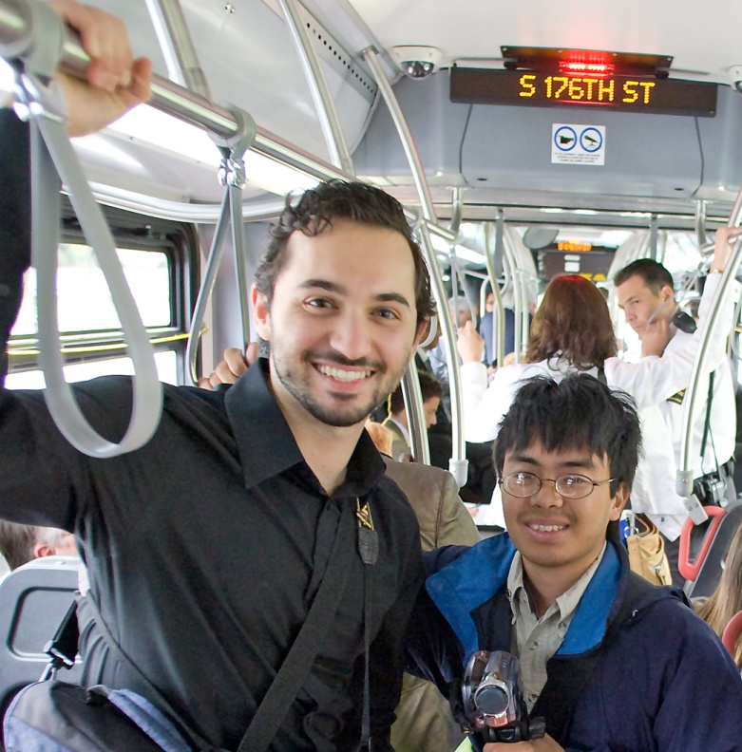
Metro’s mandate
The King County Department of Transportation’s Metro Transit Division is directed to perform the “metropolitan public transportation function” as authorized in the Revised Code of Washington 35.58, in alignment with other applicable codes and the financial policies adopted by the Metropolitan King County Council. Metro is required to plan and operate transit services consistent with county, regional, state and federal planning policies.
Countywide planning and policies: King County Countywide Planning Policies (CPPs) are developed by a group of elected officials from King County and the cities and jurisdictions within the county. These policies are consistent with state law, state agency guidance, decisions of the Growth Management Policy Council (GMPC) and the regional growth strategy outlined in Vision 2040. The CPPs provide a countywide vision and serve as a framework for each jurisdiction to develop its own comprehensive plan, which must be consistent with the overall vision for the future of King County. Metro’s Strategic Plan for Public Transportation 2011-2021 is consistent with the Countywide Planning Policies, the King County Comprehensive Plan, the King County Strategic Plan, and the King County Energy Plan.
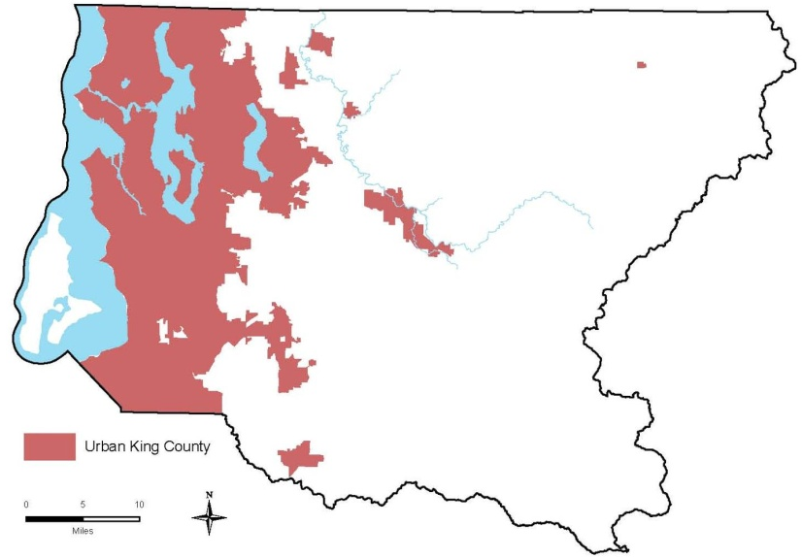
Regional planning and policies: State law (RCW 47.80.020) designates the four-county Puget Sound Regional Council (PSRC) as the Metropolitan Planning Organization (MPO) and the Regional Transportation Planning Organization (RTPO) for federal planning purposes. As the region’s MPO, PSRC develops a regional plan and strategies to guide decisions about regional growth management and environmental, economic and transportation issues. As the region’s RTPO, PSRC develops long-range transportation and development plans across multiple jurisdictions and establishes federal funding priorities for the region. Metro participates in the planning process and strives to meet the goals of the regional plans, Vision 2040 and Transportation 2040.
Figure 1: Urban growth area, King County
Washington state planning and policies: In 1990, the Washington Legislature passed the Growth Management Act (GMA). The GMA requires that the state's largest and fastest-growing counties conduct comprehensive land-use and transportation planning, to concentrate new growth in compact "urban growth areas," and protect natural resources and environmentally critical areas. King County’s UGA is shown in Figure 1. The GMA requires King County to consider population and employment growth targets and land uses when determining the future demand for travel and whether such demand can be met by existing transportation facilities. Metro contributes to the County’s compliance with the GMA by focusing public transportation services on urban growth areas.
Federal planning and policies: Metro complies with federal laws that require the public transportation system to be equitable, accessible, and just. Civil rights statutes, including Title VI of the Civil Rights Act of 1964 (see sidebar), require that Metro provide public transportation in a manner that does not discriminate on the basis of race, color, national origin, disability, or age. The Americans with Disabilities Act (ADA) requires that Metro ensure equal opportunities and access for people with disabilities. A 1994 executive order requires that all federal agencies include environmental justice in their missions. This means that Metro cannot disproportionately impact minority or low-income populations and must ensure full and fair participation by all potentially affected groups. Metro provides public transportation that adheres to these and other federal requirements.
Title VI of the Civil Rights Act of 1964 provides that “no person in the United States shall, on the ground of race, color, or national origin, be excluded from participation in, be denied the benefits of, or be subjected to discrimination under any program or activity receiving Federal financial assistance.”

Section 1.2
Strategic Planning
Why a strategic plan?
Strategic planning is a process by which an organization assesses how it is doing, figures out where it wants to go, and charts a path to get there. Strategic plans define important goals, set specific directions, and establish the policy framework for the future.
Guiding principles from King County’s Strategic Plan
The following are King County’s guiding principles about the roles and responsibilities of county government:
Collaborative – We work together effectively within the organization and in collaboration with other governments, private entities and community partners.
Service-oriented – We listen and respond to our customers in a culturally responsive way and prioritize their satisfaction as we do our work.
Results-focused – We establish community driven goals, measure our performance, and report to the public on our success in meeting those goals.
Accountable – We are responsive and transparent to the public in our roles, functions and actions as individuals and as a government.
Innovative – We are creative, learn from experience and results, and seek out new and efficient ways to solve problems and serve the public.
Professional – We uphold the high standards, skills, competence, and integrity of our professions in doing the work of King County government.
Fair and Just – We serve all residents of King County by promoting fairness and opportunity and eliminating inequities.
In 2010, King County adopted its first countywide strategic plan, King County Strategic Plan 2010–2014: Working Together for One King County. The plan is a key tool in Executive Constantine’s work to reform county government by focusing on customer service, partnerships and ways to bring down the cost of government. Metro’s strategic plan incorporates King County’s guiding principles (see sidebar) and lays out steps for implementing portions of the countywide strategic plan that influence or are influenced by public transportation.
Metro has also used the input of the Regional Transit Task Force in the creation of this plan. The task force was a major regional effort to consider a new policy framework for transit in King County that took place in 2010; it is explained in more detail on pages 12-13. Metro used input from the task force’s work a way to ensure that diverse points of view are well-represented in this strategic plan.
Metro has a particular need to create a strategic plan at this time. Metro’s structural financing problems affect its ability to deliver existing service and address increasing demand for public transportation into the future.
This strategic plan is a way for Metro to define its role in the delivery of King County’s strategic plan, follow through on the recommendations of the Regional Transit Task Force, and navigate the significant challenges it faces, while setting a sustainable course for the future.
How will this plan be used?
Metro’s strategic plan is intended for a variety of audiences. It is meant to do the following:
- Communicate Metro’s vision and its intended direction and emphasis over the next 10 years.
- Describe the policy framework in which King County Metro’s operational and budget decisions are made.
- Signify Metro’s commitment to customer satisfaction and quality service.
- Serve as a baseline to show progress and allow the public to hold Metro accountable.
- Align Metro’s employees, services and programs with King County’s goals
- Provide a structure to ensure oversight and management of Metro’s programs and services.
What will this plan achieve?
This plan lays out a vision and mission for public transportation services in King County and describes the strategies that will move Metro towards that vision. It also defines desired outcomes and how progress will be measured.
Some elements of this plan—the mission, vision, goals and objectives—are expected to be realized over a long-term time frame. The other element of the plan—the strategies—are expected to be realized in a shorter time frame. This plan will be reviewed periodically as circumstances warrant, and plan elements may be modified, added or substituted if needed.
Although this plan is intended to inform the biennial budget process, funding constraints will limit Metro’s ability to implement every strategy in this plan in any given year. Many of the goals and objectives represent ideals that Metro will continually strive to achieve, and which are likely to be included in subsequent plans.
Section 1.3
Challenges
Metro based this strategic plan in part on an assessment of its current environment and the challenges it faces both within and outside the organization; these are described below. The goals, objectives and strategies articulated later in the plan address these challenges.
Figure 2: Puget Sound region projected population and employment growth
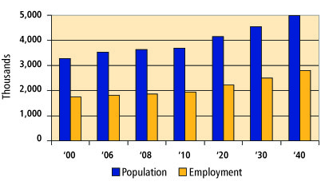
Regional growth, land use and the economy
King County is the most populous county in the state and the 14th most populous county in the nation. It has a variety of geographic characteristics and diverse communities; land uses, densities and population vary greatly.
The densest parts of the county, where most people live and work, have little room to expand existing transportation infrastructure, so building new highways, roads, and other infrastructure would be both costly and technically challenging. Because of this, the regional growth plans call for more intensive use of existing infrastructure, increasing the number of people using transit services and the proportion of overall regional trips made on transit.
Regional population and economic growth: In the past 10 years, King County’s population has grown by 11 percent. Cities throughout the county have seen population growth and have annexed large areas that previously were unincorporated. Most cities in the County have increased in population since 2000. Demand for public transportation has increased along with population growth.
More growth is expected throughout the region. The Puget Sound Regional Council estimates there will be an additional 1.5 million people in the region by 2040—a 42 percent increase. Growth in the number of jobs is also expected. An estimated 1.2 million new jobs will come to the region by 2040—a 57 percent increase since 2000. More people and jobs (shown in Figure 2) mean that Metro will have an opportunity to serve more riders and major employment centers.
This growth will be focused in King County’s centers (see sidebar). The centers referred to in Metro’s strategic plan are shown in Figure 4.
Public transportation ridership tends to fluctuate with changes in fuel prices, population and employment levels, and other changes. As shown in Figure 3, Metro’s ridership grew each year between 2002 and 2008, culminating in 2008 with its highest annual ridership of more than 118 million boardings. At that time, Metro’s ridership growth per service hour was outpacing that of the 10 largest transit agencies in the nation. Ridership has decreased since then, in part because of high unemployment. As the economy recovers and employment levels return to normal, Metro’s ridership is expected to increase again.
Ridership changes: Changing demographics, such as income, age, and ethnicity, as well as access to transit and household density, also have an impact on King County’s transit system. For example, King County’s population is aging; people 65 and older now account for 10 percent of the people who live here. An aging population may rely more on public transportation for its travel needs than a younger population would.
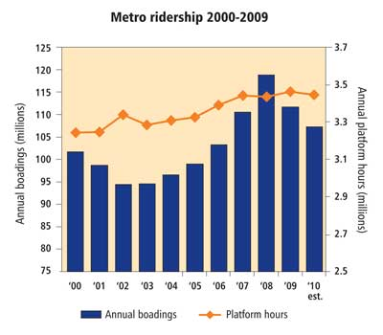
King County is also becoming more diverse in its ethnic, cultural and language makeup, and that diversity is increasingly spreading to more areas of King County. Metro’s public transportation services will be called upon to address gaps in mobility by serving people who have limited transportation options, including seniors, youth, students, people with disabilities, people of color, those with limited English proficiency and economically disadvantaged communities.
Figure 3: Metro Ridership 2000-2010
Centers
Centers are the hallmark of PSRC’s Vision 2040 and its Regional Growth Strategy. Designated regional growth centers have been identified for housing and employment growth, as well as for regional funding. Regional manufacturing/industrial centers are locations for increased employment.
In addition to PSRC’s designated centers, Metro has also identified “transit activity centers” in King County. Transit Activity centers are areas of the county that are important for Metro to serve and that are typically associated with higher levels of transit use. Transit Activity centers are further explained in the King County Metro Service Guidelines.
Regional Growth, Manufacturing/Industrial, and Transit Activity Centers are collectively referred to as “centers” in this strategic plan.

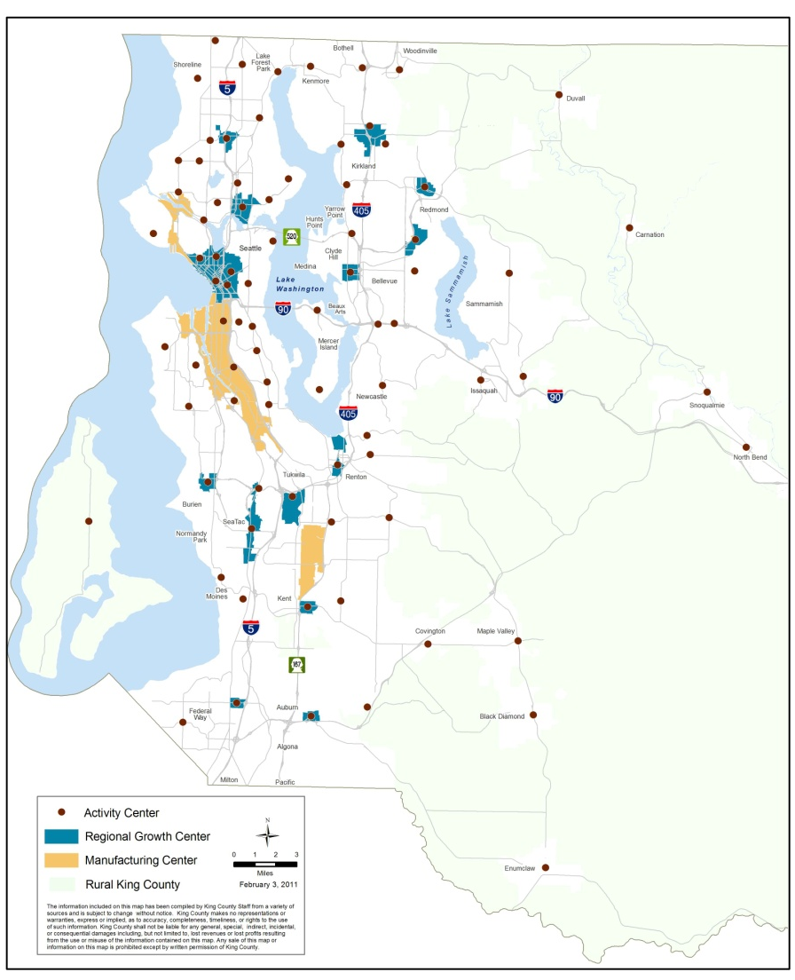
Figure 4: Regional Growth, Manufacturing/Industrial and Transit Activity Centers

Funding shortfall
Increased ridership: In 2006, voters approved a ballot measure known as Transit Now to increase public transportation services in King County. This measure included funding for five RapidRide lines, additional service for high-ridership routes and rapidly developing areas, service partnerships with cities and businesses, and expanded Access and ridesharing services. Between 2007 and 2009, Metro was on schedule for implementing these improvements.
Figure 5: Annual sales tax revenues 2000-2010
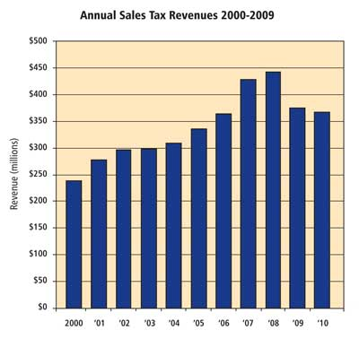
Transit Now investments in public transportation were timely. In 2007 and 2008, Metro experienced unprecedented growth in ridership, largely because people changed their travel habits in response to higher gas prices. At that time, Metro was growing, with ridership increasing more than seven percent each year. Buses were full—people accustomed to getting a seat on the bus found themselves standing, and people used to standing on the bus found themselves passed by. Metro simply could not keep up with the increasing demand for service.
Financial Challenges: Even though the economy was booming and ridership was setting all-time records, Metro struggled financially. The same factors that boosted public transportation ridership also increased Metro’s operating costs. High fuel costs, together with increasing wages and benefits, impacted Metro’s ability to respond to increasing demands for public transportation.
2009 Performance Audit of Transit
In 2009, the King County Auditor’s Office released a report with 34 recommendations for ways that Metro could be more efficient and save money. Metro is actively implementing these recommendations, finding efficiencies in the way it schedules buses and operators, performs maintenance, monitors performance, provides Paratransit services, and many other aspects of public transportation. In 2010, over $10 million in ongoing costs have been reduced as a result.
Revenue from sales tax (shown in Figure 5), which makes up nearly 60 percent of Metro’s operating funds, is vulnerable to the fluctuations in the economy. Metro experienced a sharp revenue drop of more than $130 million for the 2008-2009 biennium, which further exacerbated the challenges Metro was facing with higher costs and increased ridership. Metro was able to delay reductions in transit service by increasing fares, reducing operating expenses and scaling back capital projects. These efforts enabled Metro to maintain service levels and sustain modest service growth.
Sales tax revenues continued to fall in the wake of the recession, creating an even larger gap in the 2010-2011 biennium budget. Metro avoided large reductions in transit service by deferring expansion of bus service—including proposed Transit Now investments, making non-service related cuts, increasing transit funding through a King County property tax, increasing fares, using fleet replacement reserves, and implementing findings of a transit performance audit (see sidebar). These actions, along with some temporary, one-time use of reserves and capital fund reductions, were collectively known as the nine-point plan and allowed Metro to balance its budget for the 2010/2011 biennium.
Although the economy appeared to be recovering in early 2011, sales tax revenues are not expected to be greater than what was collected in 2008 until 2014. Recent forecasts predict that sales tax revenues will continue to be well below previous projections. Based on the County’s updated revenue forecast through 2015, Metro may have to make significant transit service reductions as soon as 2012 to balance its budget.
Structural deficit: From 2009 to 2015, Metro’s cumulative loss from lower-than-expected sales tax revenues is projected to be more than $1 billion. Despite all of the budget actions Metro has taken, it would have to fill a multi-year gap of nearly $315 million from 2012-2015 just to maintain current service levels and complete service expansions promised to voters in the 2006 Transit Now initiative.
Without additional resources, Metro is facing potential ongoing cuts of approximately 600,000 annual service hours—about 20 percent of the current system. By 2015, countywide bus services would be dramatically reduced, resulting in a system that is 20 percent smaller than in 2009.
These potential service reductions would have a dramatic impact on riders and public transportation use in King County. Difficult decisions would have to be made about where and when services would be reduced.
The environment
Transportation accounts for nearly half of all greenhouse-gas emissions in Washington. To reduce emissions, significant changes in how we live and travel are necessary. Metro can play a major role by providing transportation options that encourage public transportation ridership and help reduce the number of vehicle miles traveled. In order for the shift from single-occupant vehicles to public transportation to occur in a way that will have an impact on climate change, more areas of the county must adopt compact, dense land uses and encourage development that is more easily served by transit.
Metro also supports King County energy policies that seek to minimize the environmental and carbon footprint of its own operations. Metro does this by operating fuel-efficient vehicles, applying sustainable practices at Metro facilities, and reducing energy consumption. Reducing energy consumption will also help Metro financially. The dynamics of fuel supply, as demonstrated by the 2008 spike in gas prices, are likely to continue affecting transportation costs.
Customer service and satisfaction
Maintaining and improving customer satisfaction with Metro services is an ongoing process. Every experience a customer has on a Metro bus, at a Metro facility, or with Metro employees and information services affects perceptions about the quality of public transportation. Metro strives to ensure that a customer’s public transportation experience is positive at every stage of a trip. Metro reaches out to customers for input into service and product design and to obtain feedback about how well its services are meeting customer needs and expectations. Public meetings, correspondence, direct interactions and an annual telephone survey of riders help Metro gather planning input and measure how well it is doing in the eyes of its customers.
Figure 6 illustrates the issues that have the most impact on customer satisfaction. Vertically, the chart shows which issues are most important to riders. Horizontally, the chart shows the frequency at which customers raise these concerns. Issues in the top right corner, such as long travel times on the bus and poor on-time performance, are most important to riders and are cited frequently. Metro is working towards improving the factors identified in this chart.
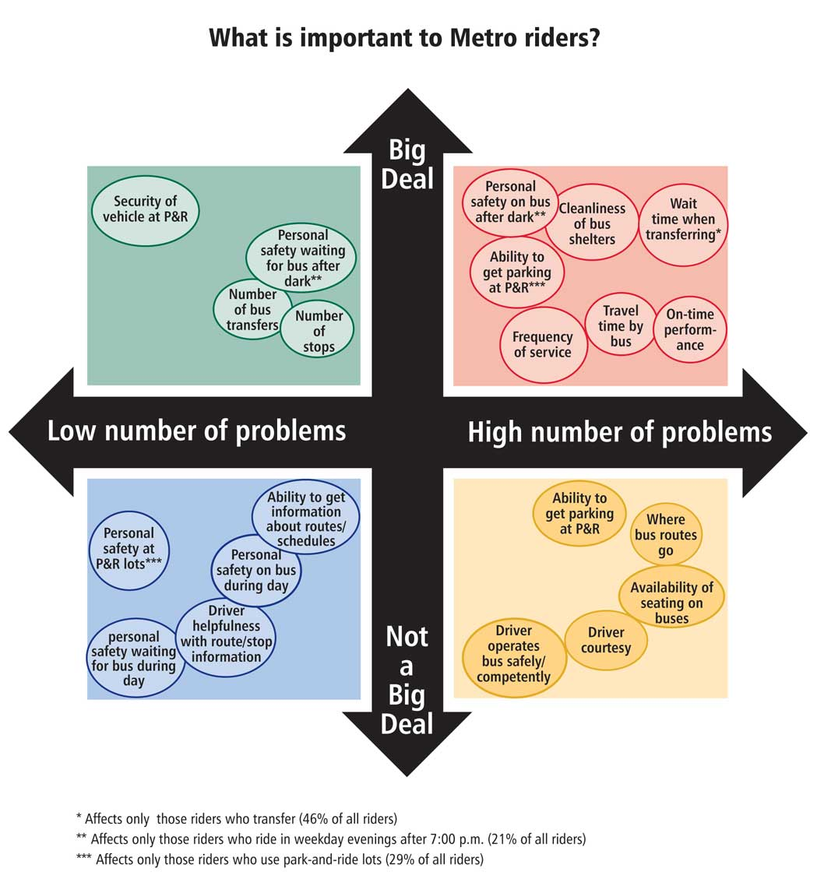
Improving quality is important to increasing customer satisfaction, but budget constraints make it difficult for the agency to do so. Metro must ensure that during times of significant change in the public transportation system, the decision-making process is clear, transparent and based on criteria and objectives that are easy for customers to understand. Whether Metro is expanding or reducing the public transportation system, a transparent decision-making process will help build trust and acceptance of the decisions made. Responding to customers, including the public in the decision-making process, and maintaining quality service are crucial ways for Metro to increase ridership and improve customer service and satisfaction.
Figure 6: What is important to Metro riders?
Evolving transportation system
The Puget Sound region’s transportation system is constantly changing and adapting to the mobility needs of its residents. The many plans and proposals for improving and expanding the transportation system will present opportunities and challenges for Metro.
Metro works closely with other regional transit and transportation agencies to plan and provide efficient, integrated travel options that enhance public transportation services in King County. Metro coordinates most closely with Sound Transit, Pierce Transit, Community Transit, Washington State Ferries and the King County Ferry District. Metro also works with the Washington State Department of Transportation (WSDOT), PSRC, various local and regional jurisdictions, and businesses such as Microsoft that provide direct transit service to their employees.
Metro collaborates on some of the region’s most important transportation projects to ensure that public transportation continues to play a vital role in the region’s broader transportation system. These projects include the following:
- Sound Transit’s Link light rail: In 2009, Sound Transit opened the Central Link light rail line connecting Seattle-Tacoma International Airport with downtown Seattle. Metro undertook an extensive public engagement effort as part of this project and redesigned transit service to better connect to light rail.
Link will be extended throughout the region over the next 10 years, reaching the University District in 2016 and Northgate by 2021, and connecting Overlake and downtown Seattle beginning in 2021. Sound Transit also plans to extend Link south along the Pacific Highway South/SR-99 corridor. The growth of the light rail system offers opportunities for Metro to provide better connections for riders to and from this high-capacity transit service, improving the overall efficiency of the region’s transportation system.
- Major highway projects: Public transportation is an essential part of major transportation projects in the Puget Sound region. Metro provides public transportation service to mitigate the impacts of major projects and is also affected by changes to the transportation infrastructure in the region. Public transportation will play a major role in the Alaskan Way Viaduct and Seawall Replacement Project and the SR 520 Bridge Replacement project, as well as other transportation infrastructure projects in the next 10 years.
As the region’s public transportation system evolves, Metro will continue to actively engage with regional, local and state entities as well as businesses and communities to build an effective system.
Section 1.4
Strategic Plan Development
This strategic plan builds on past planning efforts and policies. In early 2010, the King County Council and Executive formed the Regional Transit Task Force, made up of 31 members (28 voting and three non-voting) who represented a broad diversity of interests and perspectives from across the county. Metro’s strategic plan is based in part on the policy framework and recommendations that came out of the task force process.
Transit system design factors
The Council asked the task force to consider six design factors; the task force added one more. The following summarizes the Regional Transit Task Force definitions of these factors:
Factor 1: Land use: To support regional and local growth plans by concentrating transit service coverage and higher service levels in corridors where residential and job density is greatest.
Factor 2: Social equity and environmental justice: To support social equity and environmental justice by providing mobility options to those who have no or limited transportation options.
Factor 3: Financial sustainability: To support financial sustainability through transit that achieves higher ridership and fare revenues combined with lower costs per rider.
Factor 4: Geographic value: To support geographic value by facilitating service allocation decisions (both for reductions and growth) that are perceived as “fair” throughout the county. This involves balancing access with productivity; maintaining some relationship between the tax revenue created in a subarea and the distribution of services; and providing access to job centers and other destinations that are essential to countywide economic vitality.
Factor 5: Economic development: To support economic development by achieving the largest number of work trips at all times of the day and all days of the week via transit.
Factor 6: Productivity and efficiency: To support productivity and efficiency by focusing on a system that results in high productivity and service efficiency based on performance measures for different types of transit services.
Factor 7: Environmental sustainability: To support environmental sustainability by reducing greenhouse-gas emissions by reducing vehicle travel, reducing congestion, and supporting compact development.
Regional Transit Task Force charge
The primary charge to the task force was to recommend a policy framework that reflects the prioritization of key system design factors (see sidebar) and to make recommendations about public transportation system design and function. The overall framework was to include:
- Concurrence with, or proposed changes to, the vision and mission of Metro
- Criteria for systematically growing the public transportation system to achieve the vision
- Criteria for systematically reducing the public transportation system should revenues not be available to sustain it
- State and federal legislative agenda issues to achieve the vision
- Strategies for increasing the efficiency of Metro.
Process and public involvement
The Regional Transit Task Force conducted its work over a seven-month period, with 12 full-group meetings and eight subgroup meetings. Task force meetings were open to public comment, and a webpage posted on the County’s website included an online comment form. The task force set aside time at each meeting to hear the thoughts, ideas, and opinions of anyone who wished to speak, and these comments were included in meeting summaries.
Task Force recommendations
The task force was unanimous in approving seven recommendations. The major themes are described below. For the full version of the recommendations, visit www.kingcounty.gov/transittaskforce.
- Transparency and clarity: The task force recommendations suggest that Metro provide more transparency and clarity to the public on decision-making processes. To this end, the task force suggested that Metro create and adopt a new set of performance measures and clear and transparent guidelines to be used in service allocation decisions.
- Cost control: The task force recommendations suggest that Metro control costs and establish a sustainable financial structure that will work over time.
- Sustainable funding: The task force recommendations suggest that legislation be pursued to ensure that Metro has a more sustainable financial base and can grow in the future.
- Productivity, social equity, and geographic value: The task force recommendations suggest that Metro emphasize productivity, ensure social equity, and provide geographic value in service reduction and growth decisions.
- Mission and vision: The task force recommendations suggest that Metro revise its mission statement and create a vision statement in its strategic plan.
Chapter II
A Pathway to the Future
Metro’s vision for public transportation—and goals, objectives and strategies for achieving it
The transportation system in the Puget Sound region affects not only our ability to get around but also our economy, our environment, and our quality of life. Faced with growing transportation needs and limited space to expand roadway capacity, the region must use the existing transportation system more efficiently and effectively. Public transportation will play a vital role as we move toward a well-functioning, sustainable transportation system that helps our region grow and thrive.
Section 2.1
Metro’s vision: What public transportation will be like in the future
This is Metro’s vision statement:
Metro provides safe, efficient and reliable public transportation that people find easy to use. The agency offers a cost-effective mix of products and services, tailored to specific market needs. Its fixed-route bus system meets most public transportation needs, particularly in areas of concentrated economic activity or urban development and along the corridors that link them. Metro also offers alternative public transportation options for people who cannot use the fixed-route system. No matter what community they live in or whether they have special needs because of age, disability or income, people can use public transportation throughout King County.
Expanded and improved products and services make public transportation attractive to a growing segment of the population, and public transportation ridership and use increases as a result. With more and more people switching from single-occupant cars to buses, carpools and other alternative transportation options, roadways are more efficient—carrying more people and goods and moving them faster. Less land is paved for parking, and the region can reduce its reliance on highway expansion.

Public transportation is contributing to a better quality of life in the Puget Sound region. The local economy is thriving because public transportation has kept the region moving. Public health is improving because people are walking, biking, and using transit more. Emissions from transportation have leveled off and are starting to decline, and Metro is using new technologies to reduce its energy consumption.
The public is engaged with Metro—informed about its plans and performance and a big part of the decision-making process. Customers find the public transportation experience to be positive at every stage, from trip planning to arrival at a destination. People understand how to use Metro’s products and services, and are happy with the variety of transportation options available.
Metro has quality employees who enjoy their jobs. Their satisfaction shows in their good work ethic and responsiveness to customers.
Metro is financially stable—able to sustain its products and services in both the short and long term by emphasizing productivity and efficiency and by controlling costs. Metro receives sufficient funding to fulfill the public’s expectations for service and the region’s vision for a robust public transportation system.
Section 2.2
Metro’s goals

The “what we deliver” goals are:
- Safety: Support safe communities.
- Human potential: Provide equitable opportunities for people from all areas of King County to access the public transportation system.
- Economic growth and built environment: Encourage vibrant, economically thriving and sustainable communities.
- Environmental sustainability: Safeguard and enhance King County’s natural resources and environment.

The “how we deliver” goals are:
- Service excellence: Establish a culture of customer service and deliver services that are responsive to community needs.
- Financial stewardship: Exercise sound financial management and build Metro’s long-term sustainability.
- Public engagement: Promote robust public engagement that informs, involves, and empowers people and communities.
- Quality workforce: Develop and empower Metro’s most valuable asset, its employees.

Elements of the plan
The mission, goals, objectives and strategies in this plan reflect the priorities of King County residents, businesses, and leaders. They are designed to guide budget and implementation decisions that move Metro toward its vision.
Mission: Provide the best possible public transportation services and improve regional mobility and quality of life in King County.
Goals: Metro’s strategic plan has eight goals that mirror the goals in King County’s strategic plan. They include “what” goals that state what Metro intends to accomplish or services it intends to provide, and “how” goals that articulate how Metro intends to conduct its work (see sidebar).
Metro plans to move toward the goals by implementing this plan, but the goals are also intended to endure beyond the 10-year life of this plan.
Objectives: Objectives describe what Metro must do to achieve its goals. An objective may serve multiple goals, but each objective is listed with a specific goal to which it is most closely tied. Each of the 17 objectives has an associated outcome. Section III, Plan Performance Monitoring, describes how Metro will measure progress toward the desired outcomes.
Strategies: This plan contains 36 strategies for achieving the objectives. Even though strategies may serve multiple objectives and goals, each strategy is listed with a specific objective to which it is most closely tied. Section III, Plan Performance Monitoring, describes how Metro will measure its success in carrying out these strategies.
Section 2.3
Metro’s Goals
Goal 1: Safety. Support safe communities.
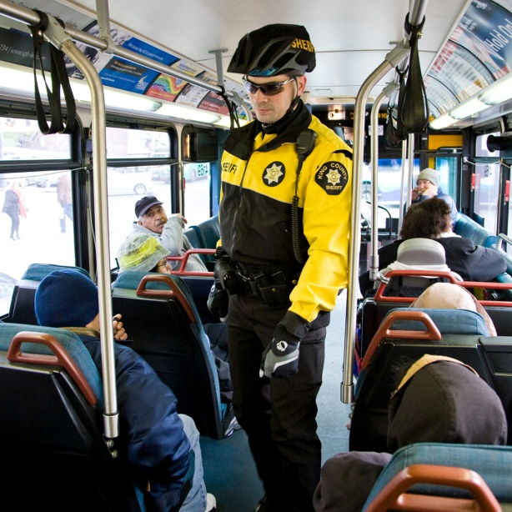
Metro provides a safe and secure transportation environment and ensures emergency preparedness.
Objective 1.1: Keep people safe and secure.
Metro protects the safety and security of customers, employees and facilities in a variety of ways, including planning, policing, facility design, operational practices, safety training, and collaboration with local jurisdictions and other agencies on safety-related matters. Intended outcome: Metro’s services and facilities are safe and secure.
- Strategy 1.1.1: Promote safety and security in public transportation operations and facilities.
The Metro Transit Police (MTP) protects Metro’s operators and riders by patrolling the Metro system and facilities by bus, bike and car. The MTP leverages its resources by creating partnerships with community groups, police and other government agencies, and other public transportation organizations. These partnerships allow the MTP to share information, ideas, and solutions to common safety issues.
Metro educates and trains its employees to improve the safety and security of the public transportation system and Metro’s offices and facilities. A major focus of safety efforts is operator training, as transit operators directly impact the safety of riders and other road users. Metro also strives to ensure that its facilities use principles of safe design, such as Crime Prevention Through Environmental Design, to maximize environmental safety.
Metro’s All Hazards Response Plan is designed to ensure the safety of all responders, deter and prevent incidents, guide the response of Metro and partnering agencies so it is quick and effective, and appropriately manage Metro’s resources during an incident.
The Adverse Weather Plan matches service delivery to the severity of the incident and outlines procedures for internal and external communications.
Metro’s Accident Prevention Program Plan and System Security Plan guide Metro’s efforts to maintain and improve the safe operations of its vehicles and the safety and security of its facilities.
- Strategy 1.1.2: Plan for and execute regional emergency response and homeland security efforts.
Metro prepares for emergency situations so it can help the Puget Sound region adapt and continue functioning when emergencies happen. Metro has developed two major plans for continuing to provide reliable transportation in “all-hazard” incidents ranging from major service interruptions to civil unrest as well as the more common adverse weather occurrences such as snow or flooding. These are the All Hazards Response Plan and the Adverse Weather Plan (see sidebar).
Metro also regularly conducts emergency-preparedness field exercises with local, county, state and federal agencies.

Goal 2: Human Potential. Provide equitable opportunities for people from all areas of King County to access the public transportation system.

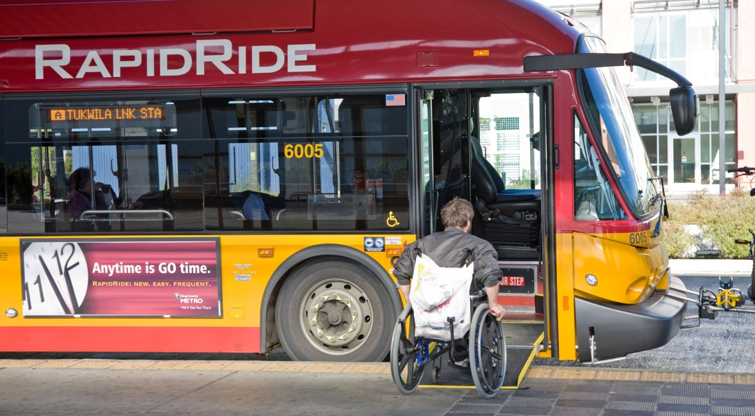
Metro provides equitable and accessible transportation options.

Objective 2.1 Provide public transportation products and services that add value throughout King County and that facilitate access to jobs, education, and other destinations.
Metro’s public transportation products and services
Fixed-route: Traditional transit service that operates on specific pathways and at specific times.
Ridesharing: Shared ride to school or work; can be a carpool, vanpool, or vanshare.
Paratransit: Shared rides on Access transportation within ¾-mile on either side of a non-commuter fixed-route bus service.
Dial-a-Ride Transit (DART): Offers variable routing for some transit trips in King County.
Other specialized products: Includes other products and services such as the Taxi Scrip Program and Community Access Transportation (CAT).
Metro strives to provide transportation choices that make it easy for people to travel throughout King County and the region. Metro provides a range of public transportation products and services, and coordinates and integrates its services with others. Intended outcome: More people throughout King County have access to public transportation products and services.
- Strategy 2.1.1: Design and offer a variety of public transportation products and services appropriate to different markets and mobility needs.
The traditional fixed-route transit system is the largest of Metro’s services, but it cannot meet every public transportation travel need. Metro provides a range of public transportation products and services to augment the fixed-route transit system and provide geographic value throughout King County. The range of Metro’s services is described in the sidebar.
Within the fixed-route system, Metro provides several families of service: very frequent, frequent, local, hourly and peak. Each provides a different frequency of service that can be matched to the community served. Metro has developed a companion piece to the strategic plan, the King County Metro Service Guidelines that consider land use, productivity, social equity and geographic value; these help identify which family of service will be appropriate in specific areas of King County.
Corridors that have the potential for high ridership give Metro opportunities to focus transit service and facility investments. Metro is pursuing these opportunities through the RapidRide program. Six RapidRide lines are currently planned, and additional lines could be developed in the future. Communities can leverage Metro’s transit investments with supportive development along each line.
In other parts of the county, fixed-route transit—even at an hourly or peak-only level—is not efficient. In these cases, Metro will find alternative service delivery options such as community vans, taxis, or flexible routings to provide mobility and value.
- Strategy 2.1.2: Provide travel opportunities for historically disadvantaged populations, such as low-income people, students, youth, seniors, people of color, people with disabilities, and others with limited transportation options.
Metro serves historically disadvantaged populations with a range of public transportation services. All buses on the fixed-route system are accessible for people using mobility devices, and complementary paratransit services are available for eligible individuals with disabilities, in compliance with the Americans with Disabilities Act. Metro offers other services as well, such as the innovative Community Transportation Program which includes the Taxi Scrip Program, Transit Instruction Program and Community Access Transportation (CAT). Metro also provides programs such as Jobs Access and Reverse Commute (JARC), a federal program that is intended to connect low-income populations with employment opportunities through public transportation. Metro also works with local school districts to respond to student transportation needs. Metro regularly reports on its services to ensure compliance with Title VI of the Civil Rights Act of 1964.
- Strategy 2.1.3: Provide products and services that are designed to provide geographic value in all parts of King County.
Metro provides public transportation products and services that offer flexible travel options for King County residents and visitors. Metro makes public transportation investments that are appropriate to the land use, employment densities, housing densities, and transit demand in various communities. Metro will continue to provide public transportation to all communities currently served by transit.
There should be a relationship, but not an exact formula, between the tax revenue created in an area of King County and the distribution of public transportation products and services. Service design should also recognize all of the revenues (taxes and fares) generated in the various areas of King County.
Public transportation investments are critical for economic recovery and the future growth of the region. Metro should get the greatest number of workers to and from job centers. Metro will support access to destinations that are essential to countywide economic vitality.

Goal 3: Economic Growth and Built Environment. Encourage vibrant, economically thriving and sustainable communities.
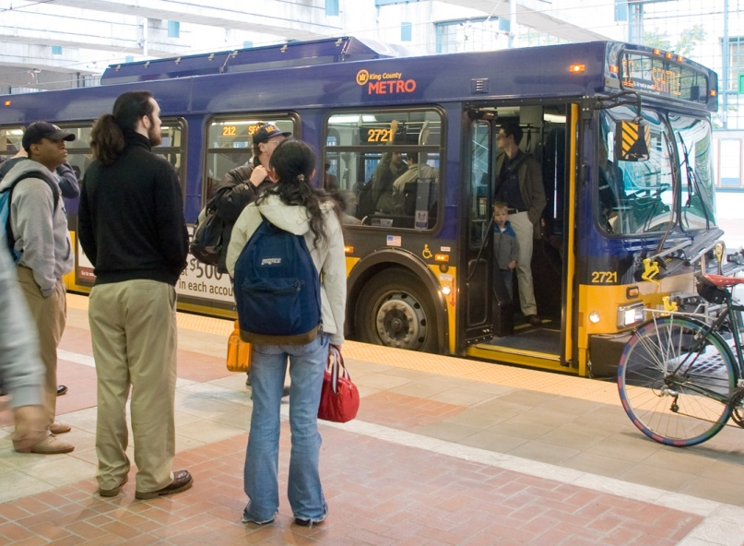
Metro supports economic vitality in the region by
moving people efficiently
and improving the performance of the transportation system.

Objective 3.1 Support a strong, diverse, sustainable economy.
A transportation system that moves people and goods efficiently is critical to economic vitality and the achievement of the region’s vision for growth. The regional growth strategy emphasizes the need for an integrated, multimodal transportation system that links major cities and centers. Metro plays an important role in the growth strategy by offering travel options that connect people to areas of concentrated activity, providing affordable access to jobs, education and important social and retail services. Intended outcome: Public Transportation products and services are available throughout King County and are well-utilized in centers and areas of concentrated economic activity.
- Strategy 3.1.1: Through investments and partnerships with regional organizations, local jurisdictions and the private sector, provide alternatives to driving alone that connect people to jobs, education and other destinations essential to King County’s economic vitality.
Metro provides a range of services to get people to work, school, and other places they want to go. The backbone of Metro’s system is a network of all-day, two-way bus routes between residential, business and other transit activity centers. Metro also provides commuter service to major destinations from many neighborhoods as well as from a network of park-and-ride lots. Metro provides local services to connect people to the larger transportation system. Rideshare services such as commuter vans, and Rideshare Online, as well as community programs such as In Motion, and car-sharing, promote alternative travel options.
Metro augments its own investments by developing partnerships with local jurisdictions, other agencies, employers, and institutions to increase public transportation services and improve service effectiveness. Metro enters into agreements with public and private entities to fund new or improved public transportation services, where the partner contribution may be in the form of direct funding or investment that results in transit speed or reliability improvements. Metro also forms partnerships to develop and promote alternative commute programs and to manage parking and traffic to make public transportation more efficient and attractive. Metro works with WSDOT and local cities to provide services that help mitigate the impacts of major construction projects.

- Strategy 3.1.2: Partner with employers to make public transportation products and services more affordable and convenient for employees.
Metro develops and pursues market-based strategies with employers, institutions and property managers to encourage the use of alternatives to driving alone. Metro offers employers and organizations technical assistance, marketing and training to establish commute benefit programs. These programs give commuters access and incentives for using transit and rideshare services, cycling, walking and teleworking. Examples are ORCA business products and Home Free Guarantee (Metro’s emergency ride home service). Metro also coordinates with employer-sponsored transportation services to avoid duplicating existing public services.
By working with employers, Metro can increase the use of its products and services as well as those of transit partners. Metro can also support progress toward community objectives, while helping employers manage parking and traffic, attract and retain employees, and meet commute trip reduction and sustainability goals.
Objective 3.2: Address the growing need for transportation services and facilities throughout the county.
King County is expected to add more than 185,000 new jobs and more than 180,000 new residents between 2010 and 2020. As the region grows and as the economy recovers, the demand for travel will rise. Metro will prepare for this growth by seeking opportunities to expand service, by being more efficient, and by partnering with others to maximize the travel options available. Intended outcome: More people have access to and regularly use public transportation products and services in King County.
- Strategy 3.2.1: Expand services to accommodate the region’s growing population and serve new transit markets.
Population and employment growth are creating emerging and expanding travel markets throughout King County. These markets range from expanding employment centers such as Kirkland’s Totem Lake or Seattle’s South Lake Union to developing residential communities throughout King County. Metro has many tactics for accommodating growth, such as starting a new route, adding peak trips, extending hours of service to include the midday or evening, or modifying a route to serve a new location.
- Strategy 3.2.2: Coordinate and develop services and facilities with other providers to create an integrated and efficient regional transportation system.
Metro collaborates with other agencies and organizations to build the best possible regional public transportation network, to make it easy for people to travel between transportation services, to maximize travel options, and to achieve efficiencies by providing services that are complementary rather than duplicative. For example, when Sound Transit introduces new services, Metro explores opportunities to restructure bus routes, improve service integration, enhance service and increase efficiency. By reconfiguring, reducing or eliminating poorly performing routes, Metro can free up resources to invest in routes with greater demand and unmet service needs. Where parallel services exist, Metro can restructure routes to create service that is more frequent, productive and reliable.
Metro also coordinates with other agencies and jurisdictions to improve the efficiency of the system through transit speed and reliability improvements. Metro works independently and in coordination with local jurisdictions to implement improvements such as traffic signal coordination, transit queue-bypass lanes, transit signal queue jumps, transit signal priority, safety improvements, and stop consolidations.
Metro also coordinates with other regional and local public transportation entities on funding, design, construction and maintenance of capital projects. Metro and other agencies have collaborated on the development of facilities such as transit hubs, park-and-rides and stations.
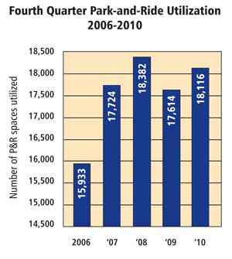
- Strategy 3.2.3: Work with transit partners, WSDOT and others to manage park-and-ride capacity needs.
Figure 7: Fourth Quarter Park-and-Ride Utilization 2006-2010
Park-and-ride locations provide access to the public transportation system for people who do not live near a bus route or who want the many service options available at park-and-rides. These facilities serve as a meeting place for carpool and vanpool partners and an addition to the capacity of the state and interstate highway system. The use of park-and-rides has increased in recent years, and many lots are at or over capacity every day. Figure 6 shows park-and-ride utilization over the past five years.
Metro will work with Sound Transit, WSDOT and others to explore affordable opportunities to increase park-and-ride capacity. Tactics for responding to demand include management of existing lots, education and marketing.
Objective 3.3: Support compact, healthy communities.
Communities that are compact and friendly to pedestrians and bicycles are most easily served by transit. Such communities foster healthier, more active lifestyles while reducing auto-dependency and associated road investments. By the same token, transit service can support and encourage development that is more compact. Intended outcome: More people regularly use public transportation products and services along corridors with compact development.
- Strategy 3.3.1: Encourage land uses, policies, and development that lead to communities that transit can serve efficiently and effectively.
Metro encourages the development of transit-supportive, pedestrian-friendly communities by consulting with jurisdictions and serving transit-oriented developments. Metro recommends strategies for jurisdictions and agencies to make communities more transit-friendly. Metro also partners with jurisdictions and the private sector to spur transit-oriented development through redevelopment opportunities at, or adjacent to, park-and-rides.
Metro’s impact on King County’s transportation infrastructure
- More than 113,000 transit passengers avoid driving alone on major state routes each weekday.
- More than 21,000 transit passengers avoid driving alone on major state routes during the evening peak hours.
- If each transit passenger drove to downtown Seattle instead of taking the bus, parking infrastructure to accommodate these drivers would cost approximately $2.6 billion⁶.

- Strategy 3.3.2: Support bicycle and pedestrian access to jobs, services, and the transit system.
Metro develops programs and facilities to improve bicyclists’ connections to transit. Metro also collaborates with public and private partners to enhance the use of bicycles for commute and non-commute purposes to help reduce drive-alone travel. Metro provides three-position bike racks on transit vehicles and is working to increase the availability of secure bicycle parking at new and existing Metro transit facilities.
Objective 3.4: Support economic development by using existing transportation infrastructure efficiently and effectively.
Use of transit can increase the efficiency of King County’s transportation infrastructure (see sidebar). By carrying more people in fewer vehicles, transit reduces the need for parking spaces at major employment centers and other activity hubs, keeping development costs down. Transit also moves more people on existing roadways, reducing the need for expansion. Intended outcome: Regional investments in major highway capacity projects and parking requirements are complemented by high transit service levels in congested corridors and centers.
- Strategy 3.4.1: Serve centers and other areas of concentrated activity, consistent with Transportation 2040.
Metro focuses on serving King County’s designated centers and other areas of concentrated activity, as shown in Figure 4 on page 7, and as prescribed in Transportation 2040 (see below).
Metro also works with property owners, building managers and employers on a variety of efforts to increase the use of transit. These include parking management, fare media programs, outreach, incentives, work-option programs such as telework, and community programs such as In Motion.
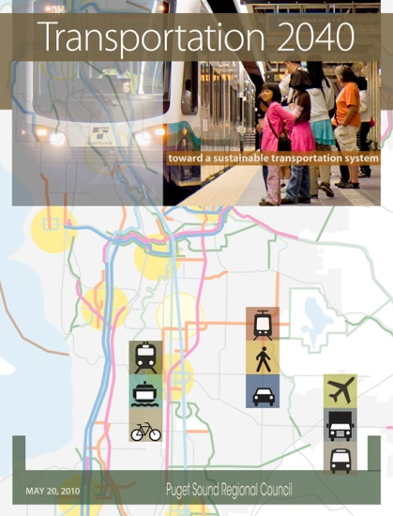
Transportation 2040
Transportation 2040 is an action plan for transportation in the central Puget Sound region for the next 30 years, developed and adopted by the Puget Sound Regional Council.
By the year 2040, the region is expected to grow by roughly 1.5 million people and support more than 1.2 million new jobs, which is expected to boost demand for travel within and through the region by about 40 percent.
Transportation 2040 outlines a long-term vision for how this region should invest in transportation to accommodate rising travel demand. The plan identifies investments in roads, transit and non-motorized travel that will support this growth and improve the transportation system. The document lays out a financing plan with more reliance on user fees to fund transportation improvements. It also proposes a strategy for reducing transportation’s contribution to climate change and its impact on air pollution and the health of Puget Sound.

Goal 4: Environmental Sustainability. Safeguard and enhance King County’s natural resources and environment.
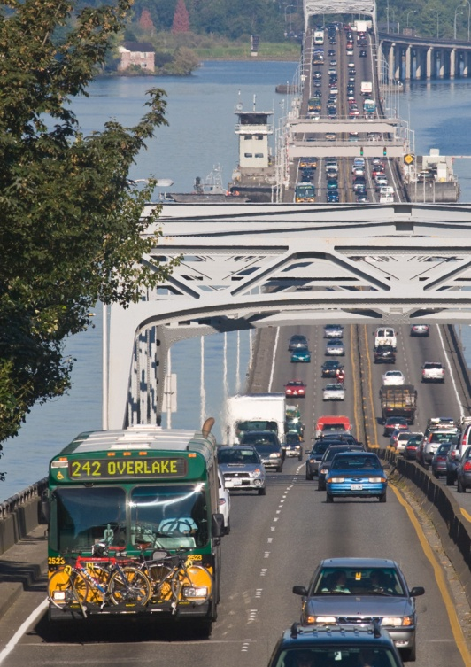
Metro provides transportation choices
and supports travel that uses less energy, produces fewer pollutants and reduces greenhouse gases in the region.
Objective 4.1: Help reduce greenhouse-gas emissions in the region.
King County has a long-term goal of reducing greenhouse-gas emissions by 80 percent between 2007 and 2050. The transportation sector is the source of more than half the emissions in the region, so reducing vehicle-miles traveled and emissions are critical parts of achieving this goal. Every step Metro takes to make transit a more accessible, competitive and attractive transportation option helps to counter climate change and improve air quality. Intended outcome: People drive single-occupant vehicles less.
- Strategy 4.1.1: Increase the proportion of travel in King County that is provided by public transportation products and services.
Metro offers an array of alternatives to single-occupant vehicle travel, and will continue to improve the attractiveness of Metro’s products and services and promote them to existing and potential customers.
Objective 4.2: Minimize Metro’s environmental footprint.
Electric vehicle charging program
King County will receive $1 million from the United States Department of Energy to expand on an earlier program and install electric vehicle charging stations at various locations over the next few years to promote the use of electric vehicles.
King County is negotiating with vendors to purchase electric vehicles for Metro’s vanpool and vanshare programs and for the County’s fleet of vehicles used by employees in County operations.

The King County Energy Plan provides a roadmap for improving energy efficiency and expanding the use of greenhouse-gas-neutral energy sources in King County, with new targets adopted by the King County Council. The County has set a goal of reducing energy use in County buildings by 10 percent by 2012 and vehicles by 2015. In support of this plan, Metro is committed to being a leader in green operating and maintenance practices and minimizing its energy use. Metro also educates its employees about reducing energy consumption at work and using public transportation to commute. Intended outcome: Metro’s environmental footprint is reduced (normalized against service growth).
- Strategy 4.2.1: Operate vehicles and adopt technology that has the least impact on the environment and maximizes long-term sustainability.
Metro will continue exploring opportunities to employ energy-efficient vehicles for both fixed-route and other services, such as its commuter van programs. Metro has already reduced vehicle emissions by developing and using clean-fuel bus technologies, such as hybrid diesel-electric coaches, in its fleet. Metro is committed to being a leader in the adoption of new energy-efficient and low-emission technologies (see sidebar on previous page).
- Strategy 4.2.2: Incorporate sustainable design, construction, operating, and maintenance practices.
Metro incorporates cost-effective green building and sustainable development practices in all capital projects that it plans, designs, constructs, remodels, renovates, and operates. Metro will continue seeking opportunities to improve energy efficiency and conservation and to decrease energy use in its facilities. Metro follows King County’s Green Building and Sustainable Development Ordinance and strives for Leadership in Energy and Environmental Design (LEED) certification where possible.

Goal 5: Service Excellence. Establish a culture of customer service and deliver services that are responsive to community needs.

Metro seeks to provide reliable,
safe and convenient transportation services that are valued by customers and responsive to the needs of people, businesses and communities.

Objective 5.1: Improve satisfaction with Metro’s products and services and the way they are delivered.
Metro associates customer satisfaction with a favorable public image, customer loyalty, and strong community support, as well as the provision of quality service. Metro is committed to giving its customers a positive experience at every stage, from trip planning to arrival at a destination. Intended outcome: People are more satisfied with Metro products and services.
- Strategy 5.1.1: Provide service that is easy to understand and use.
A public transportation system that is easy to understand and use is important to attracting and retaining riders and increasing market share. People may not try public transportation if they do not know which bus routes or other services to use, how to pay a fare, how to transfer among services, or where to get off. Customer information tools are essential to inform riders about services and help them easily navigate the public transportation system. Products such as the ORCA fare card simplify fare payment and transfers among transit agencies in the Puget Sound region. Customer information tools ease public transportation use for new and existing riders alike.
- Strategy 5.1.2: Emphasize customer service in transit operations and workforce training.
Every customer experience affects perceptions of the quality of Metro service. Metro operators are at the front lines of transit service, interacting with customers daily. Other Metro employees interact with customers at service centers, over the phone, or at public meetings. Metro will work to achieve high levels of customer service in all of these interactions, and to continually emphasize to employees the importance of good customer service.
- Strategy 5.1.3: Improve transit speed and reliability.
Transit speed and reliability is an important aspect of customer satisfaction. Metro regularly monitors its on-time performance and strives to achieve its performance guidelines. To help improve transit speed and reliability, Metro is committed to managing transit pathways. Its speed–and-reliability program places high priority on corridors with high ridership and bus volumes, such as Metro’s six RapidRide corridors, and on corridors impacted by major construction projects, such as replacement of the Alaskan Way Viaduct and the SR-520 bridge. A range of speed and reliability improvements including traffic signal coordination, transit signal priority, bus lanes, queue bypass, safety improvements and stop consolidation can be implemented on a corridor or spot basis. Metro works independently and in coordination with local jurisdictions to make improvements that enhance the speed and reliability of bus service, help maintain even intervals between buses, and reduce overcrowding and delays.

Objective 5.2: Improve public awareness of Metro products and services.
People will use public transportation products and services that meet their needs, but they must first learn about the service that is available. Marketing and customer information tools are critical for increasing ridership by communicating the availability, value, benefits and “how to” of using public transportation. Intended outcome: People understand how to use Metro’s products and services and use them more often.
Metro Online
Metro’s website was updated to improve the organization of news and alerts, making it easier to use and understand.
Specific improvements include:
Transit alerts
A subscription service that sends alerts via e-mail or text message for a specific route or for general information.
Adverse weather alerts
A color-coded snow, ice and flood map that indicates Metro service re-routes during emergency events. Customers can look up specific routes to see detailed information.
Eye on your Metro commute
A blog that offers service information during rush hours
(6-9 a.m./ 3-6 p.m.).
Third-party applications
Programs written by individuals or companies outside of Metro using Metro data. A popular example is One Bus Away, found at: http://onebusaway.org.

- Strategy 5.2.1: Use available tools, new technologies, and new methods to improve communication with customers.
Metro currently uses a range of tools to give customers up-to-date information on public transportation services and service disruptions and to promote Metro products and services. Internet-based media will offer new opportunities to reach even more people and keep them informed. Independent application developers augment and support Metro’s efforts to improve customer communications (see sidebar). Metro will continue to improve its communications so that customers can easily access information when they need it most.
- Strategy 5.2.2: Promote Metro’s products and services to existing and potential customers.
Effective marketing generates ridership and improves overall awareness and understanding of the public transportation system. Marketing activities include direct promotion, advertising, product branding and positive customer service. These activities can support events such as periodic service changes, major initiatives such as Transit Now, and campaigns focused on target groups. As Metro seeks to grow overall ridership and increase efficiency by attracting riders to services with existing capacity, expanded marketing efforts—including market research and promotion—will make a difference.

Goal 6: Financial Stewardship. Exercise sound financial management and build Metro’s long-term sustainability.
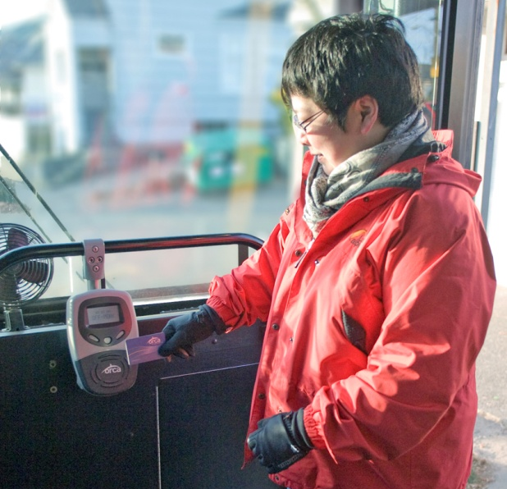
Metro is committed to using resources wisely and increasing the efficiency of its operations.
Objective 6.1: Emphasize planning and delivery of productive service.
Metro should create a public transportation system that emphasizes productivity, while ensuring social equity and providing geographic value. A focus on productivity will support regional and local growth and economic development as well as environmental and financial sustainability. Intended outcome: Service productivity improves.
- Strategy 6.1.1: Manage the transit system through service guidelines and performance measures.
Service guidelines and performance measures will help the public, Metro and King County decision-makers determine the appropriate level and type of service for different corridors and destinations. Guidelines will clearly state the balanced prioritization of emphasizing productivity, ensuring social equity and providing geographic value used for identifying the All-Day and Peak Network and changes to the network. Metro will apply the regional transit committee-recommended and County council-adopted objective service guidelines as it makes decisions about service allocation, managing service quality, the frequency of service, route spacing, the directness of service, and stop spacing. Through the establishment of route, system and peer-comparison performance measures, Metro will also be able to better understand how public transportation is performing on multiple levels.
Objective 6.2: Control costs.
Metro should control costs to provide a structure that is sustainable over time. Intended outcome: Metro costs grow at or below the rate of inflation.
- Strategy 6.2.1: Continually explore and implement cost efficiencies, including operational and administrative efficiencies.
Metro will continue to seek efficiencies in the administration and operation of the agency, including overhead costs, to ensure that Metro develops a more sustainable financial structure in the long-term. Opportunities to improve service and increase efficiency include restructuring service and implementing the findings of the 2009 King County auditor’s performance audit of Metro. This audit identified areas where Metro could achieve cost efficiencies, such as in the way it schedules fixed-route service. Metro has incorporated most of these recommendations into the 2010-2011 biennial budget and will continue striving to maximize cost-efficiency.
- Strategy 6.2.2: Provide and maintain capital assets to support efficient and effective service delivery.
Metro’s capital program supports service delivery and provides for ongoing replacement of aging infrastructure. Regular maintenance and upgrades keep Metro’s facilities in good repair and support efficient, safe and reliable transit operations. Metro also invests in new operations facilities, on-board systems, signal priority improvements, and real-time technology. Strategic investments in new infrastructure allow Metro to enhance the efficiency and effectiveness of the public transportation system.
Metro will develop a prioritized set of strategic procurement goals to guide procurement processes and decisions. Metro will replace and adjust the transit bus fleet so that the size, fleet mix, and fleet age are consistent with service projections and operating characteristics of the regular bus system. Metro will replace and expand its vanpool fleet to provide the appropriate mix of vehicle sizes, both to encourage and support vanpool program participants and to minimize costs. Metro will also replace and expand the fleet of Access paratransit vehicles to support efficient operations.
- Strategy 6.2.3: Develop and implement alternative public transportation services and delivery strategies.
Fixed-route transit service is most cost efficient in areas of King County where housing and employment are concentrated. Land uses that support walking as a mode choice encourage the use of fixed-route transit services. Fixed-route transit service is not cost-effective in some areas of King County because of the type of land uses, infrastructure, or density. However, people in these areas still have mobility needs and, by circumstance or choice, require public transportation services. Metro provides public transportation products such as ridesharing, community vans, Dial-a-Ride Transit, and Community Access Transportation in these areas. Metro will continue to augment its fixed-route system with these and other innovative public transportation services and delivery strategies that keep costs down while providing mobility to people throughout King County.
Objective 6.3: Seek to establish a sustainable funding structure to support short- and long-term public transportation needs.
New, sustainable funding sources are critical if Metro is to continue current operations and achieve the region’s goals and vision for the future. Additional and sustainable revenue sources, along with changes in the way service decisions are made and public transportation resources are allocated, will allow Metro to support the growth and economic development of King County. Intended outcome: Adequate funding to support King County’s short- and long-term public transportation needs.
- Strategy 6.3.1: Secure long-term sustainable funding.
Even with efficiency measures, Metro’s resources must increase over time to meet growing customer demand. New, sustainable funding sources are crucial to ensure that Metro can support existing transit service and plan for future growth. Metro is exploring several potential revenue sources that would improve Metro’s funding situation. Among these potential sources are fares, grants, advertising, and partnerships with local jurisdictions and businesses. Metro prioritizes funding sources that enable sustained operations over time and one-time revenue sources that allow implementation of a particular project or program. Metro will also pursue new revenue sources through state legislation, including sources that are currently authorized and those that may require new legislation. Metro must establish a stable revenue source or program that allows for system growth and keeps pace with changes in regional growth and employment.
- Strategy 6.3.2: Establish fare structures and fare levels that are simple to understand, aligned with other service providers, and meet revenue targets established by Metro’s fund management policies.
Metro’s fare structure and fare levels should enable Metro to meet cost-recovery targets that are established by fund management policies adopted by the King County Council. Fares should be set to reflect the cost of service, promote operational efficiency, ensure regional coordination, minimize impacts of fares on those least able to pay, and reduce the cost of fare collection. Metro fare prices should strike a balance between revenue generation objectives and the need to maintain existing service and attract new ridership. Metro’s fares will comply with state and federal regulations. The fare structure and level should be reviewed biennially.
Metro works with the region’s transit agencies to coordinate fares and schedules. Several transportation agencies including Metro collaborated to introduce One Regional Card for All (ORCA), the regional fare payment method that enables customers to use one card to pay their fare on multiple systems throughout the Central Puget Sound area.
Metro also regularly works with other agencies to coordinate policies, practices and services throughout the Puget Sound region to provide a consistent transit experience for customers. Simple and consistent fares are important to make transit easy to use for both new and existing transit riders.
- Strategy 6.3.3: Establish fund management policies that ensure stability through a variety of economic conditions.
Metro is committed to comprehensive and prudent financial planning and forecasting that uses reasonable economic assumptions along with specific programmatic plans to project future revenues, expenditures, and resulting fund balances. Metro’s fund management policies guide the development of a six-year financial plan that is produced through the budget process and adopted by the King County Council. Metro’s fund management policies, planning, and ongoing forecasting allow the transit system to respond effectively to unforeseen emergencies and changes in the economy without large impacts to existing services.

Goal 7: Public Engagement and Transparency. Promote robust public engagement that informs, involves, and empowers people and communities.
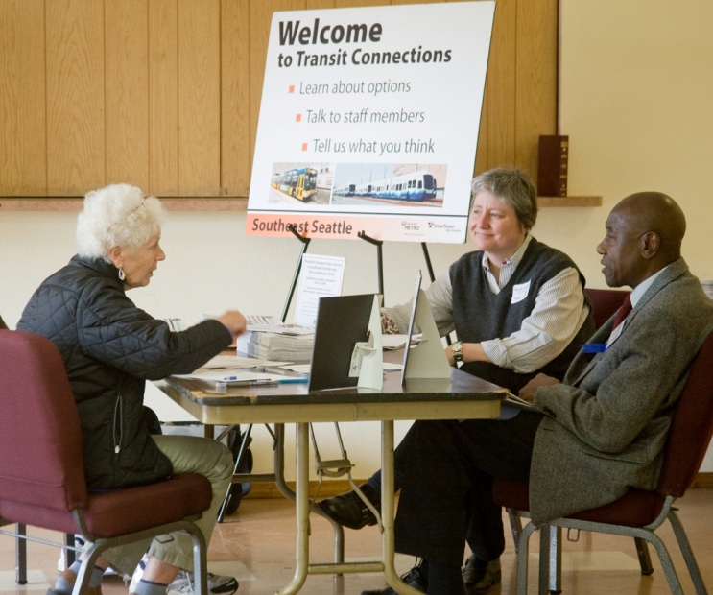
Metro is committed to informing and engaging the public as it develops products and services.

Objective 7.1: Empower people to play an active role in shaping Metro’s products and services.
Metro is committed to being responsive and accountable to the public. One way Metro will meet this commitment is by continuing to conduct a community planning process and public outreach as part of any major service change or new service initiative. Intended outcome: The public plays a role and is engaged in the development of public transportation.
- Strategy 7.1.1: Engage the public in the planning process and improve customer outreach.
Metro’s community engagement work is consistent with King County’s Equity and Social Justice Initiative. Metro seeks to build its capacity to engage all communities in a manner that promotes and fosters trust among people across geographic, race, class and gender lines, resulting in more effective policies, processes, and services as well as supporting community-based solutions to problems.
Metro’s planning process provides opportunities for the public to help design public transportation services. It involves riders, non-riders, elected officials, community leaders, city and County staff members, and social service agencies. Outreach targets historically under-represented populations, using translated materials or interpretation services as needed. Metro uses public meetings, open houses and a sounding board process to engage customers. Metro also does extensive public communication using direct mail, newspaper and radio ads, surveys and online information, and continually explores new media to reach a larger audience. Metro will strive to involve the public early in any planning process and offer opportunities for ongoing involvement.
Objective 7.2: Increase customer and public access to understandable, accurate and transparent information.
Transparent decision-making processes and information will help build public trust in Metro and acceptance of the decisions made. Intended outcome: Metro provides information that people use to access and comment on the planning process and reports.
- Strategy 7.2.1: Communicate service change concepts, the decision-making process, and public transportation information in language that is accessible and easy to understand.
Metro’s decision-making process should be clear, transparent and based on criteria that are easy for customers to understand. Metro considers equity and social justice in its decision-making process, particularly for people of color, low-income communities, and people with limited English proficiency, consistent with King County’s Equity and Social Justice Initiative and federal law. Service guidelines and performance measures provide an outline of Metro’s approach to decision-making. Guidelines are based on data that are understandable to the public and provide for a transparent process for making service allocation decisions. Performance measures will give the public a snapshot of Metro’s performance on a systemwide level and allow for comparisons between service types and between peer agencies. Using a variety of forums and media channels, Metro will reach out to customers and the public to share information on the decision-making process and on the performance measures that are the basis of Metro service changes and new service initiatives.
- Strategy 7.2.2: Explore innovative ways to report to and inform the public.
New forums for public outreach can help Metro reach more new and existing riders and make it easier for them to find the information they need. Metro will continue providing information to the public through various channels including printed materials, Metro Online, social media and other channels.

Goal 8: Quality Workforce. Develop and empower Metro’s most valuable asset, its employees.

Metro strives to develop and retain an effective, customer-oriented workforce that embraces collaboration, innovation and diversity.

Objective 8.1: Attract and recruit quality employees.
Metro’s products and services are a reflection of the employees who deliver them. To maintain excellent services, Metro recruits quality and committed employees and creates a positive work environment. Metro prides itself as being a great place to work and a fair and just employer that values a diverse and skilled workforce. Intended outcome: Metro is satisfied with the quality of its workforce.
- Strategy 8.1.1: Market Metro as an employer of choice and cultivate a diverse and highly skilled applicant pool.
Metro makes itself a prominent employer through local and national recruiting. Networking with local community-based agencies and professional organizations encourages the development of a highly skilled applicant pool.
- Strategy 8.1.2: Promote equity, social justice and transparency in hiring and recruiting activities.
Metro constantly seeks to improve its hiring and recruitment process to ensure that it is open and competitive. Successful candidates are objectively selected on the basis of their qualifications. Metro promotes diversity in its hiring process. Metro believes that its workforce should reflect the populations it serves and recruits from the local workforce.
Objective 8.2: Empower and retain efficient, effective, and productive employees.
Metro strives to support its employees, empower them to excel, recognize their achievements, and help them develop professionally. Metro values input from employees on ways to improve business practices and make Metro more efficient. Intended outcome: Metro employees are satisfied with their jobs and feel their work contributes to an improved quality of life in King County.
- Strategy 8.2.1: Build leadership and promote professional skills.
Metro employs thousands of individuals in management, maintenance and operations positions. Metro management encourages a high level of collaboration with its employees, maintains effective labor relations, and identifies situations for improvement and for employee advancement. Metro recognizes that the next generation of leaders is likely already among us and seeks to identify and develop those leaders.
- Strategy 8.2.2: Recognize employees for outstanding performance, excellent customer service, innovation and strategic thinking.
The most effective way for Metro to remain a resilient organization is to develop a work environment where employees are rewarded for high performance and innovation. Metro empowers its employees to engage in problem-solving and service improvement by collaborating with them and recognizing their efforts. Developing a work force driven by excellence will help Metro reduce costs while providing high-quality, customer-driven service.
- Strategy 8.2.3: Provide training opportunities that enable employees to reach their full potential.
Training offers opportunities for employees to learn new skills, develop existing skills and grow professionally. Metro offers employees a number of training resources through national transit organizations, county agencies and other professional development groups. A focus of Metro’s training efforts is its operators, as they interact most directly with customers. Developing the workforce further is essential to Metro’s success as the organization continues to grow and plan for the future.

Chapter III
Plan Performance Monitoring
Metro’s strategic plan is a blueprint for Metro to improve its public transportation products and services in meaningful and measurable ways. Performance monitoring will help Metro evaluate its progress, plan and budget for the future, and improve agency practices. By making performance reports readily available, Metro can make its progress transparent to internal and external audiences. This section gives an overview of how Metro and its stakeholders can measure the progress and impacts of the strategic plan.
Section 3.1
How Metro measures performance
Metro measures the performance of individual routes, of the Metro system as a whole, and of various products and services. Metro reports various measures in the Federal Transit Administration’s National Transit Database, in monthly and annual management reports (see sidebar), and in project-specific performance reports. These reports serve a number of purposes: They comply with federal and state reporting requirements, give public transportation managers the data they need, assess progress towards goals and objectives, inform management and policy decisions, and give the public a way to assess Metro’s performance.

Measuring the strategic plan

Metro performance measurement information
Metro launched an online “Monthly Performance Indicators” website to give the public current information about Metro’s performance.
On this site, people can find graphs and data showing trends in ridership, service quality, safety and security, finances, and service effectiveness.
Find this site and links to other Metro reports at http://metro.kingcounty.gov/am/reports/monthly-measures.
Reporting for this strategic plan will focus primarily on Metro’s progress towards its objectives and strategies. Metro will use some of the measures already used for other reporting purposes, augmented by measures specific to the strategic plan. Reporting for this plan will support and enhance Metro’s ongoing measurement and use of performance data.
This plan provides for performance measurement at three levels:
- Objectives
- Strategies
- Peer comparison.
The following pages provide a more detailed description of these measurement levels and potential associated measures. Metro will report on strategic plan measures on a biennial basis, and will update this section of the plan as necessary to improve performance measurement.
After January 1, 2012, prior to proposing any budget that includes a change in the system greater than 10 percent of the system hours during the next two-year period, Metro will report on strategic plan measures if a report has not been delivered within the last 12 months.
Measuring objectives
Each objective in the plan is measured by an outcome that relates to an aspect of Metro’s vision. Metro will measure progress toward these broad outcomes at the systemwide level using metrics and measurement methods that incorporate many factors. The combined results will give an indication of Metro’s overall progress toward achieving its vision. Objectives could be measured in a variety of different ways, and techniques for measurement may change over time. Table 2 shows each objective and its suggested related outcome. These outcomes will be reported in a variety of ways, including maps, graphs and text.
Table 2: Objectives and related outcomes
Goal | Objective | Outcome
1 | Keep people safe and secure. | Metro’s services and facilities are safe and secure.
2 | Provide public transportation products and services that add value throughout King County and that facilitate access to jobs, education and other destinations. | More people throughout King County have access to public transportation products and services.
3 | Support a strong, diverse, sustainable economy. | Public transportation products and services are available throughout King County and are well-utilized in centers and areas of concentrated economic activity.
3 | Address the growing need for transportation services and facilities throughout the county. | More people have access to and regularly use public transportation products and services in King County.
3 | Support compact, healthy communities. | More people regularly use public transportation products and services along corridors with compact development.
3 | Support economic development by using existing transportation infrastructure efficiently and effectively. | Regional investments in major highway capacity projects and parking requirements are complemented by high transit service levels in congested corridors and centers.
4 | Help reduce greenhouse-gas emissions in the region. | People drive single-occupant vehicles less.
4 | Minimize Metro’s environmental footprint. | Metro’s environmental footprint is reduced (normalized against service growth).
5 | Improve satisfaction with Metro’s products and services and the way they are delivered. | People are more satisfied with Metro products and services.
5 | Improve public awareness of Metro products and services. | People understand how to use Metro’s products and services and use them more often.
6 | Emphasize planning and delivery of productive service. | Service productivity improves.
6 | Control costs. | Metro costs grow at or below the rate of inflation.
6 | Seek to establish a sustainable funding structure to support short- and long-term public transportation needs. | Adequate funding to support King County’s short- and long-term public transportation needs.
7 | Empower people to play an active role in shaping Metro’s products and services. | The public plays a role and is engaged in the development of public transportation.
7 | Increase customer and public access to understandable, accurate and transparent information. | Metro provides information that people use to access and comment on the planning process and reports.
8 | Attract and recruit quality employees. | Metro is satisfied with the quality of its workforce.
8 | Empower and retain efficient, effective, and productive employees. | Metro employees are satisfied with their jobs and feel their work contributes to an improved quality of life in King County.
Measuring strategies
The strategies in the plan support the objectives. Strategies will be measured using discrete, quantifiable metrics to determine if they are being successfully implemented and are having the intended impact. Strategies could be measured in a variety of ways and measurement techniques may change over time. The 36 strategies and potential related measures in this strategic plan are listed in Table 3. These measures focus on different aspects of the public transportation system, including transit use, productivity, cost, social equity and geographic value. Specific thresholds and targets for these measures will be established in Metro’s business plans.
Table 3: Strategies and related measures
Goal | Obje-ctive | Strategies | Measures
1 | 1.1 | 1.1.1 Promote safety and security in public transportation operations and facilities.  1.1.2 Plan for and execute regional emergency response and homeland security efforts. | - Preventable accidents  - Operator and passenger incidents and assaults  - Customer satisfaction regarding safety and security  - Effectiveness of emergency responses
2 | 2.1 | 2.1.1 Design and offer a variety of public transportation products and services appropriate to different markets and mobility needs.  2.1.2 Provide travel opportunities for historically disadvantaged populations, such as low-income people, students, youth, seniors, people of color, people with disabilities, and others with limited transportation options.  2.1.3 Provide products and services that are designed to provide geographic value in all parts of King County. | - Population with ¼ mile walk access to a transit stop or 2 mile drive to a park-and-ride  - % low income population within ¼ mile walk access to transit  - % minority population within ¼ mile walk access to transit  - Accessible bus stops  - Transit mode share by market  - Student and reduced fare permits and usage  - Access applicants who undertake fixed-route travel training  - Access boardings  - Access registrants  - Requested Access trips compared to those provided  - Number of trips provided by the Jobs Access and Reverse Commute (JARC) and Community Access Transportation (CAT) programs  - Title VI compliance  - % population at 15 dwelling units per acre within ¼-mile walk access of frequent service
Goal | Obje-ctive | Strategies | Measures
3 | 3.1 | 3.1.1 Through investments and partnerships with regional organizations, local jurisdictions and the private sector, provide alternatives to driving alone that connect people to jobs, education and other destinations essential to King County’s economic vitality.  3.1.2 Work with employers to make public transportation products and services more affordable and convenient for employees. | - Transit rides per capita  - Effectiveness of partnerships  - Park-and-ride utilization  - Peak mode share at Commute Trip Reduction (CTR) sites  - Employer sponsored passes and usage  - % population at 15 dwelling units per acre within 1/4 mile walk access of frequent service  - All public transportation ridership in King County (rail, bus, paratransit, rideshare)  - Centers ridership  - Bike rack use
3 | 3.2 | 3.2.1 Expand services to accommodate the region’s growing population and serve new transit markets.  3.2.2 Coordinate and develop services and facilities with other providers to create an integrated and efficient regional transportation system.  3.2.3 Work with transit partners, WSDOT and others to manage park-and-ride capacity needs.  .
3 | 3.3 | 3.3.1 Encourage land uses, policies, and development that lead to communities that transit can serve efficiently and effectively.  3.3.2 Support bicycle and pedestrian access to jobs, services and the transit system.
3 | 3.4 | 3.4.1 Serve centers and other areas of concentrated activity, consistent with Transportation 2040.
4 | 4.1 | 4.1.1 Increase the proportion of travel in King County that is provided by public transportation products and services. | - Per capita vehicle miles traveled (VMT)  - Transit mode share  - Public transportation energy use per passenger mile  - Average miles per gallon (MPG) of the Metro bus fleet  - Energy use at Metro facilities
4 | 4.2 | 4.2.1 Operate vehicles and adopt technology that has the least impact on the environment and maximizes long-term sustainability.  4.2.2 Incorporate sustainable design, construction, operating and maintenance practices.
Goal | Obje-ctive | Strategies | Measures
5 | 5.1 | 5.1.1 Provide service that is easy to understand and use.  5.1.2 Emphasize customer service in transit operations and workforce training.  5.1.3 Improve transit speed and reliability. | - Conformance with King County policy on communications accessibility and translation to other languages  - Customer satisfaction  - Customer complaints  - On-time performance by time of day  - Load factor  - Utilization of Metro web tools  - One Regional Card for All (ORCA) usage
5 | 5.2 | 5.2.1 Use available tools and new technologies to improve communication with customers.  5.2.2 Promote Metro’s products and services to existing and potential customers.
6 | 6.1 | 6.1.1 Manage the transit system through service guidelines and performance measures. | - Boardings per platform hour  - Passenger miles per platform hour  - Boardings per revenue hour  - Passenger miles per revenue mile  - Access boardings  - Commuter van boardings  - Cost per boarding  - Cost per hour  - Service hours operated  - Asset condition assessment  - Base capacity level of service  - Fare revenues  - Farebox recovery  - Fare parity with other providers in the region  - Fully allocated costs  - Operational and cost efficiency indicators  - Service hours and service hour change per route  - Ridership and ridership change per route
6 | 6.2 | 6.2.1 Continually explore and implement cost efficiencies, including operational and administrative efficiencies.  6.2.2 Provide and maintain capital assets to support efficient and effective service delivery.  6.2.3 Develop and implement alternative public transportation services and delivery strategies.
6 | 6.3 | 6.3.1 Secure long-term stable funding.  6.3.2 Establish fare structures and fare levels that are simple to understand, aligned with other service providers, and that meet revenue targets established by Metro’s fund management policies.  6.3.3 Establish fund management policies that ensure stability through a variety of economic conditions.

Goal | Obje-ctive | Strategies | Measures
7 | 7.1 | 7.1.1 Engage the public in the planning process and improve customer outreach. | - Public participation rates  - Customer satisfaction regarding their role in Metro’s planning process  - Customer satisfaction regarding Metro communications and reporting
7 | 7.2 | 7.2.1 Communicate service change concepts, the decision-making process, and public transportation information in language that is accessible and easy to understand.  7.2.2 Explore innovative ways to report to and inform the public.
8 | 8.1 | 8.1.1 Market Metro as an employer of choice and cultivate a diverse and highly skilled applicant pool.  8.1.2 Promote equity, social justice and transparency in hiring and recruiting activities. | - Demographics of Metro employees  - Employee job satisfaction  - Promotion rate  - Probationary pass rate  - Training opportunities provided  - Trainings completed  - Employee performance
8 | 8.2 | 8.2.1 Build leadership and promote professional skills.  8.2.2 Recognize employees for outstanding performance, excellent customer service, innovation and strategic thinking.  8.2.3 Provide training opportunities that enable employees to reach their full potential.
Peer comparison
Comparisons with peer transit agencies provide an additional benchmark for measuring Metro’s performance. Metro currently compares its annual performance with other large bus agencies in the U.S. in three key areas: effectiveness (productivity), efficiency and cost-effectiveness.
Peer comparisons provide a general sense of whether Metro is improving, maintaining or falling behind in comparison to national trends. These comparisons often raise questions about why Metro is improving or not. Answering these questions typically requires further analysis, which Metro does by examining its relevant business processes or conducting in-depth research on peer agencies that are making the greatest improvements on the measure in question.
Peer comparison reporting: Strategic plan reporting will compare Metro with transit agency peers in three key areas of performance: effectiveness, efficiency and cost-effectiveness. The specific indicators for each will be calculated using the Federal Transit Administration’s annual National Transit Database reports, as follows:

Table 4: Peer Comparison Key Areas of Performance
Effectiveness | Efficiency | Cost-Effectiveness
1) Percent change in boardings per capita | 1) Percent change in cost per vehicle hour. | 1) Percent change in cost per boarding.
2) Percent change in boardings per vehicle hour | 2) Percent change in cost per vehicle mile. | 2) Percent change in cost per passenger mile.
3) Percent change in passenger miles per vehicle mile | 2) Percent change in cost per vehicle mile. | 2) Percent change in cost per passenger mile.

Section 3.2
Route Performance

Metro uses service guidelines to evaluate the performance of individual routes in the fixed-route system. Performance management guidelines are applied to individual routes to identify high and low performance, identify areas where investment is needed, and identify areas where resources are not being used efficiently and effectively. Both productivity and service quality are measured.
Public outreach process for Link light rail integration
In 2009, Sound Transit began service on the new Link Light Rail line, connecting Sea-Tac Airport to Downtown Seattle. Because of this new transit service, Metro restructured many of its bus routes to facilitate connections to Link and reduce duplication of services.
Metro and Sound Transit conducted months of extensive public outreach to help figure out the best ways to integrate the new services. This outreach included two sounding boards—groups of citizens convened to provide a recommendation to Metro on how to proceed.

Metro may adjust routes to improve the performance of the individual route as well as the performance of the entire Metro fixed-route system. Metro makes service revisions three times a year. Significant changes to routes generally have a large public outreach process (see sidebar) and are subject to approval by the King County Council. Minor changes, as defined by the King County Code, may be made administratively.

Texas Transportation Institute, Urban Mobility Report 2010 (Texas A&M University System: 2010), 30.
Based on spring APC data for Metro service on major state routes, defined as I-405, I-5, I-90, SR-104, SR-164, SR-167, SR-169, SR-181, SR-202, SR-509, SR-513, SR-515, SR-516, SR-520, SR-522, SR-523, SR-526, SR-599, SR-900, SR-908, and SR-99.
Based on spring APC data for Metro service for one hour during the PM peak period on I-405, I-5, I-90, SR-520, SR-522 and SR-99.
Highway lane equivalent is calculated by taking the total transit riders on I-405, I-5, I-90, SR-520, SR-522 and SR-99 and dividing by average hourly person throughout on each highway, assuming that the average auto occupancy is 1.1.
Puget Sound Regional Council. “Populations, Households, and Employment Forecast,” last updated 2006, www.psrc.org/data/forecasts/saf.
$2.6 billion in parking infrastructure was calculated as follows: Assumption One: Approximately 65,000 people commute on transit to downtown Seattle (using a 36% mode share); Assumption Two: A parking stall in downtown Seattle costs $40,000; Calculation: 65,000 x $40,000 = $2.6 billion.

