Lease Property Summary
Photo of Property:

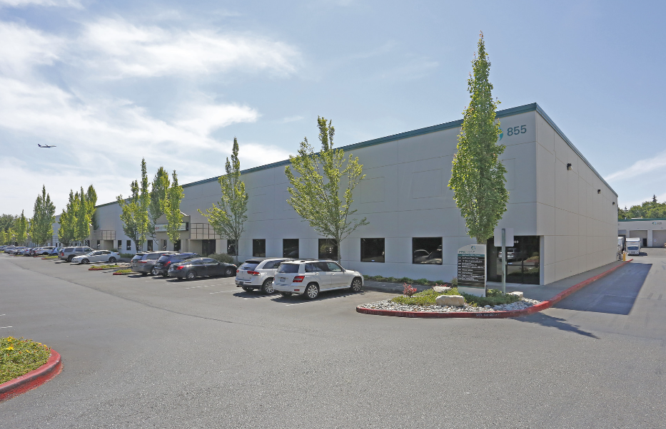

Property Owner: LBA NCC2-COMPANY IX, LLC
Address: 855 South 192nd Street, Suite 1000, SeaTac, WA 98148
Base Rentable Square Feet : $16.36 per rentable square foot (RSF) at $203,690 for nine months in 2025 and $359,658 for twelve months in 2026
Operational Costs: Estimated operating costs are $102,384 for nine months in 2025 and $143,338 for twelve months in 2026
Term: Five years and two months
Square Footage: 21,338 rentable square feet
Council District: Five
Funding Source: King County Information Technology (KCIT) Enterprise Funds
Previous Location: None
Offer Expiration: This lease expired on March 31, 2025, and is currently on a month-to-month basis, however the landlord can terminate the month-to-month tenancy at any time.

Lease Synopsis:
The proposed Ordinance provides for a new lease at the current location of the County Radio Shop at the SeaTac Logistics Park. This location has housed the KCIT Radio Shop operations for 15 years. This location specializes in the installation, maintenance, and repair of public safety radio communication devices within vehicles and buildings for first responders in King County. KCIT has invested approximately $100,000 in customized infrastructure in this location that would need to be replicated at an alternative location with funding that is not available at this time. The lease term is for a period of five years and two months and provides for one option to extend for an additional period of five years at the then current fair market rental rate. The lease also provides for the first two months’ base rent to be abated.

The landlord agreed to waive the additional rental charges (holdover fee) under the current expired lease while King County and the landlord work together in good faith to obtain Council approval of a new lease. During the negotiation period before the new lease is approved, the County pays the same monthly base rent rate as the last month of the expired lease until the new lease is executed. If approved by the Council, the new lease will be retroactively dated April 1, 2025 and the County and landlord will reconcile the amount due or owed King County upon mutual lease execution of the new lease in accordance with the table below.

Month | Base Rent Amount Due Under New Lease | Base Rent Amount Paid Under Previous Lease | Amount Due on Execution of New Lease | Total Difference Due by Month
April 2025 | $0.00 | $24,476.67 | -$24,476.67 | -$24,476.67
May 2025 | $0.00 | $24,476.67 | -$24,476.67 | -$48,953.34
June 2025 | $29,098.56 | $24,476.67 | $4,621.89 | -$44,331.45
July 2025 | $29,098.56 | $24,476.67 | $4,621.89 | -$39,709.56
August 2025 | $29,098.56 | $24,476.67 | $4,621.89 | -$35,087.67
September 2025 | $29,098.56 | $24,476.67 | $4,621.89 | -$30,465.78
October 2025 | $29,098.56 | $24,476.67 | $4,621.89 | -$25,843.89
November 2025 | $29,098.56 | $24,476.67 | $4,621.89 | -$21,222.00
December 2025 | $29,098.56 | $24,476.67 | $4,621.89 | -$16,600.11
Due to the two months of abated Base Rent for the period of April 1, 2025 - May 31, 2025 under the new lease, the County will be receiving a credit as opposed to owing the difference of the rent increase because King County continued to pay the rent amount based upon the previous lease. Once the credit zeroes out, King County will begin paying the new lease rate according to the rent schedule in the new lease at that time.

Context
Rationale for transaction: This facility supports the primary mission of the KCIT Radio Shop, to maintain, install, and service public safety radios that operate on the Puget Sound Emergency Radio Network (PSERN). PSERN is critical to providing emergency radio service to government agencies, such as the King County Sheriff’s Office, King County Department of Adult & Juvenile Detention, King County Department of Local Services, King County Office of Emergency Management as well as fire departments, schools, and hospitals across King County. The KCIT Radio Shop also maintains a service level contract with PSERN subscribers that requires every radio on the network be serviced annually.

Policy considerations: This facility provides critical emergency radio communications repair and maintenance to first responders throughout the County.
Political considerations: N/A

Community considerations
or partnerships: N/A

Fiscal considerations: The rental rate per rentable square foot is $16.36 for the first lease year, with a base rent increase in the amount of four percent annually each April 1st. This is a triple net (NNN) lease, where the tenant pays for their share of property taxes, insurance, and common area maintenance in addition to the base rent. The NNN rate for 2025 is $6.40 per square foot. The negotiated base rent rate was determined by the Facilities Management Division (FMD) to be at a fair market rate which was supported by market data.

Other considerations: The new lease also supports continued unlimited access to the surface parking lot at no additional cost. Due to the high volume of vehicles requiring maintenance and/or equipment installation, this aspect is critical for the Radio Shops service delivery.

CIP/operational impacts: This new lease includes tenant improvements to be performed at the landlord’s expense. These improvements include but are not limited to new carpet, new flooring, paint in existing office spaces, new fixtures in the restrooms and break room, as well as LED retrofit in the warehouse and office area.

King County Strategic Plan impact: N/A

Equity and Social Justice impact: In accordance with Real Property Asset Management Plan (RAMP), FMD and KCIT reviewed this lease legislation for equity and social justice impacts. FMD and KCIT note that this location is in the industrial sub-market of the City of SeaTac. It will continue to serve as the public safety backbone for the citizens of King County who rely on the emergency radio communication system network infrastructure.

Energy Efficiency impact: FMD anticipates that the facility will become more energy efficient after the installation of the LED lighting throughout the premises. FMD’s Electric Vehicle Charging Infrastructure Program, in support of King County’s fleet vehicles electrification, is also evaluating the need for installing Electric Vehicle (EV) chargers within the warehouse. This evaluation may lead to an increased need for electricity but will support the County’s fleet of electric vehicles and lead to lower carbon emissions.

Lease Alternatives Analysis
Summary: FMD employed the assistance of commercial real estate services firm, CBRE, to help identify and evaluate facility alternatives. During the process of evaluating this new lease, FMD considered several other alternative locations and issued multiple requests for proposals to nearby property owners. No alternative locations were identified that could deliver the infrastructure needs or the needed space configuration in an economically feasible manner. The Radio Shop has invested approximately $100,000 in customized infrastructure that would need to be replicated at any alternative location with funding that is not available at this time. KCIT emphasized the mission critical importance of this facility to FMD.

Vicinity View Map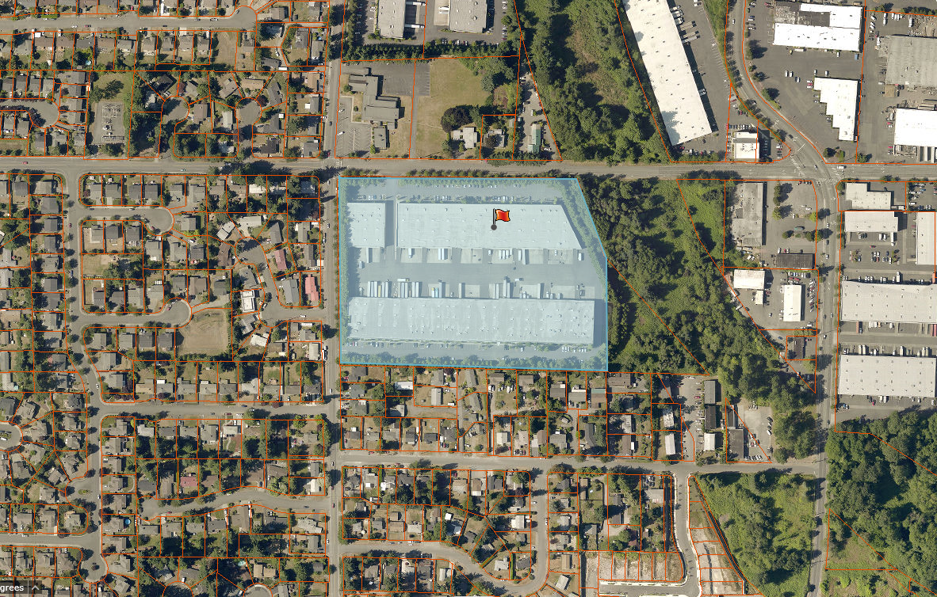

Parcel Map
