Sale Property Summary
Photo of Property
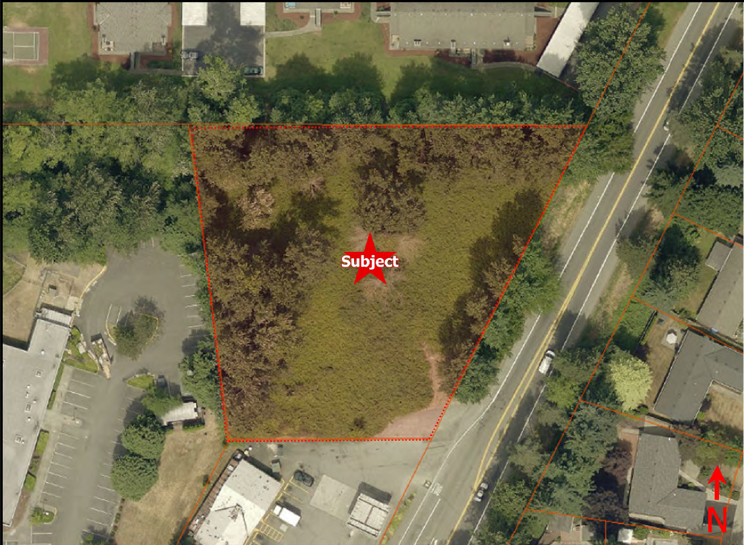
Address 14511 Juanita Woodinville Way N
Sale Price $850,000
Sale Area 50,545 square feet
Assessor's Parcel 1726059123
Zoning NB-Neighborhood Business-Bothell
Council District One
Funding Source RSD-Capital Fund for R/W#9-1999-010 CIP#100498
Declared Surplus February 6, 2020
Template Status: County template with minor changes
Offer Expiration: Ordinance must be effective by September 23, 2020 per the terms of the Purchase and Sale Agreement.

Property Information
The parcel is a little over an acre in size and is vacant land with all utilities. The parcel sits just inside the southern limits of the City of Bothell, next to a gas station and the former Northshore Public Health Building. The city of Bothell Neighborhood Business zoning allows a variety of “community type” commercial uses. The potential purchaser intends to develop the site. The city of Bothell will have jurisdictional permitting authority.

Context
The parcel was purchased by the Road Services Division on December 3, 1999 for the possible siting of a storm water retention pond associated with the widening of Juanita-Woodinville Way. The pond was never constructed and has not been used by the county. Bothell annexed the area in 2014.

Rationale for transaction: The property is surplus to the current and likely future needs of the Road Services Division and the county. DCHS submitted a notice of interest following the Surplus Property Notice but withdrew its interest in March 2019. The property was reviewed for affordable housing suitability, but the Neighborhood Business zoning designation is not a residential zone. The sale will relieve the county of liability and maintenance burdens while providing one-time revenues to the Roads Fund.

Policy considerations : Given current and future anticipated operations, this parcel is no longer needed to support the Road Services Division, or other King County operations, and retaining the parcel results in additional liability as well as lost opportunity costs.

Political considerations: None

Community considerations
or partnerships: None

Fiscal considerations: Sale of this property will relieve the county of assessments totaling $211/year and generate tax revenue estimated at $9,477 annually.

Other considerations: None

CIP/operational impacts: None

Change in property use: Property is vacant land and has never had a public use.

SEPA Review Required yes/no: No

King County Strategic Plan impact: The proposed sale furthers the King County Strategic Plan guiding principles of Financial Sustainability by relieving the county of assessments and liability associated with this unused parcel and provide one-time funds to the Roads Services Operation Fund.

Equity and Social Justice impact: In accordance with Real Property Asset Management Plan (RAMP) policies, the Facilities Management Division and Road Services Division reviewed this legislation for Equity and Social Justice (ESJ) impacts. This location is in the Oskams Corner neighborhood of Bothell and there are no anticipated ESJ impacts from the sale of this property.

Surplus Process
Interest from other county agencies? No
Property suitable for affordable housing? No, the zoning is commercial. DCHS also reviewed the property as for affordable housing and declined interest in writing on March 15, 2019.
Property determined to be surplus? Yes-February 6, 2020

Marketing and Sale
Indicate whether the property was marketed or not, and if so, how it was marketed:
MLS Limited Service Listing
Commercial Broker
County Website (number of website views:_______________)
Social Media
Onsite Signage
Not Marketed (briefly explain)

Appraisal Process
Date of valuation: February 1, 2020
Appraised by: Bates Mckee
Appraisal factors: Sales Comparison Approach was used as is typical for vacant land.
Comps analysis: All comps used are appropriate.
Estimated FMV: 800,000

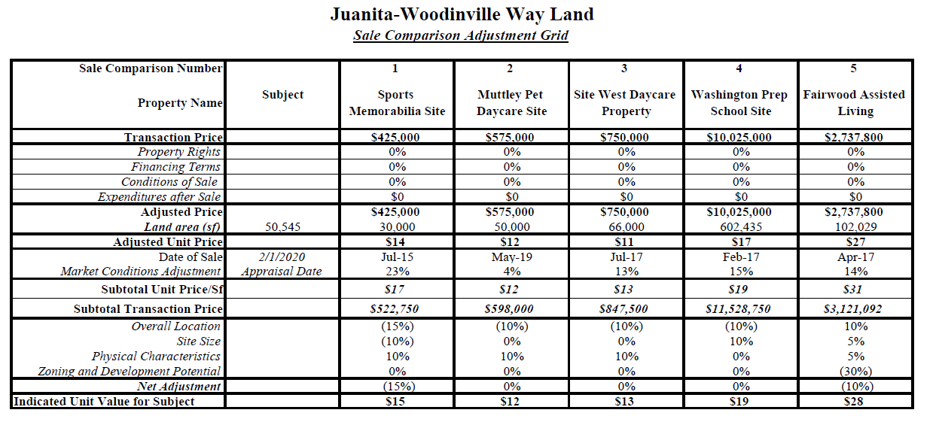
Appraisal Summary Chart

Vicinity View Map
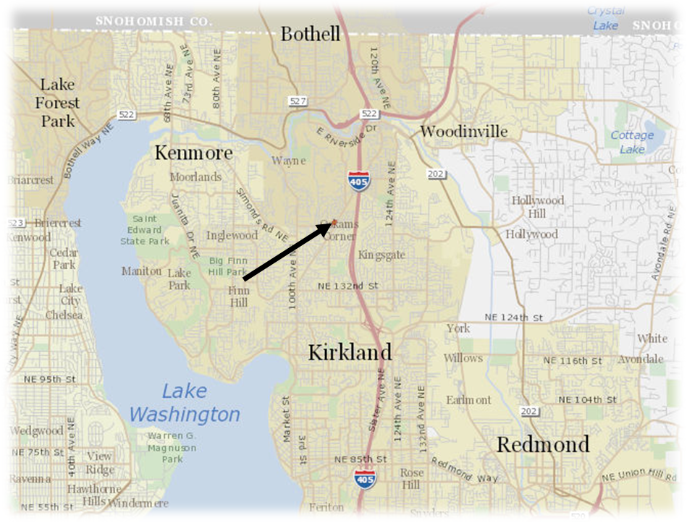
Parcel Map
