Lease Property Summary
Photo of Property:

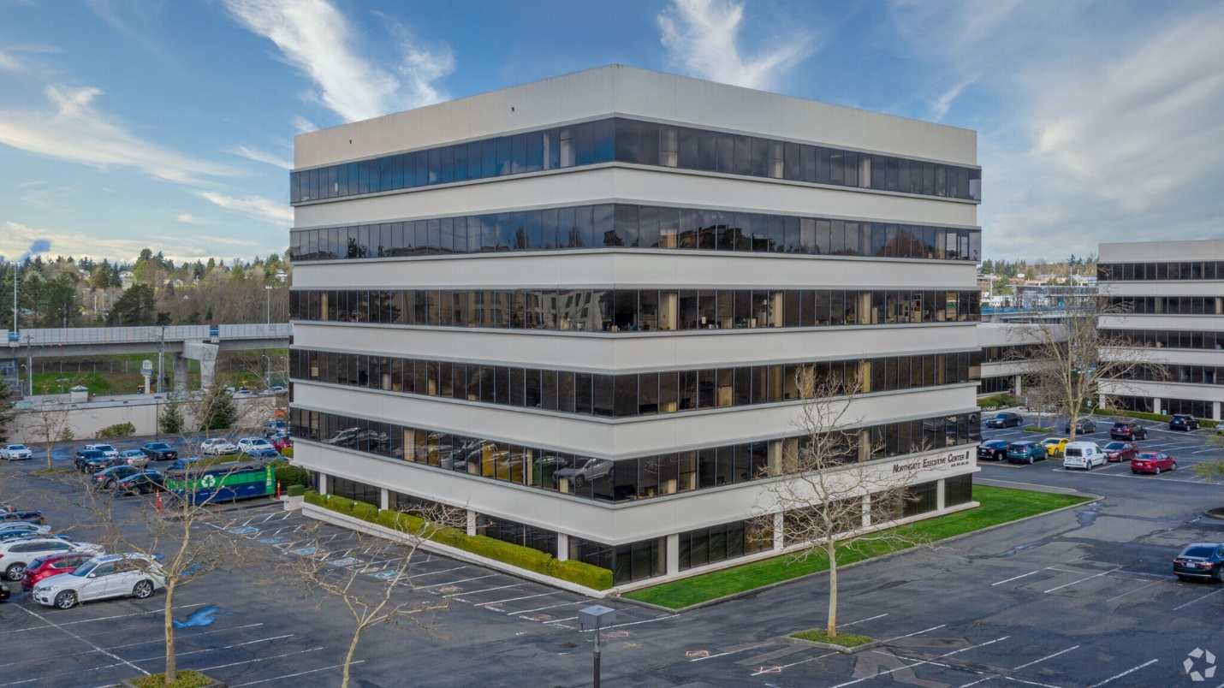

Property Owner: GATEWAY MUIRLAND INC.
Address: 9725 3rd Ave NE (Northgate Executive Center Building C), Seattle, WA 98115
Cost Per Sq. Ft.: $37.50 per rentable square foot/FS
Operational Costs: The 2020 estimated operating costs are $12.12/RSF
Term: Ten Years
Square Footage: 8,592 rentable square feet
Council District: One
Funding Source: Veterans, Seniors and Human Services Levy (VSHSL)
Time Sensitive: The current facility’s lease will expire on 9/30/20, 150% holdover provision will apply thereafter.

Lease Synopsis:
King County Veterans Program (KCVP) is seeking to relocate the Seattle location to Northgate Executive Center. The current lease located at 2106 2nd Avenue, Seattle, expires September 30, 2020. Northgate Executive Center is a three building office campus environment with prominent visibility from I-5 and located across the street from the Northgate Transit Center Park & Ride and the future Light Rail Station. The building has convenient freeway access and is within walking distance to the Northgate retail core. Building amenities include ample free parking, fiber optic capacity, and an accessible conference room. The relocation will improve access to the Department of Community and Human Services (DCHS) throughout King County (Tukwila, Downtown, and Northgate). KCVP will be the primary tenant at this location and this lease approval supports strategic geographic diversification of service access for this population. A relocation to Northgate strategically diversifies geographic availability of King County human services, creating a new service access point for north-end residents.

Context
Rationale for transaction: The King County Veterans Program (KCVP) has served low-income, homeless, disabled, and at-risk veterans and their families since the 1950s. The Veterans' Program is mandated by Washington State law (RCW 73.08.010) and is funded by King County taxpayers through the King County Veterans, Seniors, and Human Services Levy.

Policy considerations: Adult Services Division (ASD) has engaged in long-term strategic planning on how best to provide direct services through the King County Veterans program. As part of this work, ASD has identified that moving the office from Downtown Seattle (Belltown) to North Seattle (Northgate) upon lease expiration provides significant operational value not only for KCVP but for DCHS. This value comes from having several locations where veterans, service members and their families can receive services (Tukwila, Downtown Seattle, Northgate), increasing access to KCVP facilities through different modes of transportation, and improved access from rural and unincorporated areas of Northeast King County.

Political considerations: Relocating this program from Council District Four to District One furthers the reach of veteran services throughout the County by leveraging partner efforts such as the Seattle Vet Center in Georgetown, and spreading services across a wider area. The proposed new location will also improve access to services by providing free parking for clients and staff and adjacency to the Northgate transit and light rail station.

Community considerations
or partnerships: This area provides convenient access to customers of KCVP, serves as a regional hub for DCHS, and will allow state and federal partners to collaborate out of this location to better serve the community

Fiscal considerations: The full base rental rate per rentable square foot annually is $37.50 for year-1 with an increase of 3% annually. This is a full service lease which means that the Tenant’s share of property taxes, insurance and common area maintenance are included in the base rent. The negotiated rental rate is a fair market rate and includes a Tenant Improvement allowance of $343,680 to cover new carpet and paint throughout the premises, replace ceiling lighting, construction of an ADA restroom within the premises, addition of a welcoming front desk reception area, conference room, computer lab, open work areas for staff and confidential meeting rooms.

Other considerations: This lease includes access to the surface parking lot at no additional costs.

CIP/operational impacts: Tenant Improvements will be covered by the negotiated tenant improvement allowance and consist of: new carpet and paint throughout the premises, addition of a front desk area, conference room, computer lab, open work areas and private offices.

King County Strategic Plan impact: This lease supports the King County Strategic Plan by supporting goals in health and human services, accessible & affordable housing, and efficient, accountable regional and local government focus areas by providing essential direct services throughout the county to veterans, service members and their families. These services greatly contribute to removing barriers and delivering equitable opportunities.

Equity and Social Justice impact: In accordance with Real Property Asset Management Plan (RAMP) policy, the Facilities Management Division and Adult Services Division (DCHS) reviewed this legislation for Equity and Social Justice (ESJ) impacts. This location is in the Seattle neighborhood of Northgate and will serve the County’s veterans, military personnel and their families, and other individuals and families in need with a variety of housing and supportive services. This legislation will enable KCVP to continue to operate and maintain services for north-end citizens of King County.

Lease Alternatives Analysis
Summary: A comprehensive office space search for 5,000 to 10,000 square feet in the submarkets of Northgate and the University District generated six potential sites. At that time office space vacancy in those submarkets were at historic lows. Of the six sites, Northgate fit the requirement best in terms of rental rate, timing, existing office infrastructure, landlord approved use, and proximity to public transportation options.

Vicinity View Map 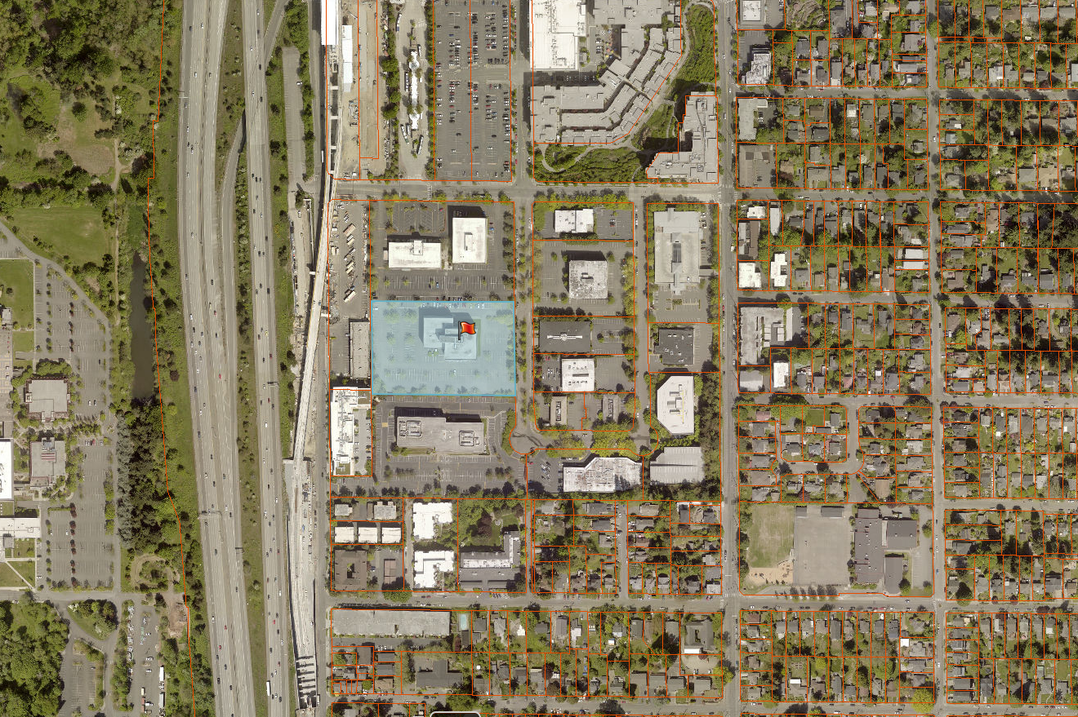
Parcel Map
