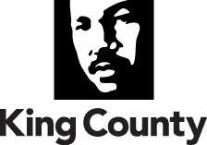

Office of Labor Relations
King County Executive Office
401 Fifth Avenue, Room 850
Seattle, WA 98104
Fax: 206-205-1395
TTY Relay: 711
www.kingcounty.gov

Date August 5, 2024

TO: |  | Dow Constantine, King County Executive
FM: |  | Megan Pedersen, Director, Office of Labor Relations
RE: |  | Labor Relations Legislative Transmittal Package

Attached, you will find the Memorandum of Agreements for:

Union: | Coalition of Unions; and  Joint Labor Management Insurance Committee of Unions
Agreements: | - Coalition Labor Agreement 2025 Extension  - Joint Labor Management Insurance Committee Benefits Agreement 2025  - JLMIC Dispute Resolution Process
Negotiator: | Megan Pedersen
Document Codes: | AttA-000U0124  AttB-000U0224  AttC-000U0324

If you have any questions, please contact me at 206-263-2898.

Approved:
 | Megan Pedersen  Director, Office of Labor Relations |  | Date

