Initial Report Regarding Remedies to Existing Fish Passage Barriers for King County

October 31, 2019

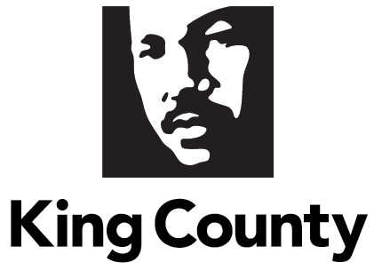

- Contents
II. Executive Summary 1
III. Motion 15328 Text 3
IV. Background 3
V. Report Requirements 4
A. Update on Elements under Development for the Final Report 4
B. Status of the Inventory of Fish Passage at King County Assets 6
C. Estimated Costs to Remedy Identified Blockages 9
VI. Conclusion 12
VII. Appendices 14
Appendix A: Motion 15328…………………………………………………………………………………………………..….15
Appendix B: Methodology and Assumptions for Developing Cost Estimate………………………………19

Executive Summary

Passed in early 2019, Motion 15328 requires the King County Executive to develop and transmit a fish passage barrier compliance plan and evaluation report incorporating eight specific topic areas (see Appendix A for the full text of the Motion). The final report is due to the Council by December 31, 2020. Motion 15328 also requires the Executive to transmit an initial report providing a status update of an inventory which includes, but is not limited to, fish passage barriers identified to date, and estimated costs to remedy those identified passage barriers. The initial report is due to the Council by October 31, 2019.

Healthy salmon stocks are key indicators of the health of Puget Sound and the rest of the Salish Sea, watersheds, and rivers and streams, and King County has a longstanding commitment to the protection and restoration of salmon stocks. To advance salmon recovery and support tribal fishing rights, in the fall of 2017 the Executive directed departments to proactively address the problem of fish passage barriers at King County assets. A subsequent United States Supreme Court ruling in June 2018 underscores the importance of this work.

The Water and Land Resources Division (WLRD) of the Department of Natural Resources and Parks (DNRP) leads work across county agencies to develop a long-term plan to accelerate and sustain restoration of fish passage by King County. Work called for by Motion 15328 complements elements of King County’s Fish Passage Restoration Program. This initial report provides a status update on the comprehensive inventory of fish passage barriers and the estimated cost to remedy the barriers identified as of August 31, 2019.

WLRD staff have engaged within the county as well as with federal, state, tribal, and city officials and staff from the cities of Bellevue and Seattle to identify barriers to fish passage, assess habitat and fish population restoration potential, coordinate with other protection and restoration actions, and sequence and accelerate investments to achieve the greatest benefits for salmon recovery.

In early 2019, WLRD hired four technical specialist term-limited temporary positions to perform fish passage assessments and mapping of King County assets, including culverts, bridges, stormwater systems conveying streams, and stormwater facilities, throughout King County. In addition to the four technical specialists, staff on the Data and Analytics Team in WLRD’s Stormwater Services Section have led the inventory effort, including: development of procedures and protocols; management and analysis of existing data on King County assets; integration of data into an ArcGIS geospatial database (map software with data storage); and, coordination across King County agencies to ensure a comprehensive survey and data dissemination.

Site inventory work started in spring 2019. The technical team will continue the field inventory through 2019 and 2020. Since beginning the inventory, the team has exceeded the target pace for site visits and data collection. Based on an analysis of the locations of streams, roads, trails, stormwater facilities, and other King County assets, WLRD expects the team will complete visits to more than 2,500 total sites in the course of the inventory. To date, 731 sites have been visited and 310 sites have the passage assessment completed. The team has found 109 sites that are not fish passage barriers and 197 sites that are partial or complete barriers to fish passage (four sites have an unknown passage status based on the assessment methodology). For 342 sites, the visits verified that fish passage assessment was not required or that the sites could be removed from the database. WLRD estimates the team has about 1,800 sites remaining to visit. Tables 1 and 2 in the report provide details on site visits and fish passage assessments completed thus far.

This initial report will consider the inventory data collected as of August 31, 2019, which provides a snapshot of the inventory status while allowing sufficient time to develop conceptual cost estimates to remedy the barriers identified as of August 31.

The fish passage assessment is based primarily on Washington Department of Fish and Wildlife (WDFW) methodology. The WDFW methods provide standardized approaches and guidance for evaluating fish passage conditions at water crossing structures such as culverts, bridges, dams, fish ladders, flumes, and natural features. The procedures provide guidance for determining barrier status of an instream feature and, if the feature is determined to be a barrier, guidance on assessing the severity of the impediment.

The Road Services Division of the Department of Local Services (Roads) is responsible for almost three-quarters of the sites assessed by DNRP thus far, and a slightly higher percentage of the sites that are fish passage barriers. The Parks and Recreation Division (Parks) of DNRP is responsible for about one-quarter of the sites assessed thus far, but with a lower percentage of the sites that are fish passage barriers. Thus far, assessments have been completed at a handful of WLRD sites, and all of these sites are fish passage barriers. Compared to Roads and WLRD, Parks has a lower relative percentage of barriers due to the nature of its stream crossings, which in many cases are light, channel-spanning bridges carrying narrow trails. The majority of Roads and WLRD sites are culverts under multilane roads or long piped conveyances, respectively, built in decades before the current emphasis on maintaining fish passage. Table 3 in the report provides a breakdown of agency responsibility for the 310 sites where passage assessments were completed as of August 31, 2019.

Staff from Roads, Parks, and WLRD collaborated to develop a high-level cumulative total cost estimate to remedy the passage barriers identified thus far in the inventory. These estimates are preliminary and are not based on detailed project information. Given the interim status of the inventory and the current status of the data quality management and cost modeling, the estimated costs should be considered very general and not for budgeting or specific project planning.

Roads, Parks, and WLRD estimate that the total cost to restore fish passage at the 197 barriers thus far identified would be between $408 million and $589 million. Table 4 in the body of the report provides the cost estimate ranges by asset owner. Important caveats on the cost estimates include:
- The cost estimates are based on a partial inventory of King County barriers.
- Total estimated costs are shown in 2019 dollars and do not adjust for inflation beyond 2019.
- The cumulative cost estimates provide preliminary total costs for the barriers inventoried to date and cost estimates did not reflect detailed site or project information.

As assets are replaced to meet updated minimum standards for fish passability, the product categorization of some assets will shift from culvert to bridge. Particularly for Roads sites, the overall Roads bridge inventory will likely increase as the Roads replaces fish passage barriers with longer-span structures that meet bridge criteria.

The fish passage restoration efforts of King County reflect a commitment to accelerate removal of known fish passage barriers. An additional important consideration is that there is not a dedicated fund source for this work at this time, nor is there sufficient available funding within existing funding sources.

Motion 15328 Text

Passed in early 2019, Motion 15328 requires the King County Executive to develop and transmit a fish passage barrier compliance plan and evaluation report incorporating eight specific topic areas. See Appendix A for the full text of the Motion. The final report is due to the Council by December 31, 2020. Motion 15328 also requires the Executive to transmit an initial report providing a status update of an inventory which includes, but is not limited to, fish passage barriers identified to date, and estimated costs to remedy those identified passage barriers. The initial report is due to the Council by October 31, 2019.

Background

Department Overview: The Water and Land Resources Division (WLRD) is part of the Department of Natural Resources and Parks (DNRP). WLRD protects, restores, and manages King County’s water and land using the best available science, innovation, and collaboration with our partners and the community. A goal of WLRD is to protect and restore water resources within the County using a broad range of approaches to achieve that outcome. WLRD’s portfolio is diverse and encompasses:
• Building green and gray infrastructure;
• Maintaining green and gray infrastructure;
• Fostering stewardship; and,
• Providing technical assistance and support.

The WLRD portfolio is diverse and delivers:
• Building and maintaining gray and green infrastructure;
• Fostering stewardship; and,
• Providing technical assistance and scientific support.

Restoration of fish passage is one of several initiatives described in the 2019-2020 WLRD Business Plan that reflects an increased focus on moving from managing resources to improving their condition. Fish passage work will involve coordination and collaboration among all King County agencies with responsibilities for infrastructure that prevents fish from migrating to areas where they would naturally seek passage.

Historical Context: King County has a longstanding commitment to the protection and restoration of salmon stocks. Among other things, King County has passed ordinances aimed at protecting “critical areas” from degradation, safeguarding the shoreline and its abundant natural resources, responsibly managing stormwater, and ensuring that clearing and grading land for development is done responsibly, with minimal risk to the environment. Additionally, the King County Comprehensive Plan affirms the County’s commitment to salmon recovery.

Since 2013, federal court decisions in the United States v. Washington proceedings have highlighted the impact of fish passage barrier culverts on salmon populations in the region. The courts made specific findings that fish passage barrier culverts are contributing to the degradation of salmon habitat and the declining salmon population and held that construction, operation, and maintenance of culverts under State roadways infringed on treaty-based, tribally reserved rights to take fish at usual and accustomed places in common with all citizens.

Current Context: In light of these rulings and in conjunction with its overall salmon protection and restoration efforts, King County has launched development of a Fish Passage Restoration Program. In coordination with Department of Local Services (DLS), other divisions in DNRP, and the Executive Office, staff in WLRD lead the program development effort.

To support tribal fishing rights and restore habitat, the Executive directed departments to proactively address the problem of fish passage barriers located on King County assets. In addition to internal collaboration, King County staff have engaged with federal, state, tribal, and city officials to identify barriers to fish passage, assess habitat and fish population restoration potential, coordinate with other protection and restoration actions, and sequence and accelerate investments to achieve the greatest benefits for salmon recovery.

Report Methodology: For this report, staff from DNRP, DLS, and Office of Performance, Strategy, and Budget (PSB) collaborated to:
- Summarize the status of the field inventory of King County assets with potential to be barriers to fish passage, and
- Develop a conceptual cost estimate to remedy the currently identified barriers.

The report summarizes information as of August 31, 2019. Detailed methods are described in each relevant section of the report and in Appendix B. In developing the report, DNRP engaged staff and leadership from DLS (with contributions and review from Roads) and PSB.

Report Requirements

This section is organized to align with the motion requirements for the initial report due October 31, 2019.

Update on Elements under Development for the Final Report
This section includes an update of work that will inform the final report required by Motion 15328, which is due to the Council by December 31, 2020.

In July 2018, WLRD hired staff to lead development of a long-term plan to accelerate and sustain restoration of fish passage by King County. The development of the Fish Passage Restoration Program includes development of:
- A comprehensive inventory of stream crossings owned or maintained by King County to determine which ones may block salmon migration (more details on the inventory status on page 5);
- Thirty-nine early action projects, in various phases, representing accelerated early investment on fish passage restoration (these projects also provide opportunity test actions under consideration for programmatic application);
- Methodology to prioritize identified passage barriers;
- Procedures to plan, design, and construct projects that restore fish passage as quickly, efficiently, and cost effectively as possible;
- Program procedures to optimize and accelerate ecosystem benefits from fish passage restoration in light of asset management responsibilities;
- Partnerships with other governmental agencies, private entities, tribes, and non-profits to leverage investments to maximize stream connectivity with fish passage restoration;
- Cost estimates for meeting programmatic success criteria developed collaboratively with regional partners; and,
- Long-term funding and financing strategies to remedy fish passage barriers in King County’s portfolio.

As noted, the work called for by Motion 15328 complement elements of the Fish Passage Restoration Program. Thus far, program work includes the following:
- Regional coordination and technical analysis associated with development of prioritization methodology includes collaboration with five tribes and the Washington Department of Fish and Wildlife (WDFW), the co-managers of fisheries in Washington State. Co-manager support for the prioritization methodology is crucial as the program will rely on it to guide development of the programmatic work plan and project identification for biennial budgeting.
- WLRD is working with the tribes and state to develop program procedures that may allow the county to focus limited resources on higher priority barriers in lieu of increased investment in barriers with very minor potential salmon benefits.
- In concert with the broader Clean Water Healthy Habitat initiative, the team, including the program’s Steering Committee, will consider options for work plan implementation, including potential organizational changes that may help integrate program goals across the various organizations and programs that are currently involved in capital projects and maintenance that involves instream assets that may be barriers to fish passage.

Status of the Inventory of Fish Passage at King County Assets

This section provides the required status update of the inventory or fish passage at King County assets.

In early 2019, WLRD hired four technical specialist term-limited temporary positions. These positions were created to perform a comprehensive assessment of assets, including culverts, bridges, and stormwater facilities conveying natural water to determine which are barriers to fish passage. The assessment effort consists of field collection of data on King County assets, analysis of the data to determine if an asset is a fish passage barrier, and integration of the assessment information and findings into the King County geospatial database as well as the WDFW statewide fish passage database. In addition to the four technical specialists, staff in the Data and Analytics Team in WLRD’s Stormwater Services Section have led the inventory effort, including: development of procedures and protocols; management and analysis of existing data on King County assets; integration of the data into an ArcGIS geospatial database; and coordination across King County agencies to ensure a comprehensive survey and data dissemination.

Site inventory methodology development and data collection started in early January 2019, prior to hiring of the technical specialists. During this time, WLRD Data and Analytics staff consulted with WDFW, tribes, other counties, Roads, Parks, and Stormwater Services to develop initial site and asset data collection methodology. The four technical specialists were on hired by the end of April 2019 and began the field inventory after training was completed in mid-May. Since beginning the inventory, the team has exceeded the target pace for site visits and data collection. As the technical specialists continue with the field inventory, the data collection methodology is being continuously improved as staff gain a better understanding of the developing program and data implementation.

The technical team will continue the field inventory through 2019 and 2020. Based on an analysis of the locations of streams, roads, trails, stormwater facilities, and other King County assets, the team is expected to visit more than 2,500 sites in the course of the inventory. Using web-based tools, WLRD tracks the progress and results of the inventory, including via an automated electronic dashboard. The fish passage assessment is based primarily on WDFW methodology for fish passage inventory and assessment.

The WDFW methods provide standardized approaches and guidance for evaluating fish passage conditions at water crossing structures such as culverts, bridges, dams, fish ladders, flumes, and natural features. The procedures provide guidance for determining barrier status of an instream feature and, if the feature is determined to be a barrier, guidance on assessing the severity of the impediment. The methodology focuses the assessment on whether the instream feature is an impediment to upstream migration by adult salmonids. The WDFW manual does not address barrier assessment for complex situations, for example closed conveyance systems and stormwater facilities conveying streams. As such, WLRD staff is still developing the methodology for accurately measuring and assessing barrier status for such asset features. To allow for incorporation into WDFW’s statewide database, the inventory is tracked by sites where streams intersect with King County roads, trails, or stormwater facilities. There may be more than one asset, as defined for the purposes of the Fish Passage Restoration Program, on an individual site.

At each identified site, the technical specialists measure the dimensions of the structures (i.e. culvert diameter, length, and slope) and the adjacent stream channel, and record observations of the location, as well as the material type and condition of the assets. During the site visit, the technical specialists remotely enter the data into the King County database in real-time via an application called ArcGIS Collector. Following the field visit, the technical specialists perform an office review of the data as part of the quality assurance process.

The Data and Analytics team is in the process of developing and performing quality control reviews of the field-collected information. As such, the data being used for the purposes of this report have not been quality controlled by the Data and Analytics team at this time. From the WLRD geospatial database, staff can view the progress and findings of the field inventory using geographic information systems and associated web maps.

Following an internal data quality control review, staff plan to share the accumulated site inventory data with WDFW to incorporate into its Fish Passage and Diversion Screening Inventory database, which functions as a central repository for fish passage inventory data collected throughout the state. Information from the WDFW database is publicly accessible online.

This initial report contains the inventory status as of August 31, 2019. WLRD selected this cutoff date to allow sufficient time to conduct the analysis required by the Motion, including the development of cost estimates to remedy the identified barriers, as well as the development and review of the initial report to meet the deadline for submittal to the King County Council by October 31, 2019.

WLRD staff identified King County sites with potential instream structures (i.e. potential fish passage barriers) based on available map resources showing factors such as the location of streams, county roads, trails, and stormwater assets. Table 1 below provides the breakdown of the status of field inventory sites with assets owned or maintained by King County that have the potential to block salmon from swimming to upstream habitat. Key findings show:
- The DNRP team has visited 731 sites through August 31, primarily in the southern portion of King County.
- WLRD estimates that there are about 1,800 sites remaining to visit.
- Full data collection has occurred for 675 of the 731 visited sites. The team will need to re-visit 56 sites, pending landowner permission, to obtain data during different site conditions (for example, when the stream is flowing later in the fall or winter), or with additional engineering expertise.
- Visits to 184 sites have resulted in removing the site from the inventory since the team found that the site duplicated another stream crossing or there was no physical stream present at the identified mapped site.
- For the 158 sites identified as No Passage Assessment Needed, the field visit found that no assessment was required since the stream at that location had no potential for salmon use (per WDFW criteria) or because the team found that the assets at the site were not owned or maintained by King County.
- WLRD has completed the barrier determination assessment at 310 sites. For 23 sites, WLRD has completed field data collection and will complete the barrier assessment using computer modeling as described in WDFW manual.

Table 1. Field Inventory Status Summary (as of August 31, 2019)
# of Sites Visited | # of Sites w/ Data Collection Complete |  |  |  | # of Sites Requiring Additional Site Visit¹
731 | 675 |  |  |  | 56
 | Passage Assessment Complete | Passage Assessment Pending Modeling | Sites Retired² | No Passage Assessment Needed at Site³
 | 310 | 23 | 184 | 158
¹ An additional site visit is needed due to site characteristics that require fall/winter conditions to fully assess the site, need for permission to access off the right-of-way to obtain necessary data, or need additional engineering expertise.
² Retired sites are locations where the team found that there either was no stream present at the mapped location or where the identified crossing was a duplicate of another mapped crossing.
³ No passage assessment is needed due to no potential salmon use of stream at the asset location (based on Washington Department of Fish and Wildlife criteria) or if the asset is not owned or maintained by King County. For example, the site visit may determine that the site is located upstream of natural barriers like impassible waterfalls, which would mean that there is no potential salmon habitat or use at the site.

Table 2 provides a breakdown of the fish passage status of the 310 sites where WLRD has completed a passage assessment as of August 31, 2019.

Table 2. Fish Passage Status of 310 Inventoried Sites with Completed Passage Assessments (as of August 31, 2019)
 |  | Passability of Identified Barriers
 | Not a Barrier | Partially Passable | Not Passable | Unknown Severity | Unknown Barrier Status
# of Sites | 109 | 79 | 110 | 8 | 4
% of Sites | 35% | 25% | 36% | 3% | 1%

Terminology for passability status follows:
- Not a Barrier: No adult salmonid should be impeded when attempting to migrate over or through the feature during stream conditions when fish migration would occur naturally.
- Partially Passable: The feature is a moderate or severe barrier to migration by some adult salmonids during stream conditions when fish migration would occur naturally.
- Not Passable: The feature is a total barrier to migration by some adult salmonids during stream conditions when fish migration would occur naturally.
- Unknown Severity: The feature is a barrier to adult salmonids during stream conditions when fish migration would occur naturally, but site conditions prevent a determination of the barrier severity using the standardized WDFW protocols. Examples include man-made ponds created by small dams where the pond level is seasonally managed by manipulating the outlet controls at the dam or culverts with some kinds of racks or screens that have spacing of the openings in the rack/screen smaller than certain minimum requirements.
- Unknown Barrier Status: Complex site conditions prevent using the standardized WDFW protocols to determine whether the feature impedes migration by adult salmonids during conditions when fish migration would occur naturally. Examples include but are not limited to certain types of tidally influenced features, many culverts with internal grade breaks (known as a broken back culvert), and fish ladders with broken components or that are filled with sediment.

Table 3 provides a breakdown of the responsible agency for the 310 sites with completed passage assessments as of August 31, 2019. Key findings include:
- Roads is responsible for an estimated 74 percent of the total sites assessed thus far, and for an estimated 81 percent of the identified barriers.
- Parks is responsible for an estimated 25 percent of the total sites assessed thus far and for an estimated 15 percent of the identified barriers.
- WLRD is responsible for an estimated 1 percent of the total sites and for an estimated 3 percent identified barriers assessed thus far.

Compared to Roads and WLRD, Parks has a lower relative percentage of barriers due to the nature of its stream crossings, which in many cases are light, channel-spanning bridges carrying narrow trails. The majority of Roads and WLRD sites are culverts under multilane roads or long piped conveyances, respectively, designed and built decades ago and without emphasis on also maintaining fish passage.

Table 3. Agency Responsibility for the 310 Inventoried Sites with Completed Passage Assessments (as of August 31, 2019)
 | Passability of Sites with Completed Passage Assessments
 | Not a Barrier | Partially Passable | Not Passable | Unknown Severity | Unknown Barrier Status | Totals
Roads | 65  (60%) | 62  (79%) | 90  (82%) | 8  (100%) | 3  (75%) | 228  (74%)
Parks | 44  (40%) | 16  (20%) | 17  (15%) | 0  (0%) | 1  (25%) | 78  (25%)
WLRD | 0  (0%) | 1  (1%) | 3  (3%) | 0  (0%) | 0  (0%) | 4  (1%)
Totals | 109  (100%) | 79  (100%) | 110  (100%) | 8  (100%) | 4  (100%) | 310  (100%)

Estimated Costs to Remedy Identified Blockages
This section will provide a range of estimated costs to remedy the fish passage barriers identified through August 31, 2019.

To identify high-level cost estimates for potential remedies to the passage barriers identified thus far by the inventory, staff from Roads, Parks, and WLRD collaborated to develop a range of costs. . Key points about preliminary cost estimates shown below:
- The cost estimates are based on restoring fish passage at all of the identified fish passage barriers, regardless of the habitat benefit or other replacement feasibility factors of the identified barriers.
- The interim data should not be used to extrapolate how many barriers will be found nor the costs associated with replacement of those barriers.
- The estimates are preliminary and do not reflect detailed project information.

Given the interim status of the inventory and the current status of the data quality management and cost modeling, the estimated costs should be considered high-level estimates that are not appropriate for budgeting or specific project planning. Appendix B provides more detail about the assumptions used to develop the cost estimates.

Costing Methodology: The sites visited to date represent about a quarter of the total sites that WLRD anticipates visiting in 2019 and 2020. However, the interim data should not be used to extrapolate how many barriers will be found nor the costs associated with replacement of those barriers. This is due to the site-specific nature of the assessments and the variability of the completed site assessments compared to conditions and asset types in other areas of the county yet to be assessed by the comprehensive inventory.

Roads and Parks barriers are similar in that they typically involve a discrete stream crossing by a culvert through a fill prism for a road or trail. To estimate costs to remedy the known Roads and Parks barriers, a cost estimate methodology was developed that incorporates key asset characteristics collected by the site inventory with financial and project data from past Roads culvert replacement projects. To develop unit cost range for each reference barrier project, staff conducted analyses of financial and project data for eight recent culvert replacements, accounting for culvert costs, average project bids, and culvert dimensions, and then adjusted these costs by a three percent to account for inflation to bring costs into 2019 dollars.

Staff then applied the lowest and highest unit costs within the range of reference projects to use for estimating the range of construction costs for the barriers identified in the site inventory. From the estimated construction costs, staff adjusted certain project construction costs for projects requiring more expensive project elements, such as road approach modifications. The estimated construction cost was then used as a basis to determine cost estimates for project contingencies, design, construction management, and right of way acquisition. Given that the Parks and Roads barriers are typically associated with stream crossings by roads and trails, which are all similar in type, both agencies applied the same methodology for estimating costs for these barriers.

Each of the four WLRD barriers is a stormwater facility, which is a very different type of in-stream feature than a road or trail crossing. Accordingly, WLRD developed a different methodology to generate conceptual low and high cost estimates for remedying the WLRD barriers. The conceptual low and high cost estimates for the WLRD barriers considered general characteristics of the stormwater facilities that are passage barriers, general characteristics of features necessary to achieve fish passage, and accounting for maintaining the general stormwater function of the particular facilities.

The methodology and estimates included in this report have been reviewed by PSB. Appendix B provides more details on the cost estimating methodologies, assumptions, and limitations.
It is important to note the limitations of this planning-level estimating exercise:
- The cost estimates are based on a partial inventory of King County barriers.
- Total estimated costs are shown in 2019 dollars and do not adjust for inflation beyond 2019.
- The cumulative cost estimates provide preliminary total costs for the barriers inventoried to date and cost estimates did not reflect detailed site or project information.
- The data used to construct cost estimates is subject to quality control review to ensure consistent interpretation of the various data fields.

DNRP will continue to refine and quality control site data and cost estimating methods as it works to develop a programmatic fish passage restoration workplan.

The initial cost estimate ranges presented here provide high-level estimates of total costs for the barriers that has been identified as of August 31, 2019, as required by the Motion. As the respective six-year capital improvement program plans address replacement of specific King County assets, project cost estimates will be updated to include more detailed project-specific data, and will more accurately represent the anticipated cost of a project. For example, detailed project-specific costs will account for many site-specific variables such as complexity of the conveyance system, the depth of the ravine, whether a bridge may be a viable approach, roadway length, construction logistics including detours or temporary crossings, market conditions, and characteristics of the approaches to the crossing and if they would need revision.

Table 4 provides the cost estimate ranges by asset owner. Roads, Parks, and WLRD estimate that the total cost to restore fish passage, for the purpose of this report, at the 197 barriers thus far identified would be between $408 million and $589 million. As noted previously, given the interim status of the inventory and the current status of the data quality management and cost modeling, the estimated costs should be considered very general and subject to significant changes.

Table 4. Cost Estimates for Restoring Fish Passage at Barriers Identified as of August 31, 2019
Agency | # of Barriers | Low Range Estimate | High Range Estimate
Roads | 160 | $375M | $530M
Parks | 33 | $23M | $26M
WLRD | 4 | $10M | $33M
Total | 197 | $408M | $589M

Since Roads is responsible for more than 80 percent of the identified barriers, the costs to remedy Roads barriers is similarly high. The estimated costs to remedy the WLRD barriers is high relative to the small number of identified barriers. The stormwater facilities where these barriers occur are made up of a variety of linked assets such as culverts, underground pipes (in some cases under one or several developed properties), catch basins, and detention/retention ponds. Given their function, these types of facilities most often occur in more urbanized parts of the county. Costs associated with these types of sites often would require extensive offsite actions, (for example, replacement of lost detention capacity, including property acquisition) which tend to increase overall per-site costs.
It is relevant to note that there is no current legal obligation related to comprehensive fish passage restoration at King County assets, but the county efforts for program development reflect a commitment to prioritize and accelerate the removal of known fish passage barriers. It is important to consider that there are insufficient existing funding resources for this program at this time.

As assets are replaced to meet updated standards for fish passability, the product categorization of some assets will shift from culvert to bridge. Particularly for Roads sites, the overall Roads’ bridge inventory will likely increase as Roads replaces fish passage barriers with longer-span structures that meet bridge criteria. Data availability at the time of this analysis does not allow for a detailed analysis of this impact to bridge inventory and additional costs associated.

To provide additional context to the cost estimates for remedies of the King County’s fish passage barriers identified thus far, WSDOT estimates that it will cost $3.7 billion to replace about 500 culverts to meet a 2030 deadline specified in the 2013 injunction in the United States v. Washington litigation. Considering the respective portfolios used for the estimates, the per culvert cost for the state is about three times the per culvert cost for the county, since the state projects often involve multilane highways, while the county projects occur on smaller roadways, trails, and stormwater assets.

Conclusion
This report meets the requirements for the initial report specified by Motion 15328.

Per Motion 15328, this report provides a status update on the comprehensive inventory of King County assets that could be fish passage barriers, along with the estimated costs to remedy passage barriers identified thus far.

As noted, the field inventory is slightly ahead of the schedule targets and DNRP is closely monitoring progress. The DNRP team has visited 731 sites through August 31, primarily in the southern portion of King County. WLRD estimates that there are about 1,800 sites remaining to visit. Full data collection has occurred for 675 of the 731 visited sites. The team will need to re-visit 56 sites, pending landowner permission, to obtain data during different site conditions (for example, when the stream is flowing later in the fall or winter), or with additional engineering expertise. WLRD has completed the barrier determination assessment at 310 sites. For 23 sites, WLRD has completed field data collection and will complete the barrier assessment using computer modeling as described in WDFW manual.

The high-level cost to restore fish passage to the 197 assets that have been inventoried through August 31 and determined to be barriers is estimated to be between $408 million to $589 million. This estimate was based on a methodology determined from a range of costs associated with recently completed relevant King County projects.

Healthy salmon stocks are key indicators of the health of Puget Sound and the rest of the Salish Sea, watersheds, and rivers and streams. Protecting and recovering salmon runs and the habitat they rely upon is essential to honoring the treaty rights and culture of Puget Sound Tribes, and is vital to Washington’s economy and culture.

Acceleration of fish passage restoration at the highest priority/benefit sites provides an effective way to amass substantial benefits for salmon with a relatively small proportion of sites. For example, the Washington State Department of Transportation (WSDOT) fish passage program estimates that restoration of passage at about half of the identified barriers associated with state highways provides 90 percent of the total habitat benefits for salmon. Reflective of these factors, WLRD expects to find that restoring passage at about half of the identified barriers would provide a high proportion of the total salmon benefits. This also means that we expect proportionately smaller benefits for a fairly sizeable percentage of the King County barriers. These barriers are typically located on small streams with relatively little salmon habitat available in upstream areas. WLRD plans to perform additional analysis to better quantify and prioritize the amount of potential habitat gain at each barrier. The work plan for the Fish Passage Restoration Program will consider how to get the best outcome for the investment, including focus on higher benefit sites in the portfolio. To achieve this goal, it will be critical to get support from WDFW and the tribes for the prioritization methodology currently under development.

Given the large number of King County passage barriers, the potential cumulative costs to remedy them will be considerable. Thus, it is necessary to develop a sustainable long-term strategy for systematically addressing King County’s portfolio of fish passage barriers.

The work outlined in this report furthers the goals of key County plans and initiatives as follows:
- It furthers the King County Strategic Plan goal of a healthy environment by protecting and supporting healthy and productive forests and open spaces, including healthy and self-sustaining salmon populations.
- It furthers the Strategic Climate Action Plan goal of planning for, and coordinating regionally, on climate change impacts on salmon recovery by addressing barriers that prevent salmon from swimming to high quality stream areas that are resilient to a changing climate and necessary for their survival.

Appendices
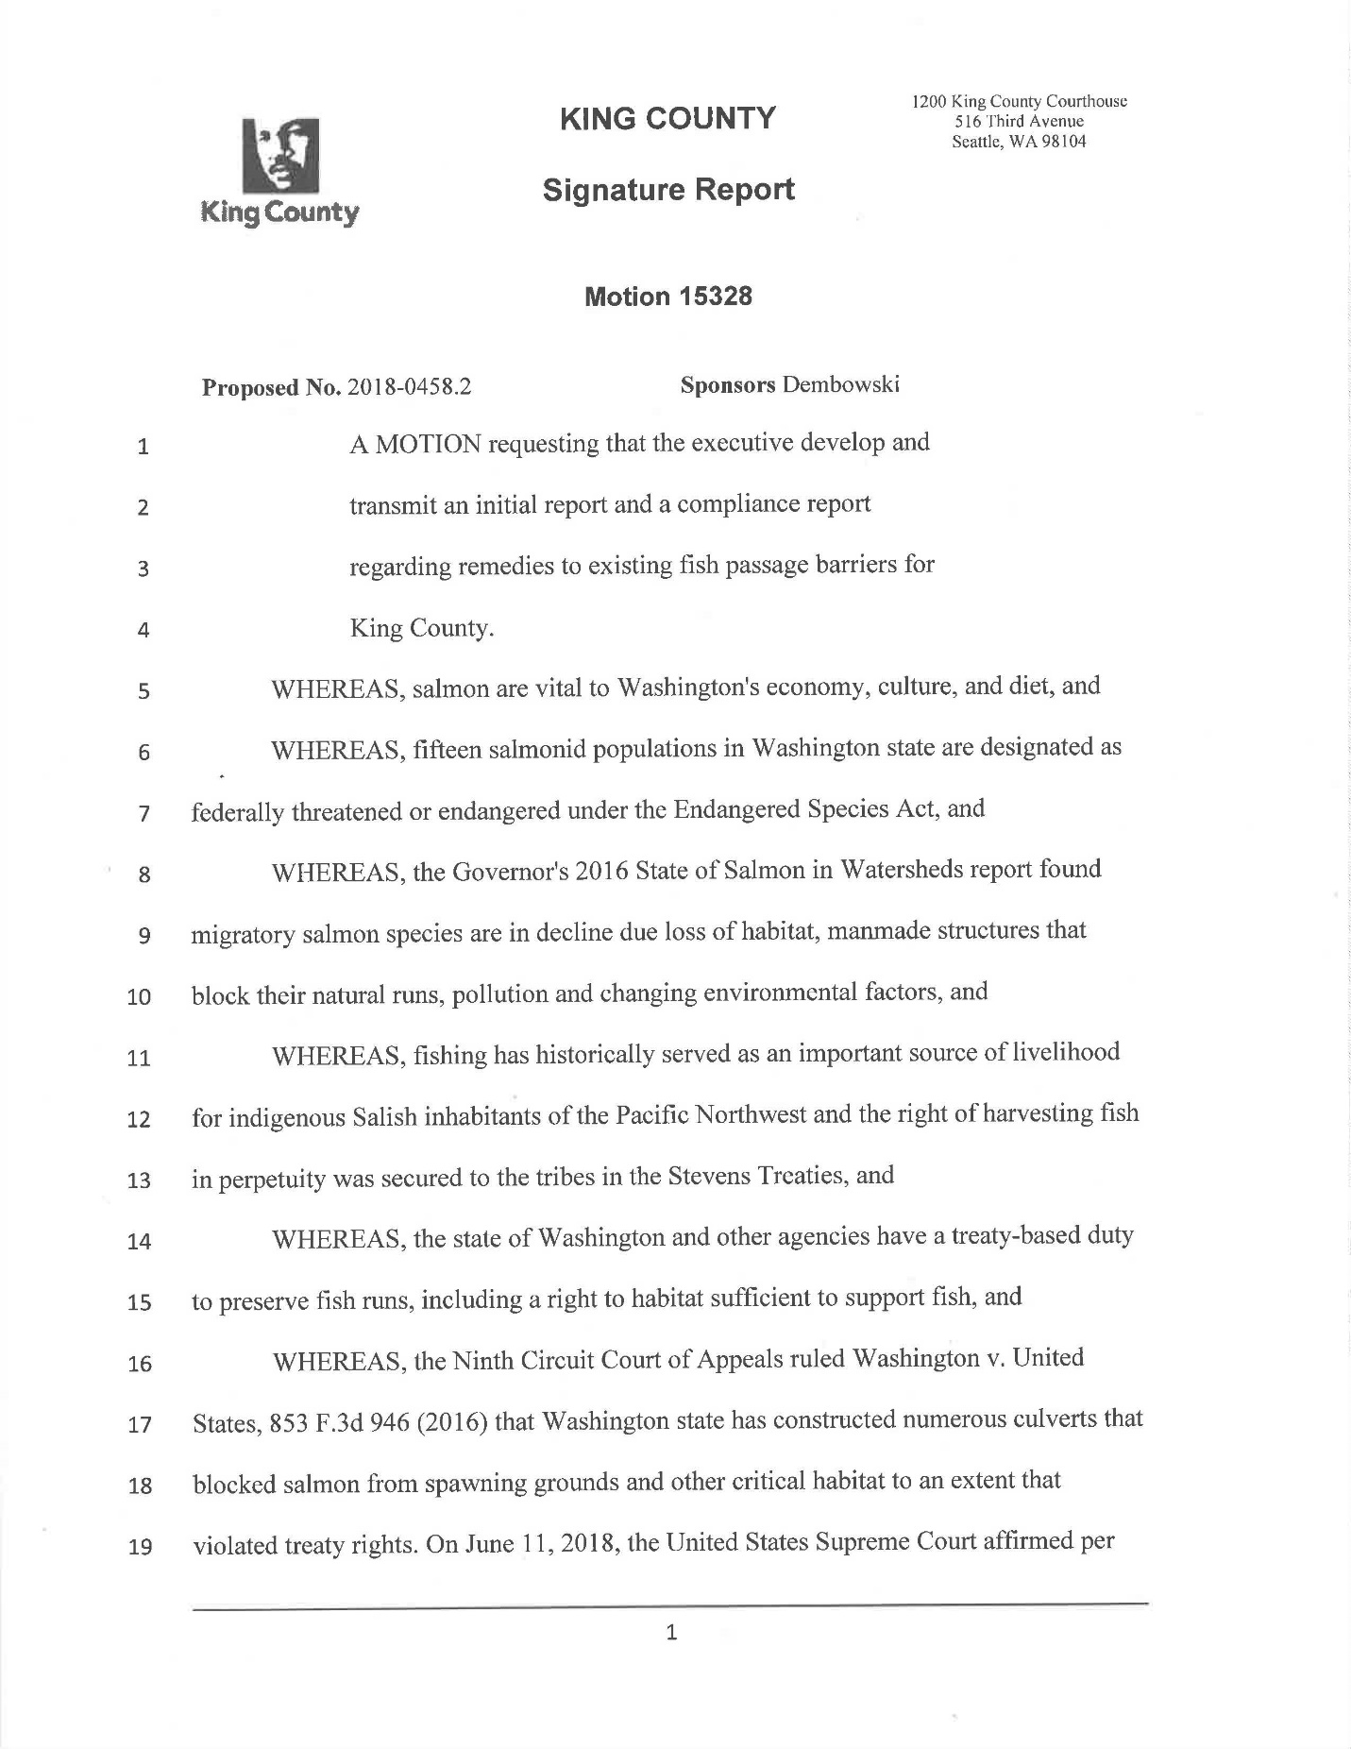

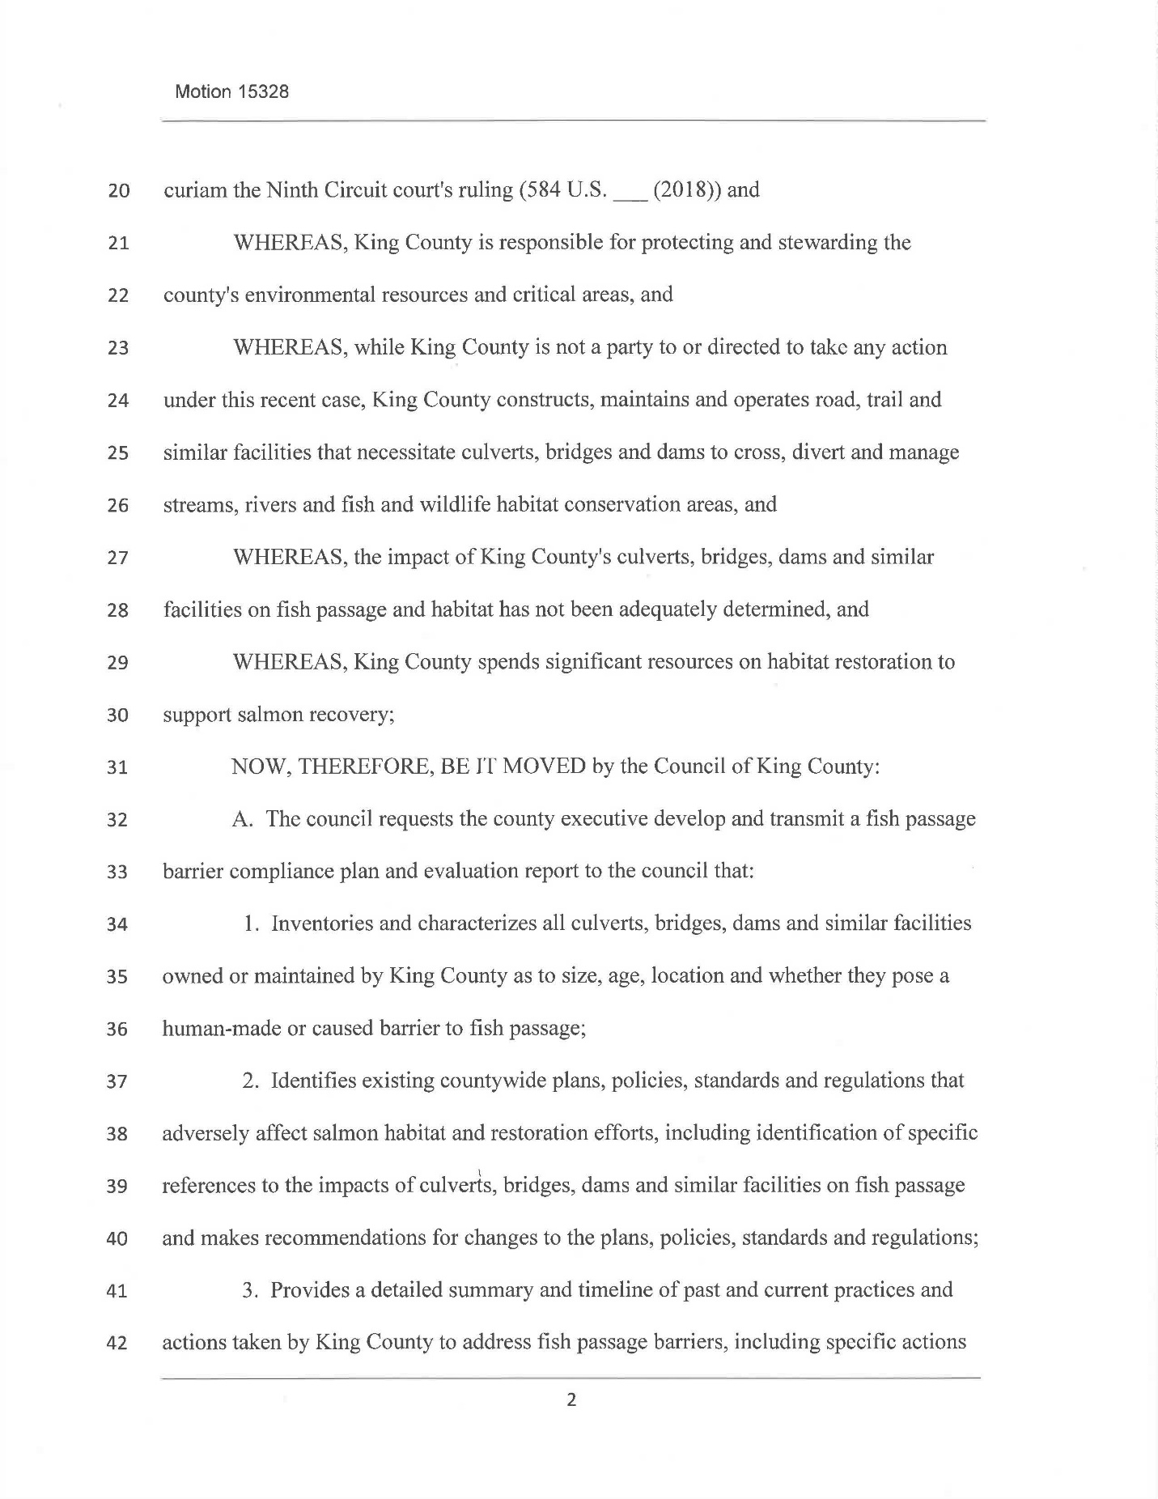

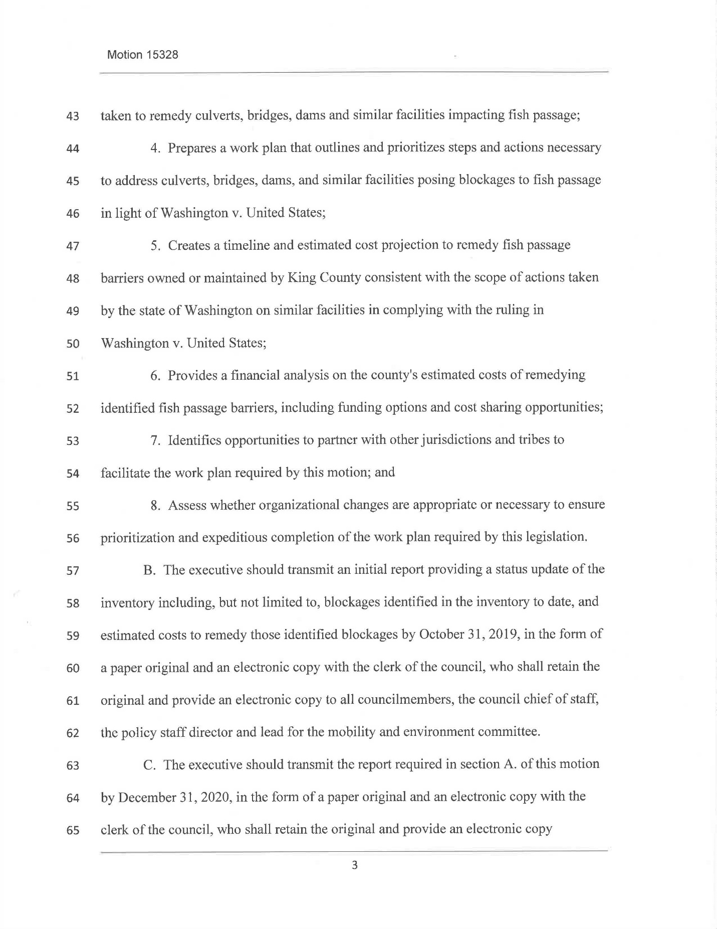

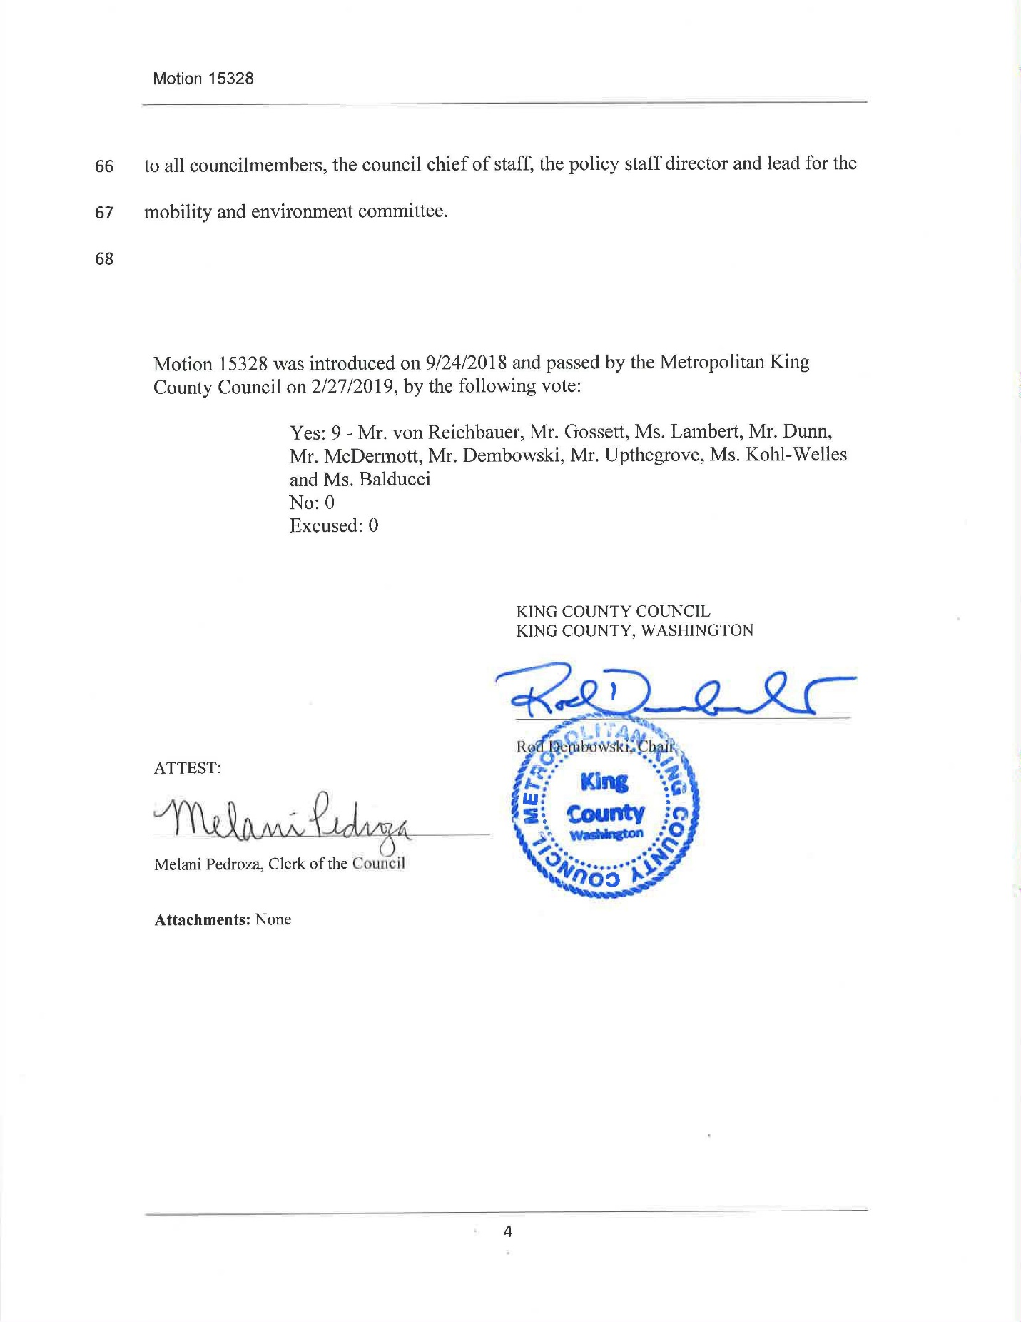
Staff used the following methodologies and assumptions to develop cost estimates based on the data available at this early stage of the inventory. These estimating tools are based on planning-level calculations applied to a suite of barrier sites. For example, the methods used to estimate the unit cost for Roads and Parks sites is based on the reference projects involving replacement by box culvert. Other options may be available or necessary based on scoping and field site visit. No scoping or adjustments were included as part of this analysis due to time constraints. Additionally, field visits were not performed by engineering staff. Projects may not take place due to unknown natural downstream barriers or other factors.

Total estimated costs do not adjust for inflation beyond 2019.

Methodology Used for Roads and Parks Barriers

Roads staff have developed a cost estimate methodology that incorporates key asset and site characteristics collected by WLRD staff and financial and project data from Road Services culvert replacement projects. Staff filtered the dataset provided by WLRD, and analyzed assets/sites with inspection statuses that required analysis, as recommended by Fish Passage Inventory staff. Staff analyzed recent financial and project data from eight Roads culvert replacements, accounting for culvert costs, average project bids, culvert dimensions, and a historical inflation rate of 3 percent to develop average unit costs for each culvert replacement project in 2019 dollars. Staff then applied the lowest and highest unit costs within the project range to key asset/site data associated with all Roads and Parks owned assets/sites within the FPP inventory to develop estimated construction costs.

Total estimated costs include estimated asset construction costs with adjustments for road approach modifications and percentage of cost allocations to account contingencies, project design, construction management, and right of way acquisition. Estimated costs do not include planning funds, and are estimated in 2019 dollars. Because staff expect that asset construction costs would not fall below $200,000 in 2019 dollars, this analysis places a minimum construction cost of $200,000 for each individual asset calculation. Additionally, because staff expect that total asset replacement costs would not exceed $5 million, this analysis places a $5 million ceiling on each individual total asset replacement cost calculation.

Methodology Used for WLRD Barriers
Based on the records of the facilities and mapping software technology (iMap) available at this early stage of the inventory, WLRD staff considered the following factors to develop the low and high cost estimates:
- Construction cost to modify the stormwater facility to provide fish passage: The cost estimates assume installation of a concrete box culvert (minimum 12 feet in width) sized per the stream simulation methodology. The width of the culvert is less of a cost factor in comparison to the length and the depth of the culvert’s placement.
- Construction cost to install infrastructure (e.g., vault or tank with supporting appurtenances) near the vicinity of the box culvert to recover some loss of retention/detention storage volume: The cost estimate assumes that not all of the volume lost is recovered by the infrastructure based on similar, previous projects. Note, many of these stormwater facilities were installed prior to current volume requirements and the potential to retrofit the facility to provide detention to current standards was not considered. Further analysis would be needed to quantify.
- Review of the facility, including:
  - Ownership status of the facility (WLRD maintains facilities where our access is provided easements and not necessarily fee ownership of the facility footprint); and
  - Size/volume and depth of facility and its appurtenances (for example, greater than 10 acre-feet of storage volume may trigger Department of Ecology, Dam Safety Office jurisdiction which would increase costs.
- Review of upstream characteristics, including:
  - Ownership of parcel(s);
  - Complaints of flooding;
  - Potential habitat value (for example, habitat amount, land use of surrounding habitat);
  - General land use (backyards vs open space); and
  - Type and extent of infrastructure (conveyance pipes) from facility to existing habitat areas.
- Review of downstream characteristics, including:
  - Ownership of parcel(s);
  - Complaints of downstream erosion or flooding;
  - Average topography grade downstream to a receiving water body; and
  - General land use (backyards vs open space).
- The low range of the cost estimates is based on employing civil engineering practices related to site design, some loss of retention/detention storage volume, grading, and drainage and prior experience.
- The high range of the cost estimates is based on applying WLRD PM Manual cost estimating guidelines which accounts for a higher degree of replacement of retention/detention and prior experience.

Limitations of Analyses
Estimates are preliminary, and due to data availability and time constraints, are not reflective of detailed project information. As such, the intent of staff data collection and analysis is to provide conceptual-level estimates of a range of potential project costs. The results of these preliminary estimates are not intended to be used for programming funding for culvert replacements into departmental budgets.

Alternative methodologies may be available or necessary based on future scoping or field site visits. No scoping or adjustments were included as part of this analysis due to time constraints. Additionally, field visits were not performed as part of the cost estimating analysis. The estimated costs are based on the barriers identified to date and do not reflect any assessment of the habitat benefit associated with fish passage restoration. As such, it is possible that asset replacements, with cost estimates included in this analysis, may not take place due to unknown natural downstream barriers.

As assets are programmed for replacement into the respective 6-Year Capital Improvement Plan, estimates would be updated to include more detailed project-specific data, and will more accurately represent actual expenditures. The estimates include contingencies to accommodate for current data availability. For example, the Roads and Parks estimates include forty percent of asset construction costs as a contingency.

Meaning that King County owns, operates, or maintains the facility or property by pursuant to a legally binding agreement with the owner.
Gray infrastructure refers to facilities such as piped drainage and rocked levees. Green infrastructure refers to land acquisition, habitat restoration, and utilization of natural systems to deliver environmental, social, and economic benefits
Implementation of these ordinances is subject to King County Code provisions detailed in specific chapters of Title 9 (Surface Water, Stormwater and Groundwater Management; Ord. 11615), Title 16 (Building and Construction Standards; Ord. 11618), and Title 21A (Zoning; Ord. 15051 and 10870).
See the 2013 Western Washington District Court permanent injunction regarding culvert correction, a 2016 judgment by the Ninth Circuit Court of Appeals affirming the 2013 injunction, and the final 2018 Supreme Court affirmation of the Ninth Circuit Court of Appeals 2016 judgment.
Meaning that King County owns, operates, or maintains the facility or property by pursuant to a legally binding agreement with the owner.
The five tribes are the Muckleshoot Indian Tribe, Puyallup Tribe of Indians, Snoqualmie Tribe, Suquamish Tribe, and Tulalip Tribes.
In addition to prioritizing King County barriers, WLRD may be able to apply prioritization to non-county barriers, which improves the ability to make decisions on projects in the context of overall stream connectivity, which is affected by all barriers on a stream, not just the King County barriers.
Executive Order LUD-12-2-EO.
The Fish Passage Restoration Program Steering Committee membership includes directors, managers, and staff from DLS, DNRP, Roads, WLRD, Parks, and Performance, Strategy and Budget. Consulting members include representatives from the Executive Office and the Prosecuting Attorney’s Office.
Sites may include more than one asset. For example, some road crossings include two separate culverts, representing two assets at one site.
This includes King County mapping of roads, parks, trails, and stormwater infrastructure and mapping of streams, rivers, and lakes provided by King County, state, and national data.
The target for August 31 was to visit at least 384 sites.
These definitions originate from the 2019 WDFW publication titled Fish Passage Inventory, Assessment, and Prioritization Manual.
Road approach modification would be necessary for new culverts that are shallowly buried under the road surface. To provide sufficient clearance for flows, the new culvert may be higher than the current roadway, thus requiring the project to gradually slope the road up and over the new culvert. This is done by modifying the road approaches.
The target for August 31 was to visit at least 384 sites.
WSDOT Fish Barrier Correction: Moving Forward, Connecting Habitat. January 2019.

