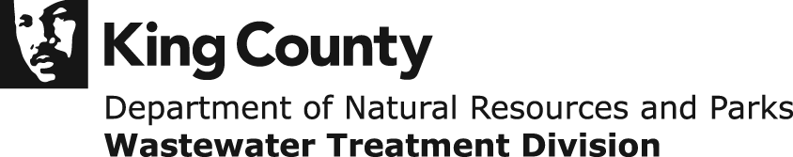

2012 Monthly Sewer Rate and Capacity Charge Overview

Funding Our Clean-Water Utility

April 21, 2011

Table of Contents Page

1. Introduction of the Executive’s 2012 Sewer Rate Proposal 1

2. Sewer Rate Management 2
Rate Stabilization
Cost Containment

3. Operations 3
Revenues
Expenses

4. Capital Improvement Program 4
Capital Spending
Capital Accomplishment Rate

5. Capital Revenues and Financing 7
Capacity Charge
Bonds and Interest Rates
Alternative Financing

6. Residential Customer Equivalents and New Connections 10

7. 2012 Rate Proposal Detail 11
Changes to the 2011-2012 Rate Forecast
Summary of 2012 Rate Projections and Assumptions

8. Comparison of 2011King County Rates with Comparable Agencies 14

1. Introduction of the Executive’s 2012 Monthly Sewer Rate Proposal

Through the King County Executive, the Wastewater Treatment Division (WTD)is transmitting to the County Council a proposed ordinance that will maintain the Wastewater Treatment Division (WTD) monthly sewer rate at $36.10 per residential customer equivalent (RCE) for a second year. Additionally, a monthly capacity charge of $51.95 for 2012, an increase of 3 percent from the current 2011 rate of $50.45 is proposed.

In this proposal, sewer rates in 2013 and 2014 are projected to remain at the levels consistent with the financial plan that was adopted with the 2011 sewer rate and budget. In support of this, WTD will identify operating efficiencies of over $4.7 million between 2012 and 2014. In addition, a significant amount of capital project program spending will be deferred for a number of projects through schedule modifications.

Two significant changes to the previous forecast resulted in upward pressure on rates, especially in 2013 and 2014. These changes include a reduction in interest earnings due to lower anticipated interest rates on wastewater financial reserves and an increase in capital expenditures on the Brightwater Project.

Spending on the Brightwater Project was increased mainly in recognition of issues in the performance of the original central tunnel contract of the conveyance system. As a result of this contract’s cancellation, the County filed a lawsuit to recover the cost of hiring a different contractor to complete the tunnel. The County's claims in the lawsuit will also encompass all costs across the project related to the late completion of the contract. The disputed amount is approximately $111 million. As the final amount and timing of a settlement is unknown at this time, these disputed costs are fully reflected in the spending projections.

In addition to the disputed costs of the tunnel contract, WTD has been negotiating with the Washington State Department of Revenue (DOR) on a refund for the manufacturing and equipment sales tax exemption on the biosolids and reclaimed water equipment. On February 25, 2011, the County reached an agreement with DOR and will receive a $9.55 million sales tax refund for the machinery and equipment used to produce biosolids. Previous cost estimates assumed a full refund of $41 million. The two actions concerning disputed costs together increase the capital spending projection by approximately $142.4 million.

If any reimbursement is received from pending litigation before 2014, WTD will re-evaluate the financial outlook with consideration of possibly reinstating the deferred capital projects.

This paper presents a discussion of the key factors considered in developing my 2012 rate and capacity charge proposal. It also discusses compliance with the financial policies adopted by the County Council and included in the King County Code (KCC), Section 28.86.160.

2. Sewer Rate Management

The level and pattern of changes in the monthly sewer rate can be managed in several ways. One of these is structuring debt service to affect the annual revenue requirements and therefore the sewer rate. For example, capitalizing portions of the interest from a bond sale can yield periods of relatively low debt service that is then “made-up” in subsequent periods. While useful for shaping the patterns of rate increases, many of these structures come with a significantly higher cost over time. Under my direction, beginning in 2011, WTD has adopted a more conservative financial approach in which the use of bond structures such as capitalized interest are not included in rate planning.

Two other means of managing sewer rates are the deferral of revenues through the use of a rate stabilization reserve and effective cost containment. Each of these is discussed in the following sections.

Rate Stabilization
A rate stabilization reserve allowing the deferral of operating revenues into a future year has been used to help manage rate patterns starting with the 2005 to 2006 sewer rates. The adopted 2011 rate and my current 2012 proposal assume that the rate stabilization reserve balance will be zero entering 2015. As shown in the table below, the rate stabilization reserve balance of $51 million at the end of 2010 is expected to increase by $17.4 million in 2011. Thereafter, the reserve will be drawn down by $26.4 million in 2012 and $21.0 million in 2013 and 2014. This pattern of rate stabilization usage maintains the utility’s required minimum debt service coverage ratio of 1.15.

Rate Stabilization Reserve, 2010-2014
($ in millions)
 | 2010 | 2011 | 2012 | 2013 | 2014
Beginning balance | 35.15 | 51.00 | 68.40 | 42.00 | 21.00
Additions | 15.85 | 17.40 | --- | --- | ---
Reductions | --- | --- | 26.40 | 21.00 | 21.00
Ending balance | 51.00 | 68.40 | 42.00 | 21.00 | 0.00

The further use of rate stabilization will need to be re-evaluated for 2015 and beyond as projected sewer rate increases are relatively small for that time period. This future period of relatively small projected rate increases reflects four major elements:

- Completion of the Brightwater Project with a return of the capital program to lower, long-term levels.
- The stabilization of debt service to level principal and interest payments.
- The growing importance of the capacity charge as a share of total revenues.

- A larger share of the capital program will be funded with transfers from the operating fund.

Cost Containment
While the rate stabilization reserve provides a means of managing rate increases by redistributing a portion of operating revenues, it is only one of the tools of rate management. Cost containment is the other key element. As in prior years, WTD scrutinized all planned capital and operating expenditures with the goal of making reductions while continuing to protect public health and the environment. The following sections provide further detail on the progress made in managing costs in the operating and capital programs of the WTD and how they affect my current rate proposal.

The financial plan projections reflect a capital program (non-Brightwater projects) restricted to the spending levels of the 2011 adopted budget. This requires the delay of over $100 million in capital spending during the 2011 to 2014 period and cancellation or indefinite delay of all new projects. Additionally, $4.7 million in operating reductions will be identified from 2012 to 2014.

The following sections provide further detail on the progress made in managing costs in the operating and capital programs of the WTD and how they affect the current proposal.

3. Operations

Revenues
Operating revenues are projected to be $382.9 million in 2012, an 11.9 percent increase over the 2011 budget of $342.1 million. Most of this increase results from a larger draw on the rate stabilization reserve than was anticipated in the 2011 budget. As seen in the table below, most revenue categories will increase but the effect of recognizing $26.4 million of the rate stabilization reserve as revenue in 2012 accounts for 82 percent of the total increase, compared to the 2011 adopted budget.

Revisions to the RCE forecast for 2011 results in additional customer charges (sewer rate revenue) of $7.8 million.

Expenses
Operating expenses were budgeted for 2011 at $111.1 million. This is a 6.2 percent increase over 2010 actual expenses. For 2012, operating expenses are expected to be $116.3 million, an increase of $5.2 million or 4.7 percent over the 2011 budget. About $3.3 million or 63 percent of this increase is because 2012 will be the first full year of operation of the Brightwater Treatment Plant.

Other changes include a projected increase in the local hazardous waste fee; increases in costs for diesel, electricity and chemicals at our treatment plants; and higher than projected increases in costs for employee benefits. Cost increases will be mitigated by operating Brightwater with no additional staff.

As noted earlier, the current outlook for 2013 and 2014 requires the commitment of WTD to future operating efficiencies of $4.7 million by 2014. A detailed plan for $1.5 million of operating efficiencies in 2012 will be included in WTD’s 2012 budget submittal in June. These assumed efficiencies are included in the financial plan submitted with this proposal.

- Capital Improvement Program

Capital Spending
In contrast to the recent past, WTD capital spending levels will be returning to more typical long-run levels in 2011 as the Brightwater Project approaches completion. Reflecting this, total capital spending is estimated at $278.7 million in 2011 and $137.4 million in 2012. After 2012, spending is projected to increase moderately, reaching $146.9 million in 2013, $130 million in 2014, and $144.5 million in 2015. The planned spending in these years shows a substantial decrease from the peak of capital program spending of $455.5 million in 2009 and $400 million in 2010.

WTD has continued to exert effective control on capital expenditures during the period of maximum impact from the Brightwater Project. In the process of defining capital priorities for the 2012 capital budget, WTD critically reviewed project scopes, schedules, cash flow projections, and risk analyses to assist in identifying project delays and cancellations that will keep spending for non-Brightwater projects at the level of the 2011 adopted budget. Key criteria for assessing the risk of delay include ensuring the continued operation and reliability of existing wastewater conveyance and treatment assets; enhancing regional water quality in compliance with federal, state and local regulations pertaining to providing secondary treatment; reducing combined sewer overflow events; and continuing to create resources from wastewater.

In order to achieve future rate goals, the capital spending for non-Brightwater projects, as a whole, has been maintained at the 2011 adopted budget level. This requires increases in some projects to be offset by proposed deferrals and changes to others. In addition, no new project requests were added to the program. Proposed new projects as a whole totaled approximately $91 million in additional spending.

Select projects identified for significant delays to maintain 2011 adopted budget levels of spending include the following:

- The Fremont Siphon Project will be re-phased to provide an 18-month pause after 30 percent design. This defers approximately $10.2 million in spending during 2011 to 2014. Currently, the siphon is functioning properly; however, the delay increases the risk of siphon failure before construction is complete at end of 2018.

- Replacement of the North Creek Interceptor will be delayed for two years resulting in a deferral of approximately $15 million in spending between 2011 and 2014. WTD will increase inspection of the interceptor during high flows to address and minimize the impacts of an overflow.

- The Sunset Heathfield Project as planned will increase the pumping capacity of the stations from 18 to as much as 31 million gallons per day and make improvements to the forcemains at Vasa Park. Delaying project activity by two years will move approximately $14.7 million in spending out of the 2011 to 2014 period. WTD will increase inspection of the facility during high flows to address and minimize the impacts of an overflow.

- The West Point Treatment Solids and Liquids Controls are obsolete with extreme maintenance challenges. Interim processors will be installed to maintain operation during design and construction. The project schedules will be modified to allow for implementation planning and sequencing development through 2013.

Design will occur in 2014 with implementation set for 2015. This will allow the deferral of approximately $2.3 million through 2014.

Key non-Brightwater projects showing significant increases in projected spending during the 2011-2014 timeframe compared to the 2011 adopted budget level of spending include:

- The Combined Sewer Overflow Projects at Magnolia, Barton and Murray have increased projected spending approximately 59 percent ($24 million) from 2011 to 2014, compared to the 2011 adopted budget. Overall, total project spending increased 13 percent ($13 million) as a result of engineering and cost estimate updates.

- The Influent Screening Project will construct the necessary modifications to the West Point Treatment Plant’s influent screening facilities to meet the requirements of new state biosolids management regulations. Updates to the pre-design cost estimate increased spending by approximately 36 percent ($9.2 million) between the 2011 and 2014 timeframe and total project cost increased 9 percent ($2.2 million) compared to the 2011 adopted budget.

- The Ballard Siphon Project will replace the existing wood-stave siphon barrels resting at the bottom of the Lake Washington Ship Canal that have reached the end of their useful lifespan. With the construction bid protest resolved on this project, the updated budget estimate shows an increase in spending of approximately 18 percent ($6.7 million) between 2011 and 2014 and total project cost increased 16 percent ($7.4 million) compared to the 2011 adopted budget. Additionally, over $30 million in State Revolving Fund low-interest loans have been secured for this project.

Capital Accomplishment Rate
Another important factor affecting the sewer rate and financing of the capital program relates to the accomplishment rate. The accomplishment rate is an estimate of cash needs

of the program and is arrived at by estimating the difference between planned capital spending in the budget and the capital spending that actually occurs. In this way, the program’s revenue requirements account for possible delays in the execution of the capital program that reduce spending and therefore cash needs. The accomplishment rate

is expressed as the percentage of the capital budget expected to actually be spent in a given year.

During the past five years, the average accomplishment rate for the entire capital program was 87 percent. During 2010, the actual accomplishment rate for Brightwater was 140 percent, due to additional spending from addressing issues in the central tunnel portion of the project. The accomplishment rate for non-Brightwater projects was 83 percent. Going forward, the accomplishment rate for Brightwater is projected at 95 percent in 2011 and 2012, with project completion at 100 percent in 2013. For non-Brightwater projects, the accomplishment rate is assumed to be 85 percent for the forecast period. These

accomplishment rate assumptions are unchanged from the 2011 adopted budget projections. Combining Brightwater and non-Brightwater projects in aggregate, the accomplishment rate for the entire program in 2012 is expected to be approximately 88 percent.

To further illustrate the relationship between the sewer rate and the accomplishment rate, if the aggregate accomplishment rate was lowered by 5 percentage points to 83 percent, estimated capital spending would be reduced by approximately $8.4 million or the equivalent of approximately $.07 of the sewer rate. Conversely, if the program accomplishment rate was raised to 100 percent, estimated capital spending would increase by $18 million, or the equivalent of approximately $.14 of the sewer rate. It is believed that 88 percent, reflecting the combined Brightwater and non-Brightwater projects is a prudent assumption in light of the continued strong performance relative to the capital budget in the Brightwater Project.

- Capital Revenues and Financing

Capacity Charge
The proposed capacity charge for 2012 is $51.95, a 3 percent increase from 2011. The capacity charge is a monthly charge (for 15 years) levied on new connections to the wastewater system in accordance with KCC 28.84.050 and KCC 28.86.160. It is set at a level to ensure that new sewer connections, over the long-term, will pay for the costs of the additional capacity required to serve them.

Financial Policy 15.3-d states that customer growth and projected costs, including inflation, shall be updated every three years. The 2011 capacity charge of $50.45 was the first year of the current three-year cycle. The 3 percent increase for the 2012 capacity charge sets the charge based on an assumed annual increase in the rate of inflation.

Bonds and Interest Rates
With Brightwater nearing completion and the capital program returning to pre-Brightwater levels, the need to issue new debt will also moderate. New issuances of parity bonds are projected at $50 million in 2012, $91 million in 2013, $86 in 2014, and $90 million in 2015.

In addition to parity bonds, current plans are for $78 million in wastewater variable rate

bonds in the fall of 2011, followed by a second variable rate bond issue of $70 million in late 2012. This will bring total wastewater treatment variable debt to approximately 15 percent of total long-term debt, which follows current policy for the use of variable debt.

WTD last issued long-term debt in January of 2011 in which an attractive interest rate of 4.9 percent was achieved. This compares favorably to the 5.25 percent forecast a year ago. However, it should be noted that the outlook for future interest rates remains uncertain. The financial plan accompanying this rate proposal assumes interest rates rising after 2011, reaching 5.5 percent in 2012, 5.65 percent in 2013, and 5.75 percent in 2014.

The greatest source of uncertainty for interest rates on municipal bonds stems from anxiety in the bond market over the difficult financial conditions faced by states and municipalities. Some experts believe there will be a record setting number of defaults on municipal bonds, perhaps as many as 50 to 100 with a total value of over $100 billion. Providing support to this view is that states such as California, Arizona, New Jersey, and Illinois have had to take drastic measures to balance their budgets. Illinois is in especially bad condition, with an estimated $7.6 billion general fund deficit fund balance at the end of 2009 and a $61 billion unfunded pension liability, and has been as much as six months behind on its current bills. However, it appears the financial industry, in general, thinks 50 to 100 defaults is far too pessimistic.

Balancing against the upward pressure on municipal bond rates is continuing weakness in the economic recovery in the United States and among industrialized nations generally. This outlook, which is incorporated in reduced investment earnings assumptions in my current 2012 sewer rate proposal, can also moderate rate increases on long-term bonds. The current bond rate assumptions are a conservative outlook based on this combination of upward and downward influences on future interest rates.

Investment interest rates have remained at historic lows in the market. The rate of return in the county investment pool was 1.76 percent in 2009 and 0.91 percent in 2010. For the rate forecast a year ago, investment interest rates were projected at 1 percent in 2010, 1.25 percent in 2011, 2 percent in 2012 and 3 percent in 2013. The projection for 2010 was very close, but the other years were considered to be too optimistic. For 2011, the earnings rate on investments is assumed to be 0.55 percent. Beyond 2011 and in accordance with the United States Office of Economic and Financial Analysis (OEFA) preliminary forecast (March 2011), the investment interest rates have been revised for this proposal to 0.55 percent in 2012 and 1.46 percent in 2013, before increasing to 2.49 percent in 2014. For 2011, this proposal assumes 0.55 percent as opposed to the OEFA forecast of 0.34 percent. Recent actual returns have been closer to 0.6 percent so the 0.34 percent was deemed to be too low.

Alternative Financing
This section highlights another element of cost containment achieved through WTD’s aggressive pursuit of low-cost financing for capital projects. As a result, some capital projects have been funded by grants or low-interest loans through the years. Collectively, these funds are referred to as alternative financing. Grants for capital projects tend to be funded by federal or state agencies and, for energy-related projects, local utilities. While the allowable use of these grants is often highly restricted, they have the obvious benefit of not having to be repaid in contrast to the low-interest loans. Grants received in the past assisted in the financing of upgrades to the South and West Point Treatment Plants, as
well as the Alki Transfer/CSO Facilities project and the Denny Way project.

Currently, the following projects are financed in whole or in part with grants:

- West Point Waste-to-Energy, Environmental Protection Agency Grant of $8,210,769
- West Point Pre-aeration Blowers, United States Department of Energy - Efficiency and Conservation Block Grant of $280,000
- Lower Duwamish Waterway, Washington State Department of Ecology Grant, of $697,500.

Low-interest loans are provided by the Washington State Department of Ecology’s State Revolving Fund (SRF) or the Washington State Public Works Trust Fund (PWTF). Loan applications to fund specific water quality projects are submitted by local jurisdictions statewide on an annual basis. These loan applications then go through a competitive process where the first step is ensuring that specific criteria and thresholds are met in order to proceed to the review process. They are then ranked on a point system. The point system is based on minimum and maximum points earned for narrative portions of the loan application in order to fund the highest priority water quality projects statewide.

Capital projects selected for loan application submittal go through a review process to ensure that they are competitive enough to be considered a high priority water quality project in the ranking process, to ensure that the project schedule fits within the loan criteria, and to ensure that the project meets specific criteria or thresholds. Projects that meet all of these are then eligible for the loan application stage. The grants administrator then coordinates with the project manager to ensure that the thresholds are met in time and takes the lead in writing and completing the application.

The table below presents some of the SRF loans and PWTF loans that have partially or entirely funded WTD capital projects in the past.

Past SRF and PWTF for WTD Loan Funded Capital Project
Project | Loan Amount | Loan Type | Term (Years) | Interest Rate | Estimated Debt Service Savings Compared to Conventional Financing
Brightwater Outfall | $16,015,812 | SRF | 20 | 2.6% | $11,768,158
Henderson/MLK CSO | 57,548,363 | SRF | 20 | 1.5% | 64,808,919
Denny Way CSO – Elliott W Pipelines | 12,549,757 | SRF | 20 | 1.5% | 14,133,090
Carnation WWTP | 14,085,238 | SRF | 20 | 3.1% | 14,125,717
Vashon WWTP | 5,000,000 | SRF | 20 | 1.5% | 3,931,091
North Creek Storage | 10,000,000 | PWTF | 20 | .5% | 10,395,533
Juanita Bay Pump Station | 10,000,000 | PWTF | 20 | .5% | 12,317,600
Brightwater Reclaimed Water Pipeline | 7,000,000 | PWTF | 20 | .5% | 8,603,773
Hidden Lake | 10,000,000 | PWTF | 20 | .5% | 11,987,946

The following table lists the current SRF loans that partially or entirely fund the indicated WTD capital projects. There are no current PWTF loans.

Current SRF for WTD Loan Funded Capital Project
Project | Loan Amount | Loan Type | Term (Years) | Interest Rate | Estimated Debt Service Savings Compared to Conventional Financing
Barton CSO Facilities Plan | $1,143,247 | SRF | 20 | 1.5% | $898,842
Murray CSO Facilities Plan | 593,435 | SRF | 20 | 1.5% | 466,569
North Beach Facilities Plan | 470,915 | SRF | 20 | 1.5% | 370,242
Ballard Siphon | 19,989,102 | SRF | 20 | 2.8% | 26,920,289

6. Residential Customer Equivalents and New Connections

The preliminary forecast prepared by the King County Office of Economic and Financial Analysis in early 2010, notes that while King County was late in being affected by the recession, more than 75,000 jobs had been lost since the middle of 2008. At that point, the regional job outlook, while serious, was not seen as dire as in many other parts of the country thanks to our relatively stable employment in the software and aerospace industries. State and regional forecasts anticipated a return to positive employment growth in 2010. However, available statistics for Seattle indicate 6,000 jobs lost from December 2009 to December 2010 and 2,600 were added to the unemployed status.

A preliminary estimate of the growth in the Gross Domestic Product for 2010 was a positive 2.9 percent. This compares to a 2.6 percent decrease in 2009. This growth, however, has not translated to a decrease in unemployment. Nationally, unemployment remains near 9 percent and is not much better in King County (about 8.4 percent at the end of 2010). High unemployment and decline in economic activity in general has continued to negatively impact both RCEs and new connections.

RCE projections have followed the evolving outlook for the regional economy. In 2010, there were 704,390 RCEs being served by WTD, an increase of 0.08 percent from 2009 levels. The current RCE forecast anticipates a 0.5 percent decline in 2011, no change for 2012 and 2013, and a 0.5 percent increase for 2014. Essentially, the customer base is expected to be flat for the next few years. Any increase in rate revenue will come from higher rates.

The table on the next page compares the current assumptions to those made for the 2011 budget. The current outlook is more positive, based in part on the stability of RCEs in 2010 relative to the impacts of the economic downturn.

Projected Residential Customer Equivalents (RCEs)

 | 2010 | 2011 | 2012 | 2013 | 2014
2012 Proposed Rate | 704,390 | 700,870 | 700,870 | 700,870 | 704,370
Percent Change | 0.08% | -0.50% | 0.00% | 0.00% | 0.50%
2011 Budget | 696,757 | 682,822 | 684,529 | 691,374 | 698,288
Percent Change | -1.00% | -2.00% | 0.25% | 1.00% | .50%
Change from 2011 Forecast | 7,633 | 18,048 | 16,341 | 9,496 | 6,082

New sewer connections to the regional system are levied a capacity charge to help pay for the cost of providing new capacity. New additions to the system tend to follow the residential and commercial construction cycle. For reference, during the 1998 to 2008 period, the number of new connections by year of connection averaged 11,200 per year with a peak of 12,700. Connections at the 2009 and 2010 capacity charges are estimated to be 6,500 in 2009 and 5,800 in 2010. The current forecast assumes that 2011 connections will be 5,800 and connections will not fully recover to the pre-recession average of 11,000 until after 2014.

Projected New Sewer Connections by Year of Connection

 | 2010 | 2011 | 2012 | 2013 | 2014
2012 Rate New Connections | 5,800 | 5,800 | 7,000 | 8,500 | 10,000
2011 Adopted Budget | 5,500 | 6,500 | 8,500 | 9,500 | 11,000
Change | 300 | -700 | -1,500 | -1,000 | -1,000

The outlook for new connections has been adjusted slightly from the numbers in the 2011 adopted budget. The budget assumed 6,500 new connections in 2011 while 5,800 are now expected. After 2010, lower numbers of new connections are expected each year through 2014 compared to the 2011 budget assumptions. This adjustment reflects the expectation of continuing weakness in the construction sector.

7. 2012 Rate Proposal Detail

Change to the 2011-2012 Rate Forecast
The following table summarizes changes to the rate forecast for the 2011 to 2012 rate period since the 2011 sewer rate was adopted in June 2010. The net impact of the changes is that use of the rate stabilization reserve during 2011 to 2012 will be reduced by $0.65 cents per RCE. The resulting $10.8 million increase in the reserve balance will be used to help keep the projected 2013 to 2014 sewer rate under $40.

Changes to the WTD 2011-12 Rate Forecast
2012 Proposed Rate Forecast Compared to the 2011 Adopted Rate Forecast

2011 Adopted Budget Rate Forecast |  | $36.10
Increase in Brightwater Project 2011 spending | $0.65
Impact of lower interest rates on investment income | 0.45
Lower capacity charge revenue forecast | 0.05
Lower operating expenditures | (0.05)
Higher RCE forecast | (0.60)
Lower interest rates on debt service | (1.15)
Total Changes |  | (0.65)
Reduced use of Rate Stabilization |  | 0.65
2012 Proposed Rate Forecast |  | $36.10

Two significant changes to the previous forecast put upward pressure on rates: an increase in capital expenditures on the Brightwater Project and a reduction in interest earnings due to lower anticipated interest rates on wastewater financial reserves. Two favorable changes, a higher RCE forecast and lower interest rates on debt service, more than compensated for the two negative impacts.

Summary of 2012 Rate Proposal Projections and Assumptions
The following table presents a summary of the general assumptions used in developing the 2012 rate proposal. Discussion of the various assumptions is included in the main body of the text in this report.

8. Comparison of 2011 King County Rates with Comparable Agencies

During 2010 and early 2011, WTD surveyed the retail wastewater rates of 25 jurisdictions around the country. These retail rates were compared to the weighted average retail rates charged by the 14 largest jurisdictions in King County that contract with King County for wastewater treatment services. These agencies provide service to 90 percent of all customers in the sewer service area.

The following charts present a comparison of 2011 retail rates for 25 agencies from various parts of the country to the weighted average for King County agencies. To approximate an average retail rate for King County, the rates of the largest 14 local component agency rates were weighted by the number of RCEs and an average was calculated. The resulting weighted average rate was $53.31 for the typical homeowner and $63.01 at the standard usage of 750 cubic feet per month.

In terms of typical monthly rates, King County ranks sixth among the surveyed agencies. The first chart shows the typical monthly sewer bill for each agency based on information from their websites. The agencies are in order of number of customers served, with the

City of Houston being the largest (2.8 million) at the left margin and the City of Portland, Oregon, the smallest (614,000) on the right margin. In the case of the typical monthly bill, King County’s weighted average ranks sixth. As the chart shows, rates vary widely for the 26 agencies from a high of $96.52 for Atlanta and a low of $6.56 for Memphis. Nine of the 26, including King County, fall within the range of $35 to $56 per month with an average of $39.98 for all agencies.

In terms of a hypothetical monthly bill assessed at monthly water consumption of 750 cubic feet, King County ranks third among the 25 agencies, reflecting higher sewer bills associated with greater than typical levels of water consumption. In this measure King County’s weighted average of $63.01 compares to the average of all agencies of $37.67 per month. These results illustrate a rate structure that encourages water conservation through higher sewer bills for increasing amounts of water consumption. The second chart shows the monthly bill that would be charged at the King County single family residence uniform usage of 750 cubic feet per month.

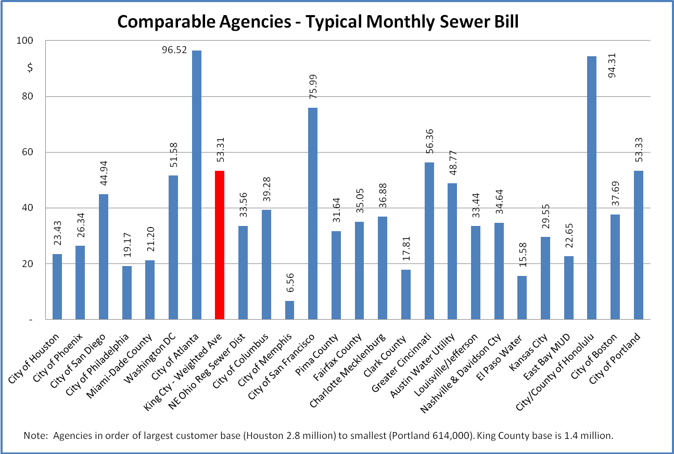

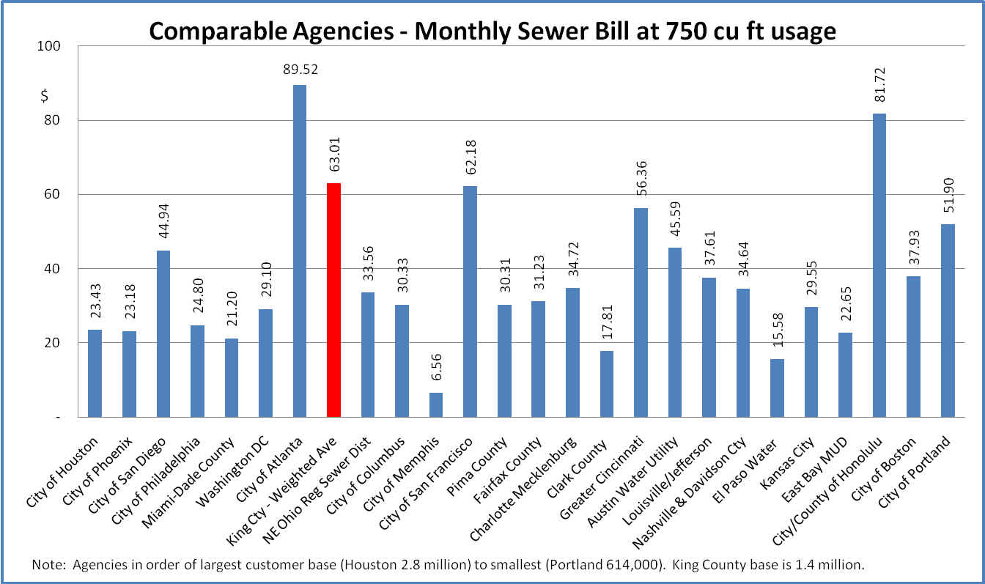

Source: 2009 State of Illinois Comprehensive Annual Financial Report.

