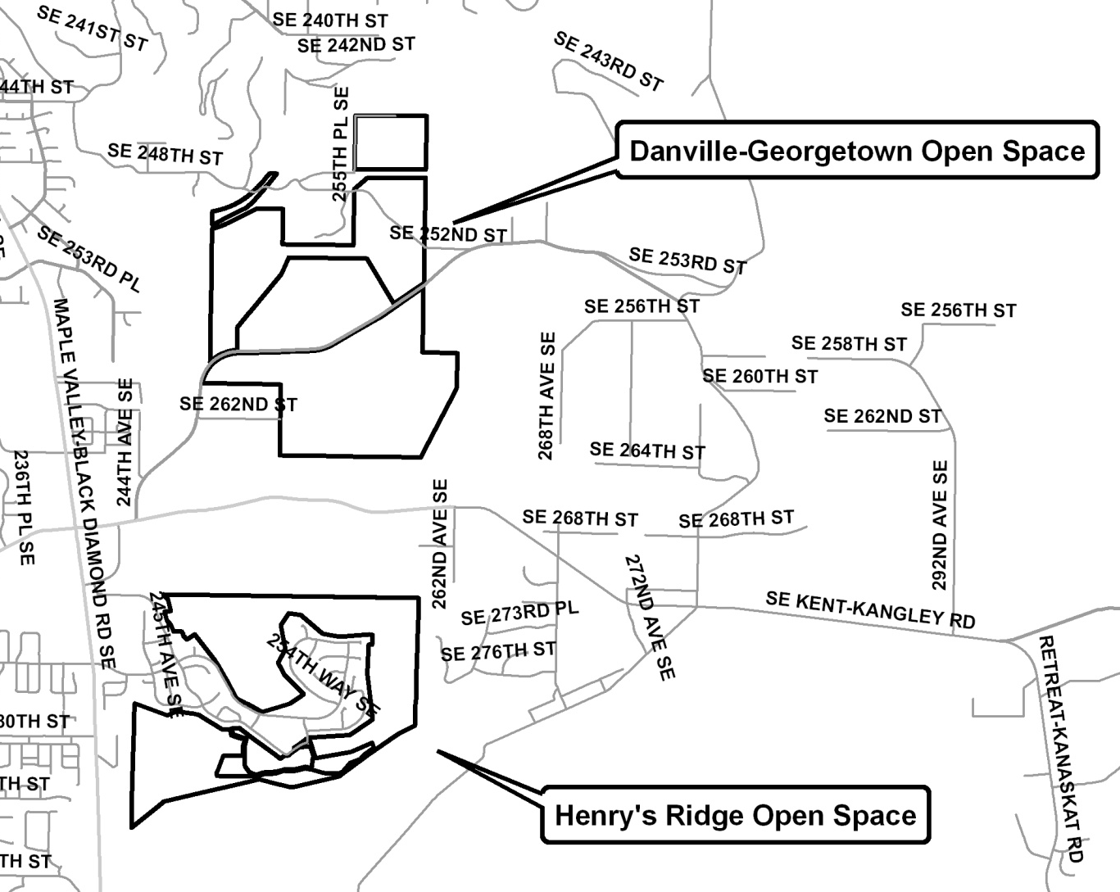
Maple Ridge Highlands Open Space Map with Proposed Changes

