When Recorded Mail To:

Seattle District U.S. Army Corps of Engineers
Regulatory Branch Mitigation Coordinator
4735 East Marginal Way South, Building 1202
Seattle, Washington 98134

DECLARATION OF LAND USE RESTRICTION
AND REAL PROPERTY COVENANT

Declarant: King County, a home rule charter county and political subdivision of the State of Washington

Beneficiary: State of Washington Department of Ecology and the United States Army Corps of Engineers.

Abbreviated Legal Description: Ptn of Govt Lt 2/NE ¼ Section 22, T23N,R05E; Ptn of Govt Lt 9/NW ¼ Section 23, T23N,R05E & Lt. 1 KCSP No. 1187005

Assessor’s Tax Parcel IDs: 222305-9134, 222305-9105, 232305-9088, 222305-9104, 232305-9097, 222305-9155, and 232305-9133.

This Declaration of Land Use Restriction and Real Property Covenant (the “Real Property Covenant”) is made this _____________ day of _________________, 2025 by King County, a home rule charter county and political subdivision of the State of Washington (“Declarant”), for the benefit of the State of Washington Department of Ecology and of the United States Army Corps of Engineers, referred to herein as “the Beneficiary”.

WHEREAS, the Declarant makes the following recitals:

A. Declarant is the sole owner in fee simple of the real property located in King County, Washington, legally described on Exhibit A (the “Property”) and depicted on Exhibit B, which are attached to and made a part of this Real Property Covenant.

B. The Property possesses natural, open space, and ecological, values that are of great importance to Declarant and the Beneficiary. These values are referred to herein as the “Conservation Values” of the Property.

C. The Declarant is creating a Real Property Covenant on this Property in accordance with the Elliott Bridge Reach Off-Channel Habitat and Floodplain Reconnection Project (“Mitigation Plan”), developed in compliance with United States Army Corps of Engineers Permit # NWS-2009-495. This Real Property Covenant is a condition of Permit # NWS-2009-495 that was issued to King County.

D. The Property also possesses opportunities to further enhance Conservation Values through future restoration activities that may include, but not be limited to, side channel construction, connections to Madsen Creek, bridge abutment removal, road reconfiguration, and levee removal or setback on or adjacent to the Property.

NOW, THEREFORE, in consideration of the above and the covenants, terms, conditions and restrictions contained herein, Declarant, does hereby establish a Real Property Covenant on the Property as follows:

1. Declaration of Real Property Covenant

Declarant voluntarily establishes this Real Property Covenant in perpetuity over the Property, subject to the Permitted Exceptions attached as Exhibit C, on the terms and conditions set forth herein exclusively for the purpose of conserving the Conservation Values of the Property.

2. Purpose

It is the purpose of this Real Property Covenant to ensure that the Property will be retained forever in a natural, open space and scenic condition and to prevent any use of the Property that will impair or interfere with the Conservation Values of the Property. Declarant and the Beneficiary intend that this Real Property Covenant will confine the use of the Property to such activities as are consistent with the purpose of this Real Property Covenant.

3. Rights of the Beneficiary

To accomplish the purpose of this Real Property Covenant the following rights may be exercised by the Beneficiary:

(a) To preserve and protect the Conservation Values of the Property;

(b) To enter upon the Property at reasonable times in order to monitor Declarant’s compliance with and otherwise enforce the terms of this Real Property Covenant in accordance with Section 9; provided that, except in cases where the Beneficiary determines that immediate entry is required to prevent, terminate, or mitigate a violation of this Real Property Covenant, such entry shall be upon prior reasonable notice to Declarant;

(c) To conduct, with reasonable prior notice to Declarant, survey, site preparation, removal of invasive non-native vegetation, installation of native plants, and other activities associated with aquatic resource mitigation. Nothing herein shall be deemed to imply any obligation to perform such restoration activities; and

(d) To prevent any activity on or use of the Property that is inconsistent with the purpose of this Real Property Covenant and to require the restoration of such areas or features of the Property that may be damaged by any inconsistent activity or use, pursuant to the remedies set forth in Section 9.

4. Prohibited Uses

Any activity on or use of the Property inconsistent with the purpose of this Real Property Covenant is prohibited, with the exception of those construction and maintenance activities performed in accordance with the Mitigation Plan and subject to the Permitted Exception attached as Exhibit C. Without limiting the generality of the foregoing, the following activities and uses are expressly prohibited, except as permitted in Sections 3 and 5:

(a) Construction and Improvements. Excavation or placement or construction of any buildings, structures, or other improvements of any kind, including, without limitation, utilities, septic systems, communication lines, communication towers, storage tanks and pipelines.

(b) Paving and Road and Trail Construction. The paving or covering of any portion of the Property with concrete, asphalt, gravel, crushed rock, wood shavings or any other paving or surfacing material or the construction of a road or trail.

(c) Commercial Development. Any commercial or industrial use or activity on the Property, including, but not limited to, commercial recreational activities involving active recreation.

(d) Agricultural Activities. Any domestic animal grazing or agricultural activities of any kind; and application of biocides except when determined by the Beneficiary to be necessary for the eradication of invasive non-native plant species and such application is by the narrowest spectrum, least persistent material appropriate for the target species.

(e) Introduced Vegetation. The planting or introduction of non-native species of plants.

(f) Waste Disposal. The disposal, storage, or release of yard waste, hazardous substances, rubbish, garbage, debris, unregistered vehicles, abandoned equipment, parts thereof, or other unsightly or offensive waste or material on the Property. The term “release” shall mean any release, generation, treatment disposal, storage, dumping, burying, abandonment, or migration from off-site. The term “hazardous substances” as used in this Real Property Covenant shall mean any substances, materials, or wastes that are hazardous, toxic, dangerous, harmful or are designed as, or contain components that are, or are designated as, hazardous, toxic, dangerous, or harmful and/or which are subject to regulation as hazardous, toxic, dangerous or harmful or as a pollutant by any federal, state, or local law, regulation, statute, or ordinance, including, but not limited to, petroleum or any petroleum product.

(g) Active Recreation. Conducting or allowing activities, such as golf courses, ball fields, motocross, equestrian, campgrounds or any other activity involving individuals or the public or private clubs or associations engaging in organized active recreation.

(h) Hunting. Conducting or allowing hunting activities, including construction of blinds, camping areas, access trails, and any other hunting related activities.

(i) Signs. The placement of commercial signs, billboards, or other commercial advertising material on the Property. This clause does not apply to non-commercial signage, such as site rules or informational signs as posted by the Declarant.

(j) Mineral Development. The exploration for, or development and extraction of, any minerals or hydrocarbons.

(k) Vehicles. The operation of motorized vehicles except as part of any aquatic resource creation or maintenance activity.

(l) Division of Property. No division of the protected Property or transfer of a portion of the protected Property shall be permitted without prior approval from Beneficiary.

5. Reserved Rights

Declarant reserves to itself and to its members and their personal representatives, heirs, successors and assigns, any use of, or activity on, the Property that is not inconsistent with the purpose of the Real Property Covenant and that is not prohibited herein. Without limiting the generality of the foregoing, Declarant specifically reserves the following uses and activities:

(a) Maintenance, Monitoring and Emergencies. The right to undertake activities necessary to maintain and monitor the Conservation Values and protect public health, property improvements, or human safety, or which are actively required by and subject to compulsion of any governmental agency with authority to require such activity.

(b) Fence. With reasonable prior notice and approval from the Beneficiary, which will not be unreasonably withheld or delayed, the right to install and maintain fences around the Property, and the Beneficiary agrees not to remove or damage said fences.

(c) Road and Cul-de-Sac Relocation. The right, but not the obligation, to relocate 149th Ave SE and the associated cul-de-sac to increase habitat connectivity, provided that such removal or relocation provides values that are equal to or greater than the Conservation Values, and provided further, that removal or relocation activities occur after the performance period of the Mitigation Plan. 149th Ave SE or cul-de-sac relocation proposals shall require evaluation of effects on Conservation Values and permission from the Beneficiary, which permission shall not be unreasonably withheld. Any areas where Conservation Values are detrimentally impacted by such relocation activities will be restored or offset by Declarant. Declarant agrees to notify Beneficiary at least 90 days prior to relocation of 149th Ave SE or the associated cul-de-sac.

(d) Levee Removal or Setback Levee. The right, but not the obligation, to remove the existing levee, or to construct a levee setback project on the Property, provided that such removal or project provides values that are equal to or greater than the Conservation Values, and provided further, that removal or project activities occur after the performance period of the Mitigation Plan. Levee removal or setback levee proposals shall require evaluation of effects on Conservation Values and permission from the Beneficiary, which permission shall not be unreasonably withheld. A levee removal or setback project that results in mitigation project footprint areas becoming part of the active river channel are considered for the purposes of this Real Property Covenant to provide values equal to or greater than the Conservation Values. Any other areas where Conservation Values are detrimentally impacted by such removal or project activities will be restored or offset by Declarant. Declarant agrees to notify Beneficiary at least 90 days prior to levee removal or construction of a levee setback.

(e) Improvements to Hydrologic Connection. The right, but not the obligation, to increase connectivity with the Cedar River or Madsen Creek on the Property, provided that such connectivity provides values that are equal to or greater than the Conservation Values, and provided further, that connection activities occur after the performance period of the Mitigation Plan. Proposals to alter the Property to increase the connectivity with the Cedar River or Madsen Creek shall require evaluation of effects on Conservation Values and permission from the Beneficiary, which permission shall not be unreasonably withheld. A project that results in portions of the Property becoming part of the active river channel are considered for the purposes of this Real Property Covenant to provide values equal to or greater than the Conservation Values. Any areas where Conservation Values are detrimentally impacted by such project activities will be restored or offset by Declarant. Declarant agrees to notify Beneficiary at least 90 days prior to connectivity project.

6. Responsibilities of Declarant Not Affected.

Other than as specified herein, this Real Property Covenant is not intended to impose any legal or other responsibility on the Beneficiary, or in any way to affect any existing obligation of the Declarant as owner of the Property. This shall apply to:

(a) Taxes. Declarant shall continue to be solely responsible for payment of all taxes and assessments levied against the Property.

(b) Upkeep and Maintenance, Costs, Legal Requirements, and Liabilities. Declarant retains all responsibilities and shall bear all costs and liabilities of any kind related to the ownership, operation, upkeep, and maintenance of the Property subject to the terms of the Mitigation Plan. Declarant remains solely responsible for obtaining any applicable governmental permits and approvals for any construction or other activity or use permitted by this Real Property Covenant and conducted by Declarant their agents or employees.

(c) Remediation. If, at any time, there occurs, or has occurred, a release in, on, or about the Property of any hazardous substances, Declarant agrees to take all steps necessary to assure its containment and remediation, including any cleanup that may be required. Should Declarant become aware of the release of any hazardous substances on the Property, Declarant shall make best efforts to inform the other of such release as soon as possible.

(d) Control. Nothing in this Real Property Covenant shall be construed as giving rise to any right or ability in Beneficiary to exercise physical or managerial control over the day-to-day operations of the Property, or any of Declarant’s activities on the Property, or otherwise to become an operator with respect to the Property within the meaning of the Comprehensive Environmental Response, Compensation, and Liability Act of 1980, as amended (“CERCLA”), or the Model Toxics Control Act, as amended (“MTCA”).

7. The Beneficiary’s Right to Restore the Property

In the event that any of the Conservation Values of the Property are impaired, the Beneficiary shall have the right, but not the obligation, to restore all or portions of the Property.

8. Access

No right of access by the general public to any portion of the Property is created by this Real Property Covenant.

9. Enforcement

The Beneficiary shall have the right to prevent and correct violations of the terms of this Real Property Covenant as set forth below.

(a) Notice of Failure. If the Beneficiary determines that the Declarant is in violation of the terms of this Real Property Covenant or that a violation is threatened, the Beneficiary shall give written notice to Declarant of such violation and demand corrective action sufficient to cure the violation and, where the violation involves injury to the Property resulting from any use or activity inconsistent with the purpose of this Real Property Covenant, to restore the portion of the Property so injured to its prior condition in accordance with a plan approved by the Beneficiary.

(b) Declarant’s Failure to Respond. In addition to the rights granted in Section 3, including the right of entry, the Beneficiary may bring an action as provided for in Section 9(c) below if Declarant fails to cure the violation within thirty (30) days after receipt of notice thereof from the Beneficiary; fails to begin curing such violation within the thirty (30) day period under circumstances where the violation cannot reasonably be cured within the thirty (30) day period; or fails to continue diligently to cure such violation until finally cured.

(c) The Beneficiary’s Action. The Beneficiary may bring action at law or in equity in a court of competent jurisdiction to enforce the terms of this Real Property Covenant, to enjoin the violation, ex parte as necessary and as allowed under the applicable civil rules, by temporary or permanent injunction, to recover any damages to which it may be entitled for violation of the terms of this Real Property Covenant or injury to any of the Conservation Values protected by this Real Property Covenant, including damages for the loss of the Conservation Values; and to require the restoration of the Property to the condition that existed prior to any such injury. Without limiting Declarant’s liability therefore, the Beneficiary, in its sole and absolute discretion, may apply any damages recovered to the cost of undertaking any corrective action on the Property. All such actions for injunctive relief may be taken without the Beneficiary being required to post bond or provide other security.

(d) Immediate Action Required. If the Beneficiary, in its sole and absolute discretion, determines that circumstances require immediate action to prevent or mitigate significant damage to the Conservation Values of the Property, The Beneficiary may pursue remedies under this Section 9 without prior notice to Declarant or without waiting for the period provided for cure to expire.

(e) Nature of Remedy. The rights under this Section 9 apply equally in the event of either actual or threatened violations of the terms of this Real Property Covenant. Declarant agrees that the remedies at law for any violation of the terms of this Real Property Covenant are inadequate and Beneficiary shall be entitled to the injunctive relief described in this Section 9 both prohibitive and mandatory, in addition to such other relief to which Beneficiary may be entitled, without the necessity of proving either actual damages or the inadequacy of otherwise available legal remedies. The remedies described in this Section 9 shall be cumulative and shall be in addition to all remedies now or hereafter existing at law or in equity.

(f) Costs of Enforcement. Provided the Beneficiary first provides Declarant with a Notice of Failure and Declarant fails to respond, all reasonable costs incurred by the Beneficiary in enforcing the terms of this Real Property Covenant against Declarant, including, without limitation, costs and expenses of suit and reasonable attorney’s fees and reasonable consultant’s fees, and any costs of restoration necessitated by Declarant’s violation of the terms of this Real Property Covenant shall be borne by Declarant. The substantially prevailing party in a judicial enforcement action regarding this Real Property Covenant shall be entitled to reimbursement of all reasonably incurred attorney’s fees and litigation expenses.

(g) The Beneficiary’s Discretion. Any forbearance by the Beneficiary to exercise rights under this Real Property Covenant in the event of any violation of any terms of this Real Property Covenant shall not be deemed or construed to be a waiver of such term or of any rights under this Real Property Covenant. No delay or omission by the Beneficiary in the exercise of any right or remedy shall impair such right or remedy or be construed as a waiver.

(h) Acts Beyond Declarant’s Control. Nothing contained in this Real Property Covenant shall be construed to entitle the Beneficiary to bring any action against Declarant to abate, correct, or restore any condition on the Property or to recover damages for any injury to or change in the Property resulting from causes beyond Declarant’s control, including, without limitation, fire, flood, storm, and earth movement, nor shall Declarant be required to take steps to abate or mitigate injury to the Property resulting from such causes.

10. Alternate Dispute Resolution

If a dispute arises between the parties concerning the consistency of any proposed use or activity with this Real Property Covenant, the parties shall attempt to resolve the dispute through informal discussion. The parties may also agree to refer the dispute to mediation and shall select a single mediator to hear the matter. Each party shall bear its own costs, including attorney’s fees, if mediation is pursued under this Section 10. The parties shall share equally the fees and expenses of the mediator.

11. Notice and Approval

(a) Notice. Whenever notice is required under this Real Property Covenant, the party required to give notice (“Notifying Party”) shall give reasonable written notice prior to the date the Notifying Party intends to undertake the use or activity in question. The notice shall describe the nature, scope, design, location, timetable, and any other material aspect of the proposed activity in sufficient detail to permit the other party to make an informed judgment as to its consistency with the purpose and terms of this Real Property Covenant.

(b) Evaluation of Proposed Activities. The purpose of requiring the Notifying Party to notify the other party prior to undertaking certain permitted uses and activities is to afford the other party an opportunity to ensure that the use or activity in question is designed and carried out in a manner consistent with the purpose and terms of this Real Property Covenant.

12. Notice of Transfer of Property by Declarant and Successor and Assigns

Anytime the Property itself, or any interest in it is transferred, or a legal claim is established by the Declarant to a third party, the Declarant, its successors and assigns, shall notify the Beneficiary in writing at least 60 days in advance of such action and the document of conveyance, transfer or establishment shall expressly refer to this Real Property Covenant.

13. Termination of Real Property Covenant

- Frustration of Purpose. This Real Property Covenant may only be terminated with the concurrence of the Beneficiary in the event the purpose for this covenant can no longer be fulfilled due to circumstances beyond the Declarant’s control but not to include a failure to enforce the terms of this restrictive covenant. In that event, concurrence with the termination of this Real Property Covenant must be received from the Shorelands and Environmental Assistance Program Manager of the State of Washington Department of Ecology and the District Engineer of the Seattle District of the U.S. Army Corps of Engineers.

(b) Economic Value. The fact that the Property may become greatly more economically valuable if it were used in a manner that is either expressly prohibited by this Real Property Covenant or inconsistent with the purpose of this Real Property Covenant, or that neighboring properties may in the future be put entirely to uses that would not be permitted hereunder, has been considered by the Declarant in granting this Real Property Covenant. It is the intent of both Declarant and the Beneficiary that any such change in the economic value of the Property from other use shall not be assumed to be circumstances justifying the termination or extinguishment of this Real Property Covenant pursuant to this section.

14. Modification

This Real Property Covenant may be amended only with the concurrence of the Beneficiary, provided that any such amendment shall be consistent with the purpose of the Real Property Covenant and shall not affect its perpetual duration. All amendments shall be in writing, approved by the Beneficiaries and recorded in the real property records of King County, Washington.

15. Interpretation

This Real Property Covenant shall be interpreted under the laws of Washington, resolving any ambiguities and questions of the validity of specific provisions so as to give maximum effect to its conservation purposes.

16. Perpetual Duration

This Real Property Covenant shall be a binding servitude running with the land in perpetuity.

17. Notices

Any notices required by this Real Property Covenant shall be in writing and shall be delivered personally, by first class mail, or electronically. Any notices delivered personally or by first class mail shall be sent to the following addresses unless the Notifying Party has been notified of a change of address. Any notices delivered electronically shall have a read receipt or delivery confirmation or both. The Notifying Party giving electronic notice shall bear the burden of proving when such notice was delivered.

To Declarant:
King County Department of Natural Resources and Parks
Attn: Mitigation Reserves Program
201 South Jackson Street, Suite 6300
Seattle, Washington 98134

To Beneficiary:

State of Washington Department of Ecology
Attn: Wetlands Section Manager
Shorelands and Environmental Assistance Program
P.O. Box 47600
Olympia, Washington 98504-7600

U.S. Army Corps of Engineers
Attn: Regulatory Branch Mitigation Coordinator
4735 East Marginal Way South, Building 1202
Seattle, Washington 98134

18. Severability

If any provision of this Real Property Covenant is found to be invalid, illegal or unenforceable, that finding shall not affect the validity, legality or enforceability of the remaining provisions.

19. Entire Agreement

This instrument sets forth the entire agreement of the parties with respect to the terms of this Agreement and supersedes all prior discussions, negotiations, understandings, or agreements relating to the terms of this Agreement, all of which merge herein.

In Witness Whereof, the Declarant has set its hands on the date first written above.

Declarant:

By:

Name:

Title:

STATE OF WASHINGTON | )
 | ) | ss
County of _________________ | )

On this ____ day of _________________, 2025, before me the undersigned, a Notary Public for the State of Washington, personally appeared ________________________________ who stated on oath that he or she is __________________________ and authorized to execute the within instrument on behalf of said King County and acknowledged said instrument as the free and voluntary act of the King County for the uses and purposes mentioned therein.

IN WITNESS WHEREOF, I have hereunto set my hand and affixed my official seal the day and year hereinabove first written.

______________________________
Notary Public for the State of Washington
Residing at__________________________
My Commission expires: ______________
EXHIBIT A

Legal Description

The following parcels of real property located in King County, Washington:

222305-9155:

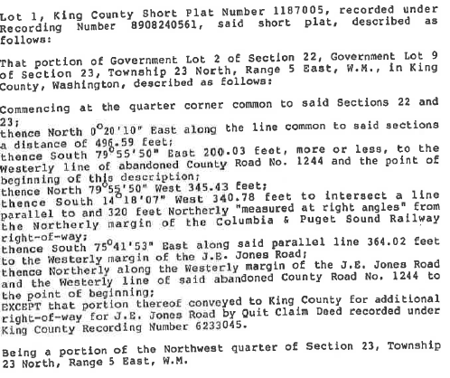

232305-9097 and 222305-9104:

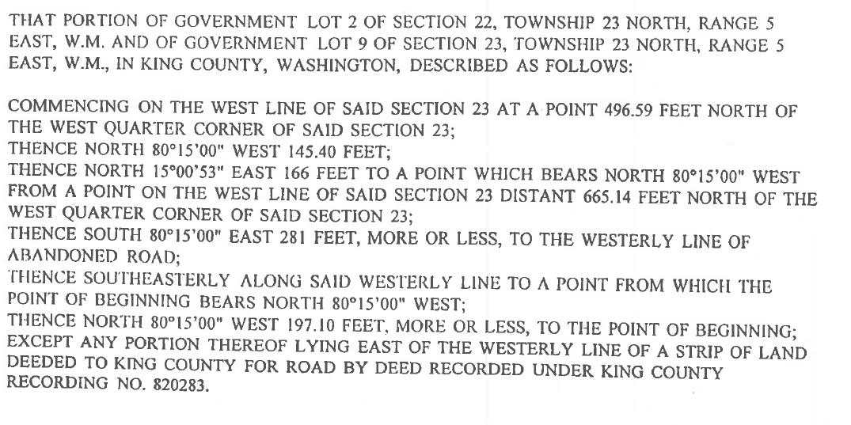

222304-9134, 222305-9105, and 232305-9088:
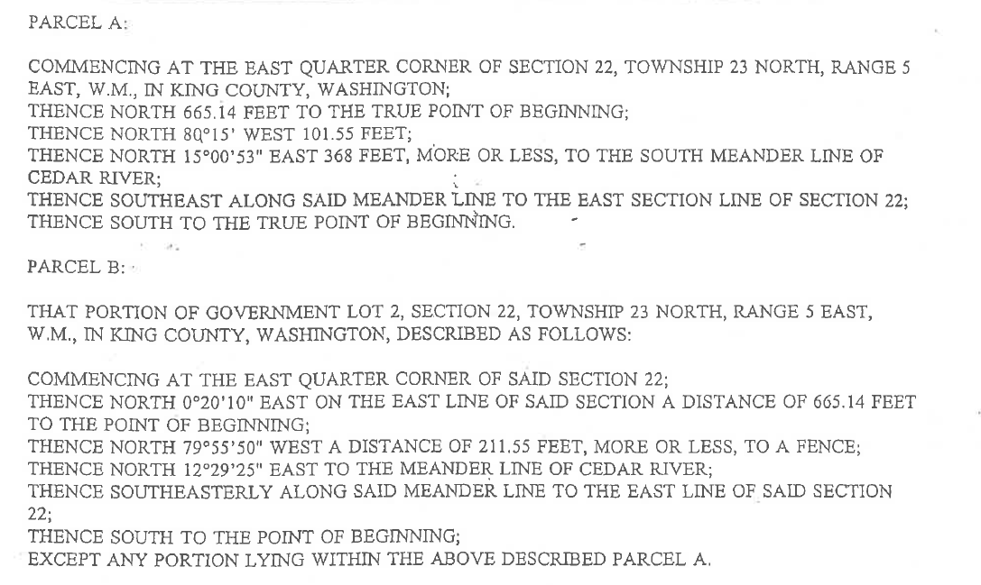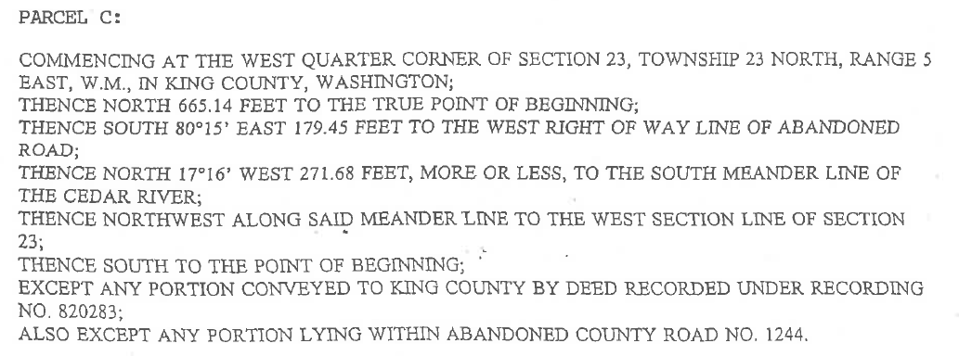

232305-9133:

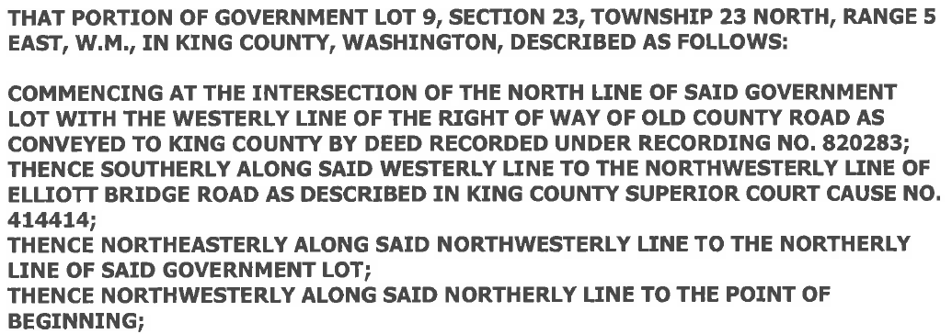

EXHIBIT B

Property Map

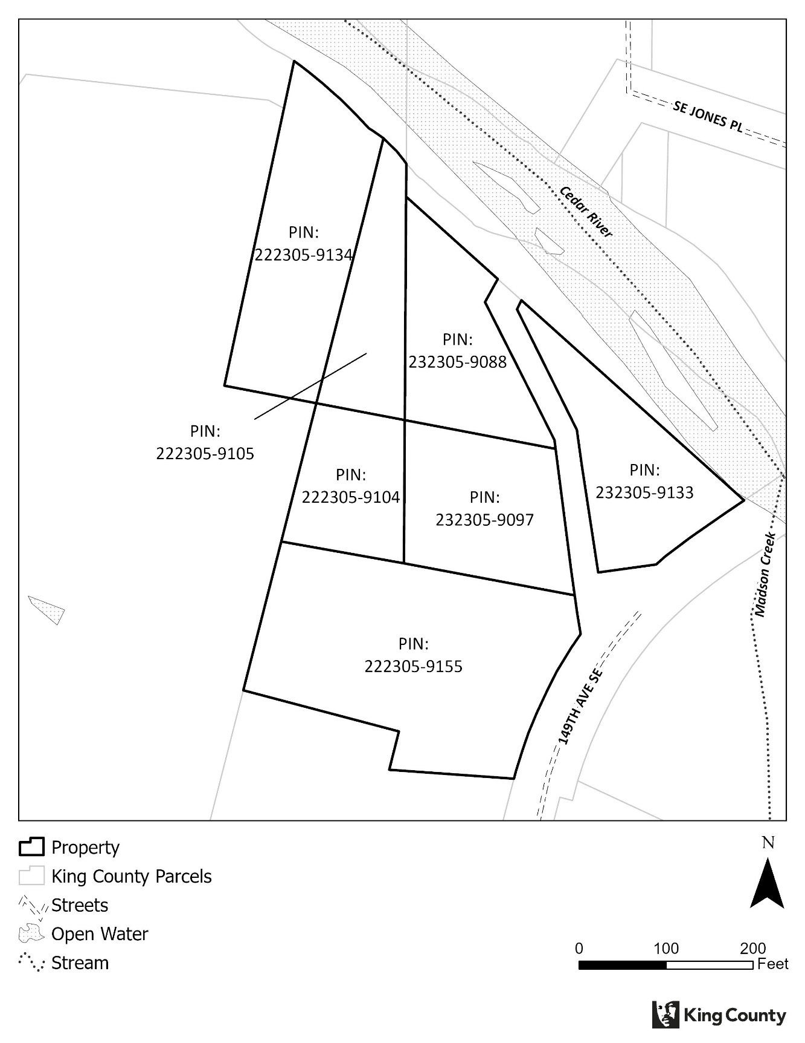

EXHIBIT C

Permitted Exceptions

- Easement for water use:
Grantee: Columbia & Puget Sound Railroad Company
Recorded: 1882
Recording No.: 839
Description: Perpetual right to the use of water from spring or stream. This easement affects parcels 232305-9097, 222305-9104, 222305-9105, 222305-9134, 232305-9133, and 232305-9088.

- Easement for road cuts and fills:
Grantee: King County
Recorded: 1950
Recording No.: 4006427
Description: In conjunction with the taking of a portion of the property for 149th Ave SE, the County acquired the right to construct cuts and fills outside the acquired right of way as necessary to protect the road from landslide hazards. This easement affects parcel 232305-9133.

- Easement for road cuts and fills:
Grantee: King County
Recorded: 1967
Recording No.: 6233045
Description: In conjunction with the taking of a portion of the property for 149th Ave SE, the County acquired the right to construct cuts and fills outside the acquired right of way as necessary to protect the road from landslide hazards. This easement affects parcel 222305-9155.

- Easement for road cuts and fills:
Grantee: King County
Recorded: 2003
Recording No.: 20031219001122
Description: In conjunction with the taking of a portion of the property for 149th Ave SE, the County acquired the right to construct cuts and fills outside the acquired right of way as necessary to protect the road from landslide hazards. This easement affects parcel 232305-9133.

- Easement for electric transmission lines:
Grantee: Puget Sound Power & Light Company
Recorded: 1990
Recording No.: 9010080265
Description: Power lines were removed during demolition. This easement affects parcel 222305-9155.

