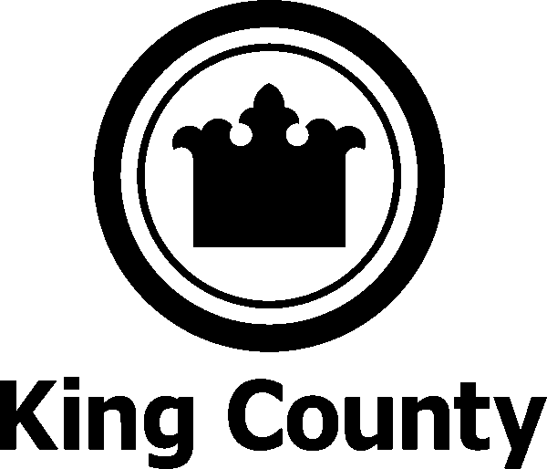

The Department of Adult and Juvenile Detention
Community Corrections Division

Background
- Spring of 2002 - the King County Executive, the Chair of the King County Council, the Presiding Judge of the Superior Court, the Presiding Judge of the District Court and the Prosecuting Attorney call for the implementation of a Community Corrections operation

- Working group headed by the Chief Deputy of the Prosecuting Attorney’s Office, submitted a plan to the Criminal Justice Council
  - Plan called for Community Corrections to continue Work and Education Release (WER) and Electronic Home Detention (EHD), consolidate offender work crews into the Community Work Program (CWP), and establish a Day Reporting Center

- CJ Council approved the plan and submitted it to the King County Council for approval
  - The working group was reconstituted as the CJ Implementation Group to oversee the implementation of the plan

- December 16, 2002 - County Council passed an Ordinance creating the Community Corrections Division

Community Corrections Programs and Services:
- Work-Education Release (WER) | - Re-licensing Programs
- Electronic Home Detention (EHD) | - Helping Hands Program (HHP)
- Intake Services Unit (ISU) | - Re-entry Programs
- Community Work Program (CWP) | - Learning Center
- Community Center for Alternative Programs (CCAP)

Community Corrections Partners include, but are not limited to:
 | - KC Superior Court | - The Public Defender’s Office
 | - KC District Court | - KC Department of Judicial Administration
 | - KC Prosecutor’s Office | - KC Department of Community and Human Services
 | - Defense Agencies | - United Way of King County
 | - County Council staff representing the Law, Justice and Human Services Committee

Community Corrections Program Service Providers include, but are not limited to:
- WA Learning Disabilities (Choices Life Skills Class) | - King County/Seattle Public Health (HIV/STD Class)
- S Seattle Community College (Life Skills-to-Work) | - Washington State Dept. of Social and Health Svcs.
- WorkSource | - Seattle Mental Health
- Family Services (Domestic Violence Education) | - King County Jobs Initiative
- Alcoholics Anonymous | - Community Psychiatric Clinic (CPC)
- Public Health (Smoking Cessation, etc.) | - People of Color Against Aids Network (POCAAN)
- Department of Community and Human Services |  | - Behavioral Investigations Incorporated

Community Corrections Court Process:
- Defendants are eligible either Pre-trial or Sentenced
- Court orders defendant directly into the program
- Court orders the conditions under which the defendant will participate
- Two orders are required to process a person into a program
- All referrals must be statutorily eligible for the program
- Defendant proceeds to court ordered program for intake

Mission
The Community Corrections Division (a division of the Department of Adult & Juvenile Detention) provides the court system as well as the offender with pretrial and sentenced alternatives to secure confinement aimed at reducing the jail population, decreasing the failure to appear rate, increasing the offender’s accountability, and reducing the offender’s rate of re-offense.

Electronic Home Detention
Electronic monitoring system that restricts pre-trial and sentenced offenders to their home, except to go to work, school, treatment, employment searches, medical appointments, and Court hearings.
- Participants wear electronic bracelet
- Participants pay intake and equipment fees (sliding scale)

Work and Education Release
An alcohol & drug free residential program where pre-trial and sentenced offenders go to work, school, conduct employment searches or treatment during the day and return to a secure building at night.
- Participants are monitored for drug & alcohol use
- Participants pay an intake fee and room and board (sliding scale)

Community Center for Alternative Programs
Based on a day reporting format, CCAP provides treatment, educational programs, and services to assist participants to change the behaviors that contribute to their frequent interaction with the criminal justice system.
- Participants are monitored for drug and alcohol use
- Participants receive a weekly itinerary of classes, treatment, and counseling they are required to attend
- Services are provided without cost to the participants

Community Work Program
A supervised manual labor program where sentenced individuals and re-licensing candidates are assigned to work crews throughout the county.
- Revenue backed program
- Provides visible restitution to the community
- Participants work off fines
- CWP contracts with municipalities and other government agencies to provide landscaping services
Clients/Contracts include:
- Lake Forest Park/Kenmore
- King County Department of Natural Resources and Parks
- White Center/Boulevard Park

Intake Services Unit
Provides information to assist the Court in their decision to detain, release, or place an individual in an alternative.
Other services include:
- Notification to defendants of their court date
- Facilitates release of individuals under Administrative Court Guidelines
- Court Liaisons are contacted by the Court, prosecutor’s office, public defense agencies, and others in the CJ System to resolve issues regarding confusing or discrepant Court paperwork.
This information is used to clarify information to release a defendant, raise bail, or to obtain documents necessary for the legal holding of a defendant.

Helping Hands Program
Assists persons court-ordered to perform community service find a site to complete their hours of service and monitors compliance for cases NOT supervised by the Washington State Department of Corrections (DOC). Helping Hands Program works closely with United Way of King County.
Community Corrections Division Contact Information

Administration
Barbara Deming - Program/Project Manager 296-3408
David Winger – Deputy Director 296-3600
Nate Caldwell - Director 296-3600
Ebony Romano – Assistant to Director 296-3600
Facsimile 205.0535

Corrections Programs
Corrections Program Administrator
Janis Dupuis 296-1260
WER/EHD - Supervisor
Ed Carter 296-1335
CCAP - Supervisor
Bernie Dennehy 296-1231
Helping Hands - Program Manager
Alyce Green 296-1199
Intake Services Unit - Supervisors
Shelley George @KCCF 205.2363
Chris Womack @ RJC 205.1370

