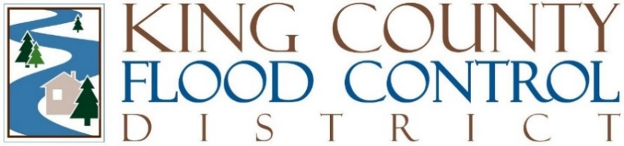

STAFF REPORT

Agenda Item: | 6 | Name: | Michelle Clark
Proposed Legislation: | FCD2024-03 | Date: | September 10, 2024

A RESOLUTION approving an Interlocal Agreement with the City of Seattle regarding the South Park Interim Flooding Preparedness and Response Program.

The Duwamish River, located in the City of Seattle, flooded the South Park neighborhood in December 2022, damaging local homes and businesses. The flooding was caused by a combination of factors including higher-than-average tides, rain runoff, and melting snow.

Before December 2022, the South Park neighborhood experienced previous flooding, as well as environmental and health damages due to historical inequities and industrial contamination. The South Park neighborhood is home to low-income, immigrant, refugee, and unsheltered people and is 74 percent people of color. Additionally, a significant portion of the 6,900 jobs in the South Park neighborhood are in the industrial area known as the Greater Duwamish MIC.

The King County Flood Control District (District) and the City of Seattle desire to create a South Park Interim Flooding Preparedness and Response Program (Project), and the City of Seattle has agreed to serve as the District's service provider for the Project.

The Board originally approved funding of $1,551,000 for the Project in Resolution FCD2023-06, the 2023 mid-year budget resolution. And increased the Project funding to $2,041,000 in Resolution FCD2023-10, the 2024 budget resolution.

Approval of this amendment is administrative and does not change the authorized Project budget. The amendment has been reviewed by legal counsel.

