STAFF REPORT

Agenda Item: | 12 | Name: | Mary Bourguignon
Proposed No.: | 2026-B0080 | Date: | June 16, 2026

SUBJECT

During today’s briefing, Metro staff will brief on transit funding needs as a preliminary response to a budget proviso.

SUMMARY

Metro’s long-range plan, Metro Connects, which was adopted in 2021, estimated a funding gap of $18 billion for transit capital investments and $724 million a year for service investments by 2050. Metro Connects indicated that additional funding would be necessary to achieve the planned transit service network.

Metro’s 2025 budget estimated that, due to expenditures outpacing revenues in the years following the pandemic, Metro would experience a $500 million shortfall in reserves by the 2028-2029 biennium.

Metro’s 2026-2027 budget estimated that, after significant cutbacks (including canceling the construction of South Annex Base, delaying the transition to a zero-emission fleet, reducing the scope of future RapidRide lines, and planning for a smaller bus fleet), Metro would face a $1 million reserve shortfall by 2030-2031 and a $755 million reserve shortfall by 2032-2033. This shortfall could require service cuts by 2030.

In response, the 2026-2027 budget asked Metro to prepare preliminary and final reports on its funding needs that would estimate projected reserve shortfalls, describe operating and capital funding needs, and identify possible funding sources to address Metro’s funding needs.

Metro staff will brief on its funding needs at today’s meeting as a preliminary response to the proviso request.
BACKGROUND

Metro Connects funding gap. Metro Connects, which was last updated in 2021, is Metro’s adopted vision for the future. It described future transit service through an Interim Network (mid-to-late 2030s) and a 2050 Network. For the 2050 Network, Metro Connects envisioned a transit system with:
- Seven million annual transit service hours, up from four million in 2019
- 200 million annual riders, up from 121 million in 2019
- 19-23 RapidRide lines, up from six in 2019
- $28.3 billion in associated capital improvements

Metro Connects, as adopted, was not fully funded. At the time it was adopted, Metro projected a funding gap of $18 billion for transit capital investments and $724 million a year for service investments to achieve the 2050 Network.

In 2022, at the Council’s request, Metro analyzed potential funding sources to implement Metro Connects, including those available through the King County Transportation District (KCTD), King County’s transportation benefit district. The KCTD Board has discussed Metro’s funding needs in the years since but has not taken action.

Metro’s reserve requirements. Metro currently depends on a dedicated 0.9% sales tax for nearly 60% of its operating revenues. Because of the volatility of the sales tax, the Council adopted fund management policies for Metro that:
- Set general financial practices, specifically the order in which Metro can spend:
  - Debt service
  - Operation of current transit system levels
  - Maintenance and replenishment of reserves
  - New transit service and capital investments
- Set requirements for financial planning, including:
  - Financial plan and cash flow projection of six years for all subfunds
  - Rolling 10-year capital improvement plan
- Set targets for farebox recovery
  - Should recover at least 10% of passenger related operating costs from farebox revenues for bus service
  - Target is 15% of passenger related operating costs from farebox revenues for bus service
- Set a fund structure with five subfunds and targets for reserve levels

Figure 1 below shows Metro’s five subfunds, as well as the interrelated requirements for reserves within the subfunds, specifically how the Operating Subfund and Revenue Stabilization Subfund have individual reserve requirements that combine to create an overarching Recession, Risk, and Cash Flow Reserve.

Figure 1. Metro Fund Structure and Reserve Requirements
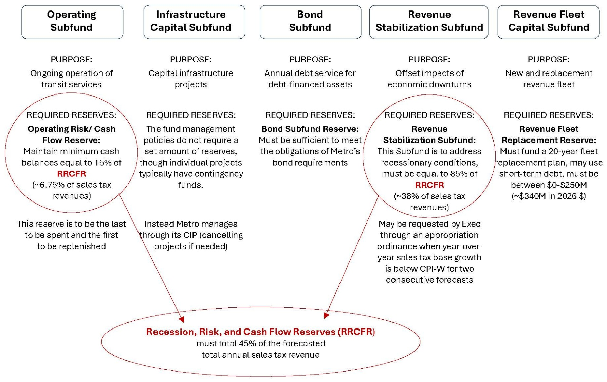

Projected reserve shortfall. Metro’s 2025 budget estimated that, due to expenditures outpacing revenues in the years following the pandemic, Metro would experience a $500 million shortfall in reserves by the 2028-2029 biennium.

Metro’s 2026-2027 budget of $3.9 billion combined operating and capital estimated that, after significant cutbacks (including canceling the construction of South Annex Base, delaying the transition to a zero-emission fleet, reducing the scope of future RapidRide lines, and planning for a smaller bus fleet), Metro would face a $1 million reserve shortfall by 2030-2031 and a $755 million reserve shortfall by 2032-2033. This shortfall could require service cuts by 2030.

Proviso request. In response to Metro’s upcoming estimated reserve shortfall, the Council included a proviso in the 2026-2027 budget asking Metro to prepare a preliminary and final Funding Needs Report to estimate its projected future reserve shortfalls, describe operating and capital funding needs, and identify possible funding sources that could be used to address Metro’s funding needs.

P7 PROVIDED FURTHER THAT:

Of this appropriation, $100,000 shall not be expended or encumbered until the executive transmits a ((preliminary and a final transit)) funding needs report and motion((s)) that should acknowledge receipt of the ((preliminary and final)) report((s)), and motions acknowledging receipt of the ((preliminary and final)) report((s)) are passed by the council. Each motion should reference the subject matter, the proviso's ordinance, ordinance section, and proviso number in both the title and body of the motion. The $100,000 shall not be released until((both motions are)) the motion is passed by the council.

The ((preliminary and final)) transit funding needs report((s)) shall include, but not be limited to:

A. An estimate of the Metro transit department's 2028-2029, 2030-2031, and 2032-2033 biennium total reserve levels, defined as the sum of the individual reserves and designations in the reserves category of the public transportation fund, which are expected to be below the level required in the King County comprehensive fund management policies adopted through Motion 15250 and the fund management policies for the public transportation fund adopted through Ordinance 19863, including, but not limited to, information on:

1. Potential impacts to the Metro transit department's operating budget, including, but not limited to, transit service, staffing, or operating procedures; and

2. Potential impacts to the Metro transit department's infrastructure capital fund or revenue fleet fund, including, but not limited to, reducing, reprioritizing, modifying, or delaying planned capital investments or planned fleet purchases;

B. A description of the Metro transit department's operational and capital funding needs, including, but not limited, to the funding needed to:

1. Provide transit service in accordance with the King County Metro Service Guidelines adopted through Ordinance 19367;

2. Strengthen the Metro transit department's operational capacity through efforts to recruit, train, and retain employees;

3. Implement the Metro Connects long-range plan adopted through Ordinance 19367;

4. Reduce greenhouse gas emissions through transit use and by continuing the transition to a zero-emission revenue bus fleet; and

5. Implement the recommendations of the King County regional transit safety task force in coordination with regional partners to ensure the safety and security of Metro transit department employees and passengers; and

C. A description of the possible funding sources that could be used to address the funding needs identified in subsection B. of this proviso, with annual estimates of the amount of revenue that could be generated, from King County, from the King County transportation district either through councilmanic or voter-approved funding sources, from debt financing, and from other sources.

The executive should give a briefing to the transit, economy, and environment committee or its successor by May 31, 2026. The executive should electronically file the ((preliminary report and motion required by this proviso by April 16, 2026, and the final)) report and motion required by this proviso by September 3, 2026, with the clerk of the council, who shall retain an electronic copy and provide an electronic copy to all councilmembers, the council chief of staff, and the lead staff for the transit, economy, and environment committee or its successor.

The original proviso requested two written reports. In the first budget omnibus ordinance, which is undergoing Council review as of this writing, the Executive proposed that the first report be replaced with a briefing to the TrEE Committee.

Today’s briefing will be Metro’s preliminary response to the proviso, with a report to be transmitted by September 3, 2026.

INVITED

- Jennifer Lehman, Enterprise Financial Planning & Analysis Lead, Metro Transit Department
- DeAnna Martin, Chief of Staff, Metro Transit Department
- Michelle Allison, General Manager, Metro Transit Department

ATTACHMENTS

- Metro transit funding needs presentation

Ordinance 20023, Section 116, Proviso P7, as proposed to be amended by Proposed Ordinance 2026-0071, Section 76, Proviso P7
Ordinance 19367, Attachment C
Motion 16155
Ordinance 19861
Ordinance 20023
Ordinance 19367, Attachment C (link)
Motion 16155
Ordinance 18321, as amended by Ordinances 19206, 19531, and 19863
These targets were reduced from 30% and 25% to 15% and 10% following the pandemic.
Ordinance 19861
Ordinance 20023
Ordinance 20023, Section 116, Proviso P7, as proposed to be amended by Proposed Ordinance 2026-0071, Section 76, Proviso P7
Proposed Ordinance 2026-0071

