Sale Property Summary
Photo of Property
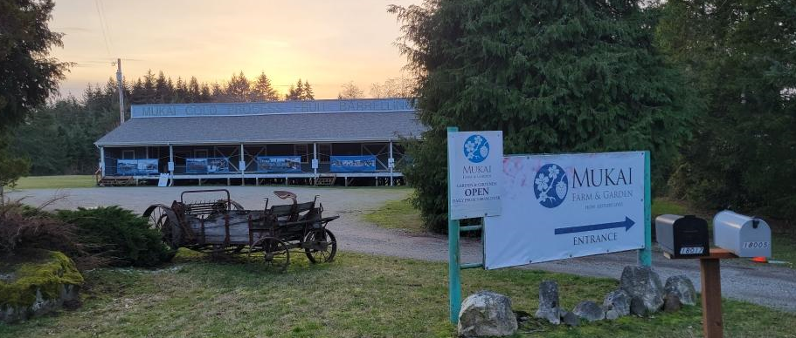
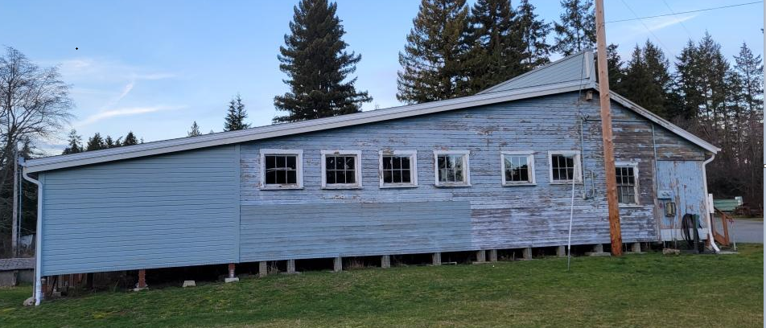

Address 18005 107th Ave SW, Vashon, Washington
Sale Price $0
Sale Area 2.05 Acres
Assessor's Parcel 312303-9044
Zoning RA5 Rural Area, one dwelling unit per 5 acres
Council District Eight
Funding Source Property was acquired in 2017 with funds from a grant from Washington State Department of Archaeology and Historic Preservation, contribution from Friends of Mukai (buyer) and a King County surplus sale on Vashon Island.
Declared Surplus January 5, 2023
Template Status: County template with no changes
Offer Expiration: Council action by October 1, 2024 to meet the timing requirements of the Purchase and Sale Agreement.

Property Information
The property, also known as the Mukai Fruit Barreling Plant, is one of two parcels that comprise the Mukai Agricultural Complex. The property was acquired in 2017 for purposes of preservation. The property is listed in National Register of Historic Places and is a designated King County Landmark. Built in 1926, together with adjacent Mukai House and Garden, it tells the story of Japanese American settlement and farming in the early 20th Century and the devastating effects of World War II and internment on the Japanese American Community. The buyer, Friends of Mukai, is a Washington nonprofit corporation dedicated to the preservation of the Mukai Agricultural Complex. King County and the buyer have worked closely for more than 10 years to secure and reunite both parcels for historic preservation purposes. A use agreement was established in 2018 for buyer’s use and rehabilitation of the property. The current use agreement between King County and buyer, Friends of Mukai, expires on November 19, 2024. The property includes a 6,400 sq. ft warehouse built in 1926 and a 435 sq. ft. office building built in 1946. The warehouse building is unoccupiable and pending completion of an estimated $2.5 million stabilization and rehabilitation project.

Context

Rationale for transaction: The property was acquired in 2017 with the intention for a long-term use agreement with Friends of Mukai. Friends of Mukai and King County Department of Natural Resources and Parks’ Parks and Recreation Division determined the property is better suited for ownership by Friends of Mukai, so it can take the lead on fundraising to stabilize, rehabilitate, and open the warehouse to the public for primary use as an interpretative center with a tangential agricultural-focused tenant.

Policy considerations : The property is no longer needed by King County. Transferring the property to an entity devoted to the preservation of the Mukai Agricultural Complex will achieve King County’s goal to preserve the Mukai Fruit Barreling Plant, which was the original purpose for acquiring the property. Per the Purchase and Sale Agreement, Friends of Mukai is required to continue to preserve and operate the Fruit Barreling Plant in accordance with the terms of the Deed of Right and Covenant to Use Land for Historic Preservation Purposes recorded in 2017. Failure to do so will result in title reversion back to King County.

Political considerations: Three King County Councilmembers participated in a site visit at the Mukai Farm and Garden on April 4, 2024.

Community considerations
or partnerships: The buyer, Friends of Mukai, owns the neighboring parcel, which is one of the two parcels that comprise the Mukai Agricultural Complex. It has been working to preserve and reunite the two parcels for many years.

Fiscal considerations: No net present value was provided as this is a zero-dollar sale to Friends of Mukai for historic preservation purposes. King County is responsible for paying approximately $1,407, which is half of the estimated closing costs.

Other considerations: N/A

CIP/operational impacts: N/A

Change in property use: There will be no change in use, however, the Fruit Barreling Plant is currently vacant and unoccupiable. If the transaction is enacted, the Friends of Mukai plan to complete the building rehabilitation and reopen it to the public as an interpretative center and local food hub.

SEPA Review Required yes/no: Yes, completed and determination of non-significance was issued.

King County Strategic Plan impact: N/A

Equity and Social Justice impact: In accordance with Real Property Asset Management Plan (RAMP) policy, the Facilities Management Division and Parks and Recreation Division reviewed this legislation for Equity and Social Justice (ESJ) impacts. This property is located on Vashon Island, the proposed buyer plans to rehabilitate the Fruit Barreling Plant and reopen it to the public. Preservation of this property by selling to the Friends of Mukai organization reflects King County’s commitment to telling the story of this chapter of its regional history. Built in the 1920s, the Mukai Agricultural Complex tells the story of Japanese American settlement and farming in the early 20th Century and the devastating effects of World War II and internment on the Japanese American Community.

Surplus Process
Interest from other county agencies? No
Property suitable for affordable housing? No
Property determined to be surplus? Yes

Marketing and Sale
Indicate whether the property was marketed or not, and if so, how it was marketed:
MLS
Commercial Broker
County Website (number of website views:_______________)
Social Media
Onsite Signage
Not Marketed – Property was acquired with the intention of transferring it to buyer.

Appraisal Process
Summary Click here to enter text.
Date of valuation: March 14, 2023
Appraised by: Kidder Mathews
Appraisal factors: A fair market as-is value was determined for the property.
Comps analysis: The sales comparison approach was used to determine the property’s land value, as if vacant for the highest and best use. However, the building improvements cannot be demolished due to the historic designation, therefore the current value is $0.
Estimated FMV: $0
Appraisal Summary Chart
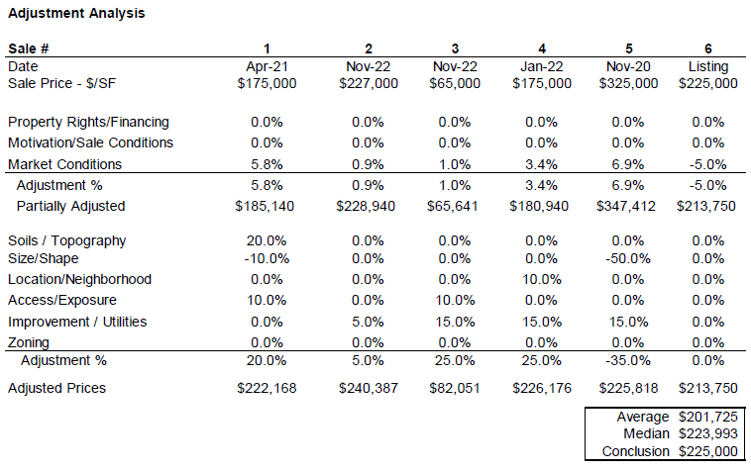

Vicinity View Map

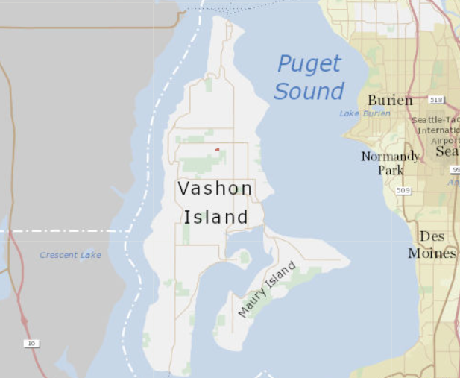

Parcel Map

