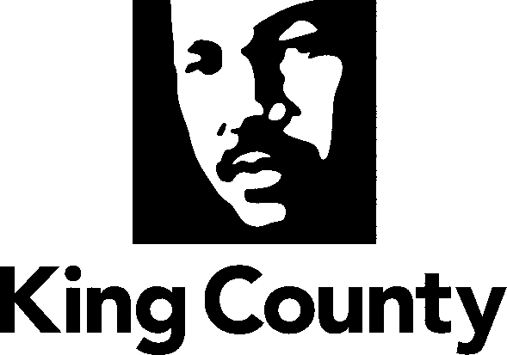

Metropolitan King County Council
Law, Justice, Health and Human Services Committee

Staff Report

Agenda Item No.: 5  Briefing No.: 2009-B0111 | Date: April 28, 2009  Prepared by: Kelli Carroll

SUBJECT

A review of the 2009 King County human services budgets.

PURPOSE

This report will provide committee members with information on King County’s 2009 human services budgets. Understanding the 2009 human budget impacts and implications builds a basis for the Council to consider its human service budget options during the upcoming 2010 budget process.

This report is the third in a series of structured monthly committee briefings focusing on the County’s human services, policies and budget. The purpose of these monthly briefings is to provide information that will assist the Council in developing policy direction regarding King County’s human services as the County works through the budget crisis for 2010 and beyond.

The following is an outline of the structured briefings currently planned for the committee. The briefings generally follow the committee’s work plan, but like the work plan, the briefings and/or dates may be changed. This table is intended to assist members in tracking the progress of the briefings and will be included in each subsequent staff report of this series.

February 24: Overview of King County Human Services (Completed)
March 24: King County Human Services Policies and Partners (Completed)
You are here→ April 28: 2009 County Budget: Impacts and Implications for 2010
May 20: Opportunities for Collaboration/Community Partner Input
State Budget Review
June 23: Options Development: Analysis of the County’s Evolving Role
July 28: Options Analysis: Review Preliminary Recommendations for Health and Human Services 2010 Budget Policy Options
August 25: Finalize Committee Recommendations for Health and Human Services 2010 Budget Policy Options

HUMAN SERVICE KEY FACTS

- King County provides human services for two reasons.

- Contractual Obligations: In some cases, the County has regional, contractual obligations with the State of Washington to engage in the planning and provision of publically funded services, such as mental health, substance abuse, veterans, and developmental disabilities.

- More effective and efficient “mandated” services: In other instances, the provision of human services helps the County meet state mandates for the provision of public health and criminal justice services in a more efficient and cost effective manner.

- Human services are defined as a group of wide ranging programs designed to assist the County’s most vulnerable citizens. The County’s human service areas range from services to older adults, to youth and family services, to housing and community development programs, and much more.

- King County’s human services are provided mainly through contracts with community-based agencies, many of which also receive support from other sources, including cities, state and federal and philanthropic sources.

- King County funded human services that were provided to over 583,000 families and individuals in 2007.
- The total 2009 human services budget, across all human service funds, is over $359 million. The King County general fund component of 2009 human service funding is $11.4 (3%). The County cut nearly 35% of its general fund out of human services in 2009. Another deep reduction of general fund to human services is anticipated for 2010.
- The foundational policy document that outlines the County’s role in human services is the adopted Framework Policies for Human Services. It states:
  - King County plays a leadership role in coordinating regional housing and human services systems. In concert with federal, state, and local governments, service providers, non-profit organizations, foundations, faith communities, businesses, schools, the criminal justice system and others, King County will seek to build and sustain a coordinated regional human services system to provide services, supports, safety and opportunity to those most in need.
- King County has lead responsibility for several regional human service systems, including mental health, substance abuse, veterans, and developmental disabilities.
- The County focuses human services efforts and funds in four key areas:
- Prevention and early intervention services
- Ending homelessness
- Criminal justice services as alternatives to incarceration
- Job training and employment services

KING COUNTY HUMAN SERVICES BUDGETS

- Department of Community and Human Services Budget Overview

- DCHS human service budgets total over $359 million for 2009, with nearly 330 full time equivalent positions (FTE).

- The 2009 County contribution of general fund to human services is $11.4 million, or about 3 percent of the total funding dedicated to human services.

- Funding to support King County’s various human services and programs comes from multiple sources, including the federal government, the state of Washington, King County, special human services levies and dedicated tax revenue, as well as public/private foundations.

- Table 1 below shows the 2009 adopted budget for each human service fund in DCHS, excluding the Office of the Public Defender. The table also shows the County general fund contribution and the percentage of general fund in each human service fund.

Table 1
2009 Human Services Adopted Budget and 2009 Human Services General Fund Percentage

Division/Program | 2009 Adopted Budget | 2009 General Fund | % General Fund 2009 | 2009 FTE
Community Services Operating | $ 8,430,739.00 | $ 4,636,906.45 | 55% | 19.5
Housing Opportunity | $ 24,544,727.00 | $ 568,703.00 | 2% | Incl. in FHCD
Mental Health | $ 164,570,449.00 | $ 1,635,420.00 | 1% | 95.25
Substance Abuse | $ 32,277,210.00 | $ 3,166,986.00 | 10% | 41.8
Director's Office | $ 2,284,377.00 | $ 286,269.00 | 13% | 15
Work Training | $ 6,302,458.00 | $ 1,115,096.00 | 18% | 40.78
Dislocated Workers | $ 3,020,399.00 | $ - | 0 | 17
Developmental Disabilities | $ 27,141,997.00 | $ - | 0 | 16.75
Federal Housing Community Dev | $ 19,228,871.00 | $ - | 0 | 36.5
Veterans Program | $ 2,577,648.00 | $ - | 0 | 8
Veterans and Families Levy | $ 9,231,515.00 | $ - | 0 | 12
Human Services Levy | $ 10,379,545.00 | $ - | 0 | 4.5
Mental Illness and Drug Dependency | $ 49,696,574.00 | $ - | 0 | 22.4
Total | $ 359,686,509.00 | $ 11,409,380.45 | 3% | 329.48

- The majority of the department’s funds are contracted to community-based agencies that provide services. According to the 2007 DCHS annual report, over 85 percent of all funds were contracted to community agencies, with eight percent supporting direct services provided by DCHS staff; and the remaining seven percent funded administration costs.

- 2009 County general fund comprises three percent of the total revenue supporting human services. By comparison to 2008, general fund was about five percent of the total human services revenue.

- 61 percent of revenue to human service funds comes from the State of Washington, with revenues from the federal government at eight percent. Other human services revenue sources include dedicated property tax, or “millage” to certain funds, sales tax and other support such a fund balance and interest earnings.

- General Fund Support of Human Services

- At three percent, County general fund comprises a proportionately small (and shrinking) amount of the total human services revenues.

- General fund support for human services provides flexible funds that allow programs to adapt to the changing needs and demographics of King County. The vast majority of DCHS budgets must be spent on specific programs, as required by funders.

- Only the County’s contract with the Department of Alcohol and Substance Abuse (DASA) requires matching local funds of 10 percent.

- Table 2 below shows the general fund allocation throughout DCHS funds as well as the percentage change in general fund allocation from 2008 to 2009.

Table 2
Human Services General Fund Allocation 2008 to 2009

Human Services Fund | 2008 General Fund | 2009 General Fund | Difference 2008-2009 General Fund | % Change to General Fund 2008-2009
Com Svs. Oper. | $ 9,753,904 | $ 4,636,906 | $ (5,116,998) | -52.5%
Work Training | $ 1,169,547 | $ 1,115,096 | $ (54,451) | -4.7%
Housing Opp. Fund | $ 785,657 | $ 568,703 | $ (216,954) | -27.6%
DCHS Director/Admin | $ 418,945 | $ 286,269 | $ (132,676) | -31.7%
Mental Health | $ 1,921,224 | $ 1,635,420 | $ (285,804) | -14.9%
Substance Abuse | $ 3,356,498 | $ 3,166,986 | $ (189,512) | -5.6%
Human Services General Fund Total | $ 17,532,227 | $ 11,409,380 | $ (6,122,847) | -34.9%

- Just over $6 million, or nearly 35 percent, of the general fund was cut to DCHS human services programs in the 2009 budget.

- Every area where general fund is allocated sustained 2009 general fund reductions.

- The County general fund flows into human service budgets in two ways, either as direct transfer from the general fund (mental health and substance abuse funds), or through the Children and Family Services Fund (CFS) where it is co-mingled with other revenues and then transferred again to other funds. Consequently, the percentage of general fund in the CFF changes each year. In 2009, general fund comprises 55 percent of the CFS transfer.

- Community Services Operating (CSO) division lost nearly 53 percent of its general fund contribution in 2009. The CSO program areas and services that were reduced in 2009 include:

- Adult day health and senior services
- Domestic violence survivor services
- Homeless prevention and emergency services
- Youth homeless shelters
- Sexual assault victim services
- Information and referral services
- Batterer’s treatment programs

Methodology of 2009 Human Services Reductions

- In March of 2008, County departments and agencies that primarily deliver discretionary services were asked to develop a three year reduction plan to completely phase out general fund for non mandatory services and programs.

- Attachment 1 is the three year reduction methodology that was developed and applied for the Community Services Operating (CSO) division 2009 reductions. Box 1 below summarizes the key points of the three year reduction plan.

Box 1
Executive’s 2009 Community Services Division (CSD)
General Fund Reduction Methodology

What are the CSD Funding Priorities?
- Preserve youth programs that defer entry into the criminal justice system and involve issues of social equity
- Prioritize those programs that meet department goals
- Preserve rural/unincorporated services as long as possible

What is the “philosophy” behind the CSD Reduction Proposal?
- Eliminate programs that don’t match the core business of the department
- Eliminate programs where primary responsibility could reside with local, state, or federal governments
- Eliminate programs not providing a direct service or providing only referrals to direct services
- Eliminate programs that in current form do not show clear success based on research/best practices

- The application of this methodology resulted in the reduction of $5.6 million from human services, or over 90 percent of the total $6.1 million cut from human services in 2009.

- Using this methodology, the reduction areas included the following programs or service areas:

  - Base Special Programs
  - Evaluation Programs
  - Programs in the Homelessness Prevention and Emergency services category, including food
  - Batterer’s Treatment
  - Women’s Advisory Board
  - Youth Homeless Shelters
  - Senior Centers serving primarily incorporated area residents
  - Senior Services-Adult Day Services
  - Information and Referral Projects
  - Various Work Training programs including digital bridge, youth case managers in Superior Court, miscellaneous youth work funds
  - Housing Opportunity Fund administration and dues
  - Federal Housing and Community Development homeless program planning work

- The implications of using this methodology for 2010 human service reductions are outlined in a subsequent section of this staff report.

Six Months General Fund Strategy: “Lifeboat”

- The adoption of the 2009 annual budget included budgeting certain general fund programs and services for six months. This approach, known as the “Lifeboat”, provides short term support for critical programs that cannot be sustained beyond July 1, 2009. Table 3 below summarizes the programs in the human services “Lifeboat”.

Table 3
Department of Community and Human Services "Lifeboat" Programs
Fund | Project/Program | Amount
Substance Abuse | Sobering and Detox | $ 44,559
Mental Health | Co Occurring Disorders | $ 240,233
Mental Health | Recovery Transformation Initiative | $ 103,603
Work Training | Digital Bridge Academy | $ 175,966
CSO Programs | Various Contracts and Staff | $ 1,565,420
DCHS Lifeboat Total |  | $2,129,781

- DCHS “Lifeboat” amounts are included in the 2009 adopted budget. The amounts in the “Lifeboat” do not necessarily reflect six months of funding.

- The Co-Occurring Disorders (COD) program provides integrated mental health and substance abuse treatment for clients referred from the County’s Drug and Mental Health Court and jail. The amount in the lifeboat also funds housing vouchers. The COD program is one example of human service programs that help mandated justice services operate more efficiently and effectively.

- The $1.5 million in “Lifeboat” reductions in the CSO are summarized in Table 4 below.

Table 4

Community Services Operating Division "Lifeboat" Reduction Program Areas
CSO Program Area | Amount
Batterers Treatment | $ 23,054
Domestic Violence Victim Services | $ 165,356
Employment/Job Training Services | $ 18,742
Homeless/Homeless Prevention | $ 280,187
Base Special Programs | $ 158,027
Region-wide Information & Referral | $ 209,745
Senior Services - Adult Day Health | $ 67,791
Senior Services - Senior Center | $ 141,436
Sexual Assault Victim Services | $ 109,507
Youth Homeless Shelters | $ 102,274
Women’s Advisory Board | $ 7,500
To be allocated from CSO base budget | $ 242,767
Six Month Budgeted Amount | $ 1,526,386

- If no additional funding is provided in 2010, the amounts of the DCHS “Lifeboat” will be annualized in 2010 and eliminated altogether.

Human Services General Fund Recent History: 2003 to the Present

- 2003: $1.8 million of general fund revenue previously supporting Cedar Hills and the North Rehab Facility is redirected to support for mental health and substance abuse treatment for those involved in the criminal justice system. Subsequent budgets to not discreetly track the $1.8 million revenue and it becomes part of the overall general fund support for human service programs. Council restored $268,000 of these programs in 2009; a portion of the programs funded with the reallocated general funds are in the 2009 “Lifeboat”.

- 2004: The County’s structural gap expands necessitating reductions, and potential elimination, of most human service programs supported by general funds. $7 million in rent from the Cedar Hills Solid Waste facility is paid to the general fund and is reallocated to support human service programs in the 2004 budget. Subsequent budgets do not track the $7 million general generated for human services by the Cedar Hills rent.

- Table 5 below shows the trend of general fund allocation to human services from 2005 to the present.

Table 5
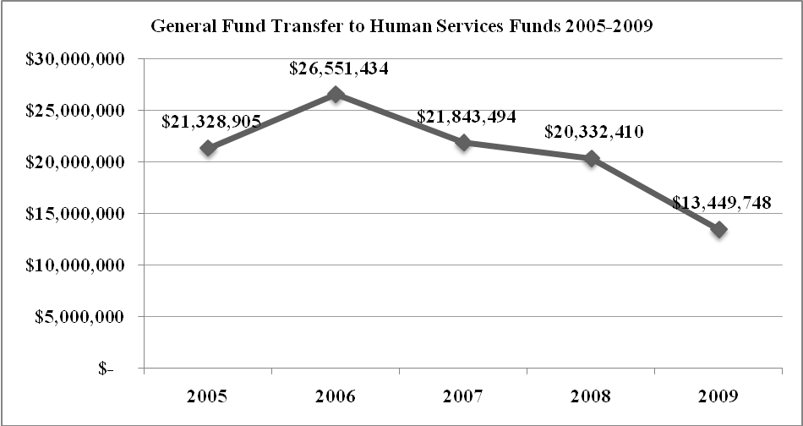

- Other Revenues Supporting Human Services

- The County relies primarily on revenue other than County general fund to support human services.

- The County has four dedicated funding streams to human services that together will provide an estimated $70.6 million to human services in 2009:

- The Children and Family Set Aside (CFSA) established in 1988, receives a portion (.046 percent) of sales tax revenue. Revenue from the County parking garage is also dedicated to the set aside. This revenue funds prevention and early intervention services for children and families in DCHS and Public Health. The 2009 revenue for that portion of the sales tax is estimated to be $3,875,000, with parking revenues at $603,531. These funds are budgeted in the CFS fund and then allocated to other funds.

- Dedicated property taxes or “millage” of $8.1 million set aside to support the County veterans (Vets), mental health (MH), and developmental disabilities (DD) services. 1.5 percent of the regular property tax levy is dedicated to MH and DD (50 percent each), with Vets dedicated funding at .67 percent of the regular levy. These funds are budgeted in the vets, MH, and DD funds.

- The Veterans and Human Services Levy (VHSL), passed by King County voters in 2005, generates approximately $13,300,000 per year ($0.05 per $1,000 assessed valuation) for six years. The collection period expires at the end of 2012. These funds are budgeted in the Levy funds and allocated to other health and human service funds.

- The Mental Illness and Drug Dependency (MIDD) sales tax, authorized by the King County Council in 2007, generates approximately$40-50 million per year through a one tenth of one percent sales tax. The collection period expires at the end of 2016. These funds are budgeted in the MIDD fund.

- Box 2 summarizes the dedicated human service revenue streams.

Box 2

Dedicated Human Service Revenues
 | Children and Family Set Aside | Property Tax Millage | Veterans and Human Services Levy | Mental Illness and Drug Dependency Sales Tax
2009 Estimated Revenue | $4,478,531 | $8,108,725 | $13,300,000 | $44,800,00
Collection Period | No sunset date | No sunset date | 2006-2012 | 2008-2016
Authorization | County Ordinance | RCW | Voter Approved | Councilmanic
Services Supported by Revenue | - Prevention and intervention services for children and families | - Veterans program services  - Mental health services  - Developmental disability services | - Housing assistance  - Mental health counseling  - Substance abuse prevention and treatment  - Employment assistance  - Capital facilities | 37 distinct service strategies include:  - Crisis diversion facility  - Mental health and chemical dependency treatment  - Crisis intervention training  - Re-entry from jail/hospital and hospital  - Housing supportive services

- As shown in Table 6, the County receives $330 million from non general fund sources to support human service programs. This revenue includes dedicated sales tax through the Children and Family Fund, dedicated property taxes or “millage” for mental health, veterans, and developmental disabilities, dedicated MIDD and VHSL tax revenues, and federal funds.

- Revenue from the State of Washington provides 61 percent of the total revenue for human services in King County at $210 million.

- The sales tax component is the next highest revenue for human services at 13 percent of the total or $44 million and reflects MIDD sales tax collections.

- The dedicated property tax component includes both millage and VHSL property tax revenue.

Table 6
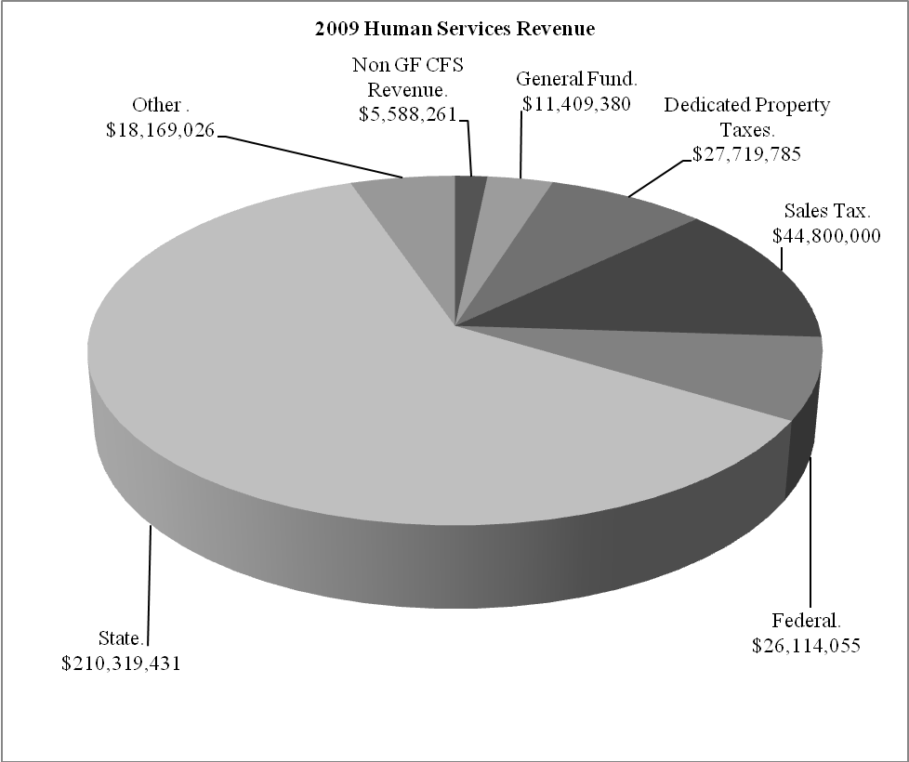

- Table 7 shows the percentage of each revenue source funding the whole of human services.

Table 7
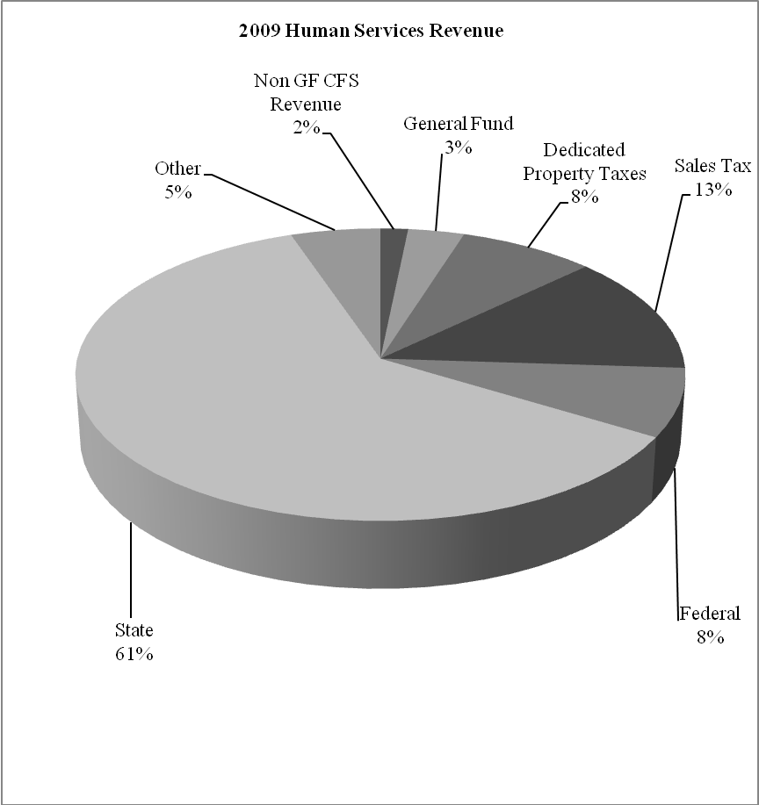

- Looking Ahead to 2010

- The Office of Management and Budget is projecting a $40-50 million general fund deficit in 2010.

- Without additional tools to address the deficit and structural gap, general fund allocated to human services will be reduced again in 2010.

- Table 8 below shows the range of potential general fund reductions to human service areas outlined in the CSO three year reduction methodology (Attachment 1).

- Table 8 includes the human service programs funded in the 2009 “Lifeboat” which will no longer be funded in 2010. It also reflects human service programs for jail diversion in Community Center for Alternative Programs (CCAP) that were restored with one time funds in 2009.

Table 8
Potential 2010 Human Service Reductions
Batter's Treatment | $ (23,054.00)
Domestic Violence Services | $ (751,058)
Sexual Assault Victim Services | $ (503,981)
Senior Centers in Unincorporated/Rural Areas | $ (200,000)
Work Training In School Youth Program | $ (30,000)
Housing Opportunity Projects, RAHP, ARCH | $ (311,787)
2009 Restoration of CCAP Housing Vouchers/Chemical Dependency Program | $ (268,542)
Total | $(3,346,266)

- 2009 Executive budget materials indicated that general fund reductions would occur through 2011, after such time general fund may entirely eliminated from human services.

- As of the writing of this staff report, the Washington State Legislature had not completed its session. Deep cuts are expected in many areas including mental health and substance abuse services. Implications of state cuts to human services will be reviewed at a subsequent Law, Justice, Health, and Human Services Committee meeting.

- The Legislature is expected to revise state law regarding use of MIDD revenues. Initially, MIDD revenue was required to be used on only new or expanded mental health, substance abuse, and therapeutic court programs along with housing that is provided as part of a coordinated system of care. The expected revision would allow the use of MIDD revenue to back fill or supplant lost revenue supporting “core” mental health, substance abuse, and therapeutic court programs. The Legislature would allow supplanting of MIDD funds for up to five years, using up to 50 percent of the revenue in year one of supplanting and reducing the supplanted amount by 10 percent for five years.

- Conclusion

- King County has four dedicated funding streams to human services, two of which are time limited. The total amount of these four revenues in 2009 is $70.6 million, or 20 percent of the total revenue supporting human service programs.

- General fund support to King County human services programs is reduced by 35 percent in 2009.

- For 2010, another series of deep reductions are anticipated from both King County and the State of Washington.

- Human service programs that are critical components of the justice system’s effort to reduce the growth of the justice costs provide and alternatives to incarceration were reduced in 2009 and are anticipated to be reduced further in 2010.

- Reductions to human services impact the County’s ability to maintain a regional role in human services by making it more challenging to ensure services to those most in need are provided.

NEXT BRIEFING

- Review State budget

- Options development process outlined

INVITED

Jackie Maclean Director, Department of Community and Human Services
Cindy West, Budget Supervisor, Office of Management and Budget

ATTACHMENTS

- Community Services Division Three Year General Fund Reduction Plan – 2009 Executive Budget Materials

This is a special meeting date scheduled due to the Memorial Day holiday on May 26th.
Department of Community of Human Services Annual Report 2007; may include duplicated numbers as some individuals and families may have accessed more than one service or program
Does not include Office of the Public Defender budget and staff
The Community Services Division changed its name in late 2008 to Community Services Operating Division, or CSO. See attachment 1 to staff report.
The method of allocating general fund changed in 2005. Instead of direct allocations of general fund to veterans, work training, housing opportunity fund and DCHS administration funds, general fund was transferred to the CFS fund as a lump sum and then transferred to the human specific human service funds.
The general fund totals in Table 5 include a portion of general fund allocated to Public Health included in the Children and Family Fund. The amount varies by year and is between $3 and $5 million.
The sales tax dedicated to the Children and Family Set Aside is included in the non-general fund CFS Revenue total.

