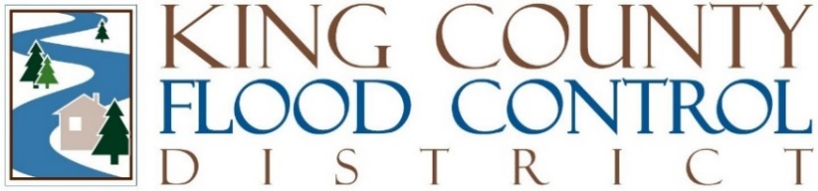

STAFF REPORT

Agenda Item: | 10 | Name: | Michelle Clark
Proposed Legislation: | FCD Briefing No: FCD2023-B05 | Date: | August 16, 2023

FCD Briefing No: FCD2023-B05: Home Elevation Program Proviso Report

The King County Flood Control District ("District") 2023 Budget directed King County to provide a report on King County's Home Elevation Program in order to understand the "unmet need" and identify potential programmatic changes to increase the pace of home elevations in King County. The report includes: (1) existing need based on the number of property owners that have contacted the county to execute a Phase 1 contract to elevate their home including the number of property owners that are placed on a waitlist because of program capacity issues; (2) innovative ways or changes to the program that will decrease the time a property is on the waitlist; (3) propose an acceptable time a property stays on the waitlist; (4) identify resources necessary to address the identified need in order of priority.

Background

Since the creation of King County's Home Elevation Program ("Program") in 1998, 81 high-flood-risk homes have been elevated – 30 funded by the District since its 2007 formation. The Program elevates high-flood-risk homes in the Snoqualmie Valley at least three feet above the 100-year flood elevation or one foot above the 500-year flood elevation, whichever is greater. While not an appropriate flood risk reduction strategy in all circumstances, home elevation is a cost-effective flood risk reduction strategy for the residents of the Snoqualmie Valley that are highly susceptible to flood damage.

Through the Program, owners of high-flood-risk homes receive limited technical and permit assistance and reimbursements for eligible expenses. The pace of a home elevation is dictated by the homeowner and typically takes three years from signing the Phase 1 Contract to completion of the home elevation. A home elevation project begins with the homeowner entering into a Phase 1 Contract with the County. This contract funds the pre-construction elements of a home elevation and allows for the reimbursement of eligible documented pre-construction costs up to 90-95% of $13,000. Upon completion of the Phase 1 Contract, a homeowner can decide to enter into the Phase 2 Contract that funds the construction or physical elevation of a home. The maximum reimbursement of eligible construction costs is the lowest of three construction bids or 90-95% of $238,655 minus the total Phase 1 reimbursement, whichever is lower.

Report

The number of homeowners that have indicated interest in the Program currently outpaces the rate of completed home elevations. Currently, there are five homes actively involved in the Program – two in Phase 1 and three that have completed pre-construction tasks. There are 36 homeowners on the waitlist. Having a home placed on the waitlist does not obligate a homeowner to enter into a Phase 1 contract with the County. Some homeowners remove themselves from the waitlist when offered a Phase 1 contract or even during the elevation process. It is likely that the "unmet need" is less than 36. Homes can stay on the waitlist for an average of over five years. King County administers five to eight home elevations at a time based on staff resources and Program implementation.

The following are the identified programmatic obstacles to home elevations:

- Participants are struggling to meet the Program requirement to obtain three construction bids due to limited contractor availability.
- Most homeowners elect to combine their home elevation project with non-reimbursable remodeling or other home improvements, which necessitates the production of one set of architectural plans for the project that is intended to be built and one set for the imaginary elevation-only project. Reviewing all of these documents and determining elements eligible for reimbursement is time consuming for staff and consultants.
- Some homeowners withdraw from the Program during or after Phase 1, which results in time and resources spent on unsuccessful projects while others wait.
- King County staff can manage only five to eight projects at a time due to the demands of their other duties.

The following are the identified innovative programmatic recommendations to increase the speed of home elevations and program efficiency:

- Remove requirement for multiple bids and cap reimbursements.
- Reduce the number of reimbursements to lessen administrative burden to homeowners and County staff.
- Limit participation to owner-occupied homes and only support one home elevation per homeowner.
- Increase staff resources to add program capacity.

The acceptable amount of time a home remains on the waitlist is difficult to determine as time on the waitlist is dependent on numerous factors, many of which are unpredictable, including homeowner interest, staff and contractor availability, permit review, homeowner directed pace of an elevations, and the pace of construction. The County proposes a reasonable goal of a completed home elevation four years after an homeowner has expressed interest in the Program. At triple the current rate of completion, it would take six years to substantially reduce the current waitlist of 36 homes. It would cost approximately $6.5 million to compete 30 projects over the next six years – approximately $1.1 million a year.

The County notes administrative changes have the potential to double existing Program capacity and recommends exploring their implementation as a first step to increasing Program capacity.

