Property Summary: Temporary Covenant Release and Reinstatement

Photo of Property

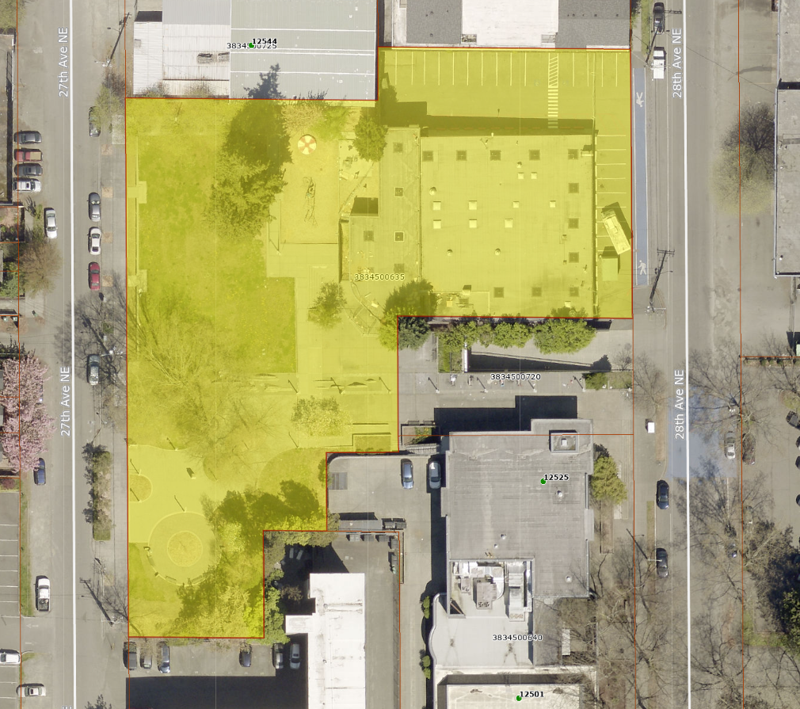

Address 12531 28th Avenue NE
Location Price N/A - $0.00
Location Area 58,774 sf
Assessor's Parcel 383450-0635
Zoning NC 3-75 and LR 3
Council District One
Funding Source N/A
Declared Surplus N/A
Template Status: N/A
Offer Expiration: Proposed Ordinance to be in effect by December 1, 2026.

Property Information
The property located at 12531 28th Avenue NE was conveyed by King County to the Lions Club in November 1953. The conveyance included a deed restriction, in the form of a covenant, requiring that the property be used solely for park and recreational purposes. In 1957, the property was transferred to the City of Seattle and served the neighborhood as the Lake City Community Center and Albert Davis Park. In 2023, a fire damaged a major portion of the building, and the Community Center was demolished. In 2025, the City of Seattle engaged with Mercy Housing to rebuild the Community Center on the street level along with approximately 113 units of housing on upper levels with an average affordability of less than 49 percent of the area median income (AMI).

Context
Rationale for transaction: In order for this affordable housing project to receive financing, King County has agreed to temporarily lift the Covenant from areas of the current parcel, depicted as parcel “X”, wait for the City of Seattle to complete a Lot Boundary Adjustment (LBA), and reinstate the covenant over Parcel “Y” of the proposed LBA. The reinstatement of the covenant document is in the form of Attachment B to this legislative package.

Picture 1: Current Covenant location (outlined in red), Parcel “X”.
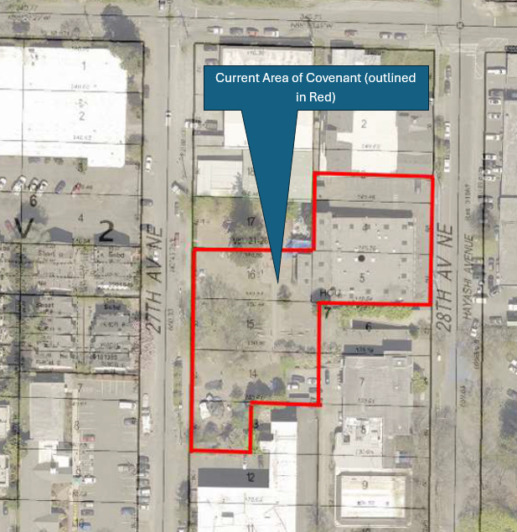

Picture 2:Proposed LBA creating Lots “Z” and “Y”
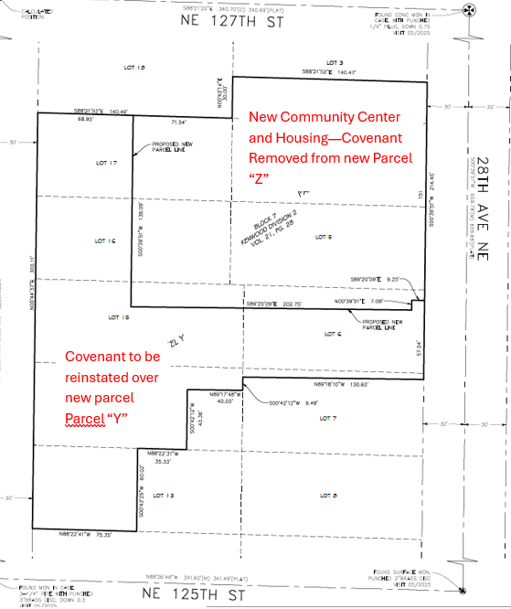

Policy considerations : Partnership and cooperation with the City of Seattle and Mercy Housing is needed to create 113 new units of affordable housing and a new community center, while still protecting the remaining property for open space and recreation consistent with the original 1953 deed restriction.

Political considerations: The City of Seattle has asked King County to complete the Release of Covenant and to approve the action and for the proposed Ordinance to be effective by December 1, 2026.

Community considerations
or partnerships: The City of Seattle has been engaging with the community.

Fiscal considerations: This transaction is a zero dollar transaction between King County and the City of Seattle. There are no anticipated fiscal impacts with this transaction.

Other considerations: None

CIP/operational impacts: None

Change in property use: Use will change on Parcel Z (depicted in picture 2) to allow affordable housing to be constructed above the newly-constructed community center. The Community Center will provide recreational opportunities for the community, consistent with the intent of the original Covenant. The covenant will be reinstated over parcel Y.

SEPA Review Required yes/no: No

King County Strategic Plan impact: N/A

Equity and Social Justice impact: In accordance with Real Property Asset Management Plan (RAMP) policies, FMD reviewed this legislation for Equity and Social Justice (ESJ) impacts. This location is in the Lake City neighborhood of Seattle. This action will allow for the rebuilding of the Lake City Community Center along with 113 planned units of affordable housing.

Surplus Process

Interest from other county agencies? No
Property suitable for affordable housing? N/A
Property determined to be surplus? N/A

Marketing and Sale

Indicate whether the property was marketed or not, and if so, how it was marketed:
MLS
Commercial Broker
County Website (number of website views:_______________)
Social Media
Onsite Signage
Not Marketed (briefly explain)

Vicinity View Map
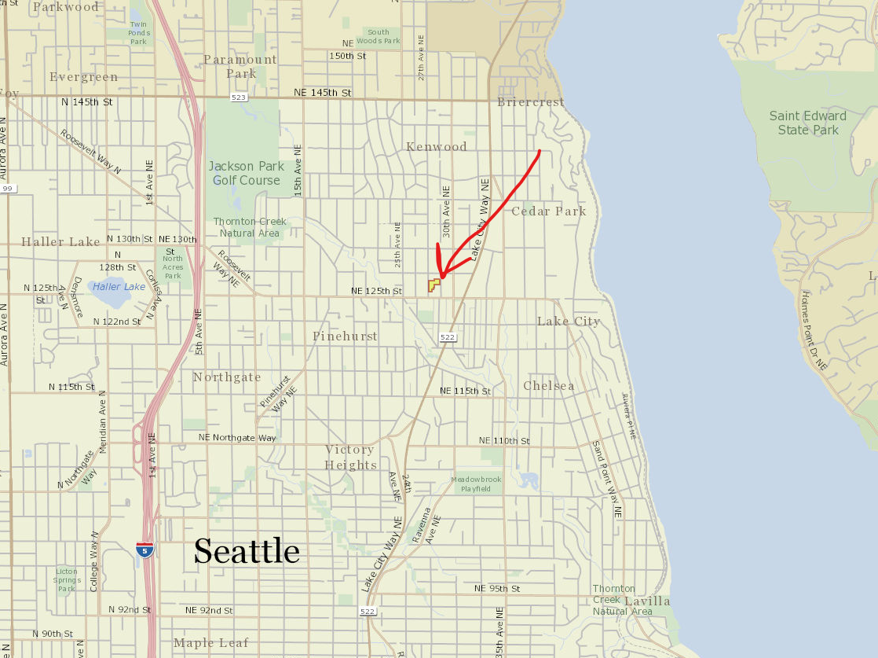

Parcel Map
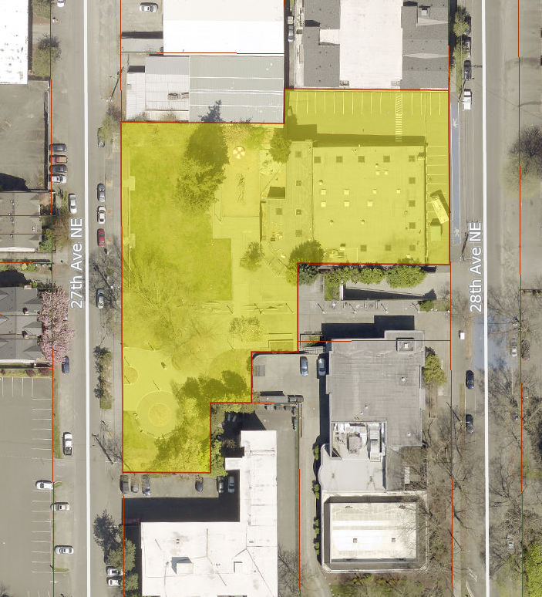

Lake City Community Center Redevelopment Project [LINK]

