

Metropolitan King County Council
Committee of the Whole

Staff Report

Agenda item No: 6  Motion No: 2010-0471 | Date: September 20, 2009  Prepared by: Wendy Soo Hoo

SUBJECT: Proposed Motion 2010-0471 would approve the Fifth Annual King County Health Reform Initiative Measurement and Evaluation Report for the 2009 reporting year.

SUMMARY:
The Health Reform Initiative is an employee benefits program to improve the long-term health of county employees and their families, while reducing the rate of growth in employee health benefit costs by one-third over the period 2005 through 2009. The fifth (and final) annual report describes performance of the program for its third full year of operation.

Key findings of the fifth annual report are that, since 2005, employees and their spouses/domestic partners have:

- Contributed to reduced growth in health care costs; cumulative healthcare costs for 2005 to 2009 were $26 million less than projected prior to implementation of the Health Reform Initiative. (Figure 2)
- Improved 12 out of 14 health risk factors, such as alcohol use and smoking. (Figure 4)
- Reduced health care utilization for key health conditions directly affected by changes in 3 of 5 risk factors. (Figure 5)

BACKGROUND:
In 2005, the Executive created the Health Reform Initiative as an approach to providing employee benefits for the 2007 to 2009 benefit period. Council has provided active oversight of this employee benefits program since its creation. In 2005, Council approved a business case for the Initiative with the goal of improving the long-term health of employees, while reducing the rate of growth in employee health benefit costs by one-third over the period 2005 through 2009 (Motion 12131), equating to $40 million in avoided costs. The initiative began in 2005 with five pilot programs and full program implementation began in January 2007.

In order for Council to provide oversight of the Health Reform Initiative, Council approved a motion requesting the Executive to transmit an annual measurement and evaluation report and an independent quality assurance review of the report by an external consultant for the life of the initiative (Motion 12479). Last year, 2009, was the last year in the formal evaluation period, so this year’s measurement and evaluation report is the last formal report on the initiative. Council has previously approved the annual reports for 2005, 2006, 2007 and 2009 (Motions 12353, 12597, 12851, and 13079).

ANALYSIS:
The following analysis describes the initiative in terms of four key measures: (1) financial analysis of healthcare costs; (2) change in self-reported health risk factors; (3) change in utilization of health care for conditions affected by behavior; and (4) change in healthy hours worked.

1. Financial Analysis

Figure 1 illustrates the three components of the Health Reform Initiative and their costs. At the center is the benefits plan design and employee health programs. The second component is the employee health education and work place wellness programs. The outer component is the Puget Sound Health Alliance which is an external non-profit organization charged with improving health and reducing health care costs in the region.

Figure 1
King County Health Reform Initiative
Contributions to Puget Sound Health Alliance PEPM*
2005 2006 2007 2008 2009 2010
$1.35 $5.48 $4.69 $3.27 $2.04 $0.97
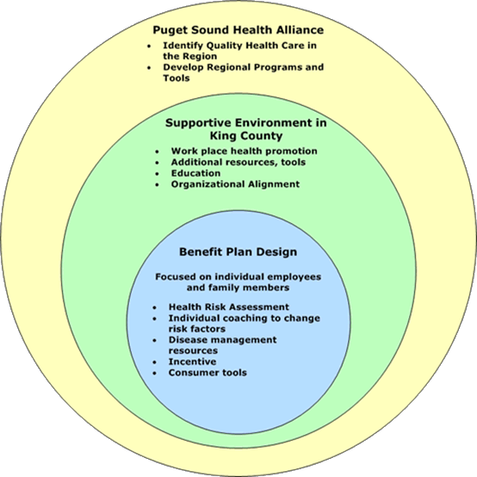

Supportive Environment PEPM*
2005 2006 2007 2008 2009 2010
$6.11 $5.34 $4.76 $4.40 $3.53 $2.89

Benefit Plan Design/Interventions PEPM*
2005 2006 2007 2008 2009 2010
$6.64 $17.25 $18.48 $17.03 $16.84 $13.82

Total PEPM*
2005 2006 2007 2008 2009 2010
$12.75 $22.59 $23.24 $21.43 $20.37 $16.71

*PEPM: Per employee-per month

Figure 1 shows that the costs of the Health Reform Initiative have declined since 2007. Since 2007 (the first year of full implementation), benefit plan and supportive environment costs have decreased by 28 percent – from $23.24 per employee-per month in 2007 to $16.71 in 2010. Meanwhile, King County’s financial support of the Puget Sound Health Alliance has decreased from a high of $5.48 per employee per month in 2006 to $0.97 per employee per month in 2009, a reduction of 82 percent.

Figure 2 shows that the rate of growth in employee health benefits costs has also decreased since 2005. Prior to implementation of the Health Reform Initiative, the annual rate of growth in claims costs was 10.8 percent.

Figure 2
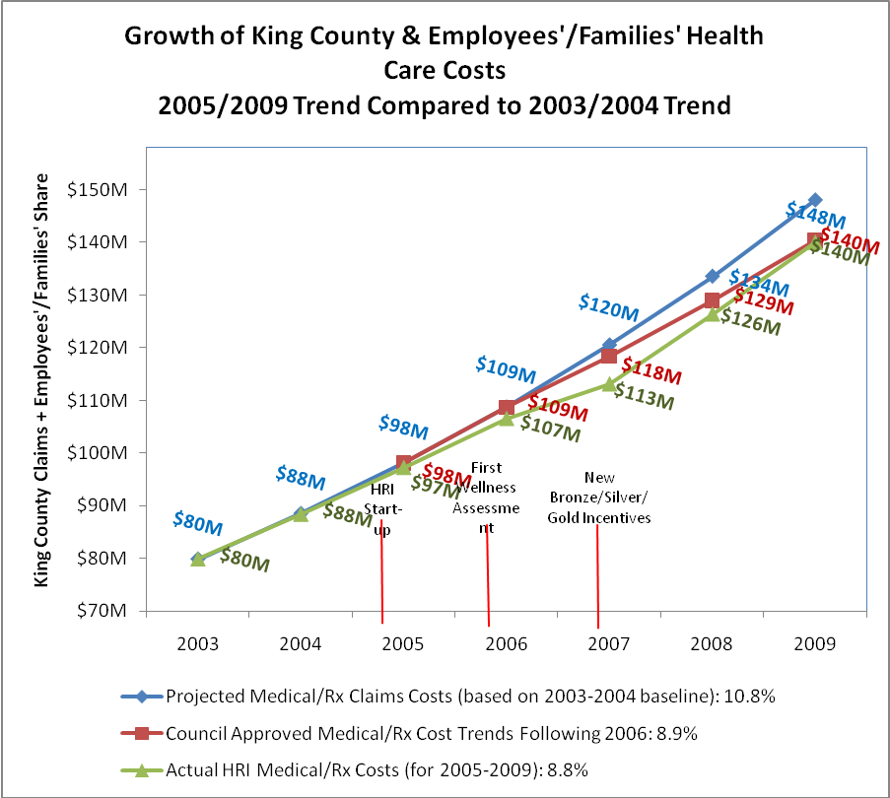
Data are for costs incurred in KingCareSM medical and prescription drug claims for active employees and their families with full benefits; excluded are costs for COBRA, early retirees, LEOFF1 retirees, and Local 587 part-time. Costs have not been adjusted for inflation.

For 2005 through 2009, the overall annual rate of growth was 8.8 percent, which was slightly lower than the Council-approved rate of cost growth of 8.9 percent. However, in 2008, the growth rate increased to 11.5 percent. This year’s report indicates that the growth rate remained high at 11 percent in 2009. This double-digit growth rate is comparable to the cost increases seen each year from 2004 through 2006, prior to implementation of the Health Reform Initiative.

Employee Benefits staff indicated a belief that the Health Reform Initiative did reduce increases in claims costs from the level projected prior to implementation of the initiative. As noted earlier, the overall cost increase from 2005-2009 was about 8.8 percent as compared to the projected 10.8 percent annual cost increase. Employee Benefits staff highlighted the importance of constraining costs in light of the county’s aging workforce and reducing health risk factors (discussed more below), as well as the continuing challenge of educating the county’s insured members that more care and more costly care are not always the most effective.

Furthermore, it is important to note that changes to the plan design (deductibles, co-pays and co-insurance, shown in Figure 3 below) for 2010-2012 are not reflected in this data. It is anticipated that a reduction in cost-growth will be observed once 2010 data has been analyzed.

Figure 3
Specific Changes to the Gold-level KingCareSM plan 2010-2012

KingCareSM Gold | 2007 - 2009 | 2010-2012
Deductible (medical) | $100 per individual  $300 per family | $300 per individual  $900 per family
Coinsurance (medical) | 90% In network  70% Out-of-network | 85% In network  65% Out-of-network
Annual out-of-pocket maximum for member coinsurance (medical) | In network services  $800 per individual  $1,600 per family  Out-of-network services  $1,600 per individual  $3,200 per family | No change from current  In network services  $800 per individual  $1,600 per family  Out-of-network services  $1,600 per individual  $3,200 per family
Prescription drug copays (at pharmacy—1 month supply) | $10 generic drugs  $15 preferred brand  $25 non-preferred brand | $7 generic drugs  $30 preferred brand  $60 non-preferred brand
Prescription drug copays (mail order—3 month supply) | $20 generic drugs  $30 preferred brand  $50 non-preferred brand | $14 generic drugs  $60 preferred brand  $120 non-preferred brand
Progressive medication for 12 drug classes | None | 12 classes of drugs
Annual out-of-pocket maximum for Rx copays | Unlimited | $1,500 per individual

Mercer, the county’s actuarial consultant, projected $37 million in avoided costs for 2010-2012 (Figure 4 below).

Figure 4
Expected Three-Year Savings from Benefits Changes for 2010-2012

Change Category | Three-Year Savings
Increased deductible (first dollar charged for medical services) | $17,295,000
Increased coinsurance | $5,791,000
Prescription drug changes | $12,244,000
Increased benefit access fee | $2,242,000

Already, for the first six months of 2010, costs for prescription drugs compared to the first six months of 2009 have declined by 14.3 percent ($10.7 million in 2010 compared to $12.5 for 2009) as more employees are choosing generic drugs.

2. Change in Self-Reported Health Risks

Employee program participation remains very high at 90 percent of eligible employees and their families. Members have reported improvements on nearly all self-reported health risk categories since implementation of the Health Reform Initiative.

Figure 5
Changes in the Percent of Members Practicing Healthy Behaviors and Testing in the “Healthy Range” on Biometric Measurements 2006 Compared to 2009

Health-Related Behaviors |  | Biometric Measurements
Moderating alcohol use |  | Body weight to height ratio | 
Managing depression |  | Blood sugar | 
Preventing injuries |  | Cholesterol | 
Maintaining good mental health |  | Systolic blood pressure | 
Eating a healthy diet |  | Diastolic blood pressure | 
Exercising regularly | 
Avoiding excess sun exposure | 
Stopping smoking | 
Managing stress | 
Key:  Improved  Stayed the same  Got worse
Data are for employees and spouses/domestic partners who completed the wellness assessment in both 2006 and 2009

The self-reported measures showing risk reduction from 2006 to 2009 were alcohol use, depression, injury prevention, mental health, nutrition, sun damage behavior, tobacco use, stress management, weight (Body Mass Index), cholesterol, and systolic and diastolic blood pressure. Physical activity and blood glucose levels have remained the same over the three-year period.

3. Change in Health Care Utilization Related to Health Risks

The report also provides data on actual utilization of health care related to five of the above risk factors measured by the wellness assessment: smoking, blood sugar and cholesterol, obesity, alcohol abuse, and common mental health conditions. Health Reform Initiative staff consulted with external experts to identify a list of diseases and health conditions that would show improvements within a period of a few months following changes in these five health behaviors. For example, if the rate of smoking in a population declines, the rate of incidents of bronchitis, asthma, respiratory infection, pneumonia, and the flu, are likely to decline within a few months.

Figure 5 below demonstrates the changes in health care utilization for conditions linked to smoking, as well as utilization claims related to high blood sugar and cholesterol, obesity, alcohol abuse, and common mental health conditions.

Figure 6
Change in Percent of Participants Reporting Healthy Behavior/Biometric Measurement and
Change in Utilization of Health Care for Associated Conditions
 | Change in % of Members Reporting Healthy Behavior and Biometric Measurements  2006 vs. 2009 * | Changes in Utilization of Health Care  2006 vs. 2008 **
Smoking |  |  Decrease in claims for bronchitis, asthma, respiratory infection, pneumonia and flu treatment
High Cholesterol  High Blood Sugar |    |  No significant change in claims for high blood glucose, cholesterol or blood pressure
Obesity |  |  Decrease in claims associated obesity as the primary diagnosis
Alcohol Abuse |  |  Decrease in claims for gastro-intestinal hemorrhage, gastritis and other conditions linked to alcohol abuse
Poor Mental Health  Stress  Depression |      |  Increase in claims associated with stress, insomnia, and depression (likely due to 2006 Washington State Mental Health Parity Act)
Key:  Improved  Stayed the same  Got worse
* Data from the wellness assessments for 2006 and 2009 are the source for the percentages of participants reporting these behaviors or conditions. The changes from 2006 to 2009 were statistically significant for all categories.
** Changes in actual health care utilization are based on actual claims data from 2006 through 2008.

As shown in Figure 6 above, in five of the risk factors, utilization of health care demonstrated improvements in conditions related to smoking, obesity, and alcohol abuse. There was no statistically significant change in utilization of health care related to high blood sugar and cholesterol. The analysis showed that utilization of care for mental health conditions did increase significantly, but this is likely due to the 2006 Washington State Mental Health Parity Act, which required insurers to expand coverage for mental health treatment. Participants seeking help for mental health issues are now able to receive more treatment, causing utilization to increase.

Because data on medical claims and wellness assessment results are maintained separately, it is not possible to determine whether the same individuals reporting changes in behavior on the wellness assessment are also reducing utilization of health care.

4. Change in Healthy Hours Worked

Since 2006, the employees have reported on how many hours of work they have missed due to health conditions (absenteeism). From 2006 to 2009, employees have not reported any appreciable difference in responses to wellness assessment questions about absenteeism.

In 2008, employees also began reporting on how many hours they have worked at less than full capacity due to a health condition (presenteeism). From 2008 to 2009, there was no appreciable difference in responses to wellness assessment questions about presenteeism.

Summary of Measurement and Evaluation Report Recommendations

The Executive’s policy recommendations are to:

- Transition the initiative to an ongoing Employee Health and Well-Being Program and continue the effort to make a healthier workforce comprised of more knowledgeable healthcare consumers.

Employee Benefits staff indicate that the Executive supports continuation of the program, as it is in alignment with three strategies in the county’s adopted Strategic Plan:
- Quality Workforce Objective 2d: Promote wellness and work/life balance initiatives, policies, and programs that contribute to an increase in healthy hours worked
- Quality Workforce Objective 3b: Enable employee health and safety
- Financial Stewardship Objective 1a: Partner with the county’s workforce to improve productivity and identify ways to contain the growth of future costs

- Establish health policy for labor negotiations focused on changing incentives and plan design in ways that reinforce and support employees taking an active role in their health care

The Measurement and Evaluation Report indicates that potential strategies include increasing member cost sharing and creating smaller health care networks with a greater focus on quality and efficiency. Any changes in plan design will take into consideration regulations associated with federal health care reform to attempt to avoid the excise tax that goes into effect in 2018 while still providing required coverage.

- Continue active support and leadership in the Puget Sound Health Alliance

The Alliance is working to improve regional information on quality and cost of health care to help consumers make informed decisions, which is a key to helping to contain costs and reduce waste system-wide.

- Integrate measurement and evaluation into the county-wide performance management process and use near-time data to identify emerging opportunities

The Employee Benefits program is well-situated to provide data in support of the county-wide performance management effort. Employee Benefits plans to utilize data from multiple sources (wellness assessments, sick leave, worker’s compensation data) to provide more robust analyses.

- Reinvigorate leadership investment in creating a healthy workplace culture. Employee Benefits annually surveys employees about their perceptions of the “supportive environment,” especially the support from managers and supervisors. Although feedback on the question is still positive, it is lower than in previous years. The report recommends identifying support of workplace wellness as a point of management accountability.

Quality Assurance Review by External Consultant

This report was reviewed by Ron Z. Goetzel, Ph.D., a Research Professor of the Institute for Health and Productivity Studies for Emory University and Vice President of Consulting and Applied Research in the Healthcare Division of Thomson Reuters. He concluded that the report and statistical methods used to analyze the initiative’s progress are sound and thorough, and that the report’s conclusions and findings are reasonable.

AMENDMENT:
An amendment is included in order to update the attachment to include the quality assurance review by Ron Goetzel.

REASONABLENESS:
Council staff has completed its review of the fifth Health Reform Initiative Measurement and Evaluation Report. As such, it would be reasonable and prudent for Council to take action on this motion.

INVITED:
Caroline Whalen, Program Project Director, Department of Executive Services (DES)
Karleen Sakumoto, Program Director, Health Reform Initiative, DES
Kerry Schaefer, Employee Benefits and Well-being Manager, DES

ATTACHMENTS:
- Proposed Motion 2010-0471 (including Fifth Annual King County Health Reform Initiative Measurement and Evaluation Report)
- Independent quality assurance review by an external consultant
- Transmittal letter
- Amendment 1

The report states that during the Health Reform Initiative, the average age of the King County population has increased nearly half a year every calendar year of the program.
Commensurate changes were made to the Silver and Bronze levels as well. See Appendix G for details.
Prepared by Mercer Health & Benefits LLC February, 2009

